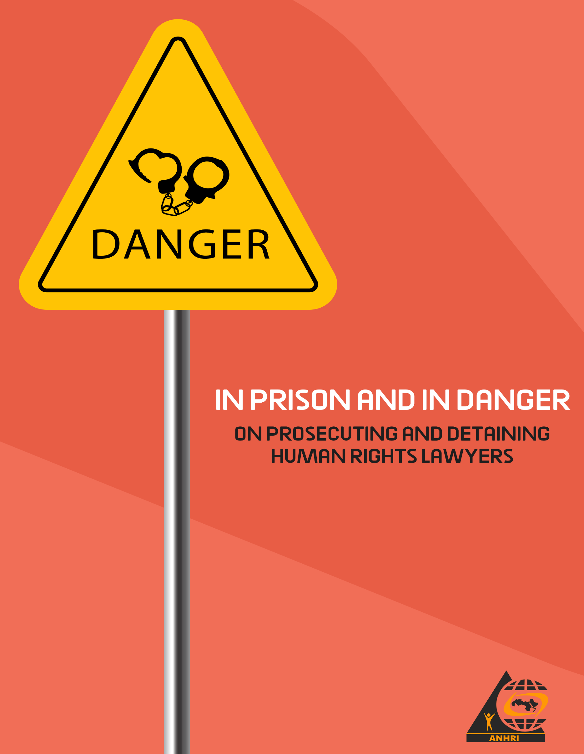

In Prison and In Danger
(On prosecuting and detaining human rights lawyers)

Introduction

Despite their abundance, the legal texts in the constitution, Egyptian laws and international conventions that recognize protection for lawyers, especially human rights defenders, have not provided them with a minimum level of protection.

In principle, Governments, in their national legislations and practices, should consider and respect the Basic Principles on the Role of Lawyers that were formulated to assist UN Member States in their task of promoting and securing the important role of lawyers, as it should be made known to lawyers and other persons such as judges, prosecutors, members of the executive, legislatures and the public in general.

Instead of the Egyptian government taking into account in its practices respect for the basic principles regarding the role of lawyers, enhancing their independence, and achieving adequate guarantees to protect them in the event that their security is endangered as a result of performing their professional work, human rights defenders have become at many times subjected to threats, intimidation and prosecution. They are held accountable for their opinions, the guilt of their clients and their cases, even physical assault on them in broad daylight and on the side of the roads.

The matter did not stop at this tragic point, but went beyond it to sinister media campaigns that lack any professional standards that attack and defame them, and accuse them of conspiracy and national treason.

In light of the Bar Association’s abandonment of providing support to its members, and the entrenchment of the phenomenon of impunity, lawyers in general, and human rights lawyers in particular, have to face and challenge prosecution, defamation, repression and,,,, imprisonment.
This Report:

This report deals with the legal framework established for some forms of protection supposed to be available to human rights defenders, then examples of grave violations that some human rights defenders have been subjected to and are still continuing.
The examples provided by the Arabic Network in its report do not include cases of travel bans and seizure of funds, under which dozens of human rights lawyers “as well as many defenders from other professions” in the so-called civil society case 173 of 2011, and its history suffices to clarify that ten years are a reference to the politicization of this case and its retaliatory target, especially from independent human rights institutions. Which continues so far to approach eleven years, and its politicization is not diminished by the decision to exclude some of them during the years 2020 and 2021, as everyone is still deprived of travel and the money of many of them is kept.

First: The legal protection granted to lawyers constitutionally, legally and internationally:

- The Egyptian constitution and the protection granted to lawyers:
With regard to lawyers, the newly issued 2014 Egyptian constitution stated in its article No. 198 that:

“The legal profession is a free profession. The judiciary participates in achieving justice, the rule of law, and ensuring the right of defense, and it is practiced by the lawyer independently, as well as lawyers for public bodies and companies and the public business sector. While performing the right of defense before the courts, all lawyers enjoy the guarantees and protection decided for them in the law. While it applies to them before the investigation and inference authorities, it is prohibited, except in cases of flagrante delicto, to arrest or detain a lawyer while he is exercising the right of defense, and all of this is in the manner specified by law.”

- Advocacy Law:

- As for the Advocacy Law, it stipulates in its first article that “the legal profession shall be practiced exclusively by lawyers in independence, and there is no authority over them in that except for their conscience and the provisions of the law.” Articles 49 and 50 regulate the exclusion of lawyers from the provisions relating to the penalty for breaching the order of court sessions in terms of disciplinary and criminal procedures incurred as a result of that.”
- Article 51 stipulates that:
" It is not permissible to investigate a lawyer or search his office without the knowledge of a member of the Public Prosecution. The Public Prosecution must notify the Council of the General Syndicate or the Council of the Subsidiary Syndicate, if a lawyer is accused of a felony or misdemeanor related to his work, that he or whomever he delegates from among the lawyers attend the investigation. The Council of the General Syndicate and the Council of the Branch Syndicate
may request copies of the investigation without fees".

- Article 54 stipulates that:

" Whoever assaults or insults a lawyer by gesture, word, or threat to his profession, or because of it, shall be punished with the penalty prescribed for anyone who commits this crime against a member of the court".

- United Nations 1990 Guidelines on the Role of Prosecutors and Guarantees for the Performance of Lawyers' Duties

16: Governments ensure that lawyers:
(a) The ability to perform all of their professional functions without intimidation, hindrance, harassment or improper interference;
(b) the ability to move freely to and consult with their clients, both within and outside the country;
(C) neither exposing them, nor threating of exposing them, to legal prosecution or administrative, economic and other penalties as a result of their carrying out an act in accordance with the duties, standards and ethics of the profession recognized.

17: The authorities shall provide adequate safeguards for lawyers, if their security is threatened by the performance of their functions.

18: Lawyers may not, as a result of the performance of their duties, take them for the crime of their clients or the cases of these clients.

19: No court or administrative authority recognizing the right to counsel shall refuse to recognize the right of any counsel to appear before it on behalf of his/her client, unless such counsel has been disqualified under the laws and functional practices and in conformity with these Principles.

20: Lawyers enjoy civil and criminal immunity for statements they make in good faith, whether in their written or oral pleadings or when they appear before courts or other executive or administrative authorities.

21: It is the duty of the competent authorities to ensure that lawyers have access to the appropriate information, files and documents in their possession or at their disposal, for a period sufficient to enable them to provide effective legal assistance to their clients, and such access should be secured within the shortest appropriate period.

22: Governments shall ensure and respect the confidentiality of all communications and consultations that take place between lawyers and their clients in the course of their professional relations.

23: Lawyers, like any other citizen, have the right to freedom of expression, to form and join associations, and to hold meetings. In particular, they shall have the right to participate in public debates relating to the law, the administration of justice and the promotion and protection of human rights, and to join or form local, national or international organizations and attend their meetings without being subject to professional restrictions because of their lawful work or membership in a lawful organization. In exercising these rights, lawyers always act in accordance with the law, recognized standards and the ethics of the legal profession.

Second: Examples of prosecution and violations of human rights lawyers:

- Arresting lawyers while performing their work

The phenomenon of arresting lawyers has increased, not only during the performance of their work, but also during their presence in the headquarters of the Public Prosecution, in violation of all the provisions of international laws and conventions, including:

- Lawyer Mahinour Al Masry

She was arrested during her attendance before the State Security Prosecution, on September 22, 2019, and she was accused in Case 488 of 2019. A year later she was rotated in Case 855 of 2020, then a year later she was released after completing 22 months of pre-trial detention, through the intervention of the International Dialogue Committee.

- Lawyer Mohamed Al Baqer:

“Mr. Mohamed, you will not be able to attend as a lawyer appointed by Alaa Abdel-Fattah in this case, because the authorities ordered to arrest and bring you in the same case.”
That sentence uttered by the State Security Prosecutor on September 29, 2019 during the request of lawyer Muhammad Al-Baqer to attend the investigations with the blogger and activist Alaa Abdel-Fattah in Case No. 1356 of 2019 State Security Restriction, to turn from a lawyer to an accused and be detained within the prosecution. He was charged of the participation of a terrorist group in achieving its goals, misuse of social media, financing and supplying terrorist groups, publishing and broadcasting false news and statements. His detention continues to be renewed so far after being rotated from inside his prison as a defendant in Case 855 of 2020, an investigation limited, and he is still in solitary confinement in Torah Prison, heavy guarded.

- Lawyer Haitham Mohammadein:
Human rights lawyer Haitham Mohammadein was arrested on May 11, 2019, while he was in Al-Saff Police Department, not as a lawyer but as a prisoner of conscience, serving precautionary measures pending a previous case he was accused and imprisoned in, which is Case 718 of 2018, but he did not appear at the Public Prosecution for investigation except on the 16th of the same month. He appeared at the Supreme State Security Prosecution in connection with Case 741 of 2019 State Security Inspection, and he was accused of joining a terrorist group with knowledge of its purpose. He is still imprisoned until now, despite his imprisonment for two years.

- Lawyer Amr Nohan

He was arrested on June 10, 2019 while he was at Karmouz Police Station to provide legal assistance to one of the accused. Since then, he has been in pretrial detention, pending Case No. 741 of 2019 Restriction Supreme State Security.

- Prolonged arrest and detention and inclusion on terrorist lists

The most serious violations that have been and are being committed against human rights defenders are those represented in the serious physical assaults or their arrest on the basis of false and malicious reports written by the officers of the National Security Sector at the Ministry of the Interior, and the Public Prosecution, especially the Supreme State Security Prosecution, responds to them and issues arrest warrants against them which last for months and years or by referral to criminal court in trials that have been described that they lack fair trial standards, including the following cases

- Lawyer Ziad Al Eliemy:
Lawyer and former parliamentarian Ziad Al-Eleimy was arrested on June 24, 2019, after a statement was presented by the Ministry of the Interior about a coalition called "The Hope Plan", which includes a number of figures from different political currents, including lawyer and former parliamentarian Ziad Al Eleimy. He appeared before the State Security Prosecution on June 25, and he was investigated and accused of participating in a terrorist group in achieving its objectives and financing the group, pending case 930 of 2019, an investigation limited. A case was copied from the latter, in which Al Eleimy is being tried on charges of deliberately spreading false news and rumors that would harm the State and its institutions. Al Eleimy is still in pretrial detention, and a judicial decision was issued to include Ziyad on the lists of terrorists.

- Physical assaults in the street and theft:

- Lawyer Gamal Eid

At 9:00 p.m on October 10, 2019, while human rights lawyer Gamal Eid was walking in one of the largest and most crowded streets in Maadi, a large-bodied person attacked him, snatched his phone from his hand, tried to steal his handbag, and hit him in the chest using the back of the pistol he was carrying, and after Eid’s cried for help the assailant ran away with the help of another person who was riding a motorcycle. A new person immediately appeared carrying a walkie-talkie, accompanied by others, declaring that he was a detective officer at the Al-Basateen Police Department. He asked Eid to follow him to the police station. There, they told him that the aggressors do not work for the police station, and despite the availability of witnesses to the incident and their testimonies, the Public Prosecution decided that Eid's report to be preserved.
- At 11:00 a.m. on December 29, 2019, near Eid’s house, while he was trying to get a taxi to go to his workplace in the Arabic Network for Human Rights Information, Eid was surprised by three cars, from which a number of security personnel and officers got down. The three threw him to the ground and started beating him. One of the National Security officers, “who is known for Gamal Eid” ordered them to drown him in wall paint, saying, “until he quit what he’s doing.” When some passers-by and neighbors tried to intervene to protect him, two security personnel pointed out pistols and threatened them, saying, “Go away, go away.”
The same officer instructed them to take several pictures of Gamal Eid while he was lying on the ground while he was covered in paint and while he was being beaten, as if they were getting evidence that they had done what was required of them.

When one of the citizens tried to photograph the cars, he found that they were all stripped of their numbers.

The stance of the Public Prosecution after this attack did not differ, as the investigations proceeded to a decision to preserve it after a number of practices that confirmed the Public Prosecution's unwillingness to provide evidence of the crime or to reveal the personalities of the infringers and the parties they work for.

- Prosecution, arrest and trying:

- Lawyer Ezzat Ghoneim
Ezzat Ghoneim, a lawyer in the Egyptian Coordination for Rights and Freedoms, and many of his colleagues were subjected not only to arrest, prosecution and prolonged detention, but also to the trial that is taking place now.
Ghoneim was initially subjected to enforced disappearance for 3 days until he appeared at the Supreme State Security Prosecution on March 3, 2018, and was interrogated without the presence of his lawyer. He was charged of joining a group that was established in violation of the provisions of the law, and the dissemination of false news and statements, in connection with Case No. 441 of 2018, known in the media as “the media movement”
- Lawyer Huda Abdul Moneim
A former member of the National Council for Human Rights, and a lawyer in the Egyptian Coordination for Rights and Freedoms now, where she was subject to arrest, detention, enforced disappearance and ban from visiting.
At dawn on Thursday, November 1, 2018, a force of the Police and National Security broke into her house at around 1:30 in the morning and took her, blindfolded, to her mother’s house, where the force searched it and then returned again to her home, where they left her in a car belonging to them under guard, blindfolded, for a period of time for two and a half hours while they searched her house, then they took her to an unknown destination until she appeared at the State Security Prosecution on November 21, 2018, after an enforced disappearance that lasted for 20 days. She was investigated and accused of joining a terrorist group and committing a financing crime. She is imprisoned in this case until now.
Lawyer Hoda Abdul Moneim, who is more than 60 years old, suffers from several health problems, as she suffers from severe osteoarthritis and cartilage erosion, with which she cannot move or walk during the exercise hour allowed in Qanater prison, which threatens her with great danger while she is being transferred to the renewal sessions in the transfer cars, she is also prohibited from visiting most of the time.
- Ban on travel and arrest at the airport

- Lawyer Ibrahim Metwalli
On September 10, 2017, human rights lawyer Ibrahim Metwally Hegazy was arrested, while he was traveling on an EgyptAir plane bound for Geneva, Switzerland, in response to the invitation extended to him by the United Nations Working Group on Enforced Disappearances to attend the proceedings of its 113th session held from 11 to September 15, 2017, inside the United Nations Human Rights Council in Geneva, and he was accused in Case 900 of 2017, and two years later he was rotated in Case 1470 of 2019, then he was rotated in Case 786 of 2020, and he is still imprisoned.

- Arrest on International Human Rights Day

- Lawyer Mohamed Ramadan Abdul Basset
It is ironic that human rights lawyer Mohamed Ramadan was arrested on December 10, 2018, particularly on the “International Human Rights Day” and appeared for interrogation at the “Al-Montazah” Prosecution Office in Alexandria, where he was accused of joining a terrorist group, promoting its purposes, spreading false news, inciting against state institutions and calling for demonstrations in Case No. 16576 for the year 2019 Al Montazah first administrator, known in the media as the "Yellow Vests" case.
The arrest of lawyer Muhammad Ramadan coincided with his appearance in a photo on his personal account on the social networking site Facebook, where he was wearing a yellow jacket, in solidarity with the demonstrations and protests that took place in France at the end of last year. Lawyer Ramadan has a precedent incident with the state in a case in which he was accused of insulting the President of the Republic, and was sentenced to five years in prison and banned from using social media for another five years. Ramadan suffers from health problems in the heart, blood pressure and knee problems.
Mohamed Ramadan had complained of constant pain in the knees, to the point of not being able to sit or move normally. However, the Tora Investigation prison administration did not enable him to obtain the necessary health care for his condition, which prompted him to repeat his request to be able to obtain a medical examination.

The officers in charge of the prison decided to abuse Ramadan, as punishment for repeating the request for a medical examination, as he was transferred from the ward where he was held to another ward with poor ventilation, in addition to preventing him from visiting him for two months.
Two years later, that is, in December 2020, he was rotated and re-charged in Case 467 of 2020, and he is still in custody.

- I am being arrested from home

- Lawyer Amr Imam
On October 16, 2019, human rights lawyer Amr Imam, who works for the Arabic Network for Human Rights Information, wrote a short statement on his account on social networks: "I am being arrested from home now."
More than thirty security personnel in uniform and in civilian clothes took him from his home at dawn on October 16, as he remained disappeared for 36 hours without informing the syndicate of his legal position or knowing where he was being held. The Arabic Network issued a statement explaining the details of his kidnapping. The disappearance continued in an illegal detention place in the grip of the National Security, blindfolded and handcuffed, until he appeared at the State Security Prosecution at noon on October 17, and was re-accused (rotated) while he was inside his prison in a new case No. 855 of 2020 “Restricted to the Supreme State Security Prosecution’s investigation with the same accusations as before, with the addition of the terrorism financing charge.

Conclusion with a recommendation:
These are some examples, and are not an inventory of human rights lawyers who are victims of violations in Egypt, and if the origin and legal imposition requires the Public Prosecution to consider charges or complaints against lawyers in their professional capacity promptly and fairly and according to appropriate procedures after hearing their statements in a fair manner.

The practice against lawyers defending human rights resulted in the arrest of many of them and the exposure of many of them to grave violations, in a behavior that is inconsistent with the state's obligations that it must fulfill as basic rights of lawyers.

Therefore, all state officials, headed by the Public Prosecutor, are called upon immediately to start fulfilling their legal obligations and to take urgent measures and real, honest and serious work to guarantee the rights of lawyers without derogation.

Our certainty is that there will be no complete legal system without independent lawyers who are able to carry out their work freely and without fear of reprisals.

Justice will not be administered in a fair and effective manner without enabling lawyers to work without fear of attacks on their persons, harassment and intimidation. Otherwise, the rule of law will inevitably erode faster than we can imagine.

The website of the Arabic Network for Human Rights Information published under the title One month after the police assault via the link https://www.anhri.info/?p=14341
The website of the Arabic Network for Human Rights Information published on May 9, 2021 with the title Human Rights Organizations condemning the prevention of health care for human rights lawyer Mohamed Ramadan in Tora Prison and calling for his release via the link https://www.anhri.info/?p=23928 أLast visit September6, 2021

