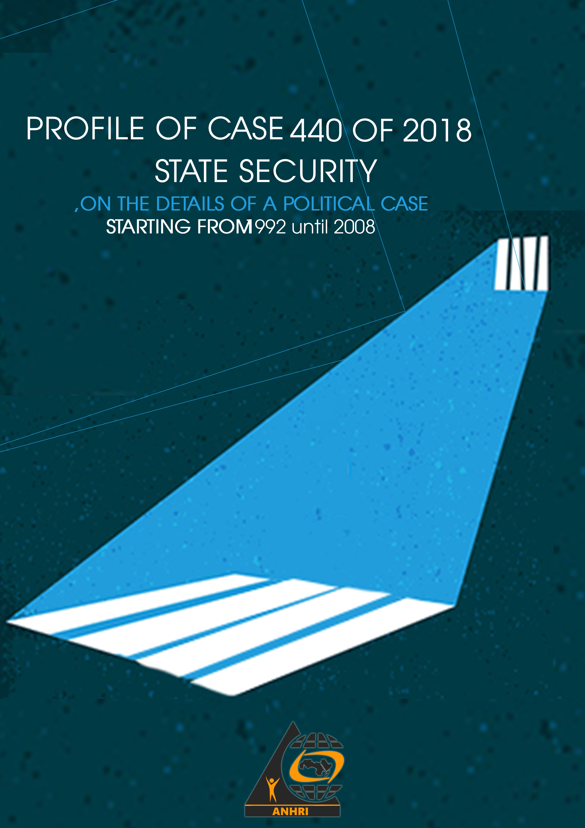

Profile of Case 440 of 2018 State Security
" On the details of a political case, starting from 1992 until 2018 "

Introduction
From pretrial detention without evidence,
to prolonged and extrajudicial detention,
to a rotation to new cases,
to trial!
Is the era of frozen cases over?
We do not know, but we believe that a wave of trials, in cases most of which lack real evidence, has begun.

Case 440 of 2018 represents an episode in the series of referring frozen cases that were locked up in the corridors of the Public Prosecution, more than three years after the investigations began with the accused.
Through the following lines, we explain some available information about Case No. 440 of 2018.

The course of the case with dates, as far as we know:

- At the beginning of February 8, 2018, Dr. Abdel Moneim Aboul Fotouh traveled to the United Kingdom and Qatar and appeared in interviews for Al Jazeera Qatar and BBC Arabic.
- On February 14, 2018, son of Dr. Abdel Moneim Aboul Fotouh published a post on the social networking site that the security forces arrested his father and 6 leaders of the Political Bureau of the Misr Al Qawya Party from inside their house in the Fifth Settlement and took them to one of the security authorities. Then leaders of the Political Bureau were released while Dr. Abdel Moneim Aboul Fotouh remained under arrest.
- On February 15, 2018, the Ministry of Interior announced in a statement the reasons for arresting of Dr. Abdel Moneim Aboul Fotouh, and that it was in compliance with the permission of the Supreme State Security Prosecution to arrest him. On the same date the State Security Prosecution began investigations with him.
- On February 21, 2018, the Ministry of Interior announced in a statement that the security forces had seized 6 elements it described as terrorists inside a farm owned by Dr. Abdel Moneim Aboul Fotouh in the area of ​​Wadi al-Natrun police station in the Beheira governorate as they took it as a den to hide and launch from to implement a hostile plan referred to in the case. No. 440 of 2018 State Security. Supreme State Security Prosecution began investigations with them on February 22, 2018.

Accusations against the defendants in the case prior to the issuance of the referral order:
The accusations in the case differed from one accused to another and were as follows:
1. Establishment and leadership of a terrorist group.
2. Supplying and financing a terrorist group.
3. Joining a terrorist group with knowledge of its purposes.
4. Promote the ideas of a terrorist group
5. Possession and acquisition of weapons and ammunition in cases other than those authorized by law.
6. Publishing and broadcasting false news and statements.
From the above accusations, it appears that the Supreme State Security Prosecution, which conducted investigations with the accused, used texts derived from the Terrorism Act No. 94 of 2015 and Information Technology Crimes Law No. 175 of 2018, which are laws that have been enacted in recent years under the authority of the current political situation is in addition to Penal Code No. 58 of 1937 and Law of Arms and Ammunition No. 394 of 1954.

Inclusion on the lists of terrorist entities:

- On February 17, 2018, the Supreme State Security Prosecution submitted a request to the Public Prosecutor, registration No. 1 of 2018, requests to list terrorist entities and terrorists, to include the Muslim Brotherhood on the list of terrorist entities and to include the accused “Abdul Moneim Abul-Fotouh Abdul-Hadi Abu Saad, Ahmed Abdul-Moneim Abul-Fotouh, Sayed Mahmoud Ezzat Ibrahim Issa, Ibrahim Monir Ahmed Mustafa, Hani Hashem Yousef El Deeb, Hussein Youssef Mohamed Mahmoud, Mohamed Sayed Mohamed Ali Sweidan, Diaa Ahmed Mohamed El Moghazi, Maha Salem Mohamed Hassan Azzam, Lotfi El Sayed Ali Mohamed, Mohamed Gamal Ahmed Heshmat Abdel Hamid, Hossam El Din Atef El Shazly, Amr Ahmed Fahmy Khattab, Amr Mohamed Rabie El Helou, Moaz Nagah Mansour Mansour El Sharkawy, Adham Qadri Metawa Hussein Shaikhoun.
- On February 19, 2018, the request submitted by the Supreme State Security Prosecution and signed with approval by the Public Prosecutor was presented to the Cairo Criminal Court - Chamber 25, South Cairo Criminal Court - to consider the request to include the accused on the lists of terrorist entities. In this session the court decided to list them in list of terrorist entities for a period of five years starting from the date of the issuance of the decision with the consequent effects regulated by Article VII of the decision by Law No. 8 of 2015.
- On February 22, 2018, "Official Gazette" published the decision issued by the Cairo Criminal Court to include the defendants whose names were included in the Supreme State Security Prosecution's request on the lists of terrorist entities in issue (44 continued), so that those listed could appeal it before the Court of Cassation.
- On different dates - within 60 days from the date of publication of the decision in the Official Gazette - those listed have filed appeals against the decision before the Court of Cassation.
- On November 17, 2018, the Court of Cassation considered the first hearings of the appeals against the listing decision submitted by the accused.
- On February 1, 2020, the Court of Cassation decided to accept the appeals submitted by the appellants against the decision issued by the South Cairo Criminal Court and to cancel the contested decision and return the papers to the Cairo Court of Appeal to determine another different department to consider the application for listing.
- On January 12, 2021, the Cairo Criminal Court - Tenth department South - decided, after presenting the papers to it, to include the aforementioned defendants on the lists of terrorist entities for a period of 5 years starting from the date of the decision, with the consequences that were regulated by Article 7 of the decision by Law No. 8 for the year 2015.
- On January 24, 2021, “Official Gazette” published the decision issued by the Cairo Criminal Court to include the defendants whose names were included in the Supreme State Security Prosecution’s request on the lists of terrorist entities in case (19 continued), so that those the listed could appeal it before the Court of Cassation.
- On different dates - within 60 days from the date of publication of the decision in the Official Gazette - those listed filed appeals against the decision before the Court of Cassation, and a hearing for the appeal has not been set yet.

Case Referral:

" Because they are from 1992 until 21/8/2018 inside and outside the Arab Republic of Egypt "
The case, then, deals with events and actions during 26 years.
On August 30, 2021, and more than three years after the start of investigations into Case 440 of 2018, the Supreme State Security Prosecution decided to refer the case’s papers to the Cairo Court of Appeal to determine a department to start hearing the case papers before the State Security Court with emergency jurisdiction, and no department or Session have been determined up to the date of writing this paper.

List of defendants in the referral order:

Notes | Stance in case | Defendant Names | No.
 | Fugitive | Ibrahim Monir Ahmed Mostafa | 1
 | Detained | Al Sayed Mahmoud Ezzaat Ibrahim Essa | 2
 | Detained | Abdul Moneim Abul Fotouh Abdul Hadi | 3
 | Fugitive | Mohamed Sayed Mohamed Ali Swiadan | 4
 | Fugitive | Ali Hashem Youssef Al Deeb | 5
 | Fugitive | Diaa Ahmed Al Moghazi | 6
 | Fugitive | Hussein Youssef Mohamed Mahmoud | 7
 | Fugitive | Mohamed Gamal Ahmed Heshmat | 8
 | Fugtivie | Lotfi Al Sayed Ali Mohamed | 9
 | Fugitive | Hossam Al Din Atef Al Shazly | 10
 | Fugitive | Maha Salem Mohamed Hassan Azzam | 11
 | Fugitive | Ahmed Abdul Monein Abul Fotouh | 12
 | Detained | Mohamed Ali Ibrahim Al Qassas | 13
 | Fugitive | Amr Ahmed Fahmi Khattab | 14
The prosecution did not state whether he is fugitive, released or detained. | released | Moaz Nagah Mansour Al Sharqawi | 15
 | Fugitive | Adham Qadri Metawe | 16
 | Fugitive | Amr Mohamed Rabie Mohamed Al Helw | 177
 | Fugitive | Ahmed Taha Mohamed Thabet Al Qadi | 18
 | Fugitive | Hossam Mohamed Eqab Hamid | 19
 | Fugitive | Ayman Mohamed Eqab Hamid | 20
Starting from the 21st to the last defendant, it is not mentioned the stance of any whether fugitive, released or detained. | ! | Ahmed Mohamed Abdul Hamid Eqab | 21
As above |  | Omar Mohamed Salah Abdul Hakim Batikha | 22
As above |  | Mohamed Abdul Aziz Abduul Aati Abdul Hamid Hamid | 23
As above |  | Ahmed Yasser Ali Abdul Hafiz | 24
As above |  | Atiya Ashour Atiya Breik | 25

Who were investigated?

- Dr. Abdul Monein Abul Fotouh Head of Misr Al Qawiya Party:
Two days after his arrest, on February 15, 2018, the Supreme State Security Prosecution investigated Abul Fotouh in Case No. 440 of 2018 the Supreme State Security inventory. The prosecution charged him with founding and assuming leadership of a terrorist group, financing terrorist groups and publishing false news and statements. The prosecution decided to hold him in pretrial detention. Sessions to renew his detention continued.
On February 2, 2020, before reaching the maximum limit of pretrial detention, Abul Fotouh was rotated from inside his prison in Case No. 1781 of 2019 State Security Restriction on charges of establishing and assuming leadership of a terrorist group and financing terrorist groups, the he was held in pretrial detention for a period of 15 days starting from the date of ending his detention in the case 440 of 2018 State Security Inventory.
- On June 15, 2021, the Supreme State Security Prosecution decided - after more than three years - to release Abul Fotouh with the guarantee of his place of residence in Case No. 440 of 2018, but he continued to be imprisoned pending Case 1781 of 2019.
On August 4, 2021, the Supreme State Security Prosecution completed investigations with Abul Fotouh in Case 440 of 2018 Supreme State Security and charged him with assuming leadership in a terrorist group, committing a crime of financing terrorist groups, possessing weapons and ammunition, promoting the ideas of a terrorist group, and deliberately broadcasting false statements and rumors at home and abroad.

- Mohamed Ali Ibrahim Al Qassas knonw as Mohamed Al Qassas:

- On February 8, 2018, the security forces arrested the Vice-President of the Misr Al Qawya Party, Mohamed Al-Qassas, after storming his house and hiding him for two days.
- On February 10, 2018, the Supreme State Security Prosecution investigated the Vice-President of Misr Al Qawya Party and accused him of joining a terrorist group in Case No. 977 of 2017, State Security Restriction, known in the media as the “Mekamelin/ We will go on 2” case, and sessions to renew his detention continued before the Public Prosecution and the renewal judge.

- On December 9, 2019, the Supreme State Security Prosecution decided to release Mohamed al-Qassas in Case 977 of 2017, Supreme State Security, and the decision was not implemented, and al-Qassas continued to be detained unlawfully.

- On December 15, 2019, the Supreme State Security Prosecution investigated Mohamed al-Qassas, after he was rotated in Case No. 1781 of 2019 Supreme State Security, on charges of joining a terrorist group established in violation of the provisions of the law and committing a financing crime, and decided to remand him in pretrial detention pending the case, and sessions to renew his detention continued.

- On August 6, 2020, the Cairo Criminal Court decided to replace pretrial detention with one of the precautionary measures in Case No. 1781 of 2019 State Security, but the decision was not implemented and Qassas continued to be detained.

On August 8, 2020, the Supreme State Security Prosecution investigated with Qassas after he was rotated in Case No. 786 of 2020 Supreme State Security on charges of assuming the leadership of a terrorist group established in violation of the provisions of the law, and decided to remand him in pretrial detention pending the case, and the sessions to renew his detention continued.

- On June 27, 2021, Mohamed al-Qassas appeared within the Supreme State Security Prosecution for interrogation for the first time since his arrest in February 2018 in Case No. 440 of 2018 State Security. The prosecution charged him with joining a terrorist group and spreading false news, and the prosecution decided to hold him in pretrial detention for 15 days. It starts from the date of ending his detention in Case 786 of 2020 State Security.

- Moaz Nagah Mansour Mansour Al Sharqawi known as Moaz Al Sharqawi

- On September 19, 2018, the security forces arrested Moaz Al-Sharqawi while he was traveling to the city of Dahab to spend a political trip in one of the check-point on the Sharm-Dahab road, the check-point is known as “Madsous”, and took him to an unknown destination and remained in enforced disappearance for 25 days.

- On October 13, 2018, the Supreme State Security Prosecution investigated with Moaz Al-Sharqawi - after his appearance - in Case No. 440 of 2018 Supreme State Security and accused him of joining a terrorist group with knowledge of its purposes, publishing false news and statements and promoting the ideas of the terrorist group, and decided to imprison him for 15 days.

On January 21, 2019, the Supreme State Security Prosecution completed investigations with “Al-Sharqawi” in Case 440 of 2018 and did not add new charges.

On March 4, 2020, the Cairo Criminal Court decided to replace Al-Sharqawi’s pretrial detention with a precautionary measure.

On April 2, 2020, the Supreme State Security Prosecution decided to cancel the precautionary measure and decided to release Al-Sharqawi under the guarantee of his place of residence.

The following names were also investigated:

- Ahmed Mohamed Abdul Hamid Eqab
- Abdul Hamid Mohamed Mostafa
- Omar Salah Abdul Hakim Batikha
- Mahmoud Abdul Aziz Abdul Aati
- Ahmed Yasser Abdul Hafiz
- Atiya Ashour Atiya Mabrouk

- On February 21, 2018, the Ministry of Interior announced, in a statement, the arrest of the accused from inside a farm owned by the head of Misr Al Qawya Party, Abdel Moneim Abul Fotouh, in the Wadi al-Natrun center in the Beheira governorate, in implementation of the permission issued by the Supreme State Security Prosecution in Case 440 of 2018 Supreme State Security.

- On February 22, 2018, the Supreme State Security Prosecution investigated the defendants without the presence of a lawyer and charged them with joining a terrorist group with knowledge of its purposes, promoting the ideas of the terrorist group, and possessing weapons and ammunition in cases other than those authorized by law. The prosecution decided to hold them in pretrial detention for a period of 15 days. Investigations, and sessions to renew their detention continued before the Public Prosecution and the renewal judge in one of the terrorism departments.

On June 2 and 14, 2020, the Supreme State Security Prosecution decided to release them “under the guarantee of their place of residence for exceeding the maximum limit of pretrial detention.”
When the referral decision appeared, the State Security Prosecution considered them fugitives.

- A summary of the content of the charges against the referral order:

- From the first defendant to the tenth: Assuming leadership in a terrorist group that aims to use force and violence inside, and aims to change the regime by force.

- From the eleventh defendant to the last: Joining a terrorist group with their knowledge of its purposes.

- Defendants from the first to the tenth, and from the nineteenth to the last: financing a terrorist group and possessing weapons for the purpose of using them.

- The third defendant, the nineteenth, and the twentieth: They prepared and trained individuals to use weapons, in order to commit terrorist crimes.

- The defendants from the twenty-first to the last: They received training in the use of weapons in aim of committing terrorist crimes.

- The third defendant: Possession of publications that promote the terrorist group and are intended for distribution.

- The third defendant and the eighteenth defendant: Broadcasting and publishing false news and information about the situation inside the country.

- The third defendant, from the nineteenth to the last: Possessing weapons and ammunition without a license, with the intention of using them in an activity that violates security and the constitution.

- Al-Masry Al-Youm newspaper website entitled "The Interior" reveals the reasons for the arrest of Abdel Moneim Aboul Fotouh - on February 15, 2018, https://www.almasryalyoum.com/news/details/1259653 - last visit Septmeber 5 2021
- Al-Masry Al-Youm, entitled "In pictures... Details of the arrest of 6 "terrorists" at the Abu Al-Fotouh farm (interior statement) - on February 21, 2018 - via the link https://www.almasryalyoum.com/news/details/1262115 - last visit Septmeber 5 2021
- The news published on the website of the Association for Freedom of Thought and Expression for the sessions of renewing the imprisonment of the Vice-President of Misr Al Qawya Party, "Mohamed Al-Qassas" - and published on different dates - via the link https://afteegypt.org/law_unit/law_unit_news/2018/12/25/13941-afteegypt.html - Last visit: September 5, 2021.

