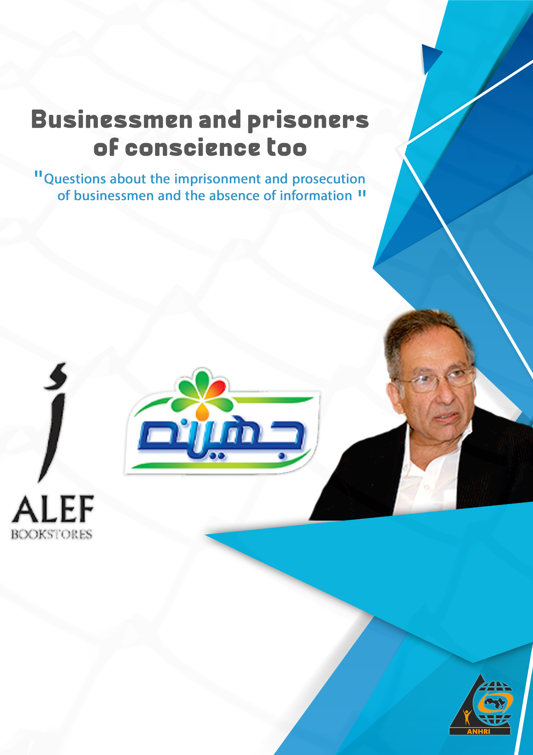

Businessmen and prisoners of conscience too,
"Questions about the imprisonment and prosecution of businessmen and the absence of information"

Introduction:
On November 23rd 2014, and for two days, the activities of the 16th session of the Conference of Business owners and investors in Cairo took place, which included more than 1,000 finance and business leaders both arab and foreigners, and especially Egyptian businessmen, it opened the door for them in all fields to invest in their country, and this conference has been held periodically since 1982 and organized by the General Federation of Chambers of Commerce, Industry and Agriculture of the Arab Countries, the General Federation of Egyptian Chambers of Commerce, in cooperation with the Egyptian government, and the Arab League Of States, and The Arab Corporation for Investment and Export Credit Guarantee, in partnership with the Economic and Business Group.
The conference represents a prominent Arab economic and investment gathering, since it’s considered one of the gatherings prepared by the government for economic development through the development of an integrated system for the development of education and training, and encouraging entrepreneurs, creating new jobs for businessmen, and so the Egyptian state continued to issue similar statements claiming to encourage investment.
However, on the other hand, it was a security pursuit of some businessmen and their projects, not for economic reasons but for reasons that appeared to be related to retaliation against them, whether for expressing opinions contrary to government policies or for taking opposing positions.

Security prosecutions and terrorism accusations against businessmen:
Human beings’ original state is innocence, where article 96 of the Egyptian Constitution and Article 11 of the Universal Declaration of Human Rights stipulate that "the accused is innocent until proven guilty in a fair legal trial in which he is guaranteed guarantees of self-defense."
But expressing your opinions that are opposed to the authorities and the government, crossing a different path than the one which the authorities want, may leave you in a position as an enemy of the state, and at any moment this may turn into an enforced disappearance, with your assets froozen, you are banned from traveling, or being locked up, on charges mostly related to national security such as joining a terrorist group, publishing ans spreading false news and information, financing banned groups, etc.. Thus you become one of the thousands of prisoners of conscience who were arrested and detained because of their political affiliations and opinions that are opposed to the state.
In these circumstances, businessmen were no better off than prisoners of conscience, whether political opponents or ordinary citizens, they were pursued and charged with committing terrorist acts and harming national security and the national economy, many of whom were arrested in flagrant violation of the Constitution and the law, without fair trials in these cases, and the state resorted to unlawfully imprisoning businessmen for long periods of time and also resorted to freezing their assets and to banning them from traveling.
We mention some examples and names of those who have been arrested and pursued:

Engineer Mamdouh Hamza:
Engineer Mamdouh Hamza is considered one of the most important participants and supporters of the January 25th revolution and did not stop there, but continued to join all events calling for freedom and democracy, which was not forgiven by the security services.
He was charged by the State Security Prosecution with inciting a terrorist crime to use force, violence and disrupting public order by posting through his personal Twitter account, obstructing and resisting the authorities in the course of their work and inciting the people of Al-Warraq Island to confront the police forces and carry arms against them in case No. 48 of 2020 Supreme State Security. It is noteworthy that the public prosecution released him on the 17th of February 2019 on bail of 20 thousand Egyptian pounds in case No. 31 of 2017 Supreme State Security after he was charged with spreading false news,
On October 26, 2020, the Cairo Criminal Court sentenced Engineer Mamdouh Hamza to six months in prison with labor, and confiscating his mobile phone in case No. 48 of 2020 and he was placed on the travel ban list and the arrival watch list, and the case is still being postponed until the release of this paper.
Sayyid Ragab Al-Swerki, Al-Tawhid wa Al-Nour:
He founded his chain of stores known as Al-Tawhid and Al Nour in 1978, which is famous for its competitive prices and provides most of the needs of the house and within 40 years spread in the provinces until it reached 70 branches, in 2001 he was arrested for having five wives at the same time and he was also said to have married 24 women, some of them minors, over the course of two years, and was nicknamed Egypt’s Shahriar and sentenced to 10 years in prison and the sentence was later commuted to three years.
In 2014, he came under the spotlight again and was accused of insulting the Egyptian flag when it was rumored that he was selling shoes that were marked by the Egyptian flag, and later acquitted by the court.
On December 5th, 2020, he was arrested on charges of financing terrorism and joining a banned group, and days later his sons donated 10 million Egyptian pounds to the Long Live Egypt Fund, but in January 2021 the state seized his money and entrusted the management of some branches of his stores to a company affiliated with a national press institution, and in April 2021 he was sentenced to three months in prison. The Helwan branch was closed for not taking fire protection precautions, followed by news of the closure of some branches after the liquidation of their goods and the renewal of his imprisonment for 45 days pending case 865 of 2020 State Security on charges of financing terrorism and joining a banned terrorist group founded contrary to the provisions of the law.

Safwan Thabet and his son Saif Thabet, Juhayna Company:
An Egyptian businessman and the owner of Juhayna Dairy and Beverage Company, was arrested on December 5th, 2020 and charged with financing a group founded against the law.
Founded by Engineer Safwan Thabet, Juhaina Food Industries was built in 1983 on the basis of a vision aimed at presenting a new business model of innovative work in the food sector.
In 2014, Safwan Thabet and a number of businessmen were engaged in talks with President Sisi on a mechanism to support Egypt's national economy. Safwan Thabet donated 50 million Egyptian pounds to the Long Live Egypt Fund.
But after a period, during which the Chairman of Juhaina Food Industries did not stop donating to the Fund, Safwan Thabet was removed from the national business list and placed right on to the list of terrorists, in a radical transformation that no one understands.
It began on August 20th, 2015, when the Seizure and Management of Assets of the Muslim Brotherhood Committee decided to seize the liquid, movable and real estate assets of Safwan Thabet.
In none of Safwan Thabet's 30 years in Egypt, was there any hint that he was in any way associated with the Muslim Brotherhood.
On December 2nd, 2020, Safwan Thabet was arrested from his home in an escalation that raised more concerns and questions.
Two months later, on February 2, 2021, his son Saif Thabet, the CEO of Juhayna, was summoned for questioning in connection with his father's case, so he went in and did not come out. Although Saif was not involved or even mentioned in any of the allegedations against his father, he is being held in a maximum security prison and his detention has so far been renewed for 45 days pending case 865 of 2020 State Security on charges of participating in the financing of terrorism and supporting terrorist entities.
- With the decline in the availability of Egyptian Juhayna products in the markets, those products that the public trusts, the decline was in favor of Saudi companies and others!
- What did Saif Safwan Thabet do to be held in a notorious prison like the Scorpion, and denied visitation?
- What is attributed to them? Why aren't they referred to trial or released?
Those are bewildering questions that need an answer.

Ahmed Bahgat, Dream Channel:
The president of The Dream Group of Companies for Urban and Recreational Activities, was subjected to injustice and restrictions on his projects because of the audacity that characterized his Dream channels and the intransigence suffered by the projects of his group of companies by banks and government agencies, especially whenever the channel programs, especially at 10 p.m., tackled any of the figures of the former regime and the ministers of its successive governments, and instead of banks helping him, successive sanctions were imposed on his projects, sometimes amounting to 3 times the value of the debt
Until it came to forcing him to sign a personal guarantee for all the debts of the companies in which he holds shares and does not own completely, following the lecture of Professor Mohamed Hassanein Heikal at the American University, which dream channels took the forefront to broadcast it, during which, for the first time, the inheritance file was opened, and stressed that Mubarak should not run again, and warned against inheriting power to his son, after which he was banned from traveling for two years, during which he had no choice but to approve to the unjust settlement agreement.
He was then forced to sign an illegal settlement agreement with creditor banks, whereby he abandoned 85% of his non-debtor companies to banks.
On January 19th, 2017, the Court of Cassation ruled in a final judgement accepting the appeal that the Banks Misr and Al Ahli lodged against businessman Ahmed Bahgat and upheld the ruling against him number 757 to sell most of his corporate assets and property to the two banks in order to pay off his debts of 3 billion Egyptian pounds.
On May 21st, 2021, his family issued an official statement confirming the death of Dr. Ahmed Bahgat during a medical trip to the United States of America.
Omar Al-Shenety, Alef Bookstores:
"Founder and CEO of Multiplies Investment Group since "2010"
He is an Egyptian economist, businessman and politician, and a former member of the Al Wasat Party, an economic researcher and financial advisor to international companies and has investments in various fields including a group of branches of Alef bookstores "37 branches",
On June 25th, 2019, he was arrested in a security campaign that included former MP Ziad al-Elemi, leader of the al-Karama Movement party Hossam Mones, labor activist Hassan al-Barbari and others, against the background of the so-called Hope Coalition, and placed on case 930 of 2019 Supreme State Security, on charges of joining a terrorist group, financing that group, spreading false news about the political and economic situation of the country, using social media to incite against the state, and calling for the disruption of the provisions of the Constitution and the law in conjunction with June 30.
On July 4th, 2019, the Public Prosecutor issued decree no.35 of 2019 ordering them to be banned from traveling, freezing their assets and annexing those assets into the state treasury. This case is the most prominent example of how the Egyptian authorities suppress the right to organize and assemble peacefully, and the renewal of the detention of the Hope Coalition for 45 days kept going one time after another until their imprisonment exceeded the maximum period of pretrial detention of two years, and during the two years they were only asked questions without any evidence in the case.
The abuse did not end with the hope coalition’s unjustified open-ended pretrial detention renewals, but they were placed on the terrorism lists and appeals were filed against the verdict, but the Court of Cassation ruled to include Al-Shenety and his colleagues on the lists of terrorists for 5 years
It should be noted that at the same time that they were included on the terrorism lists, the Central Bank of Egypt received a letter to lift the asset freeze for both Alaa and Gamal Mubarak!.

Salah Diab
Founder of Al-Masri Al-Youm newspaper and Chairman of the Board of Directors
He was arrested more than once and interrogated in several cases, and he was prosecuted for a number of irregularities during the past years and investigations have been ongoing for several years into these violations, and he was offered settlement deals to solve these violations
On November 8th, 2015, he was arrested from his home in Manil Sheeha, Giza, and his son Tawfiq, managing director of the newspaper and chairman of Beko company, was also arrested from his home in the fifth settlement without disclosing the reason for their arrest, and a picture was posted of him in chains!! As if it were a picture aimed at breaking and humiliating him.
On December 5th, 2019, the Cairo Court of Appeal ruled in the case known in the media as the case of The Sunset Valley Hills Investment Company recovering the amount of 270 million Egyptian pounds from Salah Diab and Mahmoud Al-Gamal in settlement of the charges against them, which consisted of seizing land of the state on the "Egypt-Alexandria" desert road, and changing its activity from investment and agricultural reclamation, to residential activity and turning it into resorts, palaces and villas, in violation of the law.
On October 22nd, 2020, the Basatin Misdemeanors Appeal Court exonerated him in case No. 20943 of 2019 Basatin Misdemeanors registered as 11323 for 2020, The charges were related to violations of building a fence for La Poire Company, but he submitted his resignation from the membership of the Board of Directors of La Poire Company, the owner of the factory with the fence which is the subject of the violation, since 2013, according to what is established in the company’s commercial register.
It is noteworthy that the West Misdemeanors Prosecution had earlier ordered the release of businessman Salah Diab pending investigations in the case No. 2020/7133 Misdemeanors West on bail of 20 thousand Egyptian pounds.
The question that pops up is: Was the arrest of businessmen for legal violations or to express the desire of the security services to abuse and get revenge on them for adopting opposing positions or issuing statements against government policies?
The answer becomes clear as soon as the nature of the accusations brought against them is clear, for example, engineer Mamdouh Hamza was accused of inciting a terrorist crime to use force, violence and disturbing public order, all because of his call for democracy and freedom, and for posting his opinions opposed to government policies on his personal account.
Thus, the intention behind the accusation against the businessmen is to show that it is pure political retaliation that has nothing to do with any legal irregularities related to the nature of their economic activities.

Have the accused businessmen had fair trials? :
The law guarantees the right to a fair and public trial, but the judiciary has generally failed to apply this right.
The law imposes penalties on individuals who are included by courts on terrorists lists, even without a criminal conviction. The implications of such inclusion include travel bans, asset freezes, loss of political rights and cancellation of passports. The court's decision to be placed directly may be appealed with the country's highest court of appeal,
The listed people were not allowed to appeal the sentence, and the authorities did not inform most of the them of their imminent inclusion before the court's ruling. On March 16th, the Court of Cassation upheld a five-year rule that 169 defendants should be on the terrorists list. According to media reports, prosecutors charged the defendants with "conspiring to harm the Egyptian economy" by criticizing the government's economic policies and spreading rumors of state corruption.
The law defines terrorism broadly, including "any act that harms national unity or the integrity of society." Human rights observers have expressed concern that the authorities may use this vague definition to suppress nonviolent expression and peaceful opposition.
Indeed, this definition has undermined opinion-makers and peaceful opponents, including businessmen opposed to government authorities and policies.
After a decision by the Prime Minister in 2017, the authorities used to refer certain economic and security crimes to state security courts instead of fair prosecutions.
State security courts’ rulings can only be appealed regarding legal points, not on the facts of the case, as it is the case in civil courts.
The authorities often exaggerate or use accusations to target people suspected of being members of anti-government groups or those seeking to exercise their right to political criticism, freedom to assemble or form associations.
Conclusion
After the above-mentioned ellaboration on the arrest and prosecution of some businessmen in Egypt during the past period, the question remains: For what reasons were they arrested and prosecuted?
What is the purpose of portraying some of them in a way that seems to be intended to break them?
We are with the rule of law and equality before it, but this is half the truth, and the other half, is the right to know and access information for the people, for the citizen, so that he understands and form his decision and his position, and so that rumors decrease.
In the absence of sufficient information, and the frequency of campaigns to arrest critics and hold them in pretrial detention for extended periods, these cases and security prosecutions that some businessmen faced against the background of adoption of opinions opposed to government policies, such as the cases of Engineer Mamdouh Hamza and businessman Salah Diab, these examples point to a clear case of the conflict between encouraging investment and creating free environments for the market, trade and industry and between arresting and defaming businessmen, and including some on terrorist lists or some of them having to travel or stay outside Egypt.

