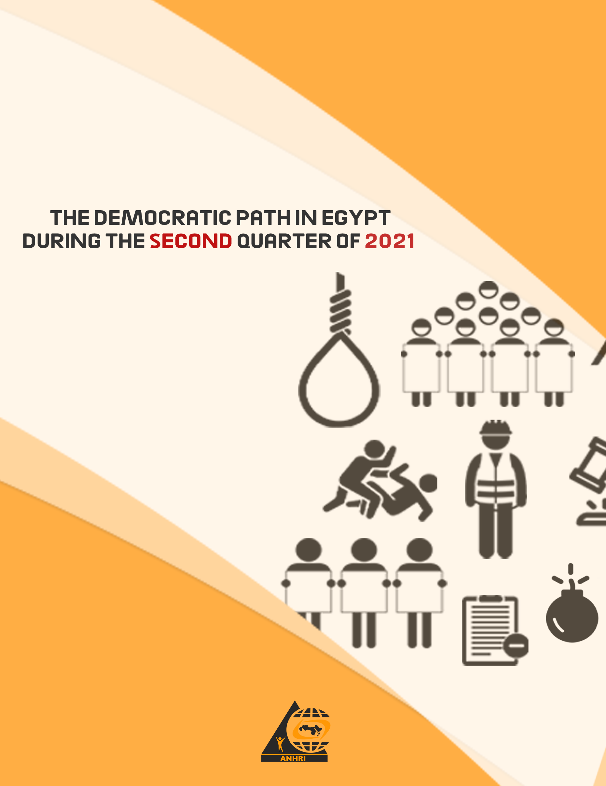

The Arabic Network for Human Rights Information (ANHRI)
"Lawyers for Democracy” Initiative

The Democratic Path in Egypt during the second Quarter of 2021(1)

Summary:
This is the second report released by the Arabic Network for Human Rights Information (ANHRI) throughout the year 2021, which:
- (The second quarter of 2021) witnessed, at its outset, the re-election of Diaa Rashwan, the chairman of the State Information Service (SIS), as the Journalists Syndicate head during the syndicate's midterm election.
- The reporting period also saw a continuation of the exceptional trials and unfair rulings against opinion-holders and activists. This is represented in the verdict issued by the New Cairo Emergency State Security Misdemeanors Court which sentenced researcher Ahmed Samir El-Santawy to 4 years in prison on charges of publishing false news and statements, in a case whose proceedings began during the period of his pretrial detention pending another case, a matter which deepens the crisis of exceptional trials that undermines the foundations of fair trial by depriving the defendant of his right to appeal or challenge the ruling.
- The Parliament's approval of a bill introduced by the government to amend the Supreme Constitutional Court Law. The bill grants the Constitutional Court jurisdiction to judicial oversight over the constitutionality of decisions issued by international organizations and adjudicative bodies, along with the foreign arbitration rules, that are required to be implemented in the face of the Egyptian state. It also stipulates that the Prime Minister may request from the Supreme Constitutional Court to rule that such (international) decisions and provisions as well as the obligations resulting from their implementation shall not be considered, sparking controversy within the Egyptian Parliament. Therefore, a question has popped up: How can a local/ national court rescind or stop the implementation of a decision issued by organizations established according to the rules of international law and which countries decided, by its own choice, to be member of?
- Protest events didn’t stop during the second quarter of 2021; as 44 protests were staged by different political forces throughout this period. Social and labor protests were at the forefront of such protest events with 25 protests being organized. Meanwhile, the protest activities held by the Muslim Brotherhood (MB) and the National Alliance to Support Legitimacy (NASL) have declined as only 10 protests were recorded, all in individual forms and in remote villages; coinciding with the anniversary of the death of former President Mohamed Morsi and the final death sentences issued in the "Rabaa sit-in dispersal" case. On the other hand, civil forces organized 4 protest events, while students organized 5 protest activities.
- Military trials of civilians also continued in the second quarter of the year; as among the 49 ongoing trials held during the reporting period, there were 2 military trials for 277 citizens.
- Violations of media freedoms have not ceased during this period as well; with 26 cases of violations recorded during the second quarter of 2021. This report does not necessarily include all the incidents that took place throughout the reporting period, but it is based on the cases monitored and documented by the “Lawyers for Democracy” initiative’s team, most prominent of which are the investigations and detention renewal sessions which were marred by 20 violations being recorded throughout the period covered by the report.
- After they were stopped in the first quarter of 2021, terrorist operations resurfaced in the second quarter of the year; as terrorist groups in North Sinai carried out 5 terrorist operations one of which the security forces managed to thwart.

The details of the state of the democratic path during the 2nd quarter of 2021 are outlined, in numbers and percentages, as follows:
First: Protest events
During the third quarter of the year, the various forces organized 44 different events, and their distribution was as follows:
* Social and labor protests: 25 protest events
* Muslim Brotherhood (MB) and the National Alliance to Support Legitimacy (NASL): 10
* Student protests: 5 protest events
* Civil power: 4 protest events

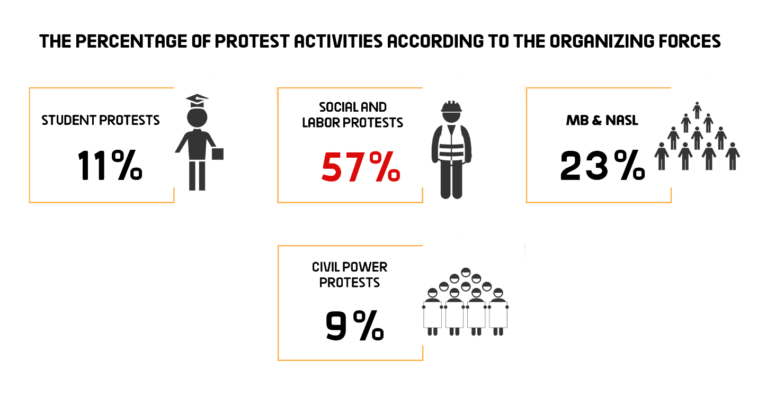

The month of June came first in witnessing the largest number of protest events with 21 different protests, as shown in the following table:
April | May | June | Total
7 | 16 | 21 | 44

Out of these different events, 6 were attacked by security forces, 36 passed without attacks, and two protests were resolved after negotiations with their participants.
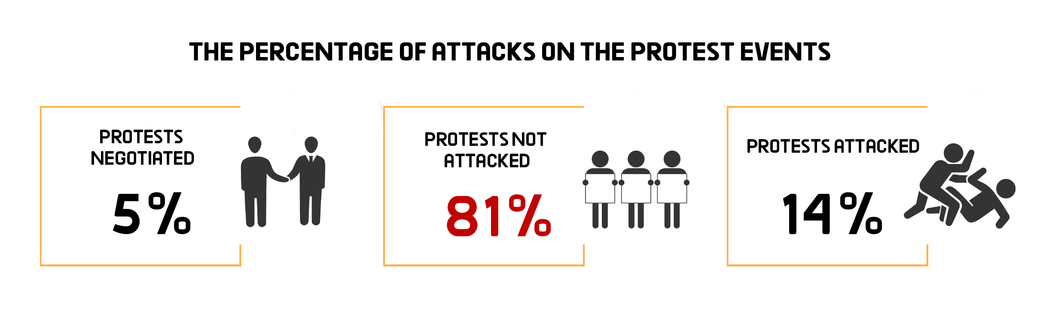
Labor and Social protests:
The second quarter of 2021 witnessed a decline in the number of labor and social protest compared to the first quarter of the year. The reporting period saw only 25 different social and labor protests being organized, one of which was attacked by security forces, whereas 22 passed without interference and two were resolved after negotiations with their organizers.
The most important demands brought by the social and labor protests:
- Residents of Masaken Nady Al-Seid district protested against the demolition of their homes.
- Workers at the Production units and Workshops of Egyptian Railways objected to the Minister of Transport's decision to extend the overtime working hours
- Workers at the Iron and Steel Company protested against the decision to liquidate their company
- Demanding the disbursement of late salaries
- A group of lawyers organized a protest vigil to show solidarity with the Palestinian people.
- Employees at Dar Al-Kotb publishing house protested the new financial regulation introduced by the Ministry of Culture
- Pensioners in Ismailia protested the lack of sufficient waiting places during the disbursement of pensions.

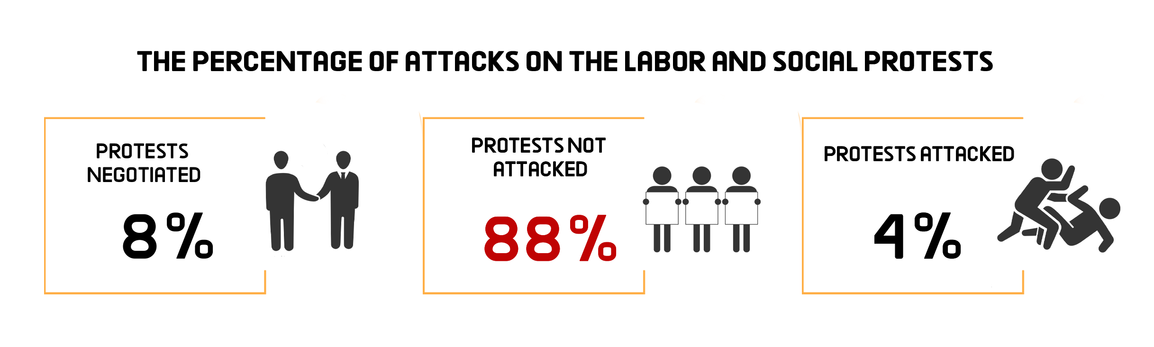MB and NASL protest activities:
The second quarter of 2021 witnessed a continuation in the remarkable decline in the protest activities organized by the Muslim Brotherhood (MB) and the National Alliance to Support Legitimacy (NASL). During the reporting period only ten protests took place, on an individual basis, in remote villages throughout Egypt governorates. These protests were organized in coincidence with the second anniversary of the death of former President Mohamed Morsi in addition to the upholding of the death sentences against 12 defendants including the MB's leaders involved in the case of the Rabaa sit-in dispersal. Two of these protests were attacked by the security forces, whereas 8 others were left without intervention.
The most important demands raised by Muslim Brotherhood and the National Alliance to Support Legitimacy:
- Solidarity with the Palestinian people
- Commemorating the second anniversary of the death of former President Mohamed Morsi.
- Denouncing the final death sentences issued in "Rabaa sit-in dispersal" case

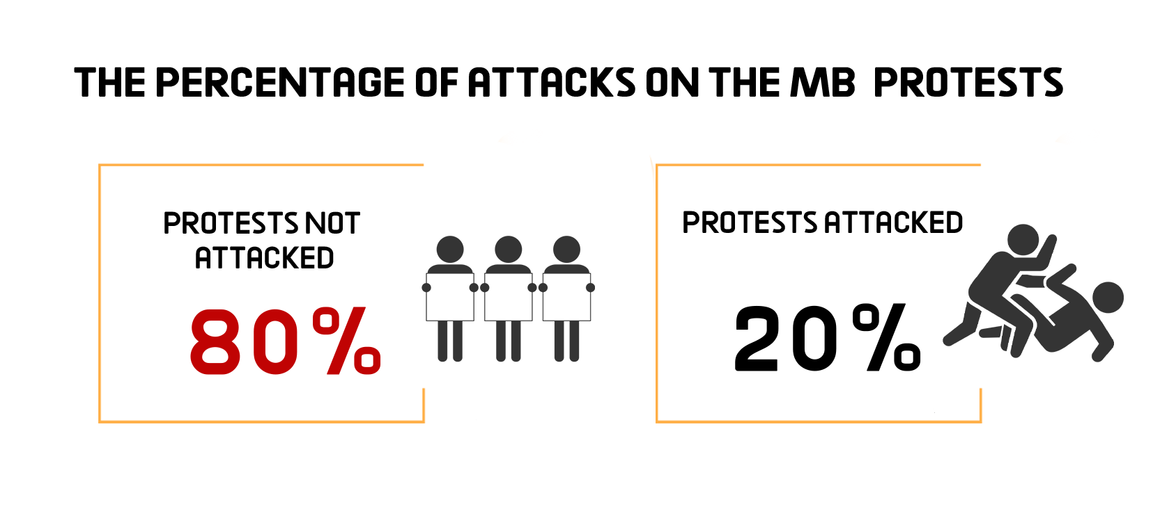Civil Power protests:
The second quarter of the year saw four protest activities organized by civil power, three of which were attacked by the security forces and the other one was left without intervention, as follows:
- Protests to show solidarity with the Palestinian people and the Sheikh Jarrah neighborhood's people
- Activist Ahmed Samir went on hunger strike in his jail in protest of the exceptional 4-year prison sentence issued against him on a charge of spreading false news
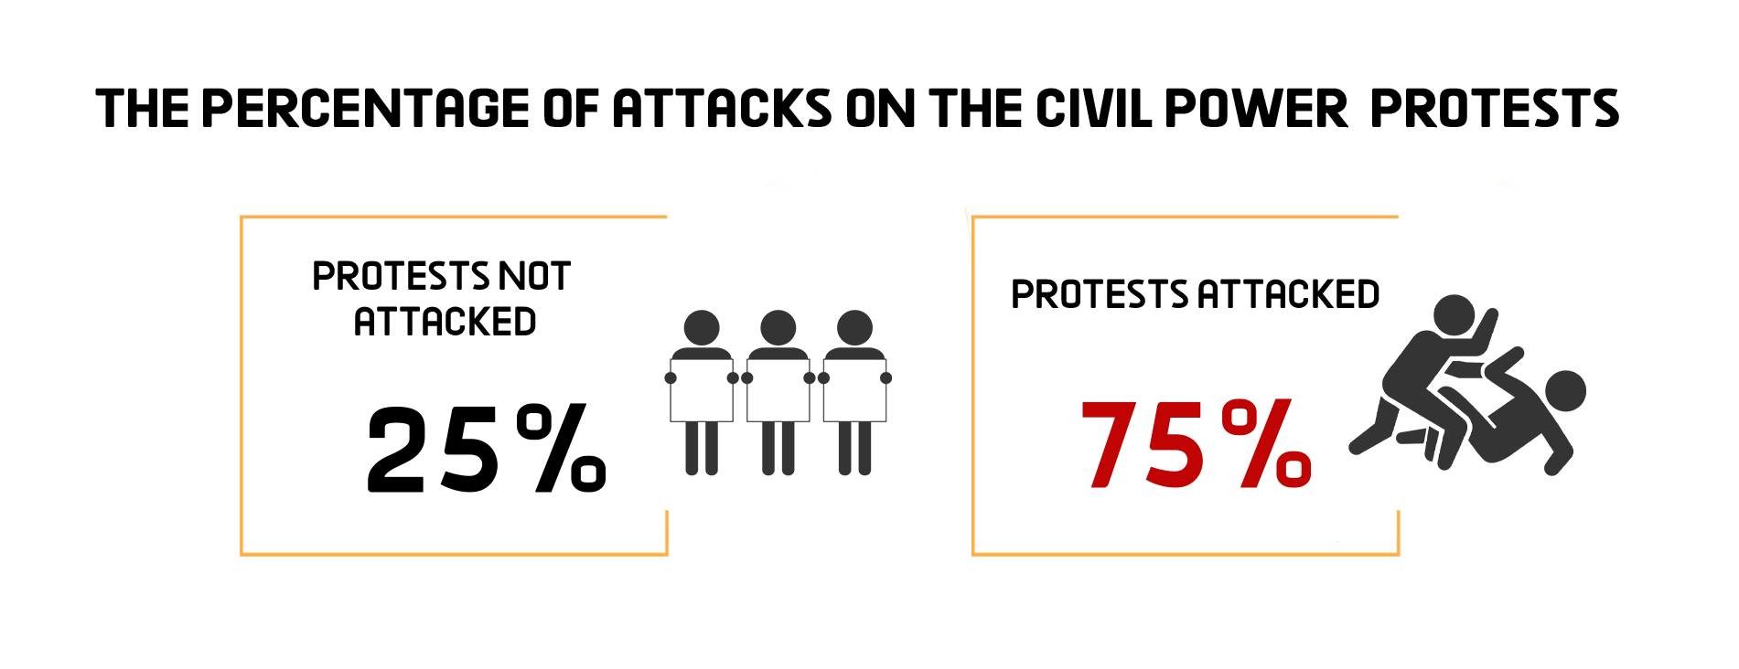

Student activities:
The second quarter of the year witnessed students organizing 5 protest events all of which hadn’t been dispersed by the security forces.
Student protests’ main demands:
- Preparatory school students in Giza governorate objected to the difficulty of exams.
- A number of Thanaweya Amma students objected to the lack of sufficient time in experimental exam.
- A number of students from the Faculty of Science at Alexandria University objected to the mistreatment of a faculty member
- Preparatory school students in Ismailia governorate objected to the leakage of the Social Studies exam.
- Alexandria University students objected to the dysfunctional electronic system followed by the university administration.

Second: Trials
The second quarter of 2021 witnessed 49 trial cases that are being considered before the Egyptian judiciary, including two deliberating before the military court. Of these, there were 24 rulings of conviction, 10 acquittals and 49 death sentences, including 41 against 81 defendants over criminal cases and 8 rulings against 42 defendants pending political cases.
1) Ongoing trials:
The distribution of the ongoing trials is as follows:
* 40 trials for the MB & NASL.
* 5 trials of the civil and democratic powers.
* 2 trials for Mubarak’s regime’s affiliates.
* The military judiciary considered two trials for 277 civilians

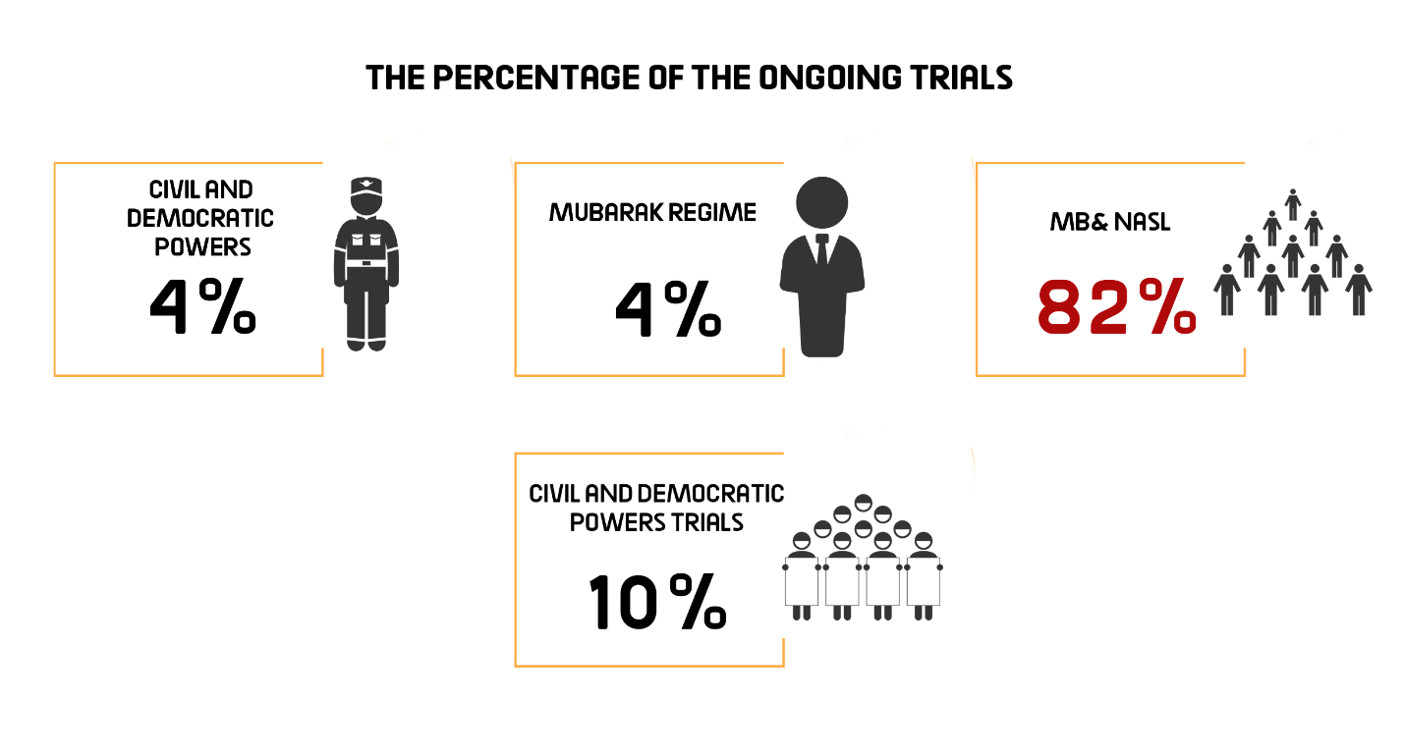The most prominent trials of MB and NASL are:
Cases known in the media as: (The US Embassy incidents II, Imbaba Terrorist Cell, Rabaa Al-Adawyia Sit-in dispersal, Hisham Ashmawi Cell, the arson of Kafr Hakim Church, ISIS-Giza Cell, El-Murabeton Terrorist Cell, The Cluster Cell, ISIS- Al-Agouza Cell, Al-Arab Police Station incidents, Ahrar Al-Sham Movement, Al-Joker terrorist cell, The raid on the Egyptian prisons, Spying for Hamas, ISIS-Helwan, Al-Salam Explosives, ISIS- Al-Zawyia Al-Hamra, Al-Agouza Explosives, Spying for ISIS, ISIS-Al-Agouza, Helwan Brigades).
The most prominent trials of Mubarak regime figures are:
Cases known in the media as: (Customs corruption, Green Belt).
The most prominent trials of civil and democratic powers are:
The cases known in the media as: (The Oppressed of Downtown, the cabinet incidents, and the appeal submitted by Zyiad Al-Alimi against the decision to place him on the lists of terrorist entities, trial of researcher Ahmed Samir, the appeal of Esraa Abdel-Fattah against the travel ban)
The Military Trials of civilians:
In the second quarter of 2021, the military judiciary considered two ongoing trials for 277 civilians.
2) Sentences
During the reporting period, there were 24 convictions and 10 acquittals. The details are as follows:
Convictions:
During the second quarter of the year, the Egyptian judiciary issued 24 convictions, distributed as follows:
* 22 rulings against the Muslim Brotherhood (MB) and the National Alliance for the Support of Legitimacy (NASL).
* Two rulings against defendants affiliated with the civil democratic forces
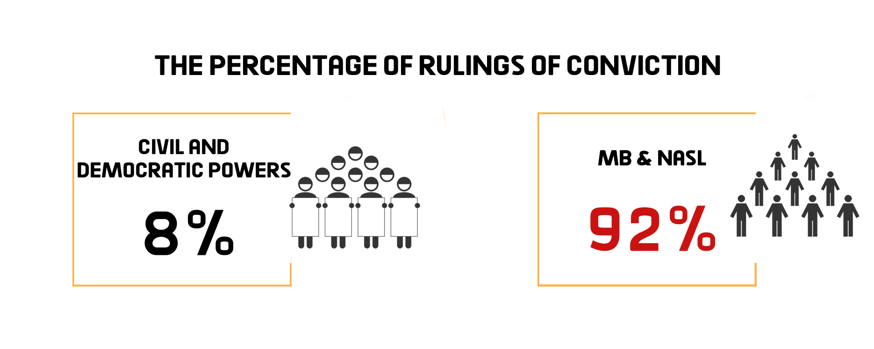Acquittals:
During the second quarter of the year, ten acquittals were handed down as follows:
* Seven rulings for the MB and NASL affiliates
* Two rulings of acquittal for Mubarak regime’s figures.
* One ruling for civil power
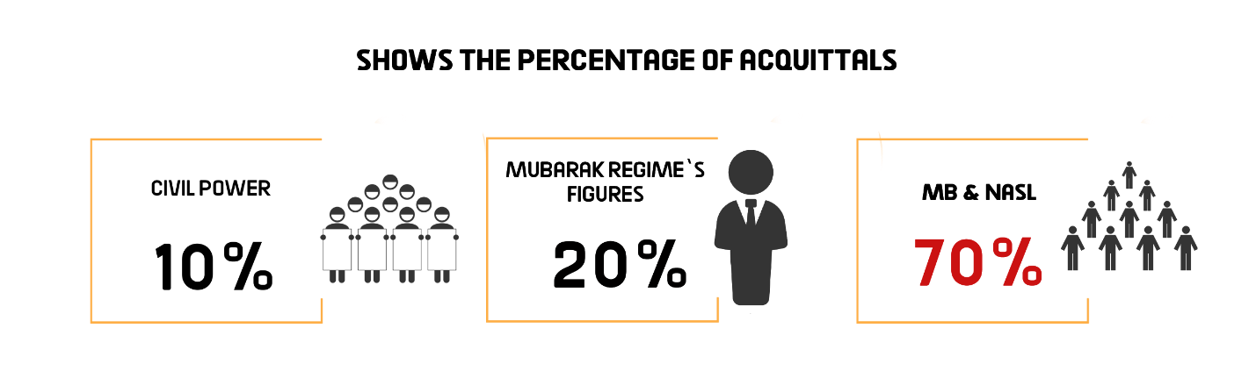
Death sentences
49 death sentences were issued during the second quarter of 2021, including 41 issued against 81 defendants over criminal cases and 8 rulings against 42 defendants pending 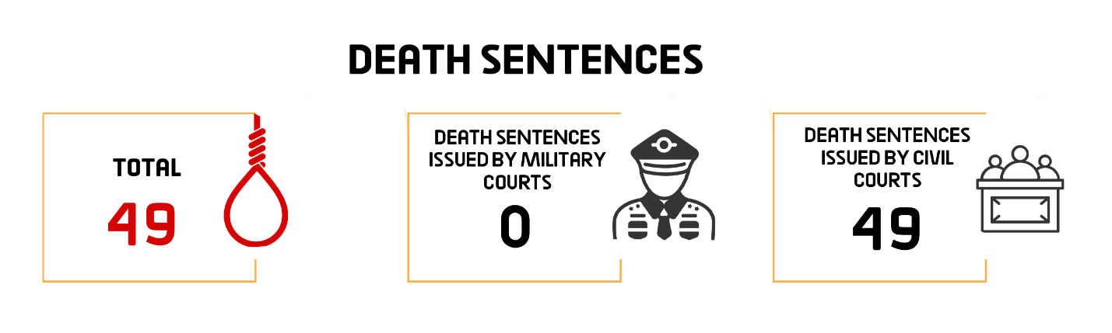political cases, as shown in the following table:
1- Rulings
Total | Death sentences issued by military courts | Death sentences issued by civil courts
49 | - | 49

2- Defendants
Total (Number of defendants) | Number of defendants upheld by the Court of Cassation to be executed | Number of defendants upheld by the Mufti to be executed | Number of defendants referred to the Mufti
123 | 22 | 28 | 73 | Civil
-- | -- | -- | -- | Military
123 | 22 | 28 | 73 | Total

3- Death sentences executed:
The second quarter of 2021 witnessed the Prisons Authority sector carrying out 5 death sentences against 27 defendants as follows:
- On 26 April 2021, the Prisons Authority sector carried out the death sentence issued against 9 defendants in the case known in the media as "The raid on Kerdasa Police Station".
- On 9 May 2021, the Prisons Authority sector executed the death sentence issued against monk Wael Saad Tawadros who is accused of killing Bishop Epiphanius of Deir Abu Makar in Wadi al-Natrun
- On 21 June 2021, the Prisons Authority sector at Alexandria's Borg Al-Arab Prison executed the death sentence issued against 7 defendants in criminal cases
- On 21 June 2021, the Prisons Authority sector at Cairo Appeal Prison executed the death sentence issued against Ahmed Saeed Al-Sunbati who is accused of killing Reverend Semaan Shehata, in connection with the case known in the media as the "Murder of the Marg Priest".
- On 27 June 2021, the Prisons Authority sector at Cairo Appeal Prison carried out the death sentence issued against 9 defendants including a woman accused over a criminal case

Third: Violence and Terrorism
After it was stopped in the first quarter of the year, terrorist operations resurfaced in the second quarter of 2021 as terrorist elements carried out 5 terrorist operations, of which the security forces managed to thwart only one operation.
- Terrorist operations:
The second quarter of the year witnessed that terrorist elements carrying out 5 terrorist operations, of which the security forces were able to thwart one operation, leaving seven people killed and wounded
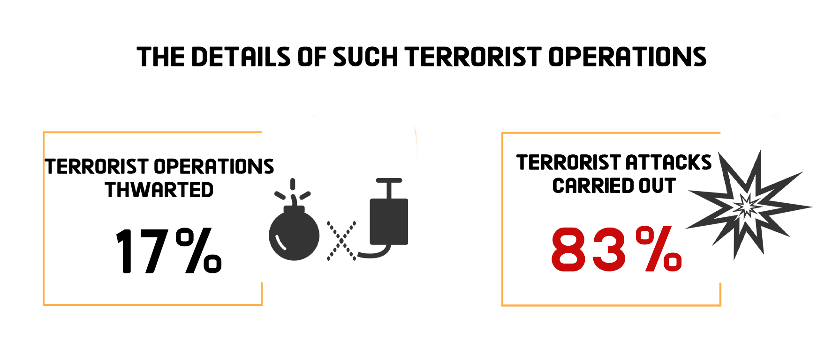
\
The following table shows the percentage of terrorist operations and counter-terrorism ones:
Total | Operations thwarted | Operations carried out | Months
3 | 1 | 2 | April
1 | -- | 1 | May
2 | -- | 2 | June
6 | 1 | 5 | Total

The following table shows the number of terrorist operations and their distribution in the different governorates:
Total | Operations thwarted | Operations carried out | Governorates
6 | 1 | 5 | North Sinai
6 | 1 | 5 | Total during the 2nd quarter of 2021

– These operations had resulted in the killing and injury of 7 people.
The following table shows the number of killed and wounded and their distribution:
Total | Terrorists | Security forces | Civilians
7 | 0 | 4 | 3 | Number of killed
0 | 0 | 0 | 0 | Number of wounded
7 | 0 | 4 | 3 | Total

- Counter-Terrorism Operations
During the 2nd quarter of the year, the security forces targeted and attacked one of the hiding places of the terrorist elements that killed the Coptic citizen Nabil Habashi. During the attack, they managed to liquidate three elements involved in the killing of the Coptic citizen.

Fourth: Attack on Freedom of Expression and Media Freedoms
The second quarter of the year witnessed 26 various violations against freedom of expression and media freedoms.
The following table shows the number of violations took place throughout the first three months of 2021:
Months | Number of violations
9 | April
7 | May
10 | June
26 | Total during the 2nd quarter of 2021

Details are as follows:

19 | Investigations and detention renewal sessions
3 | Administrative penalties (fines)
2 | Coverage ban
1 | Blocking websites
1 | Physical and verbal attacks
26 | Total of violations

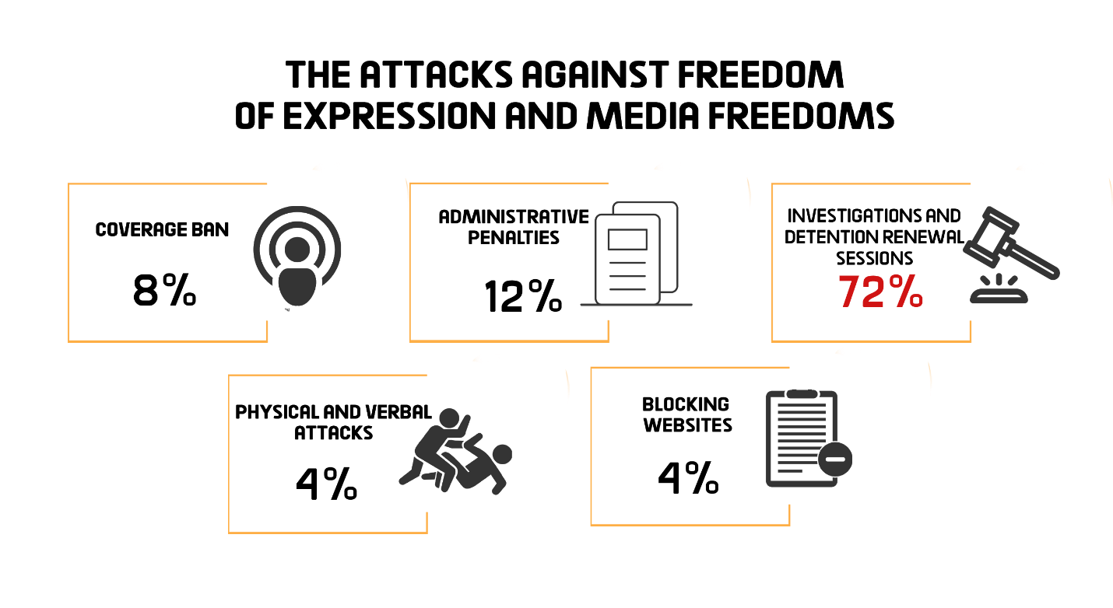
Fifth: Attack on Human Rights Defenders
1- On 5 April 2021, Cairo Criminal Court renewed the detention of human rights lawyer Mahinour El-Masry and journalists Esraa Abdel-Fattah and Solafa Magdy for 45 days pending Case No. 488 of 2019 State Security, in which they face charges of colluding with a terrorist group in achieving its goals, misusing social media, and spreading false news and statements. On 13 April 2021, the Supreme State Security Prosecution ordered the release of Solafa Magdy under the guarantee of her place of residence pending Cases No. 488 of 2019 State Security and No. 855 of 2020 State Security, before she was set free.
2- On 5 April 2021, Cairo Criminal Court renewed the detention of engineer Yehia Hussein Abdel-Hady for 45 days pending Case No. 277 of 2019 State Security, in which he faces charges of joining a terrorist group with knowledge of its goals and spreading false news and statements.
3- On 6 April 2021, Cairo Criminal Court renewed the detention of human rights lawyer Mohamed Al-Baqir for 45 days pending Case No. 1356 of 2019 State Security, in which he faces charges of joining a terrorist group with knowledge of its goals, committing a funding-related crime and spreading false news and statements. Then, on 4 May, the Criminal Court ruled to extend the detention of lawyer Mohamed Al-Baqir and blogger Alaa Abdel-Fattah for further 45 days pending the aforementioned case and accusations.
4- On 12 April 2021, the Supreme State Security Prosecution ordered the release of journalist Khaled Daoud under the guarantee of his place of residence pending Cases No. 488 of 2019 State Security, in which he is accused of abetting a terrorist group in achieving its goals, misusing social media, and spreading false news and statements. The next day, on 13 April 2021, the State Security Prosecution ordered the release of journalist Hossam Al-Sayyad under the guarantee of his place of residence pending the aforementioned case and accusations.
5- On 18 April 2021, Al-Mansoura Prosecution renewed the detention of activist Mohamed Adel for 15 days pending Case No. 4118 of 2018 Sherbin Administrative, in which he is charged with joining a terrorist group with knowledge of its goals and spreading false news.
6- On 25 April 2021, Cairo Criminal Court administratively adjourned the consideration of the detention renewal of human rights lawyer Mohamed Ramadan pending Case No. 467 of 2020 State Security for a hearing to be set later. Ramadan is facing charges of joining a terrorist group with knowledge of its objectives.
7- On 25 April 2021, Cairo Criminal Court administratively adjourned the consideration of the detention renewal of vlogger Mohamed Oxygen and activist Sameh Seoudi pending Case No. 855 of 2020 State Security for a hearing to be set later. The two are facing charges of joining a terrorist group with knowledge of its objectives. Then, on 13 June 2021, the court renewed the detention of "'Oxygen" and "Seoudi" for 45 days pending the aforementioned case and charges.
8- On 25 April 2021, Cairo Criminal Court renewed the detention of human rights lawyer Sayed Al-Banna and linguist Ayman Abdel-Moati for 45 days pending Case No. 880 of 2020 State Security, in which they face charges of joining a terrorist group with knowledge of its objectives, inciting to protest, misusing social media, and spreading false news and statements. On 8 June 2021, the Criminal Court decided to replace the pretrial detention of Al-Banna with precautionary measures, while it extended the detention of Abdel-Moati for further 45 days pending the aforementioned case and charges.
9- On 2 May 2021, Cairo Criminal Court administratively adjourned the consideration of the detention renewal of human rights lawyer Amr Imam for a hearing to be set later pending Case No. 488 of 2020 State Security. Imam is facing charges of joining a terrorist group with knowledge of its objectives, misusing social media, and spreading false news and statements. Then, on 14 June 2021, the court renewed the detention of the human rights lawyer for 45 days.
10- On 3 May 2021, Cairo Criminal Court administratively adjourned the consideration of the detention renewal of human rights lawyer Zyiad El-Eleimy and journalists Hisham Fouad and Hossam Moanis for a hearing to be set later, pending Case No. 930 of 2019 State Security, in which they face charges of abetting a terrorist group in achieving its objectives and spreading false news and statements.
11- On 4 May 2021, Cairo Criminal Court renewed the detention of lawyer Mohab El-Ebrashin for 45 days pending Case No. 1898 of 2019 State Security, in which he faces charges of joining a terrorist group with knowledge of its purposes and spreading false news and statements. On 15 June 2021, the court replaced the lawyer's pretrial detention with precautionary measures.
12- On 9 May 2021, Cairo Criminal Court renewed the detention of Abdel-Moneim Abo El-Fetouh, former presidential candidate and head of Egypt Strong Party, for 45 days pending Case No. 440 of 2018 State Security, in which he faces charges of establishing and leading a terrorist group and spreading false news and statements. Then, on 15 June 2021, the Supreme State Security Prosecution ordered the release of Abdel-Moneim under the guarantee of his place of residence pending the aforementioned case and charges, before his pretrial detention over Case No. 1781 of 2019 State Security (where he faces charges of establishing and leading a terrorist group) begins.
13- On 13 May 2021, the security forces arrested activist Ahmed Gamal Manaa after he organized a protest vigil to stand in solidarity with the Palestinian People following the Eid al-Fitr prayer and burned the Israeli flag thereafter. He was taken to the Haram police station. On 14 May, the Haram Prosecution interrogated him over communiqué/ record No. 26705 of 2021 Haram Misdemeanor and charged him with "inciting to protest, protesting without notifying the concerned authorities, and burning the Israeli flag with the aim of evoking terror in the citizens' hearts", and accordingly decided to hold him in detention pending probe. On 30 May, the appeals judge at Haram Misdemeanor Court ordered the release of the activist on bail of EGP 500.
14- On 23 May 2021, Cairo Criminal Court renewed the detention of labor leader Rashad Kamal for 45 days pending Case No. 1056 of 2020 State Security, in which he faces charges of joining a terrorist group with knowledge of its purposes.
15- On 31 May 2021, Al- Zagazig Criminal Court renewed the detention of Quranist teacher Reda Abdel-Rahman for 45 days pending Case No. 3418 of 2020 Kafr Saqr Emergency State Security Misdemeanor, in which he is accused of joining ISIS terrorist organization.
16- On 8 June 2021, New Cairo Emergency State Security Misdemeanor Court set the trial of researcher Ahmed Samir for adjudication at the hearing of 22 June 2021, on charges of publishing false news and statements that harm Egypt at home and abroad. On 22 June, the court sentenced the researcher to 4 years in prison.
17- On 12 June 2021, Cairo Criminal Court adjourned the consideration of the appeal submitted by activist and journalist Esraa Abdel-Fattah challenging the travel ban issued against her by the judge mandated by the Ministry of Justice to preside over the case known in the media as "closure of civil society". The case was postponed for the hearing of 3 July 2021.

====================================
(1)- The Democratic Path is a report launched by the Arabic Network for Human Rights Information (ANHRI) in 2014. It is now released every three months, i.e. quarterly, but ANHRI used to publish it on a monthly basis during the previous years through the “Lawyers for Democracy” initiative.
In addition to the monthly reports issued to monitor the state of democracy, ANHRI issued annual reports to monitor the democratic path, which can be accessed through the “Reports” section on ANHRI’s website by clicking on the following link:
https://www.anhri.info/?cat=14&lang=en
Note: This report is based on the cases monitored and documented by the “Lawyers for Democracy” initiative’s team and does not necessarily include all the incidents that took place throughout the reporting period.
---------------------------------------------------------------------
* Note: This report is based on the cases monitored by ANHRI and does not necessarily include all the incidents that took place throughout the month.
To view the previous Democratic Path reports:
To view the Democratic Path Report in 2014, “Obscure and stalled”
To view the Democratic Path Report in 2015, “One step back, two steps further back”
To view the Democratic Path Report in 2016 “Closed until further notice”
To view the Democratic Path Report in 2017, “Very Steep”
To view the Democratic Path Report in 2018, “Mounting Anger".
Less Hope, More Despair…The Democratic Path in Egypt 2019
To view the Democratic Path Report in 2020

