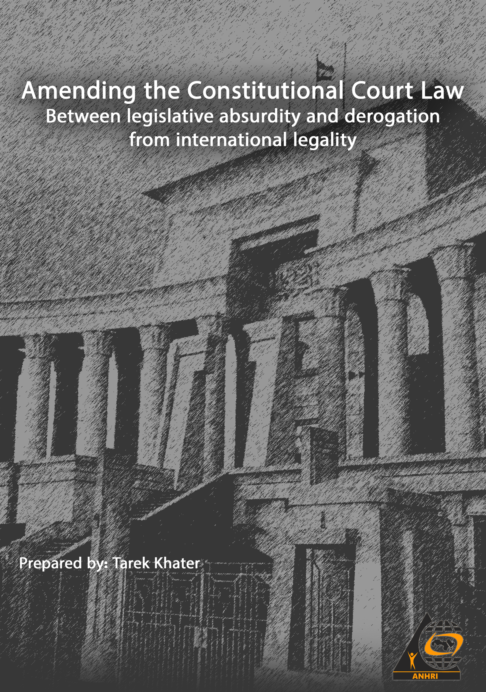

Amending the Constitutional Court Law
Between legislative absurdity and derogation from international legality
Prepared by: Tarek Khater

This paper came in a hurry as a last attempt to call upon the Supreme Constitutional Court's General Assembly judges to reject the unreasonable proposed amendment that will be introduced to the Egyptian Supreme Constitutional Court Law No. 48 of 1979 by adding two new articles. This amendment constitutes a derogation from the Supreme Constitutional Court's jurisdiction and a transgression of the constitutional legislator's aim behind establishing the court. The phrases and terms mentioned in the bill's explanatory memorandum also confirms how this amendment is absurd; as it states: "It has been viewed to add an article to the Constitutional Court Law obtaining it jurisdiction to judicial oversight over the constitutionality of the decisions issued by international organizations and adjudicative bodies, together with the foreign arbitration rules that are required to be implemented in the face of the Egyptian state. This will allow the state to deal positively with international decisions that affect its national security and interests, within the framework of the Constitution and law." (1)
The two articles proposed to be added to the Supreme Constitutional Court Law are:
Article 27 bis:
"The Supreme Constitutional Court oversees the constitutionality of decisions issued by international organizations and adjudicative bodies, along with rulings handed down by foreign courts and arbitral tribunals, which are required to be implemented against the state."
Article 33 bis:
“The Prime Minister may request the Supreme Constitutional Court to rule that the decisions and provisions referred to in Article 37 bis or the obligations resulting from their implementation shall not be considered, and all concerned parties shall be disputed in the request, and a notified copy of the decision or judgment requested to be disregarded and a certified translation thereof shall be indicated in the request. The request must indicate the constitutional text or ruling that the decision is alleged to be violating and the nature of such violation, and the court shall decide on the request expeditiously."
To get to the crux of the matter in this paper, we ask those who proposed adding the two aforementioned articles a number of questions so that they answer them, or else remain silent and reverse the amendment:
The first question: Can or may the Supreme Constitutional Court rule that a decision issued by the UN Security Council or a United Nations body is unconstitutional?
The second question: Can the Constitutional Court rule that a decision issued by the International Center for Settlement of Disputes Arising from Investment between States and Nationals of Other Countries of Origin under the auspices of the World Bank, along with the other international arbitration bodies and centers, is unconstitutional?
- The role and jurisdiction of the Supreme Constitutional Court in accordance with Egypt's Constitution 2014:
Article 192 of the Egyptian Constitution defines the competencies of the Supreme Constitutional Court in overseeing the constitutionality of laws and regulations, interpreting legislative provisions, adjudicating on disputes pertaining to the affairs of its members, on jurisdictional disputes between judicial bodies and entities that have judicial jurisdiction, on disputes pertaining to the implementation of two final contradictory judgments, one of which is rendered by a judicial body or an authority with judicial jurisdiction and the other is rendered by another body , and on disputes pertaining to the implementation of its rulings and decisions.
Clearly and unambiguously, as aimed by constitutional legislators, the goal of defining the limits of the Supreme Constitutional Court's jurisdiction is to ensure that all state institutions respect the constitution, and the jurisdiction here is to only oversee the constitutionality of national laws and regulations.
The effects of the proposed amendment on the purpose and jurisdiction of the Supreme Constitutional Court:
Considering the Egyptian Constitution as a universal document that supersedes all the constitutions and laws all over the world along with the documents establishing international bodies and organizations:
The first impact of the proposed amendment is that the Egyptian Constitution will be considered as a cosmic or universal document that prevails over the constitutions and laws of the world countries, along with the protocol guides for the establishment of international bodies and organizations. This means that the world organizations should, consequently, take into account the Egyptian Constitution provisions while making all its decisions, as if it is the reference over which all these organizations and laws should revolve, even if they include international treaties that are binding on countries including Egypt.
Considering the Egyptian Supreme Constitutional Court the first judicial body in the world:
The second effect of the proposed amendment is that Egyptian Supreme Constitutional Court will be turned into the first judicial body in the world by granting it jurisdictions that includes oversight over all the decisions issued by all international and regional organizations as well as international bodies such as the United Nations, the Organization of African Unity or even the International Court of Justice.
At first glance, it appears that the proposed amendment deviates from the purposes of the constitutional legislator. The deficiency of Article 192 of the Constitutions, which states "and the law specifies the other competencies of the court", cannot intercede or justify such amendment; as the ordinary legislator must abide by the objectives and the limits of jurisdictions imposed by the constitutional legislator, which is limited to the oversight of national laws and regulations. The jurisdiction of the Constitutional Court is only limited to laws and rulings issued by the national judicial bodies and authorities.
How can the ordinary legislator deliberately overlook the fact that Egypt, as a state with its government, constitution, and courts, is nothing but a mere part or member of the international community? It must, like other members of international community, abide by international treaties, charters, and conventions. It has no right to contravene, cancel or halt the implementation of decisions issued by international bodies and organizations, except in accordance with the documents (protocol) that guide for their establishment.
How can the ordinary legislator violate the national constitutional provision which obligates, under Article No. 94 (thereof) that "The rule of law is the basis of governance in the state and the state is governed by Law"?
The "law" here refers to both the national law and international law at the same time, and the latter included mechanisms for reviewing its provisions and the decisions issued by the organizations and bodies concerned with its implementation, without regard or consideration to the internal/national constitutions and laws pertaining to the country itself. Egypt, as a state, must respect its international commitments, including commitment to the decisions issued by international bodies and organizations. And if it wishes to review those decisions, it has no choice but to resort to the mechanisms stipulated in the international law itself, and not to circumvent those decisions by issuing rulings from local courts that were basically not considered by the international legislator. Such an amendment, if passed, would have exposed the entire Egyptian state to crises and serious penalties.
Examples of the flaws entailed in the proposed amendment to the Constitutional Court Law, and the ensuing inevitability of exposing Egypt to international crises and severe risk threatening its political and economic security in case this amendment is approved:
At the political level:
Since the beginning of the armed confrontations between the warring parties in the State of Libya, the international community represented by the United Nations and the Security Council has made many decisions of a mandatory nature, which impose international sanctions on the countries that may violate such decisions. In this context, the UN Security Council, in its session held on 15 September 2020, issued Resolution No. 2542 of 2020 (2) renewing its decision No. 1970 of 2011 which included the prohibition of member states from supplying arms to Libya.
So, is it permissible for the Egyptian Prime Minister to introduce this decision (UN Resolution) to the Supreme Constitutional Court (in accordance with the proposed amendment) or issue another decision ruling that the UN Resolution is unconstitutional and accordingly announces his determination to export arms to Libya?
At the economic level (The case of a dispute between the state and a foreign investor):
As mentioned earlier, the World Bank established the International Centre for the Settlement of Investment Disputes (ICSID) (3), under the Washington Convention issued in March 1965 (4). The number of countries that joined the agreement reached 163 out of the world’s total of 196 countries. Egypt acceded to the Washington Convention in 1971, and by joining this convention, it admitted its acceptance of settling its disputes with foreign investors before the International ICSID Center and in accordance with the provisions of Washington Convention and in accordance with the provisions of the Egyptian constitution.
So, is it possible for the Supreme Constitutional Court in Egypt or the Egyptian Prime Minister to issue a ruling challenging the constitutionality of any of the decisions issued by ICSID? Or violate Egypt's commitment and obligations under the Washington Convention? This would, undoubtedly, lead to a losing international confrontation with the World Bank.
At the economic level (the situation of international arbitration rules required to be implemented in Egypt):
In 1958, the United Nations adopted the Convention on the Recognition and Enforcement of Foreign Arbitral Awards, commonly known as the "New York Convention" (5). The number of states acceding to the agreement reached 166 at the end of 2020, and the Egyptian state was one of the first countries to join the "New York Convention" upon the Presidential Decree No. 171 of 1959 (6).
This agreement serves as essential protection and international cover for the arbitrators' judgments or rules issued by international arbitration bodies and centers. The third article of New York Convention states the following:
"Each Contracting State shall recognize arbitral awards as binding and enforce them…
There shall not be imposed substantially more onerous conditions or higher fees or charges on the recognition or enforcement of arbitral awards to which this Convention applies than are imposed on the recognition or enforcement of domestic arbitral awards."
This convention, included, but not limited to, the reasons that allow states to refuse implementation of its rules, such as the opponent (adversary) not announcing the assignment of the arbitrator, or the arbitral tribunal exceeding the limits of its jurisdiction, among other reasons that do not include the decisions issued by the Supreme Constitutional Court in Egypt.
So the question here is: Can the Supreme Constitutional Court in Egypt or the Egyptian Prime Minister issue a decision challenging the constitutionality of a decision issued by any of the recognized international arbitration centers and bodies, or prevent its implementation in the country simply because its legislator has created a constitutional court to act as an alternative to the International Arbitration Center or because he has instituted the Egyptian constitution's reference in a way that contradicts provisions of the New York Convention?
Conclusion
In fact, the proposed amendment to the Supreme Constitutional Court Law is really weird and bizarre, both in terms of legal considerations and in terms of the Egyptian state's obligations under the international conventions, treaties and charters which Egypt is a member of. The amendment also represents a legal and constitutional precedent, as it has not occurred at the global level, as far as the writer of this paper knows. Under this amendment, the Egyptian legislator assumes the supremacy of the Supreme Constitutional Court in Egypt over the United Nations in its various bodies and mechanisms, including the UN Security Council. It also perceives the Egyptian Constitution as a superior document that prevails over all the international charters and provisions and as a preliminary law that is binding on all international organizations and bodies, in disregard of the founding charters approved by international community, among them, surprisingly, is the Egyptian state. So, will the Egyptian government, by proposing this amendment, prepare to halt the implementation of the decisions pertaining to any possible or potential international human rights condemnation?
Therefore, the appeal has become obligatory and urgent for the judges of the Constitutional Court and for the Egyptian legislator to immediately reverse this proposed amendment, which may result in economic and political disasters that threaten the Egyptian state and the Egyptian people in all aspects of their affairs.
=============================
Footnotes:
- A news article published on June 7, 2021 entitled "The Legislative Committee of the House of Representatives approves the amendment of the Constitutional Court Law"- Last accessed: June 7, 2021

https://www.shorouknews.com/news/view.aspx?cdate=14062021&id=b1083c5a-7521-40d0-8f82-017

- UN missions website- Last accessed: June 20, 2021
https://unsmil.unmissions.org/sites/default/files/s_res_25422020_a.pdf
- The International Center for Settlement of Investment Disputes, Last accessed: June 20, 2021
https://www.international-arbitration-attorney.com/ar/the-international-centre-for-settlement-of-investment
- The American Institute of International Commercial Arbitration website, Last visit June 20, 2021
http://www.aifica.com/2017/04/15/%D8%A7%D8%AA%D{1%D8%A7%D{2%D}A%D8%A9- %D8%AA%D8%B3%D on Instagram: 6%D8%A7%D8%B2%D8%B9%D8%A7%D8%AA %D8%A7%D8%D8%A7%D8%B3%D8%A%D8%AB%D8%A7%D8%B1-%D8%A3%D8%D8%B3% adorable
- Convention on the Recognition and Enforcement of Foreign Arbitral Awards, United Nations website, last accessed: June 20, 2021, https://uncitral.un.org/sites/uncitral.un.org/files/media-documents/uncitral/ar/new-york-convention-a.pdf

- "Egypt Law Gate" website, Last visit June 20, 2021, http://www.laweg.net/Default.aspx?action=ViewActivePages&Type=6&ItemID=67146

