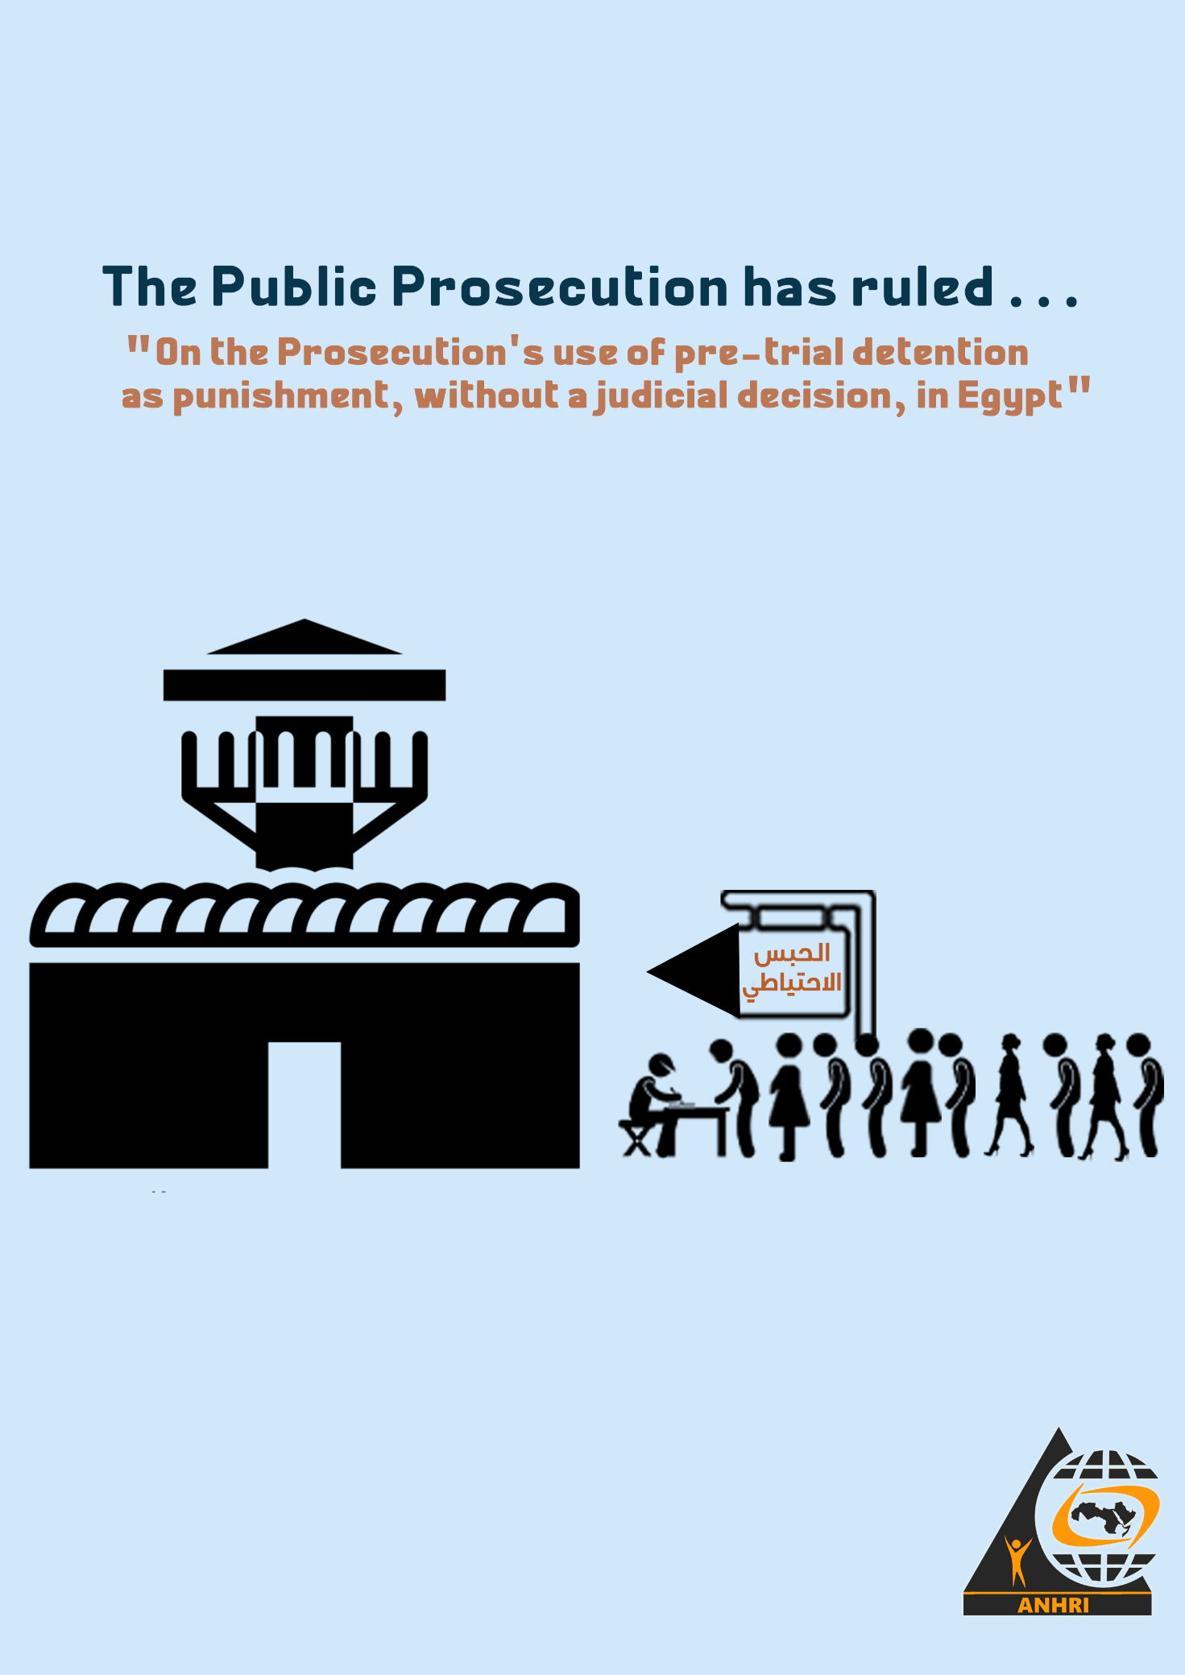

The Public Prosecution has ruled…
"On the Prosecution's use of pre-trial detention as punishment, without a judicial decision, in Egypt"

A common question before we start:
- Does the Public Prosecution use pretrial detention as a necessary measure warranted in the interest of investigation and justice?
- Or does the Public Prosecution use pretrial detention as a tool of punishment, whatever the motive is; to implement the security services' desire to retaliate and crackdown on opponents and those with views different from the political authorities' alongside those claiming their rights from different groups of society?
To answer this question, this paper will trace the approach of the Public Prosecution- especially the Supreme State Security Prosecution- in its use of pretrial detention throughout the cases it has considered during recent years, whose papers were made in police rooms. This paper will not go into complex legal details, nor will it invoke the legal provisions that talk about pretrial detention as an exceptional and abhorrent measure, but it will just refer to the text or the law when needed.
Introduction:
Freedom is an established principle. Therefore, it is settled to define pretrial detention as an exceptional measure and reprehensible procedure that restricts an individual's freedom and contradicts the presumption of innocence. It also has a great economic, social and psychological cost, and in many cases it may cause people to lose their jobs or their sources of livelihood, and it may even lead them to lose the shelter itself.
Such serious impact and damage not only affects the detained persons, but it extends to reach the social circles surrounding them, including relatives who depend on the paterfamilias for their livelihood and all their lives' aspects.
This applies to pretrial detention that meets the legal conditions and is deemed legitimate, so can you imagine the situation in case of pretrial detention which undermines the freedom of thousands of citizens over false and trumped-up accusations and unsubstantiated claims, and which deprives detainees from their right to appeal against their detention orders, let alone that some of them still remain on remand for a period exceeding the maximum limit of pretrial detention stipulated in the law?
Before January 2011 and until June 2013, things were clear as the sun and confrontation was straightforward enough. There were political dissidents who were voicing their opinions on one hand and on the other hand, there was a government and security apparatus that relied on administrative detention permissible under the emergency law (this detention doesn’t require reasons or justification by law). However, after passing 30 days starting from the date of arrest, the detainee may file a complaint/ grievance/ appeal before the judiciary, and in most cases, the court issues its rulings in favor of the detainees and accordingly the detention order is cancelled, and in some cases, the court may even issue judgments/ rulings to compensate detainees for the periods they spent in remand detention.
Until that time, the Public Prosecution was not a party to a political conflict, nor was it involved whatsoever in the process of arresting political opponents or those calling for change. But since the Supreme Constitutional Court issued a ruling on the unconstitutionality of detentions in June 2013, the security services have become confused; how can they arrest opponents of official policies? What are the legal grounds that they will use to justify the arrest warrant, and what will they do with the judicial authorities that will inevitably and promptly release these opponents?
It wasn’t long before the authoritarian mindset found a solution: introducing many exceptional laws, establishing exceptional courts, and arresting political opponents, opinion-holders and those calling for change, along with those who participated in peaceful assemblies, and pressing charges against them using the provisions of such exceptional laws. As a result, detainees have been allowed to be brought before the Supreme State Security Prosecution or even the Public Prosecution, which has started to exercise the extraordinary authority it was granted upon the amendments made to procedural laws following June 2013.
Since then, the Public Prosecution has expanded the issuance of pretrial detention orders, and thousands of people of different affiliations, views, and ways of opinion expression have become under remand detention. Members of legitimate political parties, university professors, human rights defenders, journalists, workers, and even ordinary citizens who exercise their right to criticism or peaceful assembly were not spared the detention as well.
Yes, legal books used to describe the Public Prosecution as an honorable litigant in the criminal proceedings.
But, on our part, we say that considering the Prosecution an honorable litigant/opponent doesn’t only depend on the position or the stance it takes, whether it is in favor of or against one of the parties, but it is also reflected in the extent of its ability to formulate its own vision to explore social conditions and monitor the consequences of its decision in terms of the social disturbance affecting the life of thousands of citizens and their families.
Saying otherwise stigmatizes the conduct and the performance of the Public Prosecution and its members in a subjective framework that is marked by victory for the whims of the political power or the security services, and this is a choice that clearly interprets a political desire/ whim and not the rule of law or the values of justice.
The scandalous witness, through our paper, remains that the pretrial detention would not suffice for the Public Prosecution to confront all those people at one time, so it used to re-detain them for further years until a judicial decision is accidentally issued by a court to release them. The Prosecution also used to accept and adopt the narratives made by the security services to press new accusations, similar to the previous ones, against the defendants in what is recently known as the *phenomenon of rotation/recycling * (adding detainees to new cases).
Pretrial detention in the Constitution and the law:
The Egyptian Constitution maximizes the value of personal freedom and equates it with natural rights. It also gives those whose freedom is restricted the right to file a grievance before the court, and makes it obligatory that this grievance is settled within a week; otherwise, the accused must be released immediately.
- The Constitution also requires determining the period of pretrial detention, its causes and cases of compensation for it.
Although the Constitution's provisions don’t go in line with the Criminal Procedure Code, we can clearly tease out the governing legal rule in the Criminal Procedure Code, which is:
(In cases of misdemeanors, pretrial detention's period may not exceed five months, except after obtaining, before its expiration, an order from the competent court to extend the detention for a maximum of 45 days, renewable for a term or other similar periods; otherwise the accused must be released).
The law determines the maximum period of pretrial detention at the preliminary investigation stage and at other stages of criminal proceedings at one- third of the maximum period of the custodial penalty; standardly set at no more than six months for misdemeanor crimes, 18 months for criminal offences and two years in case of crimes receiving the life sentence or the death penalty.
The Public Prosecution using the more oppressive provisions from the legislative arsenal in confronting those who hold views opposing the political authority:
Since the beginning of the era of President Abdel Fattah Al-Sisi, many exceptional laws have been issued, including the Terrorism Law, which involves loose and vaguely-worded terms and articles that defy legal arrest, in addition to adopting a severe expansion in criminalization.
It is as if the Public Prosecution has met its match when it invokes the Terrorism Law's provisions in the face of freedom of opinion and all forms of expression such as peaceful protest, instead of using it in the face of armed violence or even those inciting violence.
We can say that crimes of "joining/belonging to a terrorist/banned/outlawed group" and "spreading false news that disturbs the state of peace and public security" are the two most common crimes that have been used by the Public Prosecution in recent years. The two crimes can be briefly defined as follows:
- The terrorist entity/group: "Any group, association, body, organization, a gang consisting of at least three persons or others, or other entities or the like, whatever its legal or de facto form, whether inside or outside the country, and whatever its nationality or its affiliates', that aims to commit one or more crimes of terrorism, or that terrorism is one of the means it uses to achieve or carry out its criminal objectives."
- The terrorist act: "Every use of force, violence, threat, or intimidation, at home or abroad, for the purpose of disturbing public order or endangering the safety, interests, or security of society, or harming individuals or casting terror among them, or exposing their lives, freedoms, public or private rights, or their security to danger… or harm to national units, social peace or national security… or obstructing the application of any provisions of the constitution…"
In fact, the Public Prosecution has invoked such provisions and used it to charge persons who did not engage in violence, and without their interrogation papers containing any manifestations of violence, intimidation or incitement to it.
The Public Prosecution also didn’t indicate or determine what that terrorist group is; its name, location, members, or even the group's ideology.
It also didn’t specify the acts by which those people participate in such a group or reflect their alleged affiliation!
Legitimate doubts about the Public Prosecution's performance
Apart from that the Public Prosecution's approach constitutes a grave violation of the law and the guarantees stipulated for any defendant in the investigation proceedings, we suspect and doubt Prosecution's performance in manifold cases, as follows:
1-The Public Prosecution often adopts an approach that is closer to inquisitions (inspecting consciences and beliefs); as the questions it addressed to defendants include: information about their upbringing, names and ages of their family members, their sources of income, and how and where they live. Not only that, but the Public Prosecutor's deputies went so far to discuss the defendants about their views and opinion on the political regime, its policies and those in power. It spares no efforts to interrogate and question the defendants to inquire about their opinion and stances; whether they reject or accept the January 25 revolution and the ensuing June 30 incidents, a matter that is reminiscent of the Inquisition with its miserable face in our present time.
Even in regard to the "false news" that the Public Prosecution claimed the defendants had published leading to "disruption of security/tranquility, or stirring terror among citizens, or harming the national economy", both the defendants and their lawyers are baffled and confused at the questions raised by the Public Prosecutions and its deputies; as they fail to disclose the nature of such news, when and where it was published, and the evidence or signs of the "disturbance and damage" incurred by such ambiguous concepts (public security, public tranquility, public peace, national economy, horror and dismay).
2- Despite its insistence to imprison the accused, the Public Prosecution did not take one step forward in the investigation process and the defendants' papers remained shelved and locked in drawers. The investigation papers were not, and will not be, presented or submitted to the judiciary.
3- In the detention renewal sessions considered before the court, Public Prosecutor's representative always requests a continuation of the detention of the accused. However, it (sometimes) issues its decision to release this accused within only a few days after receiving the 45-day detention renewal order; apparently as part of political considerations or echoing of external demands or even electoral quotas, without regard to the alleged serious terrorist crimes mentioned in his investigation papers.
4- The Public Prosecution itself issued thousands of release orders, which means that there is no risk posed by the released person, but the Ministry of Interior wastes these orders by not actually releasing the accused people, rather, it arrests them once more and accuses them of the same bogus crimes that the Public Prosecution had previously investigated and revealed their falseness. However, instead of standing by the right and justice and ordering their release of defendants, we find it, with an enviable ease, open a new investigation (which it already completed) and issue new detention orders against them.
5- In many cases, the Public Prosecution didn’t open investigations, even if on formalistic grounds, into the allegations made by the defendants and their lawyers with regard to the ill-treatment and suffering endured by the accused during his/her arrest or detention. This includes: insults, physical assault, torture, or even the stealing/seizure of his/her belongings such as mobile phones, laptops, sums of money, and IDs through the use of force or police (arrest warrant) authority, not to mention the Public Prosecution's negligence towards cases of enforced disappearance in which many of those arrested went missing for several days or months.
6- The Public Prosecution did not have or provide information, nor evidence, of the percentage of terrorist crimes committed by many of those accused. Its detention orders are only based on the investigative records/reports conducted by State Security officers, while the accused persons totally deny all the accusations pressed against them citing their previous declared history in confronting terrorism and political violence groups.
7- The Public Prosecution has largely neglected the right of the defendants to lodge an appeal against their detention orders and the extension of their detention period for further new terms.
Shining truth
The above-mentioned points show that: the Public Prosecution tends to use the provisions of the Terrorism Law to crackdown on opponents of the political regime and its policies, and that many of their cases don’t involve any indication of violence or incitement to it, and that also most of these defendants belong to acts that have no connection whatsoever with terrorism.
Moreover, they indicate that these people were arrested only because they don’t appease the security services and for voicing views that are opposing the political authority's affiliations; whether through statements made in public meetings or TV interviews or through publishing via social media.
Hence, the answer to the posed question is shining brightly like the sun at noon in August, especially the answer which says: the Public Prosecution, and in particular the Supreme State Security Prosecution, used pretrial detention as a tool to implement the whim of the security apparatus.
As a consequence, pretrial detention has changed from an exceptional measure that is resorted to when necessary (as a last resort) to a tool and a means to abuse and curb/undermine freedom of opinion and expression, and as a punishment for expressing interest in public affairs and in defending people's rights. Preventive detention has become a heavy punishment without a court order.
Following are some cases and examples of the huge number of cases in which the Public Prosecution used pretrial detention as "punishment" under no legal rule or court order or law, pressing against the innocent charges of joining a terrorist group and spreading false news.
It should be noted here that the death penalty is the prescribed punishment for the first crime.

First: Ordering pretrial detention as a punishment against university professors:
1) Dr. Hazem Hosny
Case No. 488 of 2019 State Security
Date of arrest: 25 September 2019
Release order: On 1 November 2020, Cairo Criminal Court ordered his release with precautionary measures

Rotation/recycling (extending detention over new cases): On 4 November 2020, the Supreme State Security Prosecution interrogated him into Case No. 855 of 2020 State Security on a charge of joining a terrorist group. Then, on 22 February 2021, the State Security Prosecution ordered his release with precautionary measures (not leaving his home).
2) Yehia al-Qazzaz
Case No. 1305 of 2018 State Security
Date of arrest: 23 August 2018
Release order: 20 May 2019
3) Dr. Abdel-Fattah al-Banna
Case No. 1305 of 2018 State Security
Date of arrest: 23 August 2018
Release order: 20 May 2019
4) Dr. Hassan Nafaa
Case No. 488 of 2019 State Security
Date of arrest: 25 September 2019
Release order: On 19 March 2020, the State Security Prosecution ordered his release under the guarantee of his place of residence
5) Dr. Raed Salama
Case No. 1305 of 2018 State Security
Date of arrest: 23 August 2018
Release order: 20 May 2019
Second: Ordering pretrial detention as a punishment against human rights defenders
1) Amr Imam
Case No. 488 of 2019 State Security
Date of arrest: 16 October 2019
Release order: hasn’t yet been released
Rotation/ recycling/ extending detention pending new cases: On 26 August 2020, the State Security Prosecution interrogated him over Case No. 855 of 2020 State Security on charges of joining a group, committing one of financing and supply crimes, and spreading false news.
2) Mohamed al-Baqer
Case No. 1356 of 2019 State Security
Date of arrest: 29 September 2019
Release order: hasn’t yet been released
Rotation/ recycling into new cases: On 31 August 2020, the State Security Prosecution interrogated him in Case No. 855 of 2020 on charges of joining a terrorist group, committing a finance crime, spreading false news and information
3) Mahinour El-Masry
Case No. 488 of 2019 State Security
Date of arrest: 20 September 2019
Release order: hasn’t yet been released
Rotation/ recycling into new cases: On 30 August 2020, the State Security Prosecution interrogated her in Case No. 855 of 2020 on charges of joining a terrorist group and spreading false news
4) Khalil Rezk
Case No. 1475 of 2019 State Security
Date of arrest: 17 November 2019
Release order: hasn’t yet been released
Third: Ordering pretrial detention as a punishment against journalists
1) Esraa Abdel-Fattah
Case No. 488 of 2019 State Security
Date of arrest: 12 October 2019
Release order: hasn’t yet been released
Rotation/ recycling into new cases: On 31 August 2020, the State Security Prosecution interrogated her in Case No. 855 of 2020 on charges of joining a terrorist group and spreading false news
2) Moataz Wadnan
Case No. 411 of 2018 State Security
Date of arrest: 16 February 2018
Release order: 7 May 2020, the State Security Prosecution ordered his release under the guarantee of his place of residence for exceeding the pre-trial detention maximum period
Rotation/ recycling into new cases: On 9 May 2020, the State Security Prosecution interrogated him in Case No. 1898 of 2019 State Security and accused him of promoting the views and goals of a terrorist group.
3) Mohamed Ibrahim (Mohamed Oxygen):
Case No. 1356 of 2019 State Security
Date of arrest: 21 September 2019
Release order: 3 November 2020
Rotation/ recycling into new cases: On 10 November 2020, the Supreme State Security Prosecution interrogated him in Case No. 855 of 2020 on a charge of joining a terrorist group.
4) Sayed Abdellah
Case No. 1338 of 2019 State Security
Charges: Joining a terrorist group and spreading false news
Date of arrest: 22 September 2019
Release order: 3 November 2020
Rotation/ recycling into new cases: On 29 November 2020, the Supreme State Security Prosecution interrogated him in Case No. 1106 of 2020 on a charge of joining a terrorist group.
5) Solafa Magdy
Case No. 488 of 2019 State Security
Date of arrest: 26 November 2019
Release order: On 13 April 2021, the State Security Prosecution ordered her release over the cases No. 488 of 2019 and No. 855 of 2020
Rotation/ recycling into new cases: On 30 August 2020, the Supreme State Security Prosecution interrogated him in Case No. 855 of 2020 State Security on charges of joining a terrorist group and spreading false news.
6) Shaymaa Samy
Case No. 535 of 2020 State Security
Date of arrest: 20 May 2020
Release order: On 17 January 2021, the criminal court ordered her release with precautionary measures
Rotation/ recycling into new cases: On 30 January 2021, the Supreme State Security Prosecution interrogated her in Case No. 65 of 2021 State Security on charges of joining a terrorist group and spreading false news.
7) Hisham Fouad
Case No. 930 of 2018 State Security
Date of arrest: 25 June 2018
Release order: hasn’t yet been released
8) Mahmoud Hussein
Case No. 1152 of 2016 State Security
Date of arrest: 2 December 2016
Release order: On 21 May 2019, Cairo Criminal Court ordered his release with precautionary measures. The State Security Prosecution appealed against the decision, but on 23 May 2019, a different circuit of the Cairo Criminal Court rejected the appeal and accordingly upheld the release order issued for the journalist.
Rotation/ recycling into new cases: On 26 May 2019, the Supreme State Security Prosecution interrogated him in Case No. 1365 of 2018 State Security. The journalist had been kept on remand until Cairo Criminal Court eventually ordered his release with precautionary measures on 5 February 2021.
Fourth: Ordering pretrial detention as a punishment against political parties' leaders and members:
1) Khaled Daoud
Case No. 488 of 2019 State Security
Date of arrest: 25 September 2019
Release order: On 12 April 2021, the State Security Prosecution ordered his release under the guarantee of his place of residence
2) Abdel Moneim Abo El-Fotouh
Case No. 440 of 2018 State Security
Date of arrest: 14 February 2018
Release order: hasn’t been released so far
Rotation/ recycling into new cases: On 2 February, the Supreme State Security Prosecution interrogated him in Case No. 781 of 2019 State Security on charges of establishing and assuming leadership of a terrorist group.
3) Zyiad El-Eleimy
Case No. 930 of 2018 State Security
Date of arrest: 25 June 2018
Release order: hasn’t been released so far
4) Maasoum Marzouk
Case No. 1305 of 2018 State Security
Date of arrest: 23 August 2018
Release order: 20 May 2019
5) Hossam Moanes
Case No. 930 of 2018 State Security
Date of arrest: 25 June 2018
Release order: hasn’t been released so far
6) Abdel-Nasser Ismail
Case No. 488 of 2019 State Security
Date of arrest: 22 September 2019
Release order: hasn’t been released so far
Conclusion:
These are but examples of the cases that reflect the use of pretrial detention as punishment and a "sentence" or "ruling" from the Public Prosecution, and as we deem it to be unlawful, we see it as a ruling in favor of the security bodies and not in favor of society, nor the law, nor security.
The examples are too numerous to enumerate. The total number of defendants involved in one case cannot be known in an accurate figure due to the absence of official data from the Public Prosecution, which, itself, admits that it sometimes conducts invalid investigations by collectively interrogating dozens of defendants in one session, despite the fact that the criminal accusation is individual.
In conclusion, this paper does not wish to make recommendations, such as demanding to limit the use of pretrial detention or urging the Public Prosecution to swiftly put an end to such investigations. This is because we believe that it would be futile to seek small solutions, and that the only solution and the last call is to restore the demand for the independence of the judiciary; to be totally independent of the executive authority. This is the only matter that represents a legitimate way out of the deteriorating situation that justice and human rights have turned into in Egypt.

