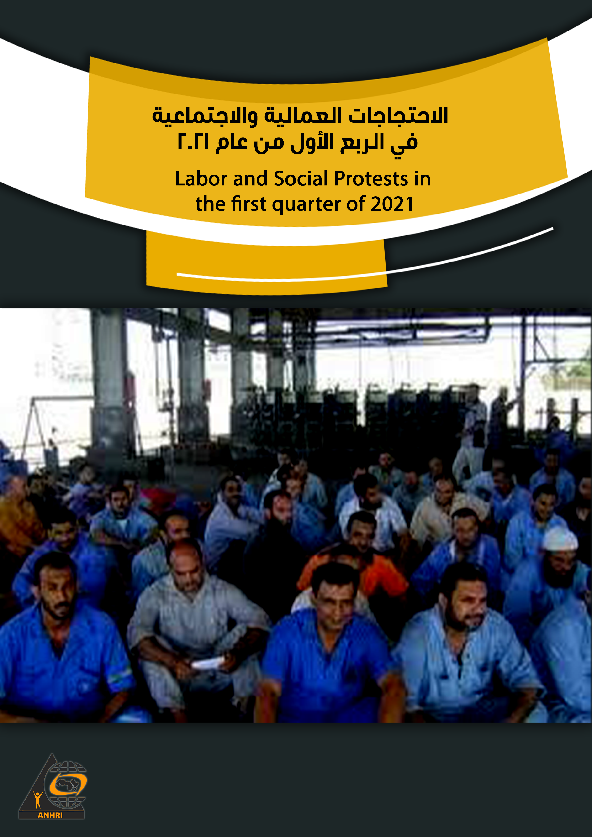

Labor and Social Protests in the first quarter of 2021

Introduction
Labor and Social Protests Monitoring Center releases its first quarterly report for the year 2021 to monitor the labor and social protests took place in Egypt during the first three months of 2021. The most important of these protests was: the sit-in staged by the workers of the Egyptian Iron and Steel Company (EISC) to protest against the government's intentions and plans to liquidate and sell the company; this is in addition to the manifold protests organized by lawyers to reject the violations they are subject to at the hands of some judges and security personnel raising the slogan that "The legal profession is not a crime".
The monitoring center also shows the resurgence of suicide incidents; as the reporting period witnessed about 16 suicide cases due to economic reasons. There have been also many protest cases in the sports sector where its workers demanded more than once the disbursement of their salaries.
The number of protests monitored:
Eighty protests took place in the first quarter of 2021 including (49) social protests and (31) labor and professional protests, as follows:
- In January, 23 protests took place
- In February, 29 protests were organized
- In March, there were 28 protests

Classification of labor and social protests:

Labor and professional protests | Social Protests
31 | 49

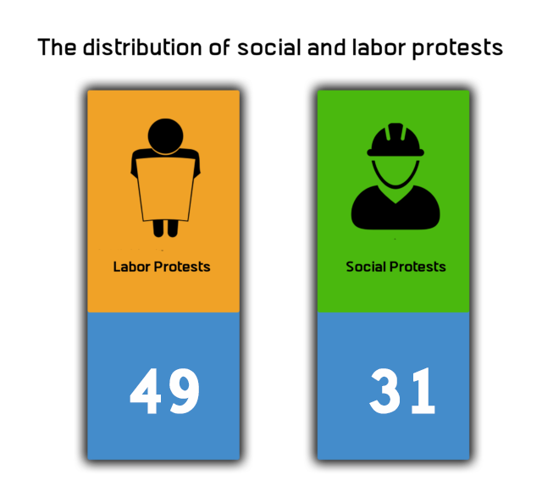

First: Details of the labor and professional protests (31 protests (:

Detail of the protest | Geographical location | The protesting category and sector | Number of protests | Type of protests
- Cleaning workers at the New Damietta City went on a strike to protest low wages  - Medical staff members at Sohag Teaching Hospital went on strike to protest the lack of incentives  - GlaxoSmithKline employees went on strike over work policy  - Drivers of the "Sars Al-Layyan - Menouf" line went on strike to protest the high tariffs and traffic fees  - Workers at Alexandria Spinning Company in Menoufia governorate went on strike in solidarity with their colleagues who were arbitrarily dismissed in the city of Sadat.  - Lawyers at Kafr Sa`ad District Court went on strike after the Deputy Public Prosecutor detained a lawyer under no legal ground. | Damietta 2  Sohag 1  Cairo 1  Menoufia 2 | Cleaning workers: 1  Medical staff: 1  Private sector workers: 1  Workers in the transport and communications sector: 1  Spinning and weaving workers: 1  Lawyers: 1 | 6 | Strike
- Workers at Egypt Aluminum Factory at Naga' Hammadi staged a sit-in to protest the non-disbursement of their late salaries  - Lawyers at Naga Hammadi court organized a sit-in to protest the arbitrariness of a judge  - Helwan's Iron and Steel factory workers organized a sit-in to protest the government's decision to liquidate the factory  - Delta Fertilizer workers in Dakahlia organized a sit-in to protest the government decision to liquidate the company  - Lawyers at Al-Ayyat court in Giza organized a sit-in to protest the assault on a lawyer at the hands of a security personnel  - Lawyers at the Benha Courts Complex organized a sit-in the court guard's assault on a lawyer  - Lawyers at Kafr El Sheikh court organized a sit-in to protest the assault on a lawyer at the hands of a low-ranking police officer  - Textile factory workers organized a sit-in in Al-Sharqiya governorate to protest the non-disbursement of their incentives  - Workers at "Leoni" company for electrical appliances held a sit-in to protest the non-disbursement of their annual incentive | Qena 2  Cairo 2  Qalyubia 1  Sharqia 1  Kafr Sheikh 1  Dakahlia 1  Giza 1 | Labor sector: 6  Lawyers sector: 3 | 9 | Sit-in
- Workers at Desouk oilfield organized a protest vigil demanding installation in their jobs  - A number of lawyers organized a protest vigil in Marsa Matrouh to show solidarity with their colleagues at Kaf Al- Shiekh Court  - Itay Al-Baroud Court's lawyers in Beheria organized a sit-in in solidarity with their colleagues at Kaf Al- Shiekh Court  - Workers at the cardboard Factory in the 10th of Ramadan staged a protest to protest layoffs of workers  - Carrefour Alexandria employees organized a protest calling on the administration to increase salaries | Kafr al-Sheikh: 1  Marsa Matrouh: 1  Beheira: 1  Sharqyia: 1  Alexandria: 1 | Labor Sector: 2  Lawyers Sector: 2  Employees: 1 | 5 | Protest vigil
- A nurse filed a lawsuit to appeal against the decision to dismiss her from her work  - Journalists filed a lawsuit before the State Council demanding to set a date for the Journalists Syndicate elections  - A group of journalists lodged a lawsuit demanding to hold the Journalists Syndicate elections at Abdel-Khalek Tharwat Street.  - A group of people filed a lawsuit before the State Council to reject the decision to liquidate the Iron and Steel Company  - Doctors and nursing specialists filed a lawsuit demanding to consider whoever died of coronavirus among the medical staff as a martyr | Cairo 5 | Medical sector 2  Journalists and media 2  Labor sector 1 | 5 | Resorting to the judiciary
- Workers at New Najeh Trading Company filed a report/complaint with the Labor Office to denounce the dismissal of 10 workers at Sharqyia governorate | Sharqyia 1 | Labor Sector 1 | 1 | A complaint with the Labor Office
- Segwart Company's workers signed a collective complaint to protest the company's decision to reduce annual incentives  - Service classes teachers filed a collective complaint and sent it to the Minister of Education and Technical Education to denounce the non-payment of financial dues  - Doctors at Al-Abbasiya Hospital filed collective complaints to denounce the decision to establish commercial stores in the hospital | Cairo 3 | Labor sector 1  Teachers sector 1  Medical sector 1 | 3 | Collective Complaint
- The Syndicate of Spinning and Weaving Workers protested the decision to fire 10 workers from the Alexandria Spinning Company  - Union lawyers protested the transfer of the elections headquarters to the sub-union Bar Association | Menoufia 1  Cairo 1 | Labor sector  Lawyers sector 2 | 2 | Trade union protest
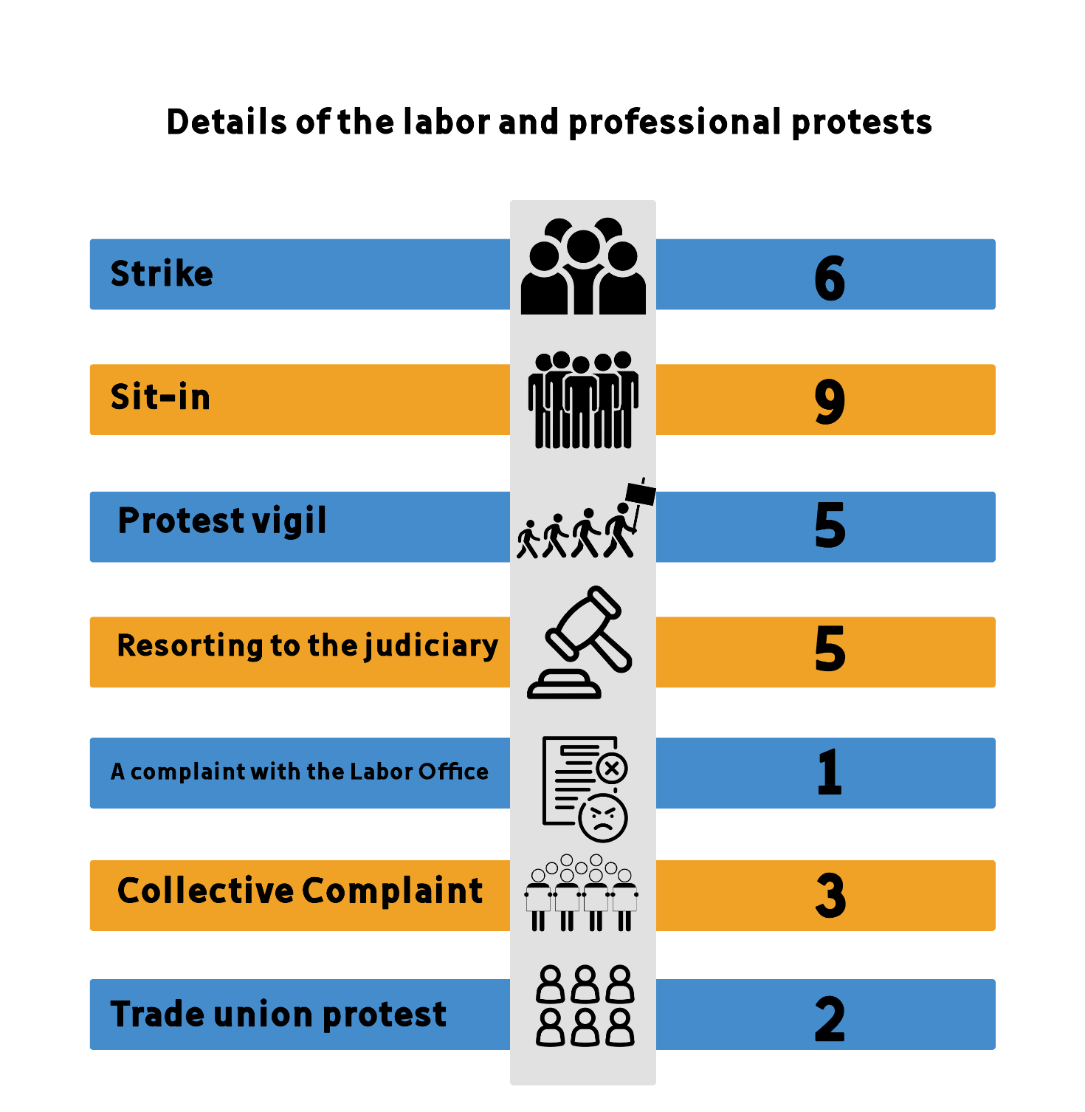

Second: Social and economic protests

Detail of the protest | Geographical location | The protesting category and sector | Number of protests | Type of protests
- The Zamalek club's swimming team staged a strike to protest the non-payment of overdue dues  - A third-class football team went on strike in Qena City to denounce the non-payment of their financial dues | Giza 1  Qena 1  Bani Suef 1 | Sport Sector 3 | 3 | Strike
- Ismaili Sporting Club fans gathered in front of the club to demand the departure of the club president  - Citizens gathered in front of Al-Ramad Hospital in Shebin El-Kom to protest the non- dispensation of necessary medicines  - A group of people gathered in front of the security forces to protest the demolishing of old buildings in Sayyda Aaisha district  - Hundreds of students gathered in front of an educational center in Tanta to protest its closure  - Residents gathered in front of Nasr al-Nuba Police Station after gunmen shot a tuk-tuk driver  - Hundreds of students gathered to protest the closure of an educational "center" in Assiut | Ismailia 1  Menoufia 1  Cairo 1  Tanta 1  Aswan 1  Assiut 1 | Sports sector 1  Residential neighborhoods sector 3  Student sector 2 | 6 | Gathering
- A complaint from Zamalek club handball players to denounce their unpaid salaries  - Collective complaints from the deputies of the "local administration" to the Minister of Local Development to denounce the garbage issue  - The Egyptian Architects Association collects collective signatures to reject the Basilica Axis  - Residents of Sheikh Shehata village in Menoufia governorate complaining about the lack of services  - A complaint by the people of Tersa against the governor of Giza to denounce the unnecessary demolition of the licensed homes  - The people of “Shawnee” asking the governor of Gharbia to move the mart outside the residential block  - Collective complaints on the difficulty of accessing the electronic examination platform  - A collective complaint for the Tanta team players in the Football Association demanding the disbursement of their dues  - A group of students in Port Said governorate filed collective reports due to their inability to access the exam | Giza 2  Cairo 3  Menoufia 1  Port Said 1  Gharbyia 2 | Sports sector 2  Residents and residential neighborhoods sector 5  Student sector 2 | 9 | Collective complaint
- A plumber in Maasra district committed suicide after passing through a financial distress  - A young man in Beni Suef committed suicide by hanging due to his poor financial conditions  - A farmer in Dakahlia took his life after passing through a financial distress  - A worker living in Khanka district burned himself to death for having many quarrels with his wife  - A worker in Menoufia governorate committed suicide after passing through a financial distress  - A young man took his life inside his room in Minya governorate due to the accumulation of his debts  - To escape his debts, a baker committed suicide in the village of Toukh Al-Khail in Minya governorate  - A father committed suicide in Beheira governorate due to his financial hardship  - A wall painter committed suicide for failure to pay his apartment's installments  - A person in Menoufia committed suicide for "failing to invest his money"  - A young man took his life in Tanta for passing through a financial distress  - A citizen residing in the Red Sea governorate committed suicide for not finding a job  - A person committed suicide because he couldn’t afford to cover marriage expenses  - An African refugee from Zimbabwe committed suicide by throwing himself from the ninth floor due to his inability to financially support his wife  - A Syrian citizen committed suicide for passing through a financial hardship  - A person committed suicide in Kafr El-Zayat due to the accumulation of his debts  - A person in the 10th of Ramadan committed suicide because he was unable to pay his debts | Cairo 3  Beni Suef 1  Dakahlia 1  Qalyubia 2  Menoufia 2  Sharqia 1  Red Sea 1  Gharbyia 2  Kafr Sheikh 2  Beheira 1  Minya 2 | Egyptians 16  Refugees 2 | 18 | Suicide
- A protest vigil organized by those who registered in the Sarayat Kattameya project  - Owners of Stella Di Mare Sokhna chalets organized a protest against the holding company at its headquarters in Cairo.  - A protest vigil staged by those who registered to buy Coronado chalets in Ain Sokhna against the Cairo-based "Shades" company  - Members of the General Assembly of Zamalek Club organized a protest against the club's administration to complain about the lack of services.  - A protest organized by a Coptic family to demand the return of their daughter who went missing.  - A protest vigil by a group of women with special needs demanding a combination of pension and salary | Cairo 5  Giza 1 | Residential neighborhoods 4  Sports sector 1  Special needs sector 1 | 6 | Protest vigil
- Al-Ahly club fans crossed the Autostrad highway in memory of the Al-Ahly martyrs | Cairo 1 | Sport Sector 1 | 1 | Blocking off roads
- Parliamentarian Ahmed Al-Sharqawi submitted a briefing request to the Ministers of Local Development and Transport in Parliament regarding the expected demolition of gardens in Mansoura  - An Egyptian MP submitted an urgent statement after 43 Egyptians were subjected to a major crisis in Iraq | Dakahlia 1  Cairo 1 | Parliament and Senate sector 2 | 2 | Parliamentary protest
- Merchants of the "Bouhi" market in Imbaba, Giza, filed a lawsuit before the Administrative Court demanding a halt to the implementation of the decision to remove the stalls  - Those who are negatively affected by the Mahmudiyah axis in Alexandria filed lawsuits to refuse the demolishing of their homes  - Legal experts filed a lawsuit against the demolition of the Champollion Palace  - PhD and master's holders filed lawsuits before the State Council demanding that they be appointed in the state's functional structure | Giza 1  Cairo 2  Alexandria 1 | Graduates sector 1  Residential neighborhoods 3 | 4 | Resorting to the judiciary

