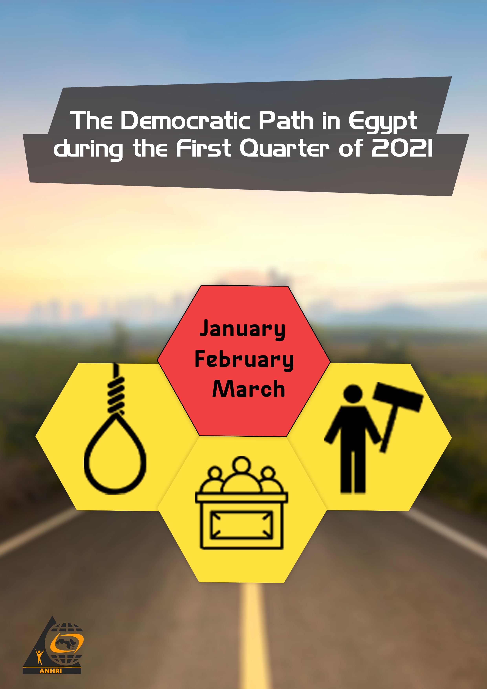

The Arabic Network for Human Rights Information (ANHRI)
"Lawyers for Democracy” Initiative

The Democratic Path in Egypt during the First Quarter of 2021(1)

Before we start
The Democratic Path is a report that is launched by the Arabic Network for Human Rights Information (ANHRI) every three months, i.e. quarterly, starting from 2018. In previous years, ANHRI used to publish the report on a monthly basis through the “Lawyers for Democracy” initiative it launched in 2014 to monitor the democratic process in Egypt.
In addition to the monthly reports issued to monitor the state of democracy, ANHRI issued annual reports to monitor the democratic path from 2014 till 2019. You can be accessed them through the “Reports and Studies” section on ANHRI’s website by clicking on the following link:
https://www.anhri.info/?cat=14&lang=en
Introduction
This is the first Democratic Path report released by ANHRI throughout the year 2021, which marks the first anniversary of the death of former president Hosni Mubarak who was toppled by the January Revolution. The first quarter of the year also saw the kicking off of the new parliamentary session headed by Counselor Hanafi al-Jabali, the former President of the Supreme Constitutional Court, by introducing the Real Estate Registration Law, but its enforcement had been later postponed for two years amid widespread controversy among citizens.
Security crackdown against writers, opinion-makers, and opponents of the current regime didn’t stop during the reporting period. During the January Revolution's anniversary, the security forces arrested cartoonist Ashraf Hamdy and photojournalist Hamdi Al-Zaeim, in addition to the National Security Agency rotating/recycling a number of political dissidents by adding them to new cases after receiving release orders upon court decisions. The most prominent of those who have been rotated are: researcher and journalist Shaima Sami and activist Nermin Hussein.
Protest events didn’t stop during the first quarter of 2021; as 57 protests were staged by different political forces throughout this period. Social and labor protests were at the forefront of such protest events with 43 protests being organized. Meanwhile, the protest activities held by the Muslim Brotherhood (MB) and the National Alliance to Support Legitimacy (NASL) have declined as only 7 protests were recorded, all in individual forms and in remote villages coinciding with the anniversary of the January revolution.
Military trials of civilians also continued in the first quarter of the year; as among the 52 ongoing trials held during the reporting period, there were 3 military trials for 634 citizens.
Violations of media freedoms have not ceased during this period as well; with 33 cases of violations recorded, most notably with respect to the investigations conducted by the competent prosecutions alongside the detention renewal sessions, which were marred by 20 violations that took place during the period covered by the report.
On the other hand, the number of terrorist operations has continued to decline compared to the previous years; as the first quarter of 2021 did not witness any terrorist operations, according to official sources and the official page of the military spokesperson on social media platforms, also there haven’t been any media statements from the bodies that adopt terrorist operations like what happened in previous years.
The details of the state of the democratic path during the 1st quarter of 2021 are outlined, in numbers and percentages, as follows:
First: Protest events
During the third quarter of the year, the various forces organized 57 different events, and their distribution was as follows:
* Social and labor protests: 43 protest events
* Muslim Brotherhood (MB) and the National Alliance to Support Legitimacy (NASL): 7
* Student protests: 3
* Pro-regime protests: 3
* Civil power: one protest

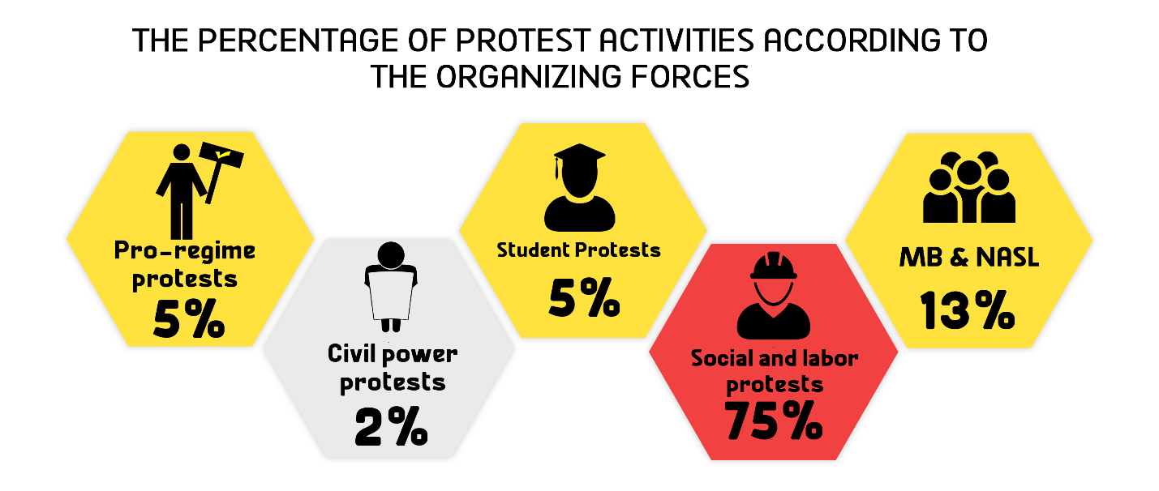
The month of January came first in witnessing the largest number of protest events with 25 different protests, as shown in the following :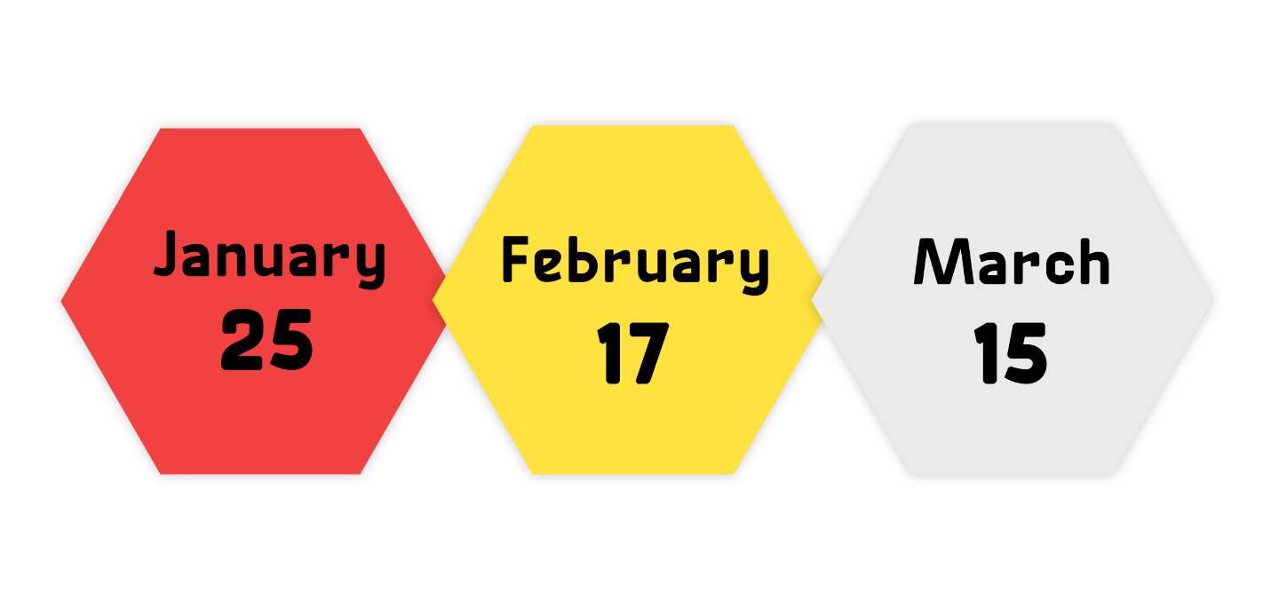Out of these different events, 3 were attacked by security forces, 46 passed without attacks, and 8 protests were resolved after negotiations with their participants.
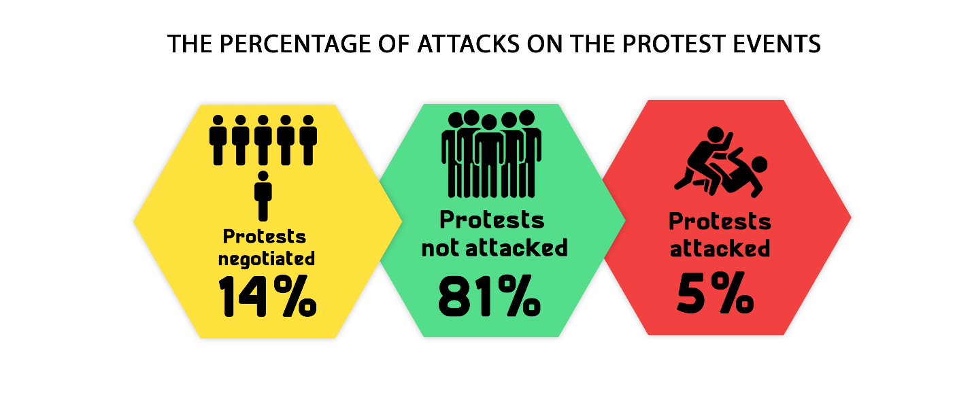
Labor and Social protests:
The first quarter of 2021 witnessed 43 different social and labor protests; three of which were attacked by security forces, whereas 32 passed without interference, and 8 were resolved after negotiations with their organizers.
The most important demands brought by the social and labor protests:
- Members of the General Assembly of Al-Zamalek Club protested against the decisions of the Club administration's appointed committee
- The Ismaili sporting club fans protested against the football team's performance and demanded the departure of the club's Board of Directors
- Workers at the Egyptian Iron and Steel Company (EISC) protested against the decision to liquidate the company.
- A number of workers demanding better wages and installation in their jobs
- A number of lawyers staged a sit-in to protest the ill treatment at the hands of security personnel and judges.
- A number of Al-Ahly club fans commemorated the Port Said Stadium massacre

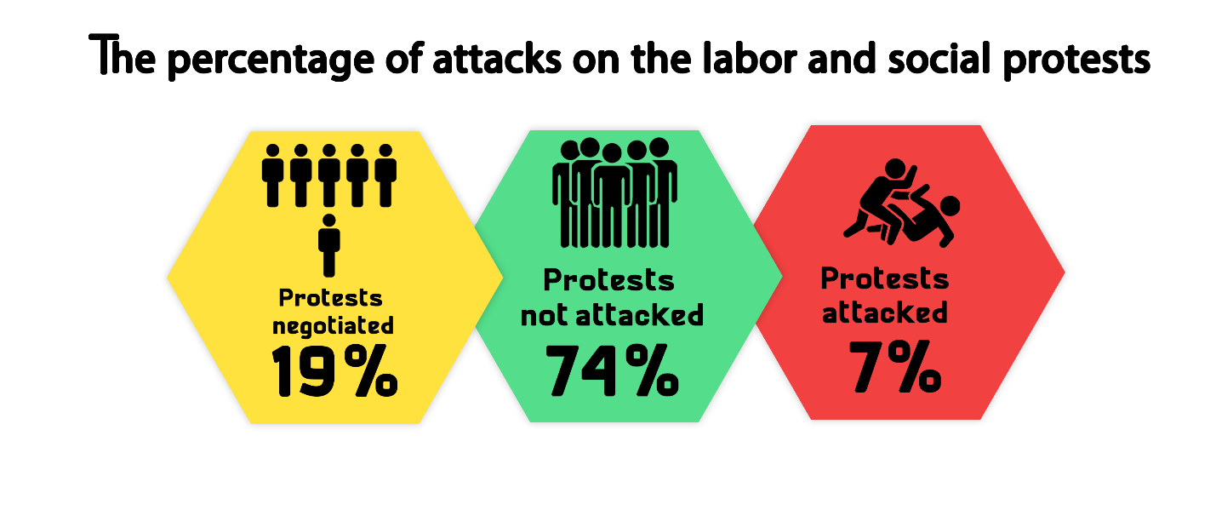MB and NASL protest activities:
The first quarter of 2021 witnessed a remarkable decline in the protest activities organized by the Muslim Brotherhood (MB) and the National Alliance to Support Legitimacy (NASL). During the reporting period only seven protests took place in remote villages and on an individual basis in coincidence with the anniversary of the January 25 revolution, and all of which were left without intervention by the security bodies.
The most important demands raised by Muslim Brotherhood and the National Alliance to Support Legitimacy:
- Commemorating the January 25 revolution

Student activities:
The first quarter of the year witnessed students organizing 3 protest events all of which hadn’t been dispersed by the security forces.
Student protests’ main demands:
- Hundreds of students objected to the closing of private lesson centers before exam revisions
- A number of 1st and 2nd grade high school students objected to the failure of the tablet-based examination system
Pro-regime protest events:
The first quarter of 2021 witnessed three protests supporting the regime; all of them had been organized outside Cairo to celebrate Police Day.
Civil Power protests:
The first quarter of the year saw only one protest activity organized by civil power; as political activist Mohamed Adel went on hunger strike in objection to the physical assault he was subjected to at the hands of the head of the North Mansoura Public Prosecution during the activist's detention renewal session.
Second: Trials
- Ongoing trials:
The first quarter of 2021 witnessed 52 trial cases that are being considered before the Egyptian judiciary, including three before the military court. Of these, there were 17 rulings of conviction, 8 acquittals and 23 death sentences against 43 defendants over criminal cases.
The distribution of the 52 ongoing trials is as follows:
* 38 trials for the MB & NASL.
* 4 trials of the civil and democratic powers.
* 6 trials for Mubarak’s regime’s affiliates.
* 1 trial for post-30 June regime's affiliates
* The military judiciary considered 3 trials for 634 civilians

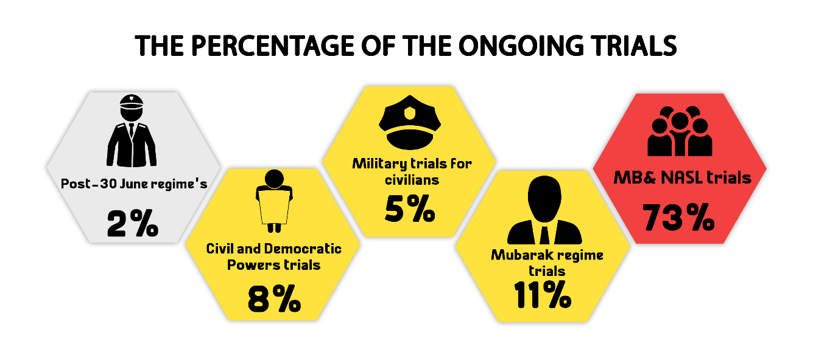
The most prominent trials of MB and NASL are:
Cases known in the media as: (Al-Matariya terrorist cell, Hisham Ashmawi cell, al-Murabitin Cell, Ahrar al-Sham organization, Helwan Brigades, Al-Maghara incidents, the raid on Egyptian prisons, The Guidance Office incidents, spying for Hamas, spying for ISIS, ISIS Ain Shams Cell, ISIS October cell, ISIS New Cairo Cell)
The most prominent trials of Mubarak regime figures are:
Cases known in the media as: (License plates, the Ministry of Aviation corruption, Sodic Land, Land of Golf, Customs corruption, Green Belt).
The most prominent trials of civil and democratic powers are:
The cases known in the media as: (The Oppressed of Downtown, the trial of the activist Sana Seif, the cabinet incidents, and the appeal submitted by Ziad Al-Alimi against the decision to place him on the lists of terrorist entities)
The most prominent trials of post- June 30th regime’s affiliates are:
Cases known in the media as (The trial of Alexandria's former deputy governor on bribery charge)
The Military Trials of civilians:
In the first quarter of 2021, the military judiciary considered 3 ongoing trials for 634 civilians.
- Sentences
During the reporting period, there were 24 convictions and 4 acquittals. The details are as follows:
Convictions:
During the first quarter of the year, the Egyptian judiciary issued 24 convictions, distributed as follows:
* 19 rulings against the Muslim Brotherhood (MB) and the National Alliance for the Support of Legitimacy (NASL).
* Two rulings against defendants affiliated with the civil democratic forces
* One ruling against defendants belonging to Mubarak regime
* One ruling issued by the military court
* One ruling against post June 30-regime’s supporters
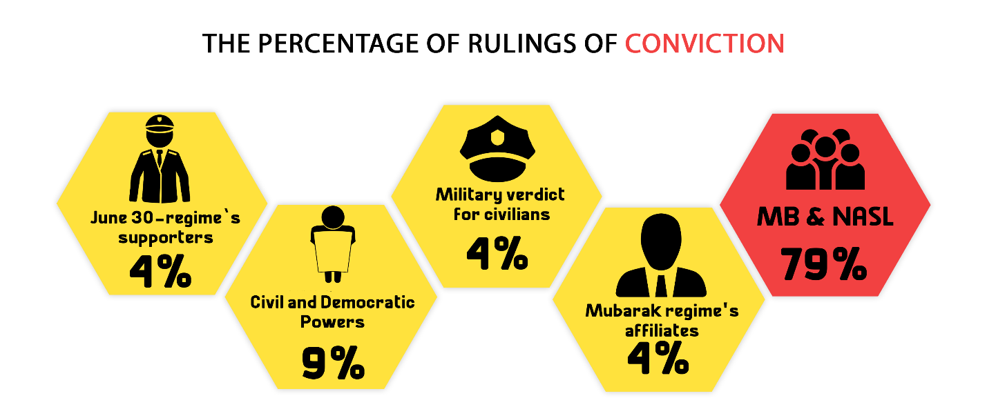
Acquittals:
During the first quarter of the year, four acquittals were handed down as follows:
* Two rulings for the MB and NASL affiliates
* One military ruling for civilians
* One ruling of acquittal for Mubarak regime’s figures.
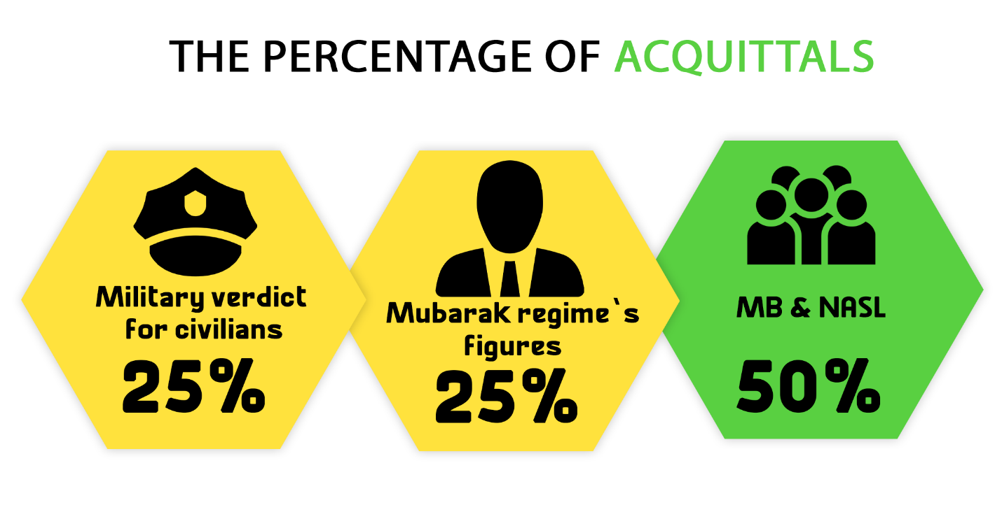

Death sentences
23 death sentences were issued against 43 defendants during the first quarter of 2021; all of them were handed down over criminal cases, in addition to the execution of 10 death sentences against 15 defendants convicted over criminal cases as shown in the following table:
1- Rulings
Total | Death sentences issued by military courts | Death sentences issued by civil courts
23 | - | 23

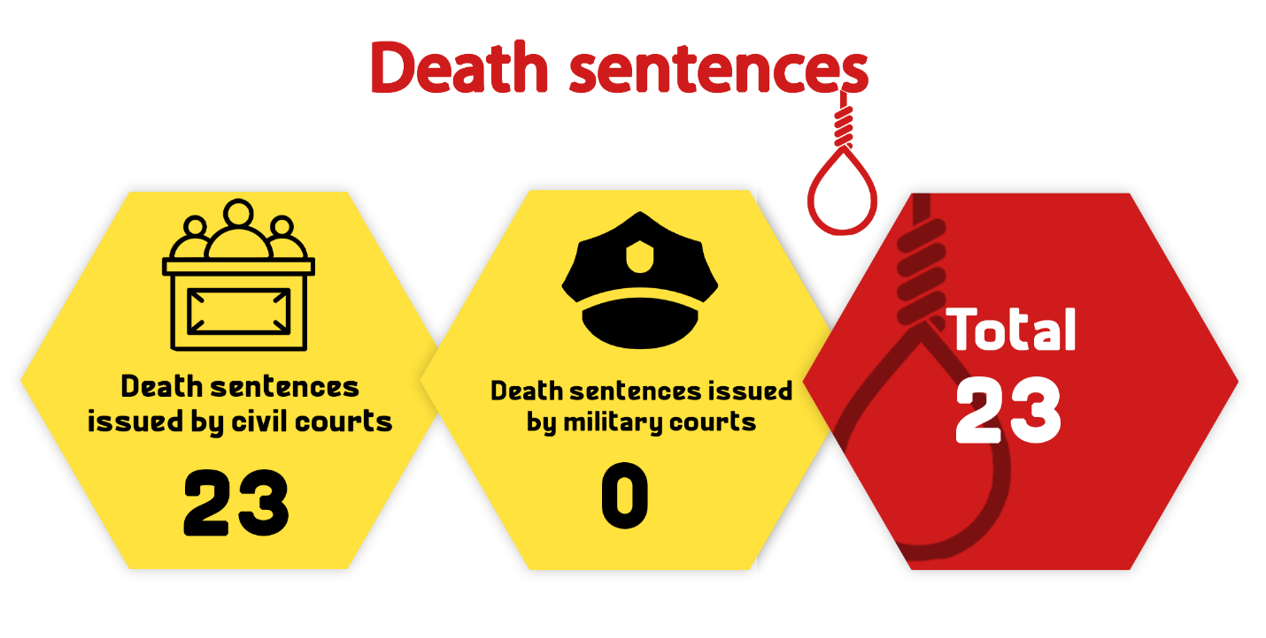

2- Defendants
Total (Number of defendants) | Number of defendants upheld by the Court of Cassation to be executed | Number of defendants upheld by the Mufti to be executed | Number of defendants referred to the Mufti
43 | -- | 32 | 11 | Civil
-- | -- | -- | -- | Military
43 | -- | 32 | 11 | Total

3- Death sentences executed:
The first quarter of 2021 witnessed the Prisons Authority sector carrying out 10 death sentences against 15 defendants in February and March as follows:
- On 16 February 2021, the Prisons Authority sector carried out the death sentence issued against a defendant convicted of killing a student at Al-Hussainiya region in the Sharqia Governorate.
- On 27 February 2021, the Prisons Authority sector executed the death sentence issued against a defendant convicted of killing the daughter of her sister-in-law due to family disputes.
- On 27 February 2021, the Prisons Authority sector executed the death sentence issued against a married couple accused of killing the owner of the apartment building where they reside, dismembering his body, placing it in bags and disposing of it.
- On 27 February 2021, the Prisons Authority sector executed the death sentence issued against a woman and her boyfriend who got rid of (killed) her husband by poisoning him
- On 1 March 2021, the Prisons Authority sector in Damanhour Prison carried out the death sentence issued against one person convicted of committing the Kafr al-Dawar massacre in which 7 members of one family were killed after being stabbed
- On 3 March 2021, the Prisons Authority Sector in Borg Al Arab Prison carried out the death sentence issued against a furniture carpenter convicted of murdering a woman after robbing and sexually raping her.
- On 3 March 2021, the Prisons Authority Sector in Borg Al Arab Prison carried out the death sentence issued against 4 defendants (members of one family) accused over a criminal case.
- On 3 March 2021, the Prisons Authority Sector in Borg Al Arab Prison carried out the death sentence issued against one person accused of killing his wife and children.
- On 3 March 2021, the Prisons Authority Sector in Borg Al Arab Prison carried out the death sentence issued against one person accused of killing his mother, smashing her head and burning her body.
- On 3 March 2021, the Prisons Authority Sector in Borg Al Arab Prison carried out the death sentence issued against one person accused of killing the brother of his ex-wife with a firearm and wounding others.

Third: Violence and Terrorism
By following all official sources, news websites, media platforms and social media pages of the military spokesman, no terrorist operations were monitored during the first quarter of the year.
- Terrorist operations:
By following all official sources, news websites, media platforms and social media pages of the military spokesman, no terrorist operations were monitored during the first quarter of the year.
The following table shows the details of such terrorist operations
Diffused bombs | Terrorist attacks carried out
-- | --

The following table shows the percentage of terrorist operations and counter-terrorism ones:
Total | Operations thwarted | Operations carried out | Months
-- | -- | -- | January
-- | -- | -- | February
-- | -- | -- | March
-- | -- | -- | Total

- Counter-Terrorism Operations
By following all official sources, news websites, media platforms and social media pages of the military spokesman, no preemptive attacks by the security forces were monitored during the first quarter of 2021.
Fourth: Attack on Freedom of Expression and Media Freedoms
The first quarter of the year witnessed 33 various violations against freedom of expression and media freedoms.
The following table shows the number of violations took place throughout the first three months of 2021:
Months | Number of violations
14 | January
10 | February
9 | March
33 | Total during the 1st quarter of 2021

Details are as follows:

20 | Investigations and detention renewal sessions
4 | Coverage ban
2 | Arrest and/or detention
2 | Physical and verbal attacks
2 | Administrative penalties (fines)
1 | Judicial orders/verdicts
1 | A complaint with the Supreme Council for Media Regulation
1 | Banning from appearing on media
33 | Total of violations

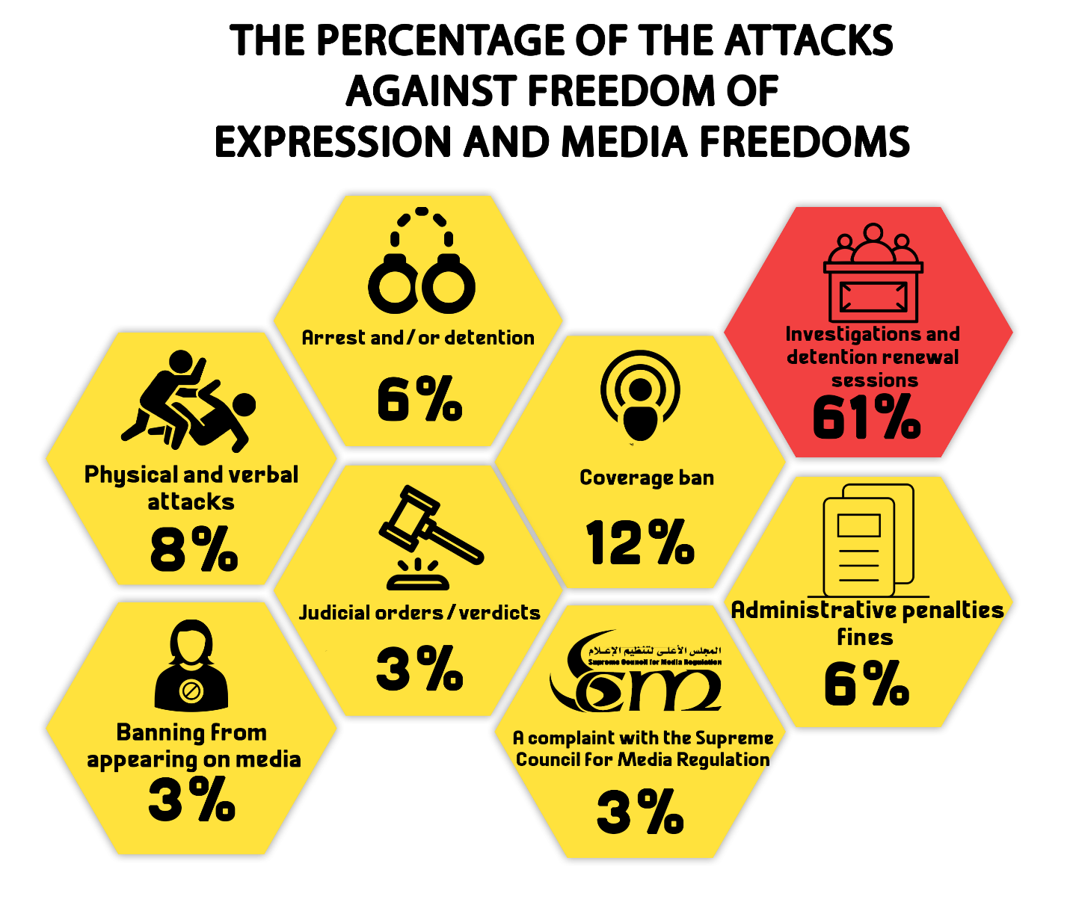

Fifth: Attack on Human Rights Defenders:
1- On 12 January 2021, Cairo Criminal Court adjourned the trial of activist Sana Seif pending Case No. 12499 of 2020 First Settlement Misdemeanor, for the hearing of 9 February 2021, on charges of: publishing and broadcasting false news and statements that call for disturbing public security, insulting- by means of publication- public employee because of carrying out his duty, using a private account on the internet to commit a crime that is punishable by law, and- verbally- insulting a police officer while he was performing his job. The activist's trial had been deliberated in court sessions until the court sentenced, on 17 March, the activist to one year in prison over the first and third charge and to six months in prison over the second and fourth charge.
2- On 17 January 2021, Cairo Criminal Court ordered the release of researcher and journalist Shaima Seif with precautionary measures pending Case No. 535 of 2020 State Security, in which she is charged with abetting a terrorist group in achieving its aims, misusing social media, and spreading false news and statements. Then, on 30 January 2021, the Supreme State Security Prosecution interrogated the journalist into Case No. 65 of 2021 State Security on a charge of joining a terrorist group and decided to hold her in pretrial detention for 15 days pending probe.
3- On 17 January 2021, Cairo Criminal Court renewed the detention of human rights lawyer Hoda Abdel Moneim, former member of the National Council for Human Rights, for a period of 45 days in Case No. 1552 of 2018 State Security in which she faces charges of joining a terrorist group with knowledge of its purposes, committing one of financing crimes and spreading false news and information.
4- On 19 January 2021, Cairo Criminal Court adjourned the consideration of the detention renewal session of human rights lawyer Mohamed al-Baqir and activist/blogger Alaa Abdel-Fattah pending Case No. 1356 of 2019 State Security, in which they face charges of joining a terrorist group with knowledge of its purposes, committing one of financing crimes, misusing social media and spreading false news and information. The case was postponed for the hearing of 31 January 2021, and on that day, the court ordered the continuation of the two activists' detention for 45 days.
5- On 19 January 2021, Cairo Criminal Court decided to administratively postpone the detention renewal session of engineer Yehia Hussein Abdel-Hady pending Case No. 277 of 2019 State Security, in which he is accused of colluding with a terrorist group to achieve its goals, misusing social media, and spreading false news and statements. Then on 31 January 2021, the Supreme State Security Prosecution interrogated Abdel-Hady in the Case No. 1356 of 2019 State Security accusing him of joining a terrorist group with knowledge of its purposes and decided to detain him for 15 days that would start after the end of his detention in the aforementioned case (No. 277 of 2019).
6- On 19 January 2021, Cairo Criminal Court adjourned the detention renewal of human rights lawyer Amr Imam and journalists Hossam al-Sayyad and Khaled Daoud pending the Case No. 488 of 2019 State Security, in which they are charged with participating with a terrorist group in achieving its objectives and publishing false news and information. The consideration of the detention renewal of the three was postponed to the hearing of 2 February 2021.
7- On 24 January 2021, Cairo Criminal Court renewed the detention of human rights lawyer Zyiad El-Eleimy for 45 days pending the Case No. 930 of 2019 State Security on charges of colluding with a terrorist group to achieve its goals and spreading false news and information. The same court also adjourned the consideration of the detention renewal of the two journalists Hossam Moanis and Hisham Fouad pending the same case and over the same charges for a hearing to be set later due to the inability to bring the two from their jail to the courthouse. Then, on 15 February 2021, Cairo Criminal Court renewed the detention of the two journalists (Hossam Moanis and Hisham Fouad) for 45 days.
8- On 27 January 2021, Mansoura Criminal Court ordered the release of activist Mohamed Adel on bail of EGP 10,000 pending investigations into the Case No. 5606 of 2018 Aga Administrative, in which he is accused of joining a terrorist group and spreading false news. Then, on 8 February 2021, and after his release order, the court decided to renew the detention of the activist for 15 days pending the Case No. 4118 of 2018 Sherbin Administrative on charges of joining a terrorist group with knowledge of its purposes and spreading false news.
9- On 6 February 2021, the Supreme State Security Prosecution interrogated researcher Ahmed Samir pending the Case No. 65 of 2021 State Security and accused him of: joining a terrorist group with knowledge of its objectives, intentionally publishing and broadcasting false news and data, using an account on the internet with the aim of committing the crime of spreading false news and information. The Prosecution decided to hold the researcher in pretrial detention for 15 days.
10- On 19 February 2021, the Supreme State Security Prosecution renewed the detention of blogger Mohamed Oxygen and activist Sameh Seoudi State Security- without bringing them before the Prosecution- for 15 days pending the Case No. 855 of 2020 State Security in which they face charges of joining a terrorist group with knowledge of its objectives.
11- On 22 February 2021, Cairo Criminal Court renewed the detention of Dr. Abdel-Moneim Abo El-Fetouh, head of Egypt Strong Party, for 45 days pending the Case No. 440 of 2018 State Security on charge of establishing and heading a terrorist group and spreading false news and information.
12- On 2 March 2021, Cairo Criminal Court renewed the detention of human rights lawyer Mahinour El-Masy and the two journalists Solada Magdy and Esraa Abdel-Fattah pending the Case No. 488 of 2019 State Security on charges of participating with a terrorist group in carrying out their objectives, misusing social media and spreading false news and information.
13- On 2 March 2021, Cairo Criminal Court renewed the detention of human rights lawyer Amr Nawahan and Haytham Mohamedin for 45 days pending Case No. 741 of 2019 State Security in which the two are facing charges of: colluding with a terrorist group to achieve its goals, misusing social media, and spreading false news and statements. Then, on 9 March, the same court ordered the release of Mohamedin with precautionary measures pending the aforementioned case. The next day, 10 March, the Supreme State Security interrogated the activist (Haytham Mohamedin) pending Case No. 1956 of 2019 State Security on charges of joining a terrorist group with knowledge of its purposes and then ruled to hold him in detention once again for 15 days.
14- On 9 March 2021, Cairo Criminal Court renewed the detention of human rights lawyer Sayed al-Banna for 45 days pending Case No. 880 of 2020 State Security in which he faces charges of joining a terrorist group with knowledge of its purposes, misusing social media, spreading false news and information and inciting to protest.
15- On 11 March 2021, the Court of Cassation rejected the appeal No. 2 of 89 (judicial year) submitted by Hisham Jaafar, journalist and head of "Mada" Foundation for Media Development, challenging the decision issued by Cairo Criminal Court to place him on the Terrorist Entities List and which was published in the Official Gazette on April 30, 2018.
====================================
(1)- The Democratic Path is a report launched by the Arabic Network for Human Rights Information (ANHRI) in 2014. It is now released every three months, i.e. quarterly, but ANHRI used to publish it on a monthly basis during the previous years through the “Lawyers for Democracy” initiative.
In addition to the monthly reports issued to monitor the state of democracy, ANHRI issued annual reports to monitor the democratic path, which can be accessed through the “Reports” section on ANHRI’s website by clicking on the following link:
https://www.anhri.info/?cat=14&lang=en
Note: This report is based on the cases monitored and documented by the “Lawyers for Democracy” initiative’s team and does not necessarily include all the incidents that took place throughout the reporting period.
---------------------------------------------------------------------
* Note: This report is based on the cases monitored by ANHRI and does not necessarily include all the incidents that took place throughout the month.
To view the previous Democratic Path reports:
To view the Democratic Path Report in 2014, “Obscure and stalled”
To view the Democratic Path Report in 2015, “One step back, two steps further back”
To view the Democratic Path Report in 2016 “Closed until further notice”
To view the Democratic Path Report in 2017, “Very Steep”
To view the Democratic Path Report in 2018, “Mounting Anger".
Less Hope, More Despair…The Democratic Path in Egypt 2019
To view the Democratic Path Report in 2020

