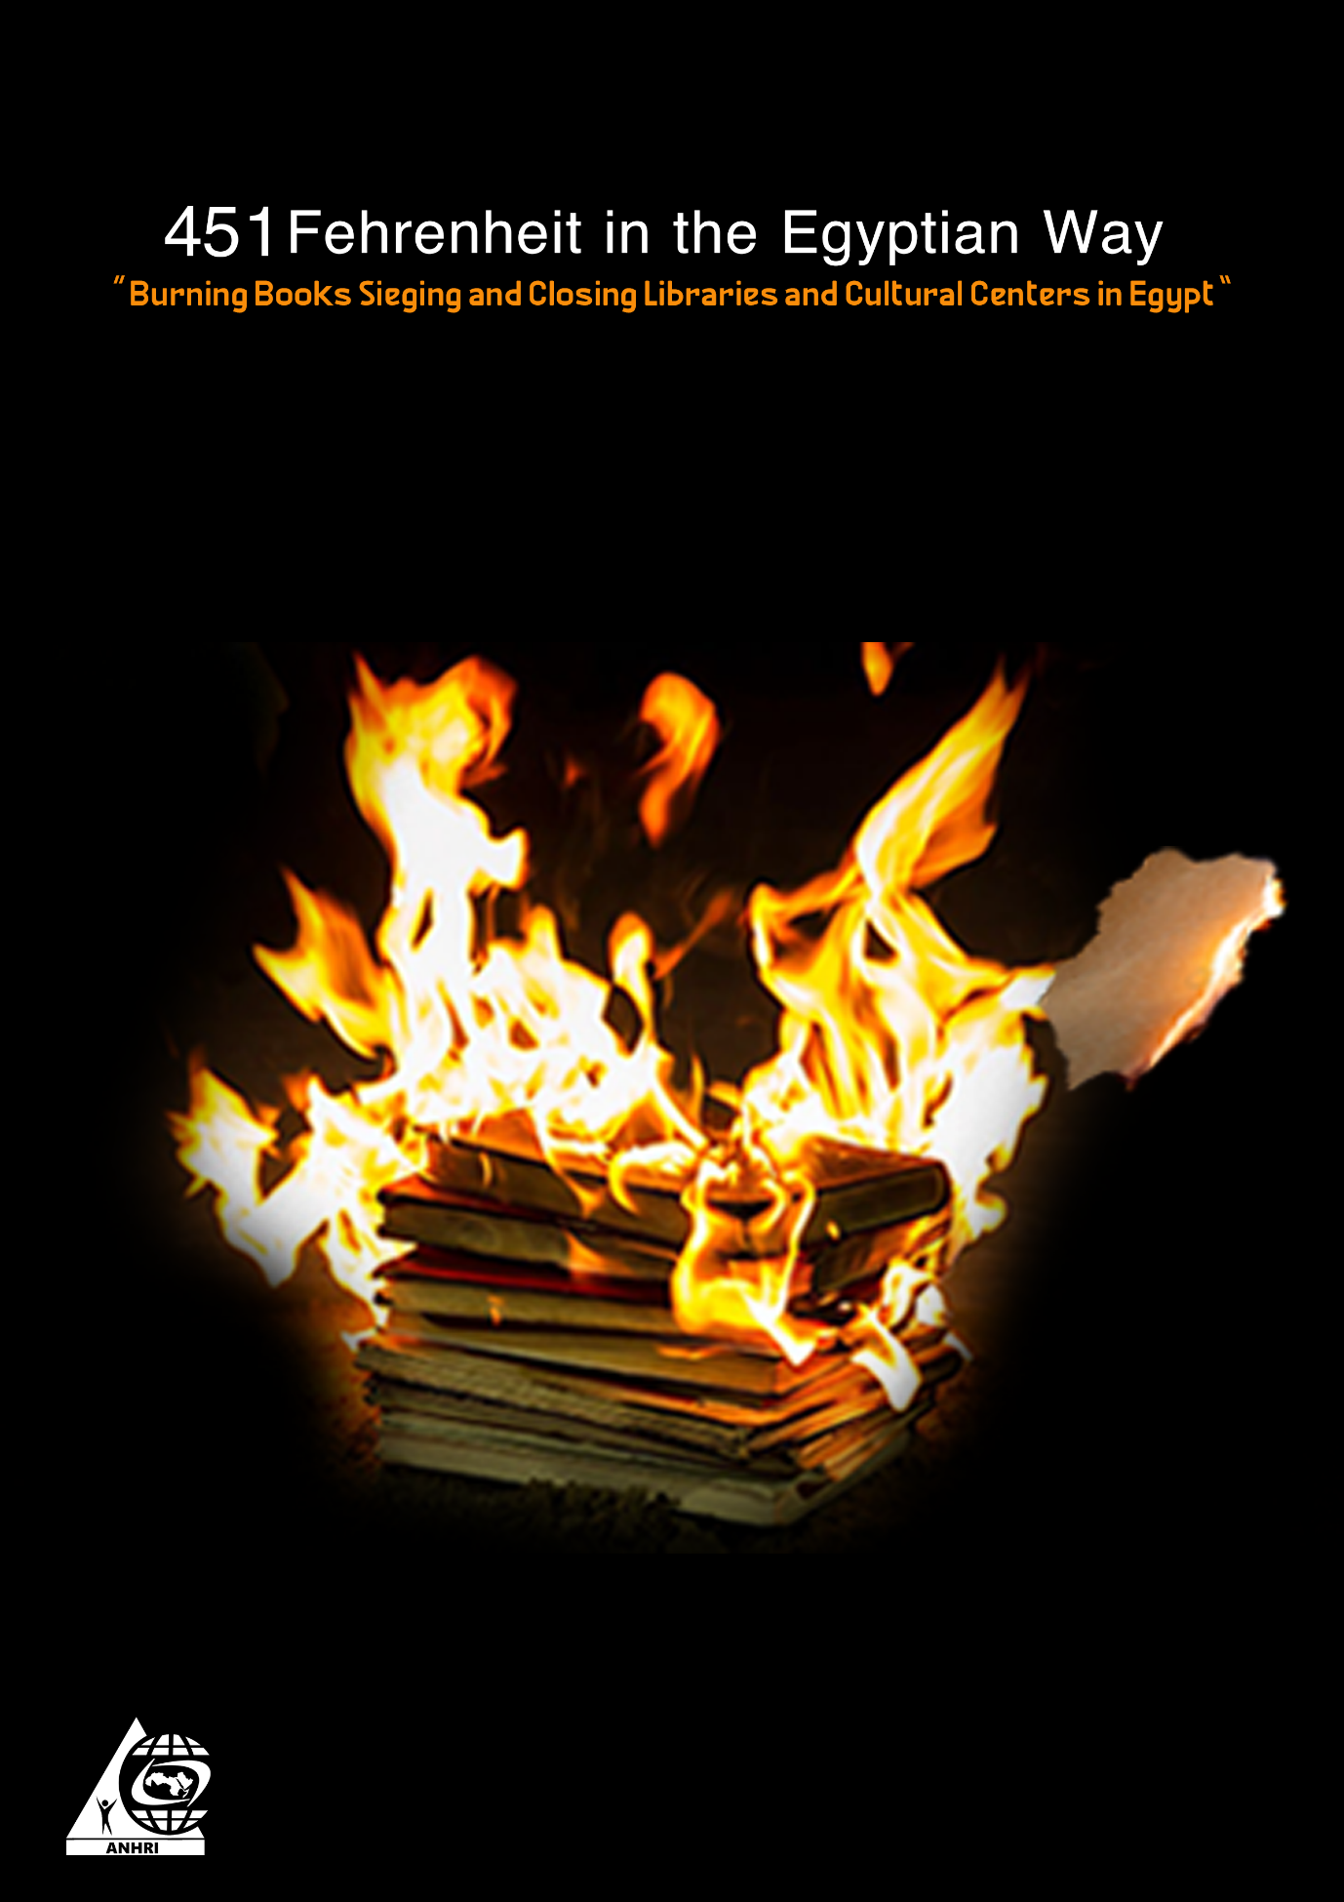

451 Fehrenheit in the Egyptian Way
“Burning Books Sieging and Closing Libraries and Cultural Centers in Egypt”

Preface

Proud of my job,,,,!
This was Dr. Bouthina Kesh, Director of the Directorate of Education and Under-Secretary of Giza Province, commenting on the fact that she burned dozens of books in the yard of Fadl Modern School, saying,
"The books that were burned call for extremism and violence and are not on the lists of education, I am proud to burn books that would have destroyed a child."
Her statements came during the controversy and the massive rejection campaign that followed the publication of a video in which she burns dozens of books in the yard of a school in 2015 for allegedly inciting terrorism and violence, in the yard of Fadl Modern School, carrying Egyptian Flag. Keshk was not punished, and She was not excluded from the teaching and educational corps. Burning books, just like the fictional 451 Fahrenheit novel, is already on the ground.
She was not just a mistaken citizen; she was in charge of a senior official position. The Government and the Ministry of Education did not react, she continued her work, and in 2018 she became Under-Secretary of Education of Kafr Al Sheikh.

Introduction:

Cultural life has returned to its path of growth, expansion and revival of cultural and artistic initiatives after the January 25 revolution, and many groups of society have come to know their way to frequent libraries, theaters and cultural palaces, after they almost disappeared in the years before the revolution.
Indeed, many citizens, intellectuals and youth initiated the establishment of libraries, cultural and artistic initiatives to provide educational, cultural and artistic services for the benefit of children, youth and families, not only in Cairo, but also in many cities and governorates in the north and south.
Most of them did it to restore cultural and artistic role in raising awareness, reviving societal memory, and in implementation of what was stated in the Egyptian constitution, Article 67, which states: "Freedom of artistic and literary creativity is guaranteed. The state is committed to promoting arts and literature, caring for creative people, protecting their creations, and providing the necessary means of encouragement for that ,,,,".
As well as what was encouraged by all international conventions, foremost of which is the Universal Declaration of Human Rights. But as in other rights, texts in Egypt are one thing, and reality is another.
The closure of libraries, centers and cultural initiatives has taken place and is under way, and it is equal in this to be civil initiatives and institutions owned and managed by citizens, private companies, or public institutions, owned by the state, or rather owned by the people.
Moreover, there is no difference between a theater, a library, a cultural forum or a publishing house, as the closure does not exclude anyone.
This report is an attempt to document and monitor the most important facts of the siege, closure, stopping, or demolition of cultural institutions that denote the hostility of the Egyptian authorities to culture.
We have taken care to complete the monitoring historically, starting from 2014 until the end of 2020.

Institutions and initiatives closed in 2014

1- Attempts to demolish Al-Arbaeen Theater
The establishment of Al Arbaeen Theater dates back to 1989 during the term of the former governor, Tahsin Shenan. Throughout the past years, the theater was known to be a haven for popular groups in the governorate.
The Society for Development in Suez issued a decision to remove the Al-Arbaeen Theater and give it to an investor to do his own project, and in a popular rejection of this decision, the youth responded to this decision and organized a protest on "March 6, 2014" in front of the theater, but the association actually tried to demolish the theater and the demolition equipment moved to the theater headquarters to start carrying out the demolition process, and they demolished parts of the inner parts of the theater, but the head of the Faisal neighborhood in Suez has stopped the demolition and has filed an official complaint on that, and the Public Prosecution has been slow to determine the fate of the theater, whether by stopping or continuing the demolition process, and it has not responded to the written complaint.
The governor of Suez stated at the time that the land had been withdrawn from the Society Development Association in Arbaeen, and that it would return to the governorate, which would rebuild a theater for the people of Suez in the same place.

2- Banning Al Fan Midan
Al Fan Midan is a cultural and artistic festival that has been held monthly since April 2, 2011 in the squares of Cairo and the governorates of Egypt as well, with the aim of spreading culture, arts and providing those artistic and creative services to the public free of charge.
The festival depended on the volunteer efforts of the organizers, the most prominent of whom was the great poet Zein El Abedin Fouad and donations from individuals and institutions, but the beneficiaries of this service and its fans were suspended in 2014 that the celebration was banned in Abdin Square in Cairo, and the ban came by security officials at Abdin Palace belonging to the Presidency, as well as the Ministry of Interior, and since August, specifically after the speech of Dr. Ahmed Harara on of the most prominent symbols of the January 25 revolution, in which he criticized the current regime on stage before 4000 attendants, pressures continued on the organizers, the cancellations continued, and the last activity of Al Fan Midan was in October 2014, since that date and till now the ban has been continuing.

Siege and closure of cultural institutions in 2015

- Townhouse Gallery and Rawabet Theater:
Townhouse is a non-profit institution whose goal is to spread culture in all its forms. It originated in a building established since the end of the nineteenth century, and depends on cooperation with European cultural institutions. The Townhouse Gallery had a valuable library with a number of Arab and foreign books dealing with different cultural topics.
It used to provide a space for arts and crafts, and it would host cultural performances and exhibitions by independent Egyptian artists within its theater, "Rawabet Theater".
However, in December 2015, a police force within several bodies, including the "Commission for the Control of Artistic Works, the Tax Authority, and National Security," closed the Townhouse Gallery and detained some of its employees. They were released after that, but it remained closed.

- Mirette Publishing House

Meritte is an Egyptian publishing house that was established on the initiative of its founder Muhammad Hashim in 1998 and was a haven for intellectuals. Many seminars and cultural and artistic discussions were held there with writers and artists, among the most prominent writers: "Alaa Al-Aswany and the poet Mustafa Ibrahim". One of the most important roles of the house was to encourage young writers by publishing their works and trying to develop their skills, and raising the ceiling for freedom of thought and expression.
In the same period that witnessed the closure of the "Town House" Gallery and the Rawabet Theater, security forces stormed the "Mirette" publishing house owned Muhammad Hashim and closed it. This prompted the Arabic Network for Human Rights Information to describe this attack with government panic that the anniversary of the January revolution is approaching, as the security attack came in December 2015, and a few weeks before the anniversary of the January revolution. While Meritte House has returned to work after the attack, the closure of its Town Hall Gallery and Rawabet Theater continues.

- The demolition of Al-Abd theater :
In April 2015, the Al-Bawaba website, which is close to the Egyptian government, published, “The decision of demolishing Al-Abd archaeological theater in preparation for building a huge residential tower for the wealthy only in Alexandria sparked a wave of anger among citizens”.
The archaeological theater dates back to the Hellenistic era, but this did not intercede for it among the influential people who wanted to demolish it to build the residential tower in Camp Caesar area directly on the sea. The presence of antiquities at the theater headquarters goes back two years ago, and dates back to the end of the Roman era and the beginning of the Hellenistic era, and the monuments in this headquarters are unparalleled throughout history, as it includes the largest Roman cemetery in history.
Despite the conflicting statements and the lack of transparency, as state officials claimed that the theater did not contain antiquities inside it, the newspaper Al-Youm Al-Sabea, which is also a newspaper close to the security services, published that the demolition of the theater represents a disaster as it is full of relics, but the matter has not changed and the theater has already been demolished along with the cemetery and both have no trace now.
2016

6 - Demolishing Assalam Theater in Alexandria
When you write on Internet search engines "demolishing the theater of peace", you will be surprised by anger and sadness felt not only the intellectuals and those concerned with art and culture, but also citizens of Alexandria and elsewhere, as a result of the demolition of this theater, which was considered one of the cultural lighthouses in Alexandria, to be demolished and erect a hotel instead !.
The theater was established in 1954 in Alexandria and was more like a cultural beacon for art and creativity, and the citizens of Alexandria considered it one of the most important artistic forums and a symbol of culture and art.
It witnessed many performances that were held on its stage,
such as the famous operetta "Al Leila Al Kebira" and others. However, in mid-2016, it was demolished instead of restoring and taking care of it, with the aim of establishing a tourist hotel on its site, and the broad campaign of intellectuals and citizens did not succeed in saving it, so we lost one of the most important symbols of culture and art in Egypt.

7- Police Closure of Al Karama Library Chain "6 Libraries"
In November of 2011, the human rights lawyer "Gamal Eid" was awarded the Defender of Human Dignity Award in the German capital "Berlin", which allowed him to achieve a dream, which was to open public libraries in the popular neighborhoods in which he has grown up.
Indeed, he embarked on the realization of this dream, and the first branches of public libraries were established in May 2012 in the Dar al-Salam district in Cairo, followed by the opening of five other libraries in Tora, Bulaq Dakrur, Khanka, Zagazig, and Ein Sira.
The libraries worked and succeeded in attracting children, youth and people of these neighborhoods to reading and arts, but this did not help, as the security forces began storming and closing them one by one, starting from December 2016 until they were totally closed.
The police General who stormed the Dar al-Salam library did not hesitate to expel and remove about 20 children from the library who were performing a collective song in order to close it.
There was no judicial decision, there was no violation, there were no legal reasons for the closure, only revenge against its founder, the human rights lawyer, and hatred for knowledge, awareness and culture.
Many intellectuals, citizens, and people have appealed to the officials and the Interior to keep Al Karama's libraries away from their dispute with Gamal Eid, to no avail.
A campaign was launched under the title "No to closing Al Karama libraries" to clarify that in closing the libraries it is the people and the poor children who are going to suffer and not Gamal Eid, to no avail.
Egypt’s candidate for UNESCO, Moshira Khattab, after pressure, visited the libraries and praised it, but she colluded after that and claimed that there is a case! And she knows that there is no case, only a police measure.
Libraries continued to be closed, and Moshira Khattab failed to secure a position at UNESCO. President Sisi himself was resorted to, but he did not do justice to the knowledge, the poor people, or the libraries. All Al Karama public libraries are closed.

2017

8- Closure Yarmouk library and throwing books on the street
Yarmouk Library is located in the Sharq district in Port Said Governorate, and it contains thousands of diverse books. The library serves not only the neighborhood, but also the whole governerate.
The headquarters of the library that Dr. Hamed Siraj rents is owned by a state-owned public sector company, but this did not protect or help to prevent the books from being thrown into the street, some of which are more than a hundred years old, as they were thrown into the street.
Police tell him that the library was confiscated for not paying the arrears, and the forces humiliatedly threw books, some more than 100 years old, onto the sidewalk.
Dr. Hamed denounced the state’s dealings with his library that helps readers, and among his words: “If the whole state focuses its efforts on combating terrorism, why do we forget that culture is an essential component of anti-terrorism? When I am a safety valve against terrorism and the state breaks me down, then there is something wrong, "the library has been closed until now and since 2017.

9 - Attempts to close the Academic Excellence and 6th of October libraries in Port Said

The Academic Excellence Libraries and the 6th of October “belonging to the palaces of culture” represent an important cultural destination and platform for all audiences and citizens of Port Said Governorate, as they provide borrowing and reading services, and a destination for school and university
students, and all those interested in culture, literature and art. Surprisingly, the Governor of Port Said, Major General Adel Ghadhban, issued a decision in October 2016 to evacuate the two libraries without providing an alternative to them, instead of developing them and improving their conditions, which alarmed the people, intellectuals and students in Port Said against this decision.
So that their fate would not the fate of books being dumped in the street, as happened at Yarmouk Library. The campaign was partly successful, as the two libraries are still standing until now after the intellectuals and the people rejected the decision. However, the fears did not disappear, as the stalking continues to try to close them.

10- Al Balad Library
A cultural place that provided cultural services to youth, writers and intellectuals, and it hosts creative training workshops. Al-Balad Library is located in midtown, Cairo, and its founder is Farid Zahran, head of the Egyptian Democratic Party.
In September 2017, forces closed the Al-Balad library and confiscated the books, furniture and contents of the library and detained two workers, including its director. At the time, Adel Al-Masry, head of the Egyptian Publishers Union justified the decision to close the library by saying that it was closed as a result of not obtaining a license to operate, while the forces that moved to the library and closed it not only closed but arrested two of the library workers, including its director.
The library continued to be closed for several years, until last January 2021, when a large number of young people interested in culture and from the library audience received the news of the library returning to work and receiving its audience again, starting on February 1, 2021, with a warm welcome.

2019

11 - Closure of all "Alef" Library Series (37 libraries)
Alef Library began to work and spread since 2009, and the library includes 37 branches in 10 governorates in the Arab Republic of Egypt and owns a branch in the United Kingdom, and the library is an independent cultural platform that is not affiliated with any religious or political party and is characterized by cultural diversity as it owns many literary, historical, religious and political books.
The library deals with more than 400 publishing houses and employs a large number of Egyptians, and it is owned by the prominent economic analyst Omar El-Shenety.
In August 2017, the Committee for the Conservation of Muslim Brotherhood Funds decided to seize the Arab International Company for Commercial Agencies, owned by Omar Muhammad Sharif Mustafa Ahmed Al-Sheniti and the owner of the "Alef" library, according to a statement issued by the committee, and this reservation is represented in the appointment of administrative and financial observers by the committee to monitor the administrative and financial performance of the company, according to the statement of the Alef libraries management.
After a two-year siege, the library and its 37 branches were completely closed in December 2019, and the library completely stopped working and the closure continues to this day.
The government did not sufficed by the decision of reservation and closure, but Omar Al-Shaniti, a prominent economic analyst and the owner of the library, was arrested from his home on June 25, 2019, and he was investigated and remanded in custody pending the investigations conducted by the Supreme State Security Prosecution in Case No. 930 of 2019, the High State Security Survey, which is known in the media, with the "Alliance of Hope", claiming that he was accused of "participating in a terrorist group in achieving its objectives," and "publishing false news and statements with the intent to undermine confidence in state institutions," and is still under pretrial detention until now, without announcing the identity of the terrorist group he is alleged to have joined, prosecuted, or released.

12- Attempts to demolish the Balloon Theater and the National Circus to sell their lands

The establishment of the National Circus dates back to 1966, and since its inauguration, it presents its performances, folklore and performing arts under the supervision of the Ministry of Culture at the Nile bank in Agouza.
As for the Balloon theater, it was established since 1962 with the support of the dean of the Egyptian theater, Youssef Wahbi, and there were performances in the Reda Dancing Band for Folk Art, the Cairo Dance Group, and the Lebanese Al-Anwar Band, and the musical and showcasing performances continued.
In 2019, parliament member Nashwi al-Deeb, submitted a proposal to the People's Assembly, to transfer the Balloon Theater and the National Circus from the Agouza area, and to exploit the land in other projects, and this proposal was completely rejected by Egyptian intellectuals and artists, and they declared their rejection of this deal in a statement bearing several signatures.
Despite this rejection and the continuing activity and work of theater and circus, however, many intellectuals fear that this door will not be closed and that attempts to seize the two distinct sites of the circus and theater will continue to be replaced by investment or tourism projects instead of culture and creativity.

Conclusion and recommendations:

We monitored the closure and demolition of 50 libraries, theaters and cultural initiatives completely during 7 years, from 2014 until 2020 (Al Arbaeen Theater, Al Fan Midan, Townhouse Gallery, Rawabet Theater, Al-Abd Theater, Al-Salam Theater, 6 Al Karama Public Libraries, Yarmouk Library, 37 Alef Libraries) and the siege and threat to close 5 libraries and cultural houses (Meritte Publishing House, Library of Academic Excellence, 6th of October Library, Al-Balad Library, Al-Balloon Theater). While the state claims that human rights are not only civil and political freedoms, but rather education and health, its position on closing these cultural institutions clarifies, apart from statements, the truth of its position on the role of culture and education. The state implements policies of closure, demolition and siege of theaters, libraries and cultural outlets, by more than 7 institutions per year. Those are the numbers. Attractive statements and constitutional articles are one thing, and the reality is something different and contradictory to it.

Recommendations:
- Minister of Culture:
It is the duty of the ministry to strive to provide cultural outlets that include many artistic, cultural and intellectual seminars, to respond to freedom of creativity and harmony with new and contemporary ideas, and to satisfy all tastes and opinions, and to perform its part to support intellectuals.

- Intellectuals:
It is the duty of every intellectual to be a product of his/her society, to maintain his/her identity and credibility, and to have a real and deep knowledge of the social and psychological structure of society in order to enable him/her to play an effective role towards spreading culture.

- Civil Society
- Civil society institutions to establish committees to defend culture and awareness in Egypt, whose role is to expose and announce the rejection of any violation of intellectuals and cultural outlets.
- To monitor and document violations of the right to culture and education, to uncover the facts in light of the prevailing media blackout, and to offer initiatives to develop cultural roles.

- Parties
- Pressuring and demanding state institutions to stop the violations committed against intellectuals and cultural roles, and to present initiatives to develop them. As well as mobilizing their deputies in Parliament to try to enact new legislation that would serve the Egyptian culture and protect the already remaining cultural roles.

Mont Carlo International, 17 April2015, browsing 7 January 2021 ، https://www.mc-doualiya.com/articles/20150417-%D9%85%D8%B5%D8%B1-%D9%81%D9%8A%D8%AF%D9%8A%D9%88-%D8%AD%D8%B1%D9%82-%D8%A7%D9%84%D9%83%D8%AA%D8%A8-%D8%A7%D9%84%D8%AC%D9%8A%D8%B2%D8%A9-%D8%A8%D8%AB%D9%86%D9%8A%D8%A9-%D9%83%D8%B4%D9%83-%D8%AC%D8%AF%D9%84
Al-Masry Al-Youm, December 29, 2015, browsing January 2021 https://www.almasryalyoum.com/news/details/864773
Al Bawaba site on April 19, 2015, accessed January 2021 https://www.albawabhnews.com/1242228
Al Youm Al Sabae, April 18 2015, browsing January 2021 https://www.youm7.com/story/2015/4/18/%D8%A8%D8%A7%D9%84%D8%B5%D9%88%D8%B1-%D9%83%D8%A7%D8%B1%D8%AB%D8%A9-%D9%87%D8%AF%D9%85-%D9%88%D8%AA%D8%AF%D9%85%D9%8A%D8%B1-%D9%85%D8%B3%D8%B1%D8%AD-%D8%A7%D9%84%D8%B9%D8%A8%D8%AF-%D8%A7%D9%84%D8%A3%D8%AB%D8%B1%D9%89-%D8%A8%D8%A7%D9%84%D8%A5%D8%B3%D9%83%D9%86%D8%AF%D8%B1%D9%8A%D8%A9/2145887
Al Watan, 15th June 2016, browsed: January 2021 https://www.elwatannews.com/news/details/1226842
Masrawy website, October 5, 2017, browsing January 2021 https://www.masrawy.com/news/news_regions/details/2017/10/5/1166731/%D8%AA%D8%B6%D9%85-%D9%83%D8%AA%D8%A8%D8%A7-%D8%B9%D9%85%D8%B1%D9%87%D8%A7-150-%D8%B9%D8%A7%D9%85%D8%A7-%D9%85%D9%83%D8%AA%D8%A8%D8%A9-%D8%A7%D9%84%D9%8A%D8%B1%D9%85%D9%88%D9%83-%D8%AA%D9%86%D8%AA%D8%B8%D8%B1-%D8%AE%D9%88%D8%B3%D9%8A%D9%87-%D8%A3%D9%84%D8%A8%D8%B1%D8%AA%D9%88-%D9%84%D8%A5%D9%86%D9%82%D8%A7%D8%B0%D9%87%D8%A7
2021 Facebook, Al Balad Liberary pate, 28th January 2021, browsed January 2121 https://www.facebook.com/elbaladbookstore/photos/a.448353625209973/4092195700825729/
Masrawy site, 21st Aucugst 2017, browsed January 2021 https://www.masrawy.com/news/news_egypt/details/2017/8/21/1141342/%D9%85%D9%83%D8%AA%D8%A8%D8%A9-%D8%A3-%D8%AA%D8%A4%D9%83%D8%AF-%D8%A7%D9%84%D8%AA%D8%AD%D9%81%D8%B8-%D8%B9%D9%84%D9%89-%D8%A3%D9%85%D9%88%D8%A7%D9%84%D9%87%D8%A7-%D9%81%D9%8A-%D8%A8%D9%8A%D8%A7%D9%86-%D8%B1%D8%B3%D9%85%D9%8A

