The Arabic Network for Human Rights Information (ANRHI)
Freedom of expression for social and labor movements program

Labor and professional protests index during July 2018
Introduction:

A state of shock has dominated the Egyptian society during July after a video going viral caught by the surveillance camera in Mary Gerges metro station for a young woman in her 20’s throwing herself in front of the metro train on July 1st, hitting and killing her immediately.
Also at the same day, Ayman E. who is a police cadet from the forces securing Tora, under Cairo security directorate, tried to commit suicide by throwing himself on the same rails at the Shohada metro station, after running into some work and family issues.

The same scene has been repeated several time during this month, as a young man tried to kill himself on July 20th by throwing himself a few meters away from the line-1 metro train while going to Ghamra metro station-Helwan direction, which made the driver use the emmergency breaks, and the police forces came afterwards to pick up the unconscious young man from beneath the train.

Train no. 119 was ambushed while entering Marg Qadima station with a young man throwing himself in front of it on July 22nd which lead to running him over and killing him immediately.
A young man in his 30’s also killed himself by throwing himself in front of the metro train at Orabi station on July 30th.

Such repeated sad incidents are grounds for a social and psychological study to understand what makes young people at the beginning of their lives, kill themselves in such a dramatic way.
Throwing themselves in front of metro stations was not the only method of suicide on the background of poor social and economic situation, as the number of suicide cases has significantly increased, after the shock of the consecutive increases in the prices of petroleum, gas, and electricity, that lead to the increase of prices of all goods and services, which a lot of social sectors are no longer capable of keeping up with, especially while the economic situation has been deteriorating already.

The program monitored 53 protests this month, of which 18 were labor and professional while 35 were social, briefed as follows:

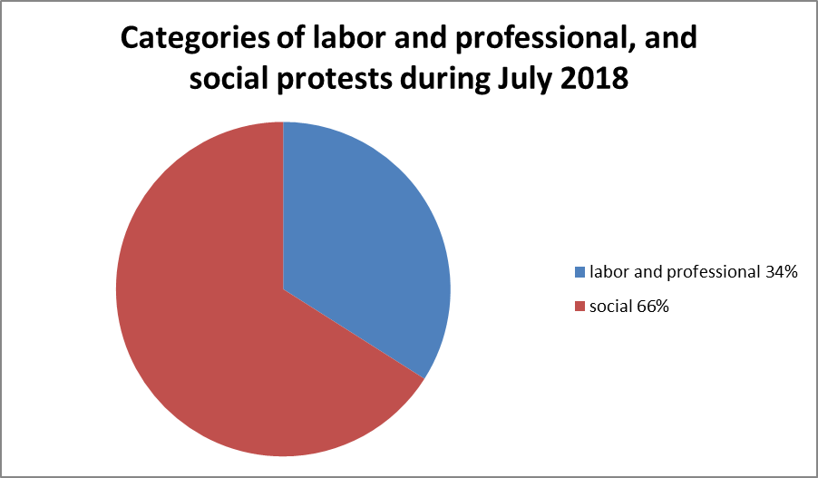

- Labor and Professional Protests:

The program monitored 18 labor and professional protests during July, detailed as follows:
- Strike to work: 9 cases.
- Hunger strike: 3 cases
- Vigil: 3 cases.
- Threatening to protest: 2 cases
- Sit-in: 1 case.
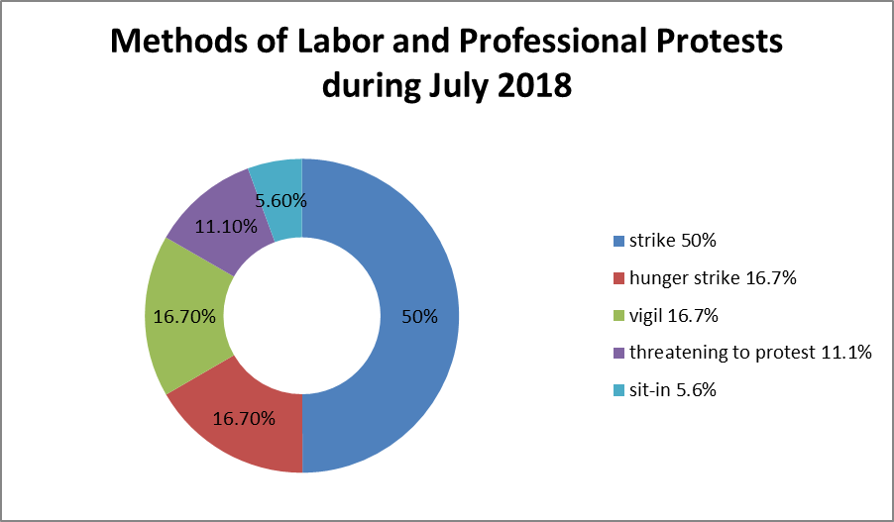

Detailed as follows:

- Striking to Work:

The striking to work came first among all the labor and professional protests in July with 9 cases:
- The workers of Salhia Company for Investment, Development and Agricultural Reclamation in Sharqia entered into an open strike on Sunday July 15th in protest against the non-payment of the bonuses approved by the President of the Republic and manipulating them by the administration by approving the bonuses, then striking them back. The workers ended their strike the next morning after company officials responded to their demands.
- On Friday July 15th, drivers of the scout cars in the village of Hessa Batoukh in Qalubia entered a strike to work for their desire to increase the price of the "shift" from L.E.50 to 70, which the citizens refused, so the drivers refrained from working.
- The drivers at the Mataana station in Esna, in the southern city of Luxor, staged a four-day strike which began on July 9th and ended on July 12th, so cars and buses belonging to Luxor traffic were used by the city council of Esna and charities to transport the citizens to their places. Dozens of car drivers for "El-Farsia, Naja-Abu Humaid, Al-Nawasser, Asfun, Tanfis, Al-Kaiman and other villages"lines, entered a strike to work, and stoped the transfer of citizens in all the villages and towns mentioned above.
- Taxi drivers on the Shubrakhit-Fernawi line in the Shubrakhit district of Beheira entered on Wednesday July 11th in a strike to work and loaded passengers, wanting to increase the ride tariff, causing passengers to accumulate in the village of Mahalla Farnawi and disrupt their errands.
- The drivers of Mahalla ​​Damnah in a strike on Monday July 2nd, in protest against the new tariff for passenger transport. The security services intervened, and issued infractions for the drivers, while mass transfer vehicles and private clubs vehicles were used to meet the needs of people to go to their homes and workplaces.
- On Monday morning July 2nd, the drivers of the Tanah-Mansoura line in Daqahlia entered a strike protesting the new tariff, demanding an increase, refusing to load the passengers while a number of them attempted to block the road, preventing any other vehicles from loading passengers. The security and local authorities intervened with mass transit buses, Mansoura Stadium buses, private buses and minibuses were used to meet the drivers' strike. The necessary measures were also made to prevent the drivers from blocking the road.
- Dozens of drivers of the "Al-Mahalla Al-Kubra" line stopped working and refrained from loading the passengers on the morning of July 3rd, announcing that they had stopped until the taxi tariff be raised and unified, leading to the accumulation of citizens on the road and the disruption of traffic. The drivers returned to work until their demands were discussed.
- Dozens of taxi drivers organized at Tamiya station in Fayoum, on Sunday, July 15th, a strike to demand a higher tariff for the ride. This resulted in overcrowding among passengers who did not find cars to transport them to Tamiya and vice versa, forcing them to use cars from other centers. Security forces arrested 7 drivers and car owners on July 17th, while the necessary records were released against them and they were referred to the prosecution, which decided to detain them for interrogation, and a decision was also made to remove their cars from the stations department and to withdraw and cancel their licenses, whether driving or steering.
- The drivers of Tukh-Shebin al-Qanater started a strike on the morning of July 2nd, and the drivers refused to load the passengers, leading to the congestion of citizens and passengers on the road.

- Hunger Strike:

July witnessed 3 cases of hunger strike:
- Mohammad Soliman, a lawyer in the national institute for sea sciences in Alexandria, entered a hunger strike on July 22nd because of the issuance of a decision transfer him to Suez. The lawyer union and legal departments have stood in solidarity with the lawyer.
- Ibrahim Mohammad, an employee in South Delta Electricity Company in Gharbia, entered an open sit-in and a hunger strike on July 8th, in the company’s branch in Mahalla Kubra, protesting the arbitrary transfer. The head of the company ordered the necessity of investigating the decision to punish the employee for his sit-in.
- 5 technicians from the sewage station in Abu Qurqas, Menia, entered a strike from food, water and medication on July 18th, inside Fekria central hospital, after issuing arbitrary fines and transfer decisions to Diramous, Adwa, Maghagha and Matay centers that are far from where they live. Menia governor intervened and ordered the head of the water and sewage company to hold a meeting with those in the hunger strike to listen to them and end this problem with a radical solution.
- Vigil:

July witnessed 3 cases of vigils:
- Dozens of employees in the Art Academy, gathered in a vigil on July 10th against what they had called “the financial corruption in the academy”, and demanded the dismissal of the General Assembly of the Workers' Fund of the Academy.
- A number of employees in the drinking water and Sewage Company in Qena organized a vigil on July 18th in front of the company’s headquarters in Qena, protesting not increasing the incentive to 200% and only increasing the main salary without the special incentive. The head of the board of directors met the protestors and listened to their demands.
- A number of employees in Cinema city organized a vigil on July 18th because the arbitration of the administration and shifting them from law no. 203 in 1999 sector-1 public work, to law no. 81 in 2017 of civil service.

- Threatening to protest:

July witnessed 2 cases of threatening to protest
- The employees of Sono Cairo Company, threatened to organize a vigil objecting decreasing their salaries by more than L.E. 650 of their main salary after transferring them to the national authority of media and distributing them to different sectors.
- Workers in the Iron and Steel Company threatened to enter a strike to work on July 3rd in protest against the decision of the Chairman of the Company, the dismissal of the President of the Iron and Steel Company Eng. Sami Abdul Rahman from his office without clear reasons, and the assignment of Abdelati Saleh Abdelatti Karim, head of the workshops production and maintenance company, to serve as Chairman of the Board and Managing Director.

- Sit-in:

July witnessed one case of sit-in:
A number of journalists in Al-Osbou newspaper, had a sit-in on July 11th demanding the structuring of their wages and providing an environment suitable for work in which the most basic human and professional conditions are met, in addition to their right to promotion.
- Social Protests:

The program monitored 35 social protests during July, distributed as follows:
- Suicide: 13 cases
- Vigils: 6 cases
- Threatening to protest and strike: 3 cases
- Suicide attempts, sit-in, and gathering: 2 cases each.
- Strike, striking to accept services, protesting, blocking the roads: 1 case each.

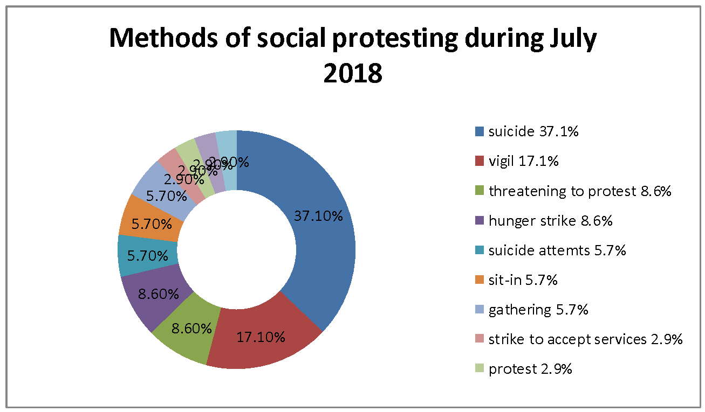

Broken down as follows:
- Suicide for Economic Reasons:

Economic suicide came at the top of the social protests in July with 13 cases that have already occurred, in addition to attempts, summarized in:

- G. A.E., 56, a resident of Karamoz center, in the intensive care unit at Fatima Al-Zahraa Hospital, in Al-Dekheila, killed himself by jumping from the hospital's intensive care room on July 1st due to the high costs of his treatment while his progress was slow and him not feeling getting any better.
- Reda B., a 12 years old 6th grade student and resident of the village of Shtet al-An'am in the district of Itay al-Baroud police station in Beheira, committed suicide on July 13th because his parents pressed him to go to the carpentry workshop of his uncle, and police report no. 8252 was issued by the director of the Itay El Baroud police station.
- Hany K., a 32 years old worker and resident of the village of Al-Bagalat, Minya Al-Nasr police station, committed suicide on July 10th by taking a chemical tablet used for grain keeping, after going through a bad psychological condition because his relatives wanted to sell the family's house and his financial inability to buy it.
- Mohammed, 18, was a garbage collector in the village of Badawi, Mansoura police station. He was killed on July 23 after he committed suicide by hanging in a psychological crisis because of financial distress.
- The bodybuilding coach, Hassan, killed himself on Tuesday night July 17th because his gymnasium license was revoked, which was his only source of income.
- M. A 32 years old resident of the Suareya district of Abu Bakir, Sharqia, died of serious burns after he decided to set fire to his body on Sunday, July 1st, for failing to meet his family's financial requirements.
- Amira Yahia Mohammed, 20, committed suicide in front of the Metro train at Mary Gerges station on July 1st and after inquiry about the cause of the incident, it turned out that she was in a bad psychological condition.
- A young man at the beginning of the fourth decade of life, named "AM", committed suicide by hanging in Shorouq in New Cairo on July 2nd after learning that his wife was working as a house maid without his knowledge to help him manage his living and financial difficulties.
- A young Sudanese man in Maadi committed suicide by hanging on July 22nd after an accident two and a half years ago, during which he lost his sight and decided to get rid of his life because he could not afford to deal with the aftermath.
- Ashraf Mohammed Sayed Allahouni, 22, from the village of Fidimin of the Senors Center in Fayoum, died under the wheels of Train No. 119 at the Marg Qadema Station in line-1 of the metro while he was in Cairo on July 22nd to participate in a competition offered by the Ministry of Education.
- On July 13th, a worker named "A.AS." was killed at the Shebin El Koum police station, suffering from poisoning after eating a pill to save wheat.
- A.E.K.A., an 18 years old Tok Tok driver and a resident of the village of Beitanoun, Shebin El Koum, Menoufia, killed himself by hanging inside his bedroom, on July 17th, for his financial difficulties hindering him from completing his marriage.
- The residents of the village of Beahou in Samalut, Menia, found the body of a young man in his 30’s, in the Ibrahimia canal on July 11th. He was identified as "M.A." from the village of Itay al-Baroud in Beheira, holding an Azhar high school diploma, who had committed suicide by throwing himself into the water for failing to get a job in several governorates.

- Vigils:

July witnessed 6 vigils coming 2nd in July, as follows:
- Those who contracted on the housing units of the modern and contemporary marriage staged a protest in front of the Suez Governorate building on July 11th, demanding the handover of the units and ending their ongoing crisis of 2011. Special Forces were used after increasing the numbers at the vigil.
- The students of the fourth year of the Faculty of Commerce at Zagazig University on July 22nd organized a protest in front of the university building to protest the failure of 1200 students.
- On Monday July 16th, dozens of parents from STEM students organized a protest in front of the Cabinet to protest against the low success rate, which was only 56% in high school.
- On July 17th, dozens of fishermen organized a protest in the Abu Qir district of Alexandria, protesting the authorities' decision to ban sea fishing, claiming that it affected the fry.
- On July 28th, the residents of the Ashmoun Center in Menoufia, held a vigil at the regional road in the village of Dalhamou to protest against the neglect of those who set up the regional road to set up their own roadway serving about 8 villages.
- Hundreds of residents of the village of Ezbet al-Boussa of the center of Naga Hammadi, north of Qena, organized a protest against the appointment of a new mayor of the village who had come against the will of the people.

- Threatening to protest:

Threatening to protest came in third place with 3 cases:
- A number of members of the Journalists Syndicate decided to hold a silent protest at 6 pm on July 4TH , in protest against the draft law regulating press and information before the House of Representatives, and before the time the protest was cancelled.
- Al-Ahli club members on July 8th threatened to organize a protest inside the club to protest against some recent decisions, most notably a decision issued by Al Ahli club chairman Mahmoud Al-Khateeb for the players in some games to pay a fee of L.E.500 for sport bags, although not available.
- On Sunday July 15th, a number of graduates of the Aboridis Industrial High School for Petroleum Technology, in South Sinai, threatened to enter a hunger strike to meet their demands for appointment. The graduates had gathered in front of Abordis Hospital to meet the Governor of South Sinai during his visit to the hospital.

- Hunger Strike:

July witnessed three hunger strikes:
- The resident of the Khurshid districtin Dekheila-3 police station entered a hunger strike, on July 18th, inside the building of the Health Insurance Authority in Smouha in protest against postponing his competent consultant consultation until next October. Security services intervened and dealt with the complaint of the citizen, where the specialized consultant examined him, and the necessary treatment was given to him.
- Yassin M. A 54-year-old employee and resident of the village of "Meet Abu al-Hussein" Department of the center of Aga in Dakahlia province on July 5, about food and drink inside the Central Hospital of Aga, entered a strike in protest to his sister in law preventing him from building another floor in their house, and the investigation agents persuaded him to stop the strike.
- The detainee, Bilal al-Qallawi, went on a hunger strike after the director of 430 prison hospital in Al-Natroun district mocked his condition.

- Attempt to suicide:

July witnessed two suicide attempts:
- Shahat B. H., 46, a driver in the village of Bahut of the Nabruh district of Daqahlia, attempted to commit suicide on July 8TH by taking a poisonous tablet used in the preservation of the grain after passing through a financial crisis.
- Ayman A., a police secretary of the Cairo Security Directorate's security forces, attempted to commit suicide on July 1st by throwing himself at the bars at the Al-Shohada Metro station because he was suffering from problems in his work for some time, as well as family problems.

- sit-in:

July witnessed two sit-ins:
- On Monday, July 2nd, Dr. Hisham El-Badri, Professor of Public Law at the Faculty of Law, Menoufia University, held a sit-in on behalf of the Vice-President of the University, announcing his hunger strike after being referred to a disciplinary office for accusing him of stealing the scientific material from a professor.
- Employees of Petro-Sport company in 5th assembly entered a peaceful sit-in at their offices at the company's headquarters on July 8th, in order to demand correcting the situation after the departure of the company's president. The union's committee notified them about the peaceful sit-in at their offices at the company's headquarters.

- Gatherings:

July witnessed 2 cases:
- The Copts in Minbal village in Matai district of Menia governorate were attacked on the night of July 9th, when a number of militants gathered and threw stones at houses amidst shouting slogans, accusing a Christian in the village of publishing a link to an article they described as offensive to religions.
- A number of residents of the Masaken Al Mawaleh area in Benha and the family of the victim of the quarrel were gathered in front of the morgue of Banha Educational Hospital early on the morning of July 11th to demand the speedy completion of the burial procedure.

- Strike on receiving service

July witnessed one case of a strike on recieving services:
- Dozens of patients with renal failure stroked on their kidney dialysis sessions at the Edfu Hospital in Aswan on Tuesday July 10th, protesting the disruption of many machines and the lack of medical supplies endangering their lives. Patients responded to going through the sessions after issuing police records.

- Protests

July witnessed one case when:
- On Saturday July 14th, parents and families of 82 students at the literary department at the secondary school in Sohag protested against the decision of the Minister of Education to cancel the examination of their children at the Dar El-Salaam Preparatory School Committee and not to declare their results, claiming they had cheated. The Undersecretary of the Ministry of Education of the governorate went to the protesters and asked them to write petitions to the Minister of Education and sign them.

- Blocking the road

July witnessed one case when:
- On Tuesday July 31st, residents of al-Mataria governorate of Daqahlia prevented the death buses going to the investment factories in Port Said from traveling and preventing their children from going to them. The main gate of the city was closed because 11 workers were killed and more than 18 were injured in a collision on July 29th. The people called on the Minister of Investment and the Governor of Port Said to the rights of their children who have gone due to the tremendous speed on the roads and recklessness of transport drivers

- Strike:

This month witnessed one case when:
- About 120 taxi drivers in Arment, west of Luxor, went on strike on Monday July 30th from 8 am in protest against allowing cabod cars without plates to operate illegally.
- Geographical distribution of labor and professional protests:

Cairo governorate topped the labor and professional protests during July with 4 protests, while Daqahlia, Gharbia and Qalubia came second with two protests each. Governorates of Qena, Luxor, Alexandria, Beheira, Giza, Sharqia and Fayoum came in the third place with one protest each.

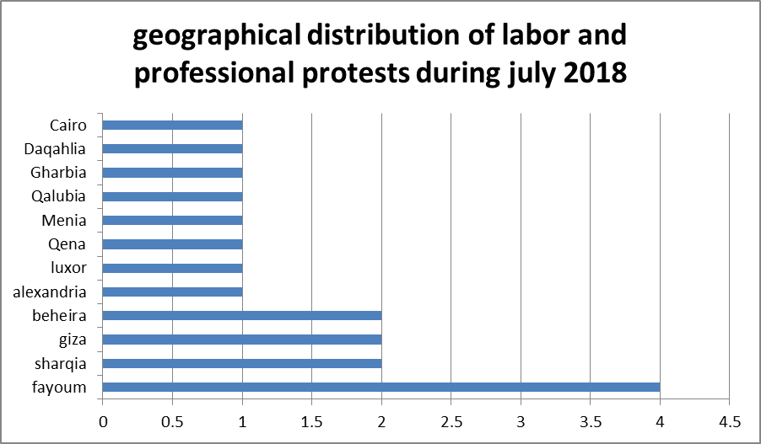
- geographical distribution of social protests:
Cairo also topped the social protests by 9 protests during the month of July, and Daqahlia came in second by 5 protests, while Menoufia in the third place with 4, Alexandria came in fourth place with 3, Suez, Sharqia and Menia in the fifth place with 2 each, and finally, the governorates of South Sinai, Sohag, Qena, Aswan, Luxor and Qalubia came in the sixth place with one protest each.

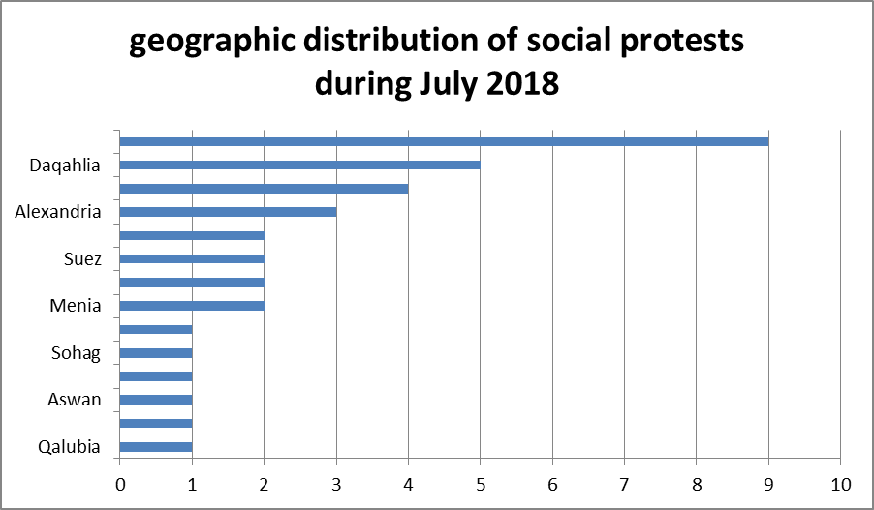

- Sectorial distribution of labor and professional protests:

The sector of transport topped in all sectors in terms of the number of labor and professional protests during the month of July by 7 protests.
In the second place came the water, sewage and electricity sector with 4 protests.
In the third place came the media, journalism, printing and publishing sector, and the employees sector with two labor protests.
The fourth and last place was occupied by sectors of agriculture, irrigation, fishing, lawyers, and the metal industry with one protest per sector. 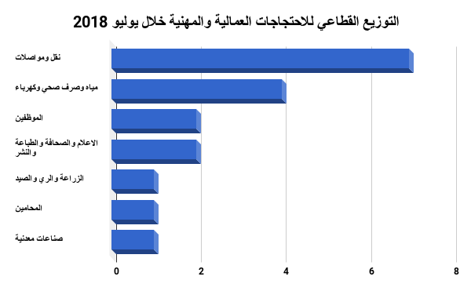
- Sectorial Distribution of Social Protests:

Suicide and attempt to suicide against the backdrop of poor living conditions topped all forms of social protest during the month of July with 15 suicides and attempts of suicide.
The local sector came in second place with 5 protests.
Education and scientific research came in the third place with 4 social protests this month.
Health came in fourth place with 3 protests.
In the fifth place came the sectors of sports and security with 2 protests each.
Transport, Housing, Media, Press, Printing, Publishing, Agriculture, Irrigation and Fishing sectors ranked sixth and last with one protest each.

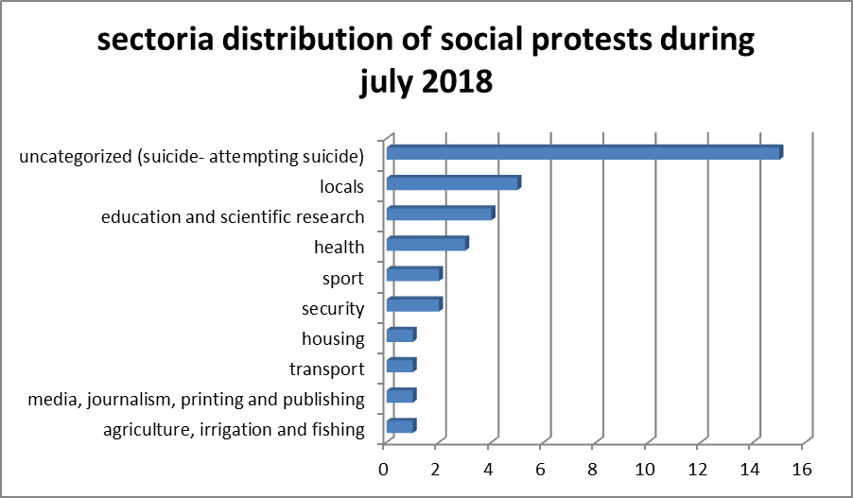
Thus, from the previous presentation, it’s obvious that:

- Suicide due to poor economic and social conditions still tops the list of methods to protest, with 15 suicide cases including two failed attempts.
- Cairo is still the first governorate where people express their opinions through the various methods of protesting.
This requires studying the phenomenon of suicide, with all its repercussions and causes, which puts the responsibility on researchers at specialized research centers, sociology professors, civil society organizations and parties to urge the state, its agencies and ministries to address this phenomenon in order to reduce or mitigate it to the least after responding to the legitimate demands of those who commit suicide by reducing unemployment, creating jobs and improving their living conditions.

The Arabic Network for Human Rights Information (ANHRI)
Program of Freedom of expression of workers and social movements

