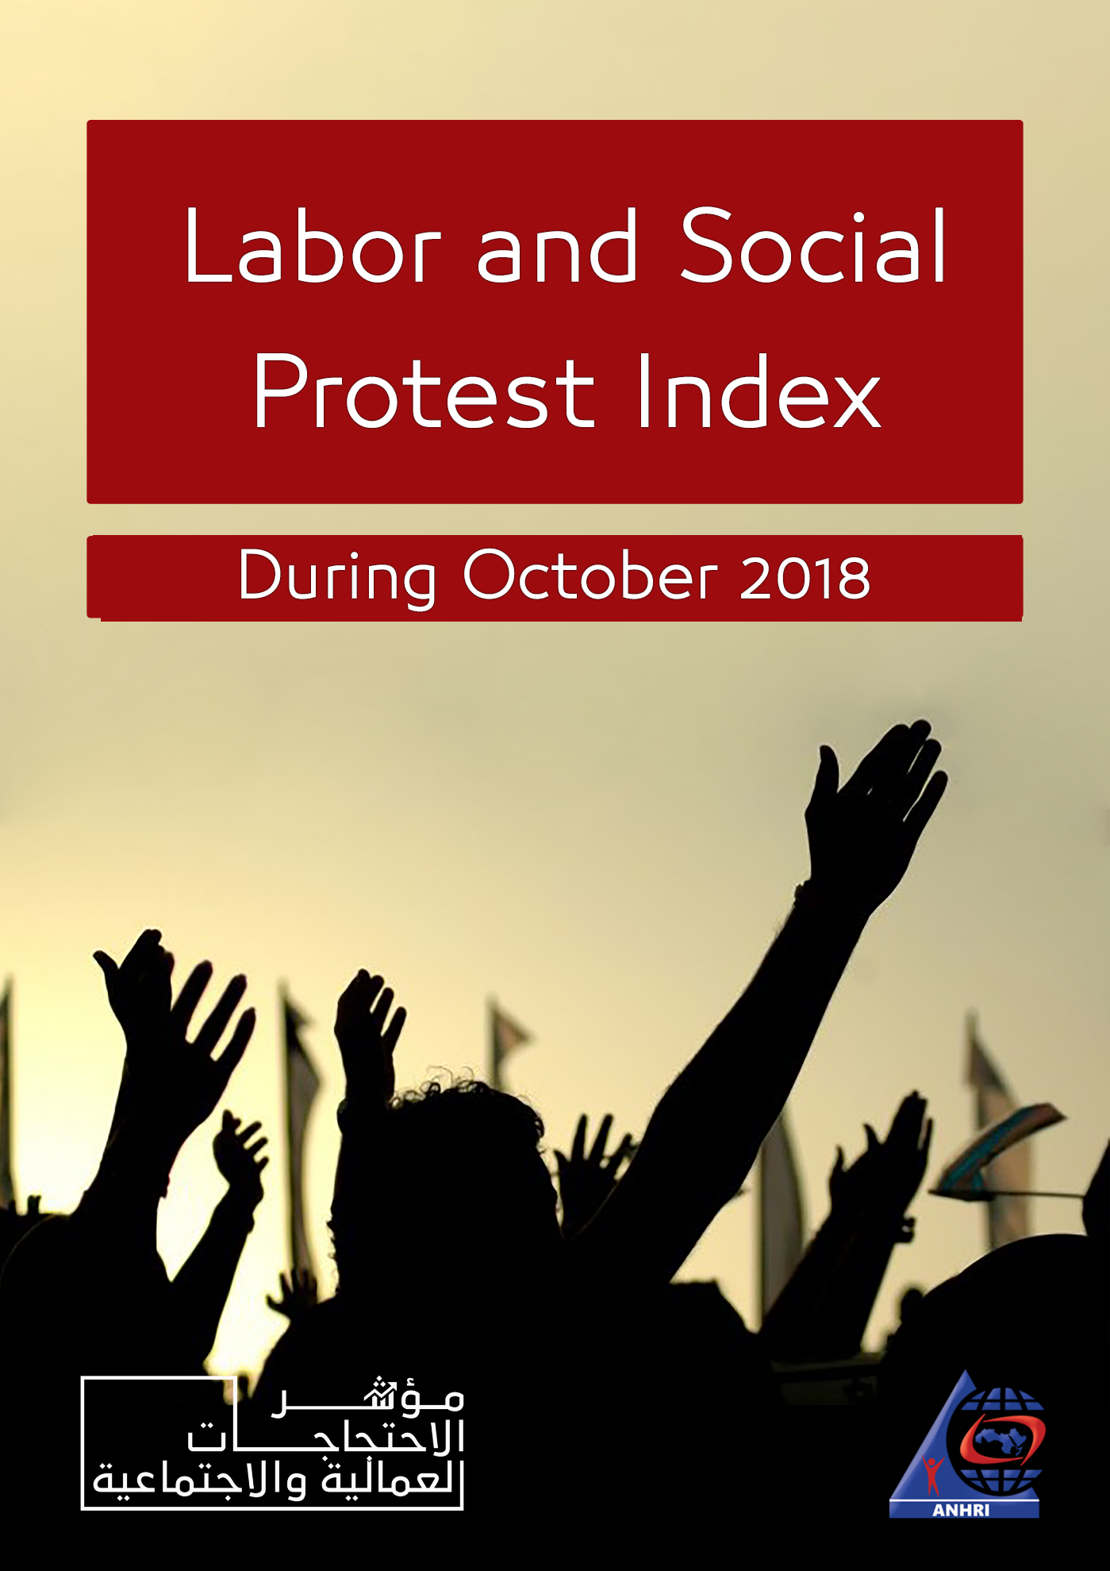

Arabic Network for Human Rights Information (ANHRI)
Freedom of expression of workers and social movements Program

Labor and Social Protest Index during October 2018

Introduction

The month of October witnessed 3 important events in the Egyptian protest movement, in terms of; the demands, the number of protesters, the duration, and the intensity of solidarity.
The first event was the sit-in of about 5000 workers in 6 f Unionaire factories, in solidarity with dozens of workers who had been dismissed from the company, in addition to protest against cancelling the incentives. The sit-in lasted for 8days and gained the solidarity of public figures and politicians until the workers decided to end it under pressure from the administration and threats of dismissal.

The second event was the protest of the workers of the Egyptian contracting company "Mukhtar Ibrahim" due to the non-payment of workers’ salaries for the months of August and September, and the importance of this event that the protest was in several governorates at the level of the Republic at the same time, and the continuation of the two-day stand, as well as the success of workers in the dismissal of Chairman of the company's board, and fulfilling some of their demands.

As for the third event, which was of no less significance, was the hunger-strike of both lawyers; Hammad al-Ghannam and Ashraf Said, in the dining room of the lawyer's office in Beheira, in protest against the intransigence of the judges in the retroactive application of VAT.
The protest also received wide support from Lawyers Syndicates of both South Giza and South-Valley, where the two unions decided to suspend the work before the first district court in the Delengat court.
The court suspended the work for more than a week until the meeting of the Beheira Lawyers’ Association, with the President of the Judges Club, and then the court counselors moved to the courtrooms.
The program monitored 60 protests during October, including 21 labor and professional protests, and 39 social protests, summarizes it as follows:

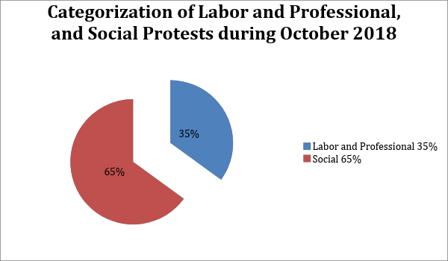
First: Labor and Professional Protests:

The program monitored 21 protests during October, distributed as follows:

- Strike to work: 6
- Hunger-strikes: 4
- Sit-in: 3
- Vigils: 3
- Protest-stands: 3
- Threats to protest: 1
- Petition or Complaint: 1

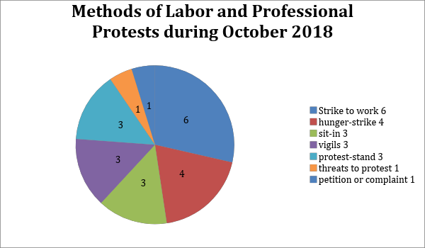
All of this is broken down as follows:

- Strike to Work:

The striking to work has come first among all the methods of the labor and professional protests during the month of October with six cases:

- The soccer players of Beni Suef Telephone Club, stroked to go to their training in early October, to demand the payment of arrears. The players held a meeting with company officials in Cairo on Oct. 9th and it was agreed that the company would transfer the players' dues to the club, to be paid on Wednesday Oct. 10th.
- Lawyers Association South Beheira decided on Oct. 15th on the suspension of work before the First District Court in the Delengat Court, in protest to what they had described as the abuse of judiciary with the Council of the Bar. Lawyers returned to work after a meeting between the Association of Lawyers of Beheira with the President of the Judges Club and the club's agent on Oct. 21st and counselors then moved to the courtrooms.
- The Southern Giza Bar Association decided on Oct. 15th, decided on the suspension of work before the First District Court of the Delengat Court, at the request of the General Assembly of the Court Counsel, because of what they had described as mistreatment of Judge Ahmed Al-Geaidi to lawyers and solidarity with their colleagues in Beheira.
- The workers of Cedar–Egypt entered a strike to work on Oct. 15th in protest at the change in the labor system, where the administration had increased the working hours to 12 instead of 8 hours, with the cancellation of the production incentive, according to the company workers. The company's management paid the first installment for the workers, who had requested a settlement, with 2 months for each year of service, by mutual consent and without recourse to the judiciary.
- Players of Shebin-Weaving club entered a strike on Oct. 23rd, because of the delayed payment of their salaries and not paying bonuses. Members of the team's technical team also presented a collective resignation letter of the team training, due to the decline in results, and not paying the dues and salaries of players, in the eighth group in the third section.
- Workers at the Muharram Bek garage, went on a strike, on Oct. 31st, in the new garage area in Alexandria for 3 hours, to protest the imprisonment of their colleague on murder charges as a collision had happened between the bus on which he worked and a private car, in Sidi Gabber area in Alexandria, insisting that their colleague was not in the bus at the time of collision.
- Hunger-Strikes:

Coming 2nd in term of methods of labor & professional protests during October, as follows:

- Ferial A., 46, the director of Martyr Omar Shaaban Qorshi Preparatory School in Sohag, went on hunger-strike, on Oct. 11th to protest the arbitrary transfer to the Department of Education. She was detained at the Central Hospital, and a record of the incident was issued; Administrative Gerga2018. She ended he strike later that day.
- The legal researcher at the Directorate of Education in Luxor; Ahmed Mousaed Mahmoud, entered a hunger strike on Saturday, Oct. 13th, in protest against the procrastination of Acting Undersecretary of the Ministry of Education in Luxor in carrying out its decision to transfer him to the Financial Directorate, and he later ended the strike that same day.
- Both lawyers; Hammad al-Ghannam and Ashraf Said, entered a hunger strike in the Delengat lawyer's office, on Oct. 13th after the intransigence of the Court in the retroactive application of VAT, the judge's mistreatment of lawyers, and banning them from attending hearings.
- The Director General in the health affairs of North Sinai entered a hunger strike on Oct. 18th, because of a decision to transfer him to the director of Legal Affairs, which he had described it as "arbitrary". He called on the Undersecretary to abandon his decision.

- Sit-in:
October witnessed 3 sit-ins by dozens to thousands of citizens as follows:

- 70 employees at the Public Taxation Office in Nozha, participated in a sit-in for several hours, on Oct. 4th, inside the Senior Contractors Building, because of their objections to their transfer to the mission of tourist taxes, without giving justifications from the Head of the Tax Authority.
- About 5,000 workers at Unionaire Company, entered a sit-in on Oct. 17th, in the 3rd industrial zone on 6th of October city, against the administration decision to terminate dozens of workers and cancel the incentives. Security forces surrounded the company building in order to pressure the workers to end the sit-in, but it lasted for about 8 days and was joined by the workers at "Petrogaz" factory. The sit-in ended without reaching a satisfactory agreement, under pressure from the administration and termination threats.
- Dozens of journalists from Al-Alam Al-Youm newspaper, entered a sit-in on Oct. 20th in the headquarters of the Journalists Syndicate, after the announcement of the liquidation of the company that owns the newspaper – which is owned by media figure Emad El-din Adib – and transferring the journalists under the umbrella of a foreign company owned by the Group.
- Vigils:
This means spontaneous gathering of a group of citizens in the same place and time immediately after an incident that violated their rights. During October;

- Workers at the Egyptian Workers' Union in Ismailia, on Oct. 1st, gathered in front of the union’s Headquarters, in protest against the non-payment of either their salaries or incentives for more than 3 months. The workers issued a memorandum to the labor force in Ismailia, accusing the administration of the Union of ignoring them in the payment of salaries while maintaining the salaries of their colleagues in Cairo.
- Some Egyptian workers in one of the oil companies in Shubra al-Kheima, on Oct. 2nd, gathered in protest against a foreign engineer causing injury to their colleague. Security services in Qalubia intervened, to disperse the crowd and worked on securing the transfer of the foreign engineers to their residence in a hotel, while Prosecutors investigated the matter.
- Dozens of janitors and workers of the baking project, gathered on Wednesday Oct. 24th, in front of the city council of Zefta, Gharbia to demand the officials their arrears since 2004 and for the annual increase to be disbursed by the President. Security services immediately intervened.

- Protest Stand:
October witnessed 3 protest stands against administrative decisions or to demand financial dues, as follows:

- A few lawyers organized a protest, on Monday, Oct. 1st – first day of the new judicial year – in front of Amieria Misdemeanor Court, announcing their strike, objecting the relocation of the Marg Court of Misdemeanors to Amieria Court, the transfer of Marg Prosecutions from the 5th assembly to Heliopolis court, and holding both "civil" & "appellant" in 5th assembly. Lawyers declined to attend the hearings, and in response, Marg Misdemeanor Court was transferred to the Court of Heliopolis, on Oct. 3rd.
- Doctors – of the March 2018 residency – organized a protest in front of the Medical Syndicate, in protest to the delay in their own residencies, and the unfair distribution that some were assigned for hospitals far from home.
- Employees of Mukhtar Ibrahim "Egyptian Contracting Company", in several governorates, organized a protest, on Tuesday, Oct. 16th, outside the headquarters, objecting the non-payment of their salaries for August & September, which caused the interruption of work in projects implemented by the company. The protests continued until the Holding Company for Construction and Development intervened on Oct. 18th, by supplying part of the salaries, and terminating the Chairman of the Board of Directors.

- Threats to Protest:
- Both Uber and Careem drivers, announced a strike on Sunday, Oct. 14th, through Facebook where they called all the drivers to stop working, in objection to the delays by the corporates to legalize their legal status with the Egyptian government, causing traffic restrictions on the drivers, and forcing them to pay fines in case of accepting trips.

- Petition or Complaint:
- About 80 observers, workers and employees, of the Egyptian Contracting Company, Fayoum branch, issued on Oct. 18th, a formal complaint to the Directorate of Manpower in Fayoum, No. 680/2018, stating they had been affected by not being paid their salaries for two months, demanding the officials of the Directorate of Manpower to help them gain their rights, and take legal actions against the company’s management.

Second: Social Protests:

The program monitored 39 social protests during October, detailed as follows:

- Vigils: 11 cases.
- Suicide: 10
- Protest stands: 8
- Threats to protest / roadblocks: 2 each.
- Protest/ petition or complaints/ parade/hunger-strike/sit-in/strike: 1 each.

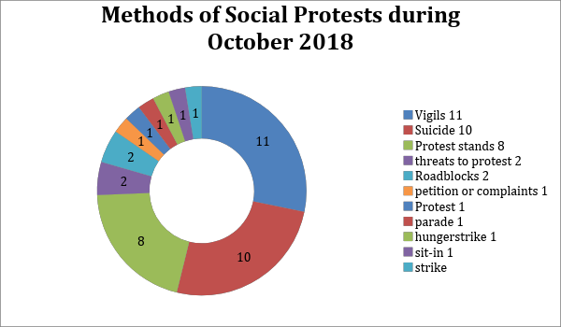

Detailed as follows:
- Vigils:
This came at the top of the methods of social protests during October, as follows:

- A crowd of street vendors gathered, on Oct. 1st after a raid campaign by the Al- Ayyat City Council in Giza, in cooperation with security forces, to remove all occupants of the main streets and squares in the city of Ayyat.
- Dozens of parents of students, gathered on Oct. 11th, in front of Sadiq Al-Rafaie Experimental School under the East Tanta Educational administration, because their children were harassed and bullied by students at various stages of the school, and a number of officials intervened to calm the parents.
- Dozens of patients of the renal dialysis unit at the "Health Insurance" Hospital in 10th of Ramadan, on Thursday, Oct. 11th, in protest against the decision to demolish the building. D
- Dozens of owners and of concern of the Baladia-Al-Mahalla membership crisis gathered at club on Oct. 16th after they were surprised by the falsification of their membership, and the lack of payment of membership receipts, which amounted to L.E.10, 200, after more than two years.
- The gathering of people and pensioners, at Damietta Youth Center Stadium, gathered on Tuesday, Oct. 2nd due to the disruption of pensions, causing a state of anger.
- A number of parents gathered in Omar Bin Al Khattab Preparatory Mixed School under the Haram Department of Educational gathering on Oct. 2nd, while calling the police, to protest the storming of unknown school students to the school after the end of the evening on Oct. 1st then stealing 24 ceiling fans and a mobile phone belonged to a female student. The police ended the crowd gathering, and helped to regularize the study in the evening session.
- Dozens of students gathered in El Shaheed Mahmoud Soliman Primary Mixed School, in Adwa village, Koum Ambo Education Administration in Aswan, on Oct. 20th in front of their old school in which the study had been stopped for completion of replacement and renewal. The students missed the school day, because they did not have a school to learn in during the maintenance process.
- Crowds of people from ​​Kafr Abyan, in Abouzabal in Qalubia, on Oct. 21st protested against the establishment of a mobile network station above the roof of a house that is near schools and residential communities, without obtaining any licenses or approvals from the competent authorities. It was immediately removed.
- Dozens of merchants from Port Said, on Oct. 24th, protested in front of the Chamber of Commerce building, in the Arab neighborhood of Port Said, after the decision of the governor of Port Said, to charge importers in factories according to the actual value of the import, which was interpreted by all as a cancellation of the free zone.
- A number of people gathered in the village of Menia al-Murshid, of the Metobas Center in Kafr al-Sheikh, on Oct. 25th, in front of a sewage station that witnessed the death of 4 workers while repairing a submersible motor inside the station's special lighting two days before.
- A crowd of 50 parents of the students of "Manarat Al-Saharaa" school in the "Abdul Qadir" complex of schools in Alexandria, inside the school on Oct. 4th, refusing to allow their children for classes, in protest against the violence of an English teacher with pupils, as well as the deterioration of the situation of the complex, which had become life threatening to the students.

- Suicide or Attempted Suicide:
Came 2nd as follows:
- A child – D.F, 14, resident of Al-Ahli Bank Street, in Abshaway center in Fayoum – killed herself, on Oct. 1st by swallowing poisonous "wheat mite" tablets, because she had being forced by her family to work in a salon against her will.
- An apartment broker – 42 – committed suicide, in Oaseem region, by hanging himself in his house in the village of Baragil, due to his recent poor financial conditions as he had been complaining about his inability to meet the needs and requirements of his children.
- Sayed Fattouh – a kiosk owner in Al-Amir district – tried to commit suicide on Oct. 9th by cutting the arteries of his hand by knife, in protest against the decision of the local unit, to transfer the kiosk to another area.
- A citizen tried to commit suicide, in Tanta, Gharbia, by jumping from the balcony of the Social Affairs Building, in the city on Oct. 11th, and the police intervened and descended with the citizen.
- An employee named M. H.E. – 33 in Banha – killed himself by hanging himself from the ceiling of the bedroom, on Oct. 15th because of his money shortcoming.
- Radi Rafik Gendi Mikhail – 38 civil engineer, resident in the Angel Monastery in Hadayek Al-Hubba district, and the owner of the United Corporation for Contracting – tried to commit suicide in front of Shuhada Metro station on Oct. 21st to get rid of his debts which amounts to two million pounds, but he fell away from the train track.
- An unemployed citizen threw himself from the 8th floor, in Imbaba police station to get rid of his life, after failing to provide for his family. His body was taken to the morgue and the prosecution took over.
- "Khaled S. – 53, farmer in Daquf village in Samalut center of Menia –committed suicide by hanging himself on Oct. 26th, because of a disease that put him out of work and a financial crisis.
- Muhammad A. A. – 27 restaurant worker in Fayoum – committed suicide by taking mice poison, on Oct. 28th, for passing through financial distress. A record No. 4357 for 2018 was issued by Fayoum-II police station.
- Ahmad – an employee at the sanitation company in Alexandria – attempted suicide from the top of the electricity tower of Western purification area, on Oct. 31st, for passing through family, psychological and health conditions, in addition to obtaining several loans. Security succeeded in dissuading him with the help of company top management.

- Protest Stands:
October witnessed 8 protest stands, as follows:

- A number of people from Agouza and Dokki organized on Oct. 3rd, protested in front of the Ministry of Social Solidarity for being deprived of the cash disbursement, and the guarantee pension. The police intervened to stop the incident.
- Residents of the City of Counselor Adly Mansour in Ataqa, Suez, protested on Friday, Oct. 5th due to high-voltage towers that are close to the buildings.
- A number of parents of language schools organized a protest, on Monday, Oct. 8th, in front of the Ministry of Education, to object to the ministry's recent decisions on cancelling the high levels in private schools. The minister refused to meet them.
- A number of students of the “Workers’ University” on Oct. 8th organized a protest, inside the university headquarters, against the decision to cancel the bachelor's degree, and limiting the university degree to a "finished vocational diploma". The students had organized several stands before, condemning that decision, which they considered a loss of their future.
- Residents of Madinty, organized a protest in the city, on Friday, Oct. 12th to support an educational teacher named "Ahmed Nasr" who had been assaulted by his retired officer neighbor, resulting in serious injuries that required surgery.
- A number of parents of Coptic Sisters, Experimental and Private Schools, on Oct. 16th announced a new protest, to be held on Oct. 18th, in front of the Ministry of Education, to denounce the ministry's decisions towards schools, cancelling the high level and second language.
- Hundreds of residents of the Emirati neighborhood, South Port Said organized a protest, on Oct. 24th in front of Sinmar Chemical Factory which is known among the residents as the "Factory of Death" to demand its closure due to the emission of gases causing respiratory distress to their children. Central security forces intervened, ended the stand, and arrested 8 people, then the prosecution released them with the guarantee of their place of residence. The forces imposed a security cordon in the area.
- Residents of the Hagug, Islah, and Ganayen slums, organized a protest, South of Port Said and blocked the highway, on the morning of Oct., in protest against ignoring their names in the list of names eligible for residential units in slum development projects. Security forces tried to end the stand, but things escalated into clashes between security forces and protesters.

- Threats to Protest:
- Parents at the Future Language School in Dokki, threatened to organize a protest in front of the school and the ministry on Oct. 4th to express their objection to the poor situation of the school after joining the June 30th schools.
- Futsal clubs threatened on Oct. 21st, to organize a protest on the sidelines of the General Assembly of the Football Federation, to be scheduled for Oct. 30th-31st to complain about the poor Union support to the game in general.

- Roadblocks:
- Dozens from the village of Shwanan, Shebin Al-Koum, Menoufia, bloacked the “Tanta - Menouf" railway, on Monday, Oct. 8th after a student ; Ahmed Rafat Ali Mikled, 21, from Kafr al-Amra , Manouf, had fallen off the train coming from Tanta and heading to Shebin El Koum, as a result of the overcrowding, which led to his loss of consciousness. Police forces intervened, and the railway bar was open for trains, after an about half an hour block.
- A number of people form Qus, Qena, on Oct. 22nd blocked the "Qena-Luxor" agricultural road in the area of ​​the seven springs bridge, to protest the absence of a child; "Salah Orabi, 10 years, after leaving his primary school, in an attempt to pressure the security services to intensify efforts to search for him. The security services intervened and called on the residents to reopen the road, so as not to be subjected to legal punishment, and the road was opened.
- Protest:
- A number of parents of students at Mohammad Karim schools – one of the Cooperative Education Corporation for National Institutes – in Ebis East Alexandria, protested on Oct.16th to demand terminating the general director of the school because of the deteriorated educational process and conditions of the school, after the strike by the bus drivers for not being paid, and the spread of stray animals and reptiles in the school.

- Petition or Complaint:
- A group of parents of the students at “Ouqba ben Nafee” school in East Alexandria issued on Oct. 10th a number of group records against the school administration and Montaza Educational Directorate, against the abrupt decision to transfer close to 2,000 students to another school, allegedly because of the high school capacity.

- Peace Parade:
- Members of “Ultras Ahlawy” organized a parade in 20 street in Bulaq Dakrour, on Oct. 23rd after Al-Ahly club had won its match against the Algerian club; Wefaq-Sateef. A police force from the Bulaq Dakrour police station intervened, arrested 10 Ultras members, and seized the flags and banners. 6 of the 10 were presented to the prosecution that charged them with inciting riots, and released them on Oct. 25th with a L.E. 5,000 bail.

- Hunger-Strike:
- 4 citizens entered a hunger-strike on Oct. 28th in Nawasser village of Esna, Luxor, inside Esna Central Hospital because the Esna city council had removed the blocks from around their properties.

- Sit-in:
- Journalists working in banned parties’ newspapers entered an open sit-in inside the office of the general secretary of the Journalists Syndicate; Hatem Zakaria, on Oct. 20th to demand a resolution for the problems, distributing them on some newspapers and finishing their website.
- Strike:
- Drivers of the “Berhamoush-Sinbellawein” line in Daqahlia entered a strike to work on Oct. 18th on the background of disputes with Tahway drivers. Security Police force intervened, issued immediate fines on the striking drivers, and took written undertakings on both sides not to confront the other.

Third: Geographical Distribution of Labor and Professional Protests:

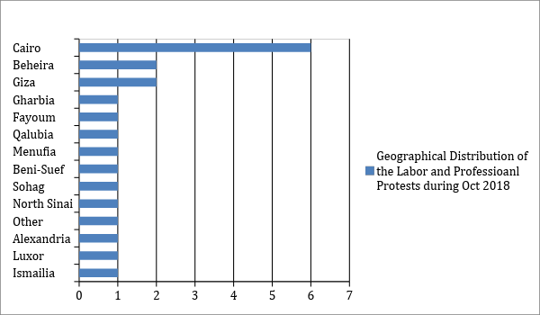

Cairo topped other governorates in terms of labor and professional protests, then it was followed by Beheira and Giza, then Gharbia, , Fayoum, Qalubia, Menoufia, Beni Suef, Sohag, North Sinai, Alexandria, Luxor, Ismailia, and several governorates.

Fourth: Geographical Distribution of Social Protests:

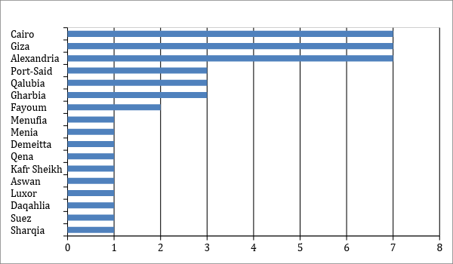

Both Cairo and Giza topped the social protests with 7 each during October, followed by Alexandria, then Port Said, Qalubia and Gharbia, then Fayoum, followed last by Menoufia, Menia, Damietta, Qena, Kafr El-Sheikh, Aswan, Luxor, Daqahlia, Suez and Sharqia.

Fifth: Sectorial Distribution of Labor and Professional Protests:

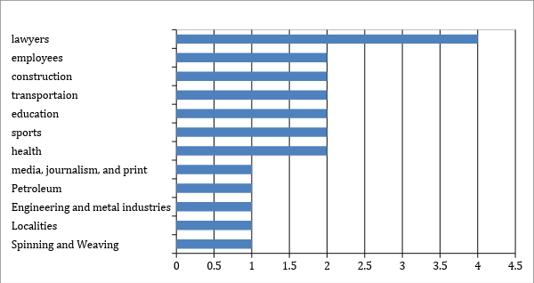

Lawyers topped the labor and professional protests with 4 ones, then the sectors of (Contracting and construction materials, transport and communications, education and scientific research, sport, health and personnel) came second, and in last came the sectors of (Media, journalism, printing and publishing, petroleum, metallurgical and engineering industries, localities, and spinning and weaving)

Sixth: Sectorial Distribution of Social Protests:
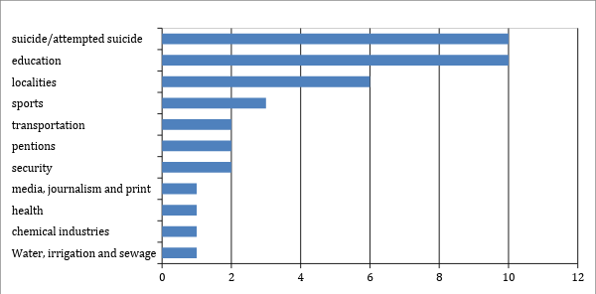
Suicide/attempted suicide and Education topped the social protests, followed by localities in the second place, sports came third, then section of (Transportation, communications, pensioners, and security) came fourth, followed by sectors of (Media, journalism, printing).
Thus, from the previous presentation, we can conclude that:

Labor protests were concentrated, in general, in Cairo, Giza and Beheira, while social protests were dispersed in a larger number of governorates, but still concentrated in large cities, such as Cairo, Giza, Alexandria and Port Said.
This can be attributed to the central nature of power in Egypt.

The construction and construction materials sector continues to occupy an advanced ranking in labor and professional protests for the second consecutive month, while the protests of lawyers occupied the forefront of labor protests, and education and scientific research sector has maintained a high position on the scale of protests.

And in terms of social protests; Suicide still tops the social protests, due to the absence of public institutions that are capable of organizing social protests democratically and peacefully for individuals who see themselves as vulnerable to social pressures and rapid political and economic changes, to express themselves.

Arabic Network for Human Rights Information ANHRI
Freedom of expression of workers and social movements Program

