The Arabic Network for Human Rights Information ANHRI
Freedom of expression for workers and social movements program

Labor and Social Protest Index during May 2018

Introduction:

This month witnessed the labor union elections that was held in May after a 12-year hiatus. Labor union elections witnessed the exclusion of thousands of unionists on police grounds for their labor union activity in defending workers' rights or their peaceful political activity criticizing the existing politics.
The activists estimated the number of workers excluded by the thousands, and the excluded candidates came up with a number of forms to object to such exclusion as calling the police to report "proof of the case," and to prosecute and file lawsuits.
The stage of submission of candidates' papers for the labor elections during the first phase witnessed a state of turmoil and verbal clashes with the officials, which led to the demand of Mohamed Saaffan, Minister of Manpower, to arrest the Director of the Manpower Directorate in Cairo.
All these forms of protest were not counted in our monitoring of the protests in May. Our monitoring was limited to protests such as strikes, demonstrations and vigils.
We prefer to have a special report after the elections in June.

The program monitored (61 protests) during the month .. Among them (15 labor and professional protest) and (46 social protests) summarized as follows:

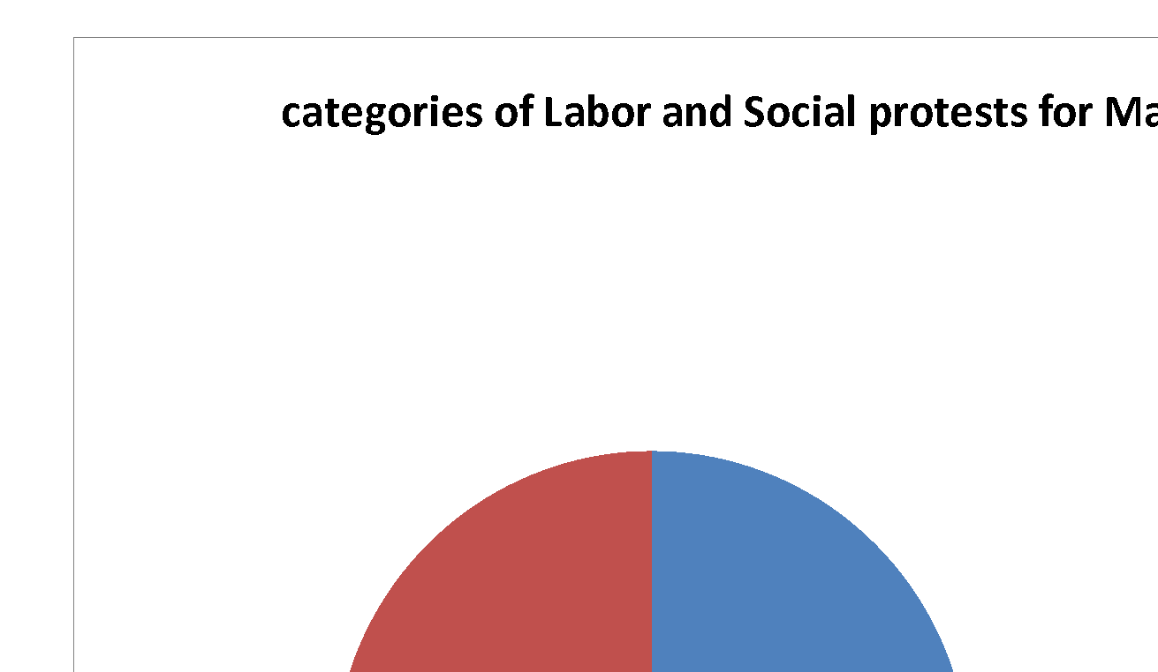

First: Labor and Professional Protests:
- Vigils (4)
- Threats to protest (4)
- Strikes (3)
- Hunger strikes (2)
- Sit-in (1)
- Petition (1)

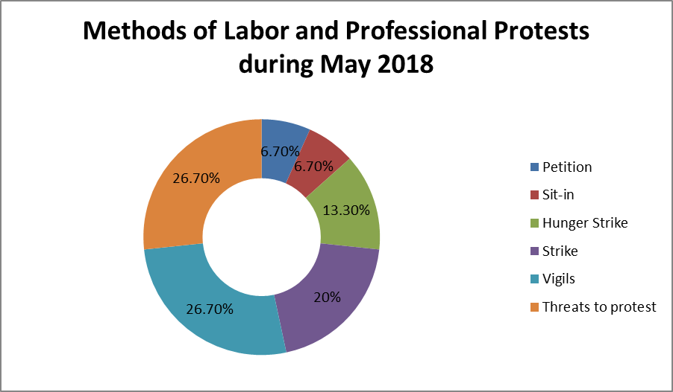

Detailed as follows:

- Vigils
May witnessed 4 vigils. First was organized by administrative security personnel in Monufia university hospital in Shebein Al-Koum inside the hospital on May 21st, 27th, and 28th, demanding their installation in their jobs according to the legal procedures of the university.
Second was organized by hundreds of workers in Delta Company for Fertilizers and Chemical Industries in Talkha, Daqahlia on May 27th, in front of the factory protesting the decision of the governor of Daqahlia for the administrative suspension of the unit of production of urea completely, and demanding the departure of the Chairman of the Board of Directors because of the repeated negligence in the maintenance work, which leads to continuous problems.
Also, the workers in General Nile Company for Construction and Roads Paving on May 14th organized a vigil because they haven’t been paid their financial dues for nearly 18 months.

- Threats to protest
May witnessed 4 cases of threatening to protest. First by a number of lawyers who threatened to organize a vigil on the stairs of the syndicate on Saturday May 12th noon because they were negatively affected by the syndicate’s entry restrictions and registration requirements for 2018.
Labor Union leader member Mohammad Omar, in Helwan Iron and Steel Company, threatened with his fellow colleagues to stage a sit-in in the company’s headquarters to protest against being excluded from the final lists of the labor union committee elections.
One of the technical team leaders in the Circle of Light TV show presented by Ibrahim Hegazi on Channel 2, threatened on May 13th to strike from work on May 16th because the employees have not been paid their financial dues for four months.
The workers in Omar Effendi company threatened on May 5th to organize a vigil in front of the company’s headquarters in Downtown to demand the 1 month due unpaid salary, last year bonus, and Ramadan incentive.

- Strikes:

Strikes came third after both threatening to protest and vigils during May, with 3 cases. First the administrative security team in the technical institute in Shobra entered on May 1st after the attack by one of the students on one of them causing injuries. The ministry of Higher Education was able to resolve the situation after four days of striking, and after promising to look into the situation after the end of the exams, which encouraged the workers to resume working.
On Wednesday May 23rd, around 90 administrative security guards in Shebin Al-Koum university hospital, entered a strike to demand their installation according to their degrees and based on what’s to be set by the organizing and managing department. And that was after the Menoufia University administrative had been stalling to fulfill their demands which were supposed to be met last February.
A number of security employees in Abul Matamir general hospital entered work strike inside the hospital on May 2nd for not being paying their 3 months dues by the security company responsible for them. The police commissioner moved to the hospital to persuade them to resume work.

- Hunger strikes
May witnessed 2 cases of hunger strike, done by Hanem Abdel Khalek the first writer in Derb Khedr school for primary education in Beni Ebeid, Daqahlia on May 2nd protesting what she has described as arbitrary transmission, and Fathia Al-Abiad the head of Fareskour school for boys in Damietta on May 24th inside Fareskour central hospital protesting the decision by the head of the educational directorate in Fareskour to execute the administrative eviction decision and exclude her from her job.

- Sit-in
One case of sit-in occurred in May 24th that was organized by more than 40 workers from the older generation of workers in Mega Textile factory for clothes in Sadat City, Menoufia, where they organized an open sit-in to demand including them in the system of work in the factory, after its restart last month, and the payment of their wages that have been delayed for more than a year.

- Petition
Workers have used the option of petition or complaining once during the month of May. That was done as a plea by Hamada Hussein who is an employee at Gomhuria newspaper under Tahrir publishing and printing house, on May 15th to the president of the republic requesting his interference to get back his job and his right after being arbitrarily fired according to his story.
Second: Social Protests:
During the month of May, the program monitored 46 social protests.
We believe that it’s our duty to point out that for the first time, during our monitoring of labor, professional and social protests; we’ve monitored the tendency of citizens to use violence against public facilities.
That was in 2 cases:

First was on May 24th in Kafr El Dawar when a number of people from Kafr El Dawar, Beheira broke into the headquarters of the drinking water company and broke its contents in protest against the daily interruption of water during the month of Ramadan

The second was by the Zamalek Ultras group" White Knights" who smashed the Zamalek bus heading to the Burj Al Arab Stadium by throwing bricks at it.

Such is a phenomenon that is resulting from the failure of the administration to interact with the demands of the citizens, which led to that behavior, for which we hold the administration responsible.

The distribution of social protests was as follows:
- Suicides came first (14)
- Vigils came second (9)
- Protests came third (6)
- Threats to protest came fourth (4)
- Petition came fourth (4)
- Strikes came fifth (3)
- Hunger strike came fifth (3)
- Gatherings came first (3)

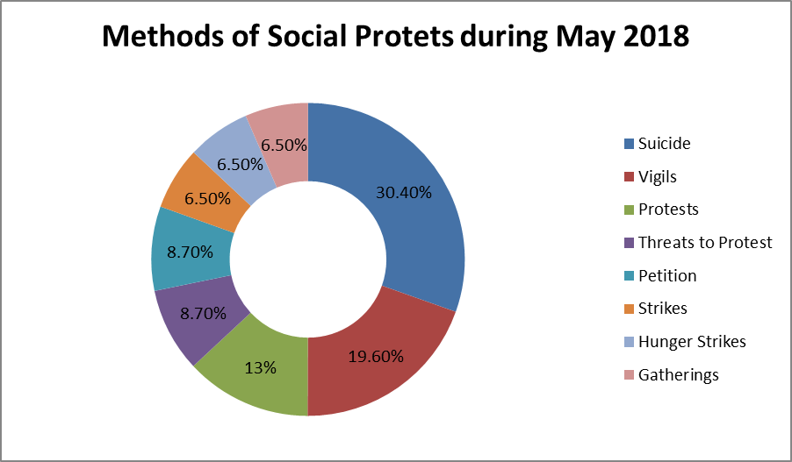
Detailed as follows:

- Suicide for Economic Reasons:
This came as the first method of social protesting during the month of May, with 14 cases including:

On Wednesday May 2nd, the security of Daqahlia discovered the body of Mahmoud Mohsen Bayoumi, 30 years, a resident in Talkha, who committed suicide by drowning because of financial distress and not finding work to save him.

Mohammad S.E., 32 years, Alexandria, committed suicide on May 3rd because of a bad psychological condition, after his wife had left their home because he could not afford to support her.

Al-Said R.M., 35 years, committed suicide with his young son, on May 4th by taking the poisonous pills which prevent toxic wheat decay after passing through psychological and financial distress following his separation from his wife and living alone with his young son and inability to provide for him.

Hussein M., 32 years, who was a fruits vendor, committed suicide in the city of 6th October on May 7th, because of passing by bad psychological state, due to poor living conditions and the lack of job opportunities.

Ahmed Said Abdel Hamid, a 24 years old worker and a resident in Al-Hajjara Village in Fayoum, committed suicide on May 7th for financial hardship.

Mubarak M., a 37 years old unemployed man, committed suicide by throwing himself from the top of the Sahel bridge in Imbaba district on Tuesday May 15th after passing through financial hardship and divorcing his wife.

Rajab S.M. killed himself on May 15th in the village of Abu Jinshu in the center of Abshway in Fayoum, for financial distress.

Mohammed E., 32 years, hanged himself in his flat in Kerdasa, ​​Giza on May 16th to escape debt and his wife’s insults in front of her family because of his inability to support her.

M.A., a housewife committed suicide on May 17th in Al-Zawya Al-Hamra due to difficult financial distress.

Al-Sheikh Jamal, who lives near the homes of Montaser in Ma'asara, committed suicide on May 19th after his wife's constant insults for his stay at home despite the financial hardship he had been experiencing.

Ahmed A., 22 years, from Al-Shuhadaa City in Menoufia, committed suicide on May 19th to get rid of the poor living conditions and the many demands of life that he cannot meet.

A young man killed himself on May 20th, by throwing himself in the sea of ​​Mois in the city of Zagazig in Sharqia, after the security services took away his auto rickshaw in a security campaign near the General Secretariat of the province.

M.I.A. a young man, committed suicide in the city of Armant, west of Luxor, on May 21st because of disagreements with his father over work matters.

The engineer "Mohammed" and his vet wife "Mayar" committed suicide in Faisal, Giza, on May 26th , due to poor living and social conditions.

- Vigils:
May witnessed 9 cases of vigils coming to the second place, including one by a number of Green Valley lands owners in 6th October city, on May 28th in front of ministry of housing for legalizing their lands conditions.

Also, a number of experimental schools and language schools students’ parents in May 3rd in front of ministry of education protesting the statements of minister of education about transferring the studying in KG and primary stages to Arabic language in all government schools.

A number of relatives of Amani Magdi Moussa who was kidnapped in Zefta center, organized protests in front of the papal headquarters in Abbasia, demanding the return of their daughter, who disappeared after leaving her college in Benha on May 24th.

A number of doctors organized a protest on the stairs of Doctors syndicate HQ, following a meeting of the General Assembly of the Syndicate on May 15th, to discuss a number of topics most notably the case of Dr. Mohammed Hassan.

Dozens of students from the Faculty of Applied and Medical Sciences at Beni-Suef University organized a protest in front of the faculty HQ on May 1st, protesting the amendment of the college regulations.

The faculty and associate staff of the Faculty of Medicine, Beni-Suef University, organized a symbolic protest to express their rejection of granting of the title of Specialist after graduation.

Dozens of used clothing vendors in Port Said organized a protest on May 1st in protest against the decision to evacuate them.

On May 29th, a group of women from the village of Seriwa, in Beila, Kafr El-Sheikh, held a protest with empty bottles in front of the city council of Bila, protesting the interruption of drinking water in the village for 12 days.

- Protests:
With 6 cases, protesting came in the sixth place. First the students of faculty of Medical Sciences in Farous university in Alexandria, organized a protest infront of the dean’s office on May 3rd protesting the change of the professional term of those graduating from that college from a specialist to a technician.
Also, hundreds of people of Met Sarrem village in Daqahlia, organized a protest on Thursday May 10th demanding the release of Lawyer Hisham El-Demerdash, who had been detained in KSA while coming back home with his mom after finishing Omra because he was born in Yemen.
Next, a number of beneficiaries of the Agricultural Development and Reconstruction Authority organized a protest on May 15th to demand receiving their land that they were supposed to receive in exchange for leaving the service in the Authority.
Metro users went on protests on both May 11th and May 12th in several metro stations and protested on the pavements of numerous stations on the first Line “Helwan-Marg” such as Helwan, Marg, Tahrir, protesting the increase of the prices of metro tickets.

- Threats to Protest:
Threatening to protest came in the fourth place with 4 cases.
Supporters and fans of Ismaeili club coordinated a vigil in front of the club because of the news about letting the first rank stars of the football team go.
Parents of the players in the swimming team of Terssanna club threatened on May 4th to have a vigil because of the decision Chairman of the Board of Terssanna Club to arbitrarily dismiss the swimming coach and technical director.
Drivers of the (Sandoub-Agga) highroad in Daqahlia threatened to enter a work strike on May 22nd because of the pavement of the whole road and not only the damaged parts.
Lawyers who are against the new registration conditions of their syndicate threatened to file lawsuits to guard the syndicate and organize an open sit-in to demand the implementation of the legal provisions issued to invalidate the decisions of the syndicate council.
- Petition or complaint:
May witnessed 4 cases of petitions or complaints including that done by the pensioners on May 8th who filed for a direct misdemeanor against the Minister of Social Solidarity and the Prime Minister on the pretext of abstaining from implementing the administrative court ruling by spending 80% of the allowances.

Parents of the official language schools started on May 2nd to issue documents of authorization to a lawyer to prepare a case for the cancellation of the minister's shift to Arabic decision.

They also sent complaints on May 6th, on the President's page on Facebook, against the decision to shift the studying in language schools to Arabic.

The doctors’ syndicate sent a letter to Dr. Ali Abdel Aal, Speaker of the House of Representatives, to demand the amendment of some provisions of Law No. 14 of 2014 concerning the organization of the affairs of members of medical professions.

- Strike:
Strikes in May came in fifth place with 3 cases;

On May 17th, drivers of "Kabbut" vehicles in Mahmudiya line in Aswan, entered a strike after the licenses of a group of them were confiscated and one of thm, Adham, was beaten after a dispute about preventing them from standing at the Sail intersection and at the commercial market.

On Sunday May 20th, the drivers of the Nabroh-Talkha line in Dakahlia entered a strike to protest the transfer of their parking lot near the Talkha bridge to another position, in implementation of the governorate's decision.

Microbuses drivers in Kafr El-Zayat, Gharbia, entered a strike on May 19th due to a quarrel between a driver and a police officer, resulting in a total paralysis in the city.

- Hunger Strikes:
Also in the fifth place there was the hunger striking, with 3 ones happening during May.
Five citizens died at the Luxor General Hospital on Sunday May 13th, all belonging to Al-Baghdadi village, in the city and center of Bayadiya, protesting a removal decision issued by the city council authorities.

Mahmoud Abu El-Lail, secretary-general of the Egypt 2000 party, said on his official Facebook page on May 9th that he was on hunger strike at the party headquarters, threatening to commit suicide on Friday May 11th in Sidi Abu El Hajjaj Square, after the Minister of Local Development, Minister of Agriculture and Minister of Antiquities, and Minister of Tourism had ignored his demands.

On May 23rd, Hazem Salah Abu Ismail was also declared on hunger strike in his prison cell in Tora Prison, in protest against the denial of his visitations and of access to his lawyer for more than two years.

- Gathering:

Gatherings also came fifth during the month of May with 3 cases of which 2 included violence;

Where a number of people of Kafr El Dawar, Beheira, broke into the headquarters of the drinking water company on May 24th and broke the contents in protest against the daily interruption of water during the month of Ramadan

The White Knights team smashed the Zamalek bus heading to the Burj Al Arab Stadium inside the club where they threw bricks, causing damage to the bus.

On the other hand, a number of pensioners gathered on May 2nd in front of the office of the president of the National Information Commission, demanding their financial entitlements and the payment of the end of service benefits to those who had been referred to retirement two years ago.
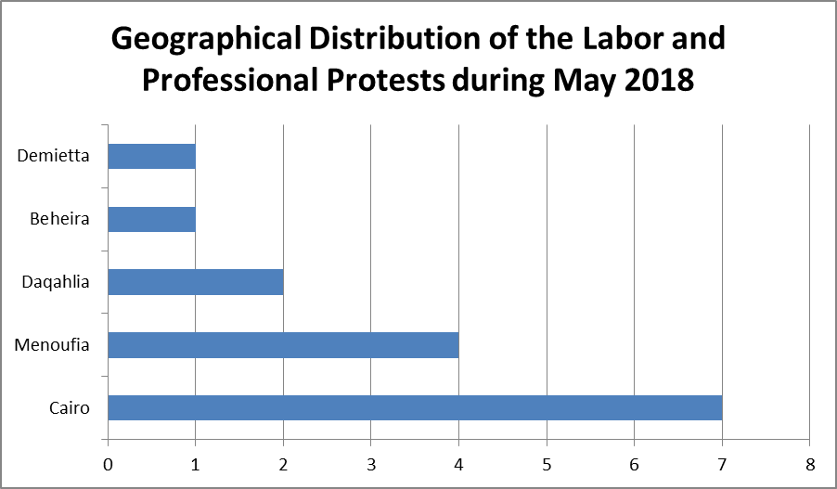

Third: Geographical Distribution of the Labor and Professional Protests during May 2018:

Cairo came first in terms of professional and labor protests during May with 7 protests, while Menoufia came second with 4 cases, Daqahlia came third with two, and both Beheira and Damietta came fourth with one protest each.

Third: Geographical Distribution of the Social Protests during May 2018:

Cairo also topped the social protests by 17 social protests during May, and Giza came in second place with six social protests.
In the third place came Daqahlia with four protests during the month.
In the fourth place came both Luxor and Fayoum with three protests each.
In the fifth place came both Beni Suef and Alexandria by two protests each.
The sixth and last place was occupied by Aswan, Ismailia, Beheira, Sharqia, Gharbia, Qalubia, Menoufia, Port Said and Kafr El-Sheikh with one protest each.

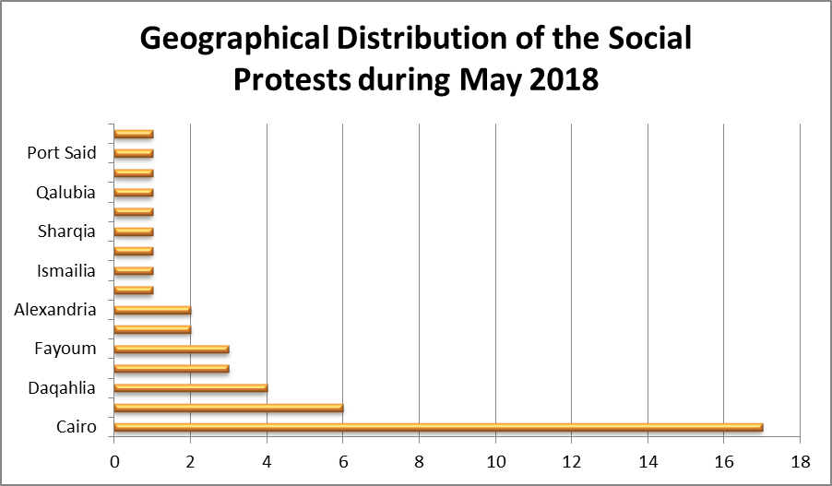
Fifth: Sectorial Distribution of the Labor and Professional Protests during May 2018:

Health came as the first sector in which labor and professional protests occurred with 4 ones.
In the second place came education and scientific research with 3 ones.
In the third place came media, journalism, printing and publishing, with two each.
In the fourth and last came textile and weaving, lawyers, chemical industries, metal industries, contracting and building materials and the commercial sector.

Sixth: Sectorial Distribution of the Social Protests during May 2018:

Suicide for economic reasons came first in the social protests with 14 cases which is the highest rate since the beginning of the year.
Both education and scientific research, and transportation came second with 7 protests each.
Security and sports came third with two ones each.
In the fourth place came agriculture, irrigation, fishing, health, localities, water, sanitation and electricity with 2 each.
Fifth and last was for pensioners, housing, media, journalism, printing and publishing, and lawyers with one each.
Thus, from the previous presentation:

That the governorate of Cairo is still at the top of all governorates of the Republic in terms of the number of labor and professional protests and social protests as well, and that the health sector came first in terms of labor protests, while suicide was the first way to express the poor economic and social conditions of other social groups.

The Arabic Network for Human Rights Information
Freedom of expression for workers and social movements

