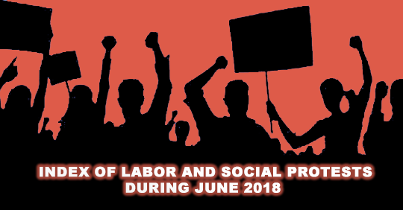

Arabic Network for Human Rights Information (ANHRI)
Freedom of Expression for Workers and Social Movements Program

Index of Labor and Social Protests during June 2018

Introduction:
In June the Egyptian government has lifted subsidies on petroleum products and increased their prices in accordance with the instructions of the International Monetary Fund (IMF) and set a new tariff for passenger transport, which led to a general feeling of anger expressed by drivers of transportation cars in many governorates, from striking to protesting against the limited value of the increase for them, despite complaints from citizens.
June also witnessed the end of the so-called "trade union elections" after a planned process in which the Egyptian authorities excluded independent unions and independent labor leaders and expressed the demands of workers through police and administrative interventions.

Gibali Al Maraghi, as President of the Union (Government), continued by acclamation, while Mohammed Wahaballah continued as Secretary General of the Union, and Adel Abdul Fadil was appointed as Treasurer. In general, the General Union returned to its old form, and in addition, 68% of the heads of public trade unions came by acclamation, while 60% of the General Trade Union Councils were elected by acclamation.
The representation of women was 0% in the presidency of the general syndicates.
June also witnessed Eid al-Fitr holiday and part of the month of Ramadan, which explains the lack of protests compared to previous months.

The program monitored (38 protests) during the month. Among which (20 were labor and professional protests) and (18 were social protests) summarized as follows:

- Labor and Social Protests:
- Striking to work, 10 cases.
- Vigils, 7 cases.
- Sit-in, 2 cases.
- Threatening to protest, 1 case.

Detailed as follows:
- Striking:
Striking came first in terms of methods to protest for labor and professional protests during June with 10 cases, where:
- Drivers from Koum-Hamada, Delengat, entered a strike to work in protest to the new tariff for transportation, and the city council of the Delengat city was able to dismantle the strike by providing cars for public transportation from the secondary stations and the governance.
- About 100 drivers from the Tanah-Mansoura line, entered a strike to work on Tuesday June 19th and were absent from the stop, in protest to the new transportation tariff and demanding a new higher one. The city council intervened with a number of private buses during rush hours to overcome the strike.
- Drivers of Husseinia stop in Sharqia entered a strike on June 20th because of their dissatisfaction to the new designated tariff in Sharqia.
- Dozens of drivers from Samnoud general stop in Gharbia entered a strike to work on June 19th and refused to transport passengers in objection to the new tariff decided by the administration of the stop and traffic investigations after the recent increase in petroleum prices. The security leadership in the city used public transport busses and private ones for passengers transportation.
- Some drivers in Zenada stop in Talla, Menoufia entered a strike to work on June 22nd in objection to the new tariff for passenger transport after the new petroleum prices and the president of Tala center used the cars from other lines till the strike was over.
- The taxi and bus drivers in Beni Suef line entered a strike to work on June 19th after the increase in petroleum prices and deciding a new tariff for taxi, busses, and microbuses.
- Drivers in Qaft, Qena entered a strike to work and returned home on June 17th after they had refused the suggested prices by the city council.
- Drivers of the Mehalla-Dsouq line, Kafr El-Shaikh, entered a strike to work on June 19th on objection to the new tariff demanding its increase. So the governor assistant of West area and the president of Dsouq city decided to push 15 microbuses from different lines to support the Mehalla-Dsouq line.
- Dozens of workers at the railway company for services in Alexandria entered an open strike on Monday June 4th demanding a 10% increase and the termination of the chairman of board, only a day after their organization to a vigil without any positive response, so they decided to enter the open strike to work, the next day.
- Workers of the gas filling factory in Toud, South Luxor, entered an open strike on June 20th in objection to the mistreatment of the administration to the employees and the random salary deductions, demanding the return of their colleagues whose contracted had ended.

B- vigils:
June witnessed 7 vigils, as follows:

- A number of employees in the sound engineering department organized a vigil on June 25th in front of the office of the head of the national media apparatus, demanding the implementation of the employment settlements after the head of the economic sector had agreed on settling for a number of the service workers and other in Maspreo.
- Dozens of nurses of the health insurance hospital in Beni Suef organized a vigil on June 6th in the hospital main entrance in objection to what they described as ‘the collusion of the policemen in the hospital, with the family of a patient to attack a doctor and two nurses” at dawn that day.
- Dozens of workers in Gomhoria newspaper, organized a vigil on June 25th to demand their 2016, 2017, and 2018 bonuses that had not been given till that date for the alleged lack of resources.
- Dozens of workers at the railway services in Alexandria organized a vigil to demand their 10% bonus and termination of chairman of board of directors.
- Workers of Kafr Al-Shaikh organized a vigil, on June 4th, in the main hall of the company where they were prevented from entering to the chairman of board of directors, in objection to not paying their incentives, salaries and financial dues for the past two months.
- Dozens of workers at Queen service company for cleaning services organized a vigil in front of Tanta French Teaching university hospital in Gharbia on June 27th because the hospital had laid off the company which caused more than 250 workers to be affected.
- Workers of Cement National Company organized a vigil on June 27th in front of the west coast on Helwan Corniche in objection to stopping the company factories, turning workers at them to early retirement and decreasing the incentives.

C- Sit-ins:
June witnessed two cases of labor and professional protests where nurse Mohammad Al-Gindi entered a sit-in on June 2nd in objection to discriminating against him by removing the daily entrance and leave checklist from the nurses office.

Also, a big number of employees and workers at Zamalek club organized a sit-in inside the club on June 12th because of the refusal of the Banque Egypte to lift the ban of the club accounts after Mamdouh Abbas had appealed on the sentence issues in favor of the club to lift the ban.

D- Threats to Sit-in:
June witnessed one case of threatening to sit-in when the union of workers of those established on private funds at the level of the Republic on June 19th, adopting escalatory steps up to the strike in all government ministries to protest the delay of their salaries for several months, for lack of sufficient to fund.

- Social Protests:
The program monitored 18 cases of social protests, distributed as follows:
- Suicide came first with 8 cases.
- Vigils, 4 cases
- Sit-ins, 3 cases
- Petitions or complaints, 2 cases
- Strikes, 1 case.

Detailed as follows:
- Economic Suicide:
Economic suicide was at the top of the social protests in June (for the second month in a row) with 8 cases of suicides (May 14cases, 30.4% - June 8 cases, 44.4%).

- A 28-year-old young man named Hassan Al-Sufaifi, in Al-Tal Al-Kabeer in Ismailia, threw himself from the top of the bridge for a financial crisis.
- Abul-Nour, 23, committed suicide at his home in the village of Al-Shorfa, Giza on June 22nd, because of his inability to buy the necessary treatment for his sick mother, which led him to commit suicide by hanging, leaving a letter of apology to his mother.
- A 32-year-old butcher, who hanged himself in his butcher's shop in Al-Zoraiqi village in Sinbillawin on June 10th, committed suicide because of a financial crisis.
- A 35-year-old police officer with a wife and two children committed suicide by shooting himself in his car on June 27th in Badr city, for suffering from financial distress due to the illness of his young daughter after doctors failed to treat her for more than two years.
- The body of Mohammed R, 21, was found on June 28th, and the investigation revealed that he had committed suicide after a financial crisis leading his mother to work as a servant to spend on his sick father. Investigations added that the young man was unemployed and had a bad psychological condition because of his financial condition and was forced to hang himself.
- On Saturday June 9th, a butcher, in Shebin El Koum, tried to commit suicide by taking the wheat-preserving pills because of financial hardship and was taken to the hospital for treatment.
- A furniture carpenter in Bagour, Menoufia, on June 25th, committed suicide by taking a poisonous substance after going through financial distress.
- A 19-year-old worker in Kafr Al-Sheikh, committed suicide by hanging himself because of going through financial hardship that caused his inability to get married.

- The vigils:
June witnessed 4 vigils that came in second place of protests during the month, where:
- On Wednesday June 20th, dozens of parents in Gharbia organized a peaceful protest against the results of the secondary school in front of the governorate's bureau, stressing that the result of this year is unfair compared to last year.
- On June 7th, dozens of employees of the General Authority for Reconstruction and Projecgt Development organized a protest at the main entrance of the Authority to protest what they described as the "waste of their rights and access to the lands allocated to them in the area of ​Mehwar Al Hamam".
- Dozens of people from Beshri in al-Fashn Center in South Beni Suef organized a protest in front of the headquarters of the local unit of Al-Fashn city center on June21st.
- On June 1st, hundreds of people from the Kanayes village in Kafr El Dawar district of Beheira held a protest in front of the main road of the village because of the interruption of drinking water for more than two months without any solutions from the company or the intervention of any official.

- The sit-in
The sit-in came in third place with 3 cases, represented in:
- The doctors of the Obstetrics and Gynecology Department at the General Hospital of Assiut in Assiut entered an open sit-in on June 2nd to protest the disregard of the Minister of Health, Assiut Governorate and the Undersecretary of the Ministry of Health in Assiut for their complaint against two doctors who assaulted them with profanity and violating their lounge without legal grounds.
- Workers of the quarry project in Sharqia held a meeting on Monday June 5th in front of the project headquarters in the housing bank buildings in Zagazig. A number of workers expressed their anger in protest of the decision of Major General Khalid Said, Governor of Sharqia, to liquidate the quarry project, and continued the sit-in until Tuesday, June 12th.
- A number of the referees of Alexandria held a sit-in at the headquarters of Gezeira football federation on Saturday June 2nd, protesting their unpaid dues since last year.

- Petition or Complaint:
The protest by submitting a petition or complaint came in fourth place with 2 petitions or complaints represented in:
- A large number of Alexandria referees lodged a complaint with the Alexandria Football Federation to express their discontent and anger at the main referees 'committee for failing to pay their dues on time, in addition to carrying out referees' tests outside their governorate, causing them the trouble of travel, hardship and high expenses.
- The residents of the villages of Arab Mahjoub, Othman Ramzi, Owili, Ezbet Malika Al Kabira, Ezba 27 and Malikah Al-Saghira, and Al-Sersi of Al-Sinbillaween Center in Daqahlia filed a complaint through the "Citizen's Gate" website, about their suffering from the interruption of drinking water for years and submitted many complaints deputies and official in vain.

- Strike:
The strike in June came in fifth place with 1 strike by a number of bakery owners in the city of Zineya, north of Luxor, on June 27th, following the decision to deduct 60% of their quota.
- Geographic distribution of labor and professional protests during June 2018

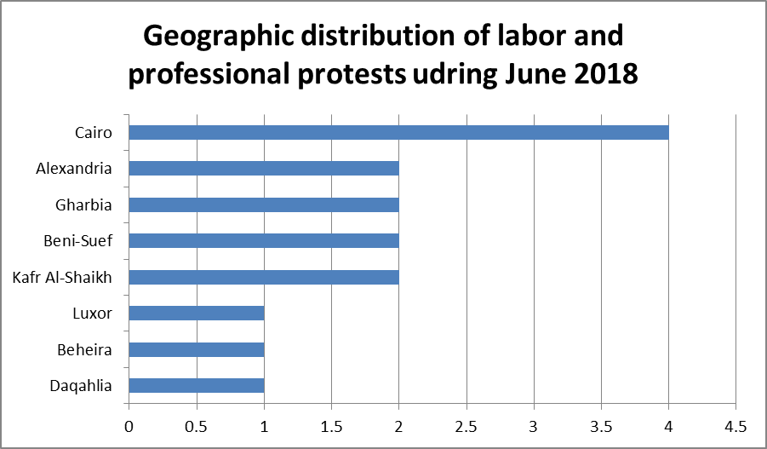

Cairo topped the labor and professional protests during June with 4 protests. Alexandria, Gharbia, Beni Suef and Kafr El Sheikh ranked second with two protests each.
While Luxor, Beheira, Daqahlia, Sharqia, Qalubia, Menoufia, Qena and several governorates came in third place.

- Geographic distribution of social protests:

Cairo also topped the social protests by 4 social protests in June, while Giza, Daqahlia and Menoufia came in the second ranking with two protests each of them
Finally, Beni Suef, Kafr El-Sheikh, Assiut, Luxor, Ismailia, Beheira, Sharqia and Gharbia came in the third order with one protest each.

- Sectorial distribution of Labor and professional protests:

The transportation sector was the most important sector in terms of the number of labor and professional protests during June, with 10 protests.
In second place came the health sector with (3) protests.
In the third place came the media sector, the press, printing and publishing labor protests.
The fourth and last place was occupied by sectors (petroleum, sport, food industries, chemical industries and the local sector) with one protest per sector.

- Sectorial Distribution of Social Protests:

As it has been the case in the recent months, committing suicide for poor living conditions topped all forms of social protests during the month of June with 8 cases of suicide.
The sectors of sports, water, sanitation and electricity came in second place with 2 protests each.
In the third and final rankings came sectors of education and scientific research, agriculture, irrigation, fishing, health, food industries, quarries, mining, and localities.

Thus, from the previous presentation, it’s obvious that:
The increase in the prices of petroleum products has angered the users of mass transportation and drove many drivers, especially in Upper Egypt and Delta to strike to work, while the security services and the local administration dealt with those strikes through the use of some buses and services.

Suicide due to poor economic and social conditions is still at the top of the list of protests, and Cairo is still the first province to express its opinion through the various images of the protests.

The Arabic Network for Human Rights Information
Freedom of expression of workers and social movements

The report is based on a number of sources: field monitoring of the program of freedom of expression of workers and social movements, labor cases at ANHRI, in addition to several newspapers and websites (Al Watan, Al Masry Al Youm, Al Wafd, Masrawy, Youm7 and others)

