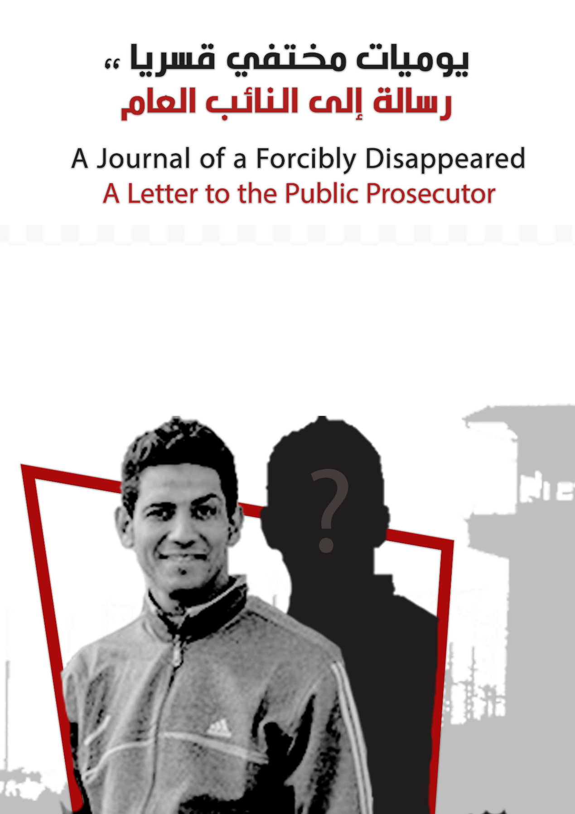

A Journal of a Forcibly Disappeared
A Letter to the Public Prosecutor

Before you read:

The following "journal" is a message of the prisoner of conscience and the former forced disappeared "Hossam al-Arabi" is the second of a kind to be published, and we know that national security and the Public Prosecutor will be aware of it.
The Arab Network believes that the Public Prosecutor will not remember him, since Hossam Al-Arabi for him is a case of thousands of cases that did not find justice or fairness, a state of a citizen that lost his rights and was deprived his freedom, by an order of the prosecution, just for investigations!
The same prosecutor who knew he was being held illegally, after knowing where he was forcibly disappeared, did nothing. Hossam al-Arabi was officially imprisoned for 12 months (January 2017-mid-December 2017) in a "fabricated political case". Hossam al-Arabi was hidden 100 days, and was released only at the end of March 2018.

To the Public Prosecutor: This is the title of your justice

To the Text:
*****************

Name: Hossam Ismail Ibrahim
Title: Hossam Al Arabi
Age: 31 years

Maybe I was dead for one year and four months

Arresting me

On January 25 2017, I was arrested, and I was taken to the Dar al-Salaam department, and I had 3 other youths with me. We were sitting in a cafe next to the Dar al-Salam metro station. It was an unparalleled siege as if they were arresting dangerous criminals. After searching my mobile phone they found some posts calling for the freedom for the detainees and some of my opinions. My views were not harmful to the state in anything, there was nothing but peaceful criticism in it, and there were no calls for violence, for example, or the like.
The beginning of the nightmare was when I got off the car in which I was arrested, as if I was dead, and with every slap on the backs of my head, made me feel that these are the last moments in my life! It was like the fists of death hitting me, and when my eyes were blinded, I remembered my house, my family and my friends, and everything was like a tape. Shamefully I walked towards the officer who asked for my name and age then charged me with several accusations, at last he told me that my friends confessed against me, so I must confess. I got weak so he nailed me and forced me to sign the minutes.
I was the Dar al-Salam police station, in a place called (the refrigerator), which is a place where people are stored until they are brought before the prosecution.

The Prosecution

I was brought before the prosecution the next day on 01/26/2017
The prosecution accused me of joining a group founded against the law, spreading false news, disturbing public peace, and demonstrating without a license! in the case No. 1334 of 2017
I denied all the accusations, and the lawyers submitted to the investigation a newspaper on January 26 stating that there were no demonstrations in memory of January, a statement from the Minister of the Interior at this time and published in the newspapers, and yet I was imprisoned.
And I went back to the detention facility in the Dar al-Salam police station
After the renewal, we were transferred to Tora Prison

Prison
It was difficult days, starting from entering, I was stripped of my clothes, my hair was shaved, and I was taken to rooms called revenue, and then I was placed in the politicians' ward no. (3) after ten days.
After that, I entered into a cycle of detention renewal for 45 days
Each time, I was brought before different judges in different circles, including terrorism department
I was taken to disciplinary cells more than once, and my hair was shaved, and some informants beat me.
With the renewal going on, I was overwhelmed and my friends and I went into hunger strike.
I survived several suicide attempts because I was feeling desperate to leave this place. I felt disappointed and helpless, especially from the stories of my friends and some of those I met in prison and some of them were executed, and those who were sentenced to life imprisonment and other stories that negatively affected my determination, my mind and my body, and I used to say why All this happens? Even though I was never a criminal and I did not breach the law?

False Release

- On 12/14/2017 I was released and I was at that time sitting in a criminal cell, most of which were sentenced to death in cases of murder. The chief of investigations insisted on disciplining me in this cell. I was asleep when some of my friends woke me up telling me that I was released. I ran to the exit door and screamed in everyone's surprise and cried in front of the informant calling out the names, but my joy ceased.

The period of enforced disappearance

I went to the Dar es Salaam police station, but my colleagues and I were not released, and we were dying in fear of rotating us into a new case. We were sitting in a room of approximately 12 meters in which there was one bathroom and about forty detainees and forcibly disappeared persons from different departments, they brought them to this place to be rotated in New cases.
We slept in turn, ate only bread, and sometimes the detainees who were visited by their relatives gave us some food. The moment of horror was when someone came saying that he was an officer in the National Security. He took four adolescents whose age was less than 15 years old. They were accused of terrorism, and the court acquitted them, and they were waiting for the National Security signal like us. The officer had new clothes and a gel for hairdressing and he took the youth, cleaned them, dressed them and combed their hair and listed them in a new case!
This happened with several other people from different departments, and I, we all exploded inside the room, I specifically hung myself in a gallows and screamed loudly after the detectives came down to us and hit the elderly, because we objected to the accumulation in the room.
They were shocked when I tried to hang myself so they led us to Al-Basateen, and I do not remember how many days we have lived between moving from section to department after the lawyers submitted several reports stating our disappearance.
One day it was a very terrifying day, a person from the National Security came and bound us all, blindfolded us, and said to us, (We will liquidate you), he put us in the car, and got off to a place, and there were soldiers walking behind us with rifles poking us with the barrel of the rifle and we prayed to God to take our lives to him without pain.
We were surprised that we went back to the Dar al-Salaam police station again, and when our eyes were opened, the officers laughed in our eyes, mocking us, and we cried after we felt that we lost our lives and regained it, so we entered a room and after four months we were released, yet we are no longer as we were before. For about 100 days of enforced disappearance, it will change you and it is difficult to be back as you were.

*****

I think that that period of the unforgotten does not disappear from the memory,
No time, you cannot know what time is now?
I don't know is it night or day?
I don't know are we going to die?
Are we rotated in a new case?
It is fear and panic in the souls of the forcibly disappeared, old and young, we are in a cemetery-like room of about 4 m by 6 m in which there is only one bathroom and more than forty people are detained!
They alternately sleep, exchange frightening conversations, how they were arrested, how they were among their children and now they do not exist, they wish to go out to their families, some of them are patients with chronic diseases who need medicine, and some of them only dream of sleeping on a bed or even in a single room, and some of them want to see their mothers because.
Scenes that go through my mind, they were not cinematic scenes, but a bitter reality that some people live in. They already existed and became
disappeared and now they just do not exist, for days, weeks and months. A very dangerous feeling that you do not exist, the authorities deny your existence !!
A prisoner without papers, you do not know where you are, and you may know where you are, but you are unable to communicate with the outside world.
Nobody knows whether you are alive or not and you don't know what will happen to you!
Are you going to your university again? Will you see your brothers, your mother, your father, your friends, your neighbors, the street? Is this a nightmare? Well, if I die, what do they do to my body? I was thinking that even if I was rotated in a new case, this is might be a wish to just to be able to see the light.
I am now silent, I remember and suffer while I do not know why all this injustice?
Hossam Al Arabi
******
Details of Hussam's case in a previous report by the Arabic Network, entitled "The Signal is above the Law."

https://www.anhri.info/?p=3281

