Labor and Social Protests in the last quarter of 2020

Introduction
The year 2020 has ended, and the government of Egypt is still turning its back on economic and social rights. The burden on families with limited income has been exacerbated due to the coronavirus pandemic, while the year has ended with the government's decision to liquidate the Egyptian Iron and Steel Company, the country's citadel of heavy industry.
Seventy three different protests, ranging from sit-ins, strikes, protest vigils, suicide cases, blocking off roads, collective complaints, and trade union movements, have been monitored by ANHRI during the last three months of the year (October, November and December).
During the reporting period, 40 protests were staged by unorganized social groups (neighborhood residents and citizens' gatherings), in addition to 33 protests organized by workers and trade unionists, protesting against the delay in disbursement of salaries, privatization, and layoffs of workers. The Egyptian authorities, however, responded to the various modes of protest with repression and baseless arrests of protesters over flimsy accusations. For example, 9 workers and union leaders at the Delta Company for Fertilizers and Chemical Industries (Talkha Fertilizer factory) were arrested and interrogated by the State Security Prosecution in connection with Case No. 1 of 2021, against the backdrop of their protests denouncing the selling of the factory.
The most important protests monitored during the last quarter of 2020 can be summarized as follows:
The distribution of social and labor protests:
Social Protests | Labor Protests
40 | 33

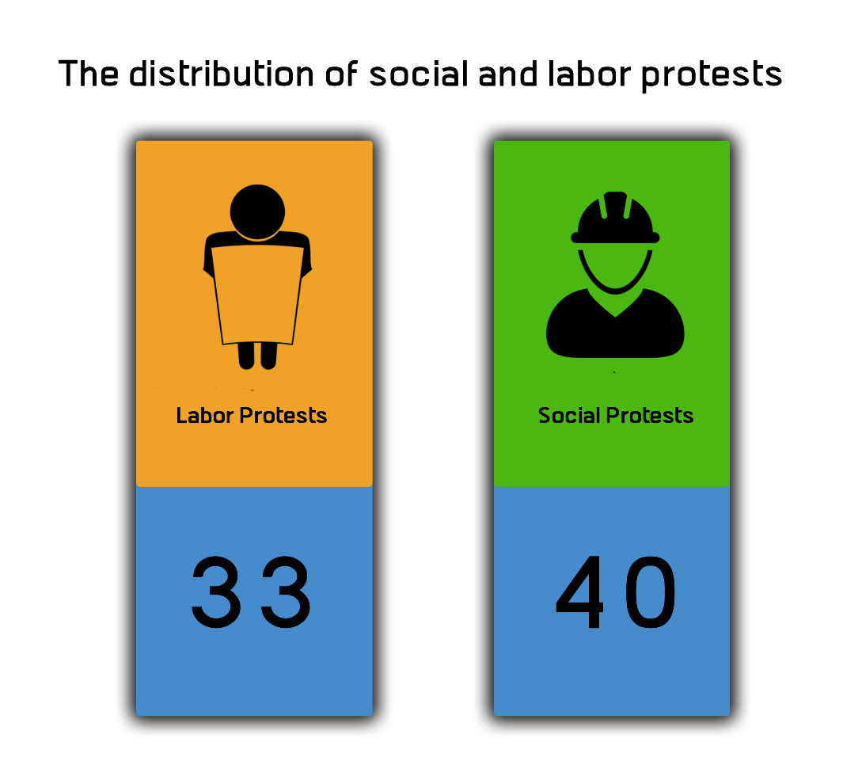
First: Labor and professional protests (33 protests):
The following chart shows the number and kind of labor and professional protests:
Kind of protests | Number of protests
Strike | 9
Sit-in | 5
Collective complaint | 5
Protest vigil | 4
Demonstration | 1
Trade union movement | 3
Gathering | 3
Threatening to protest | 1
Arbitrary dismissal | 2

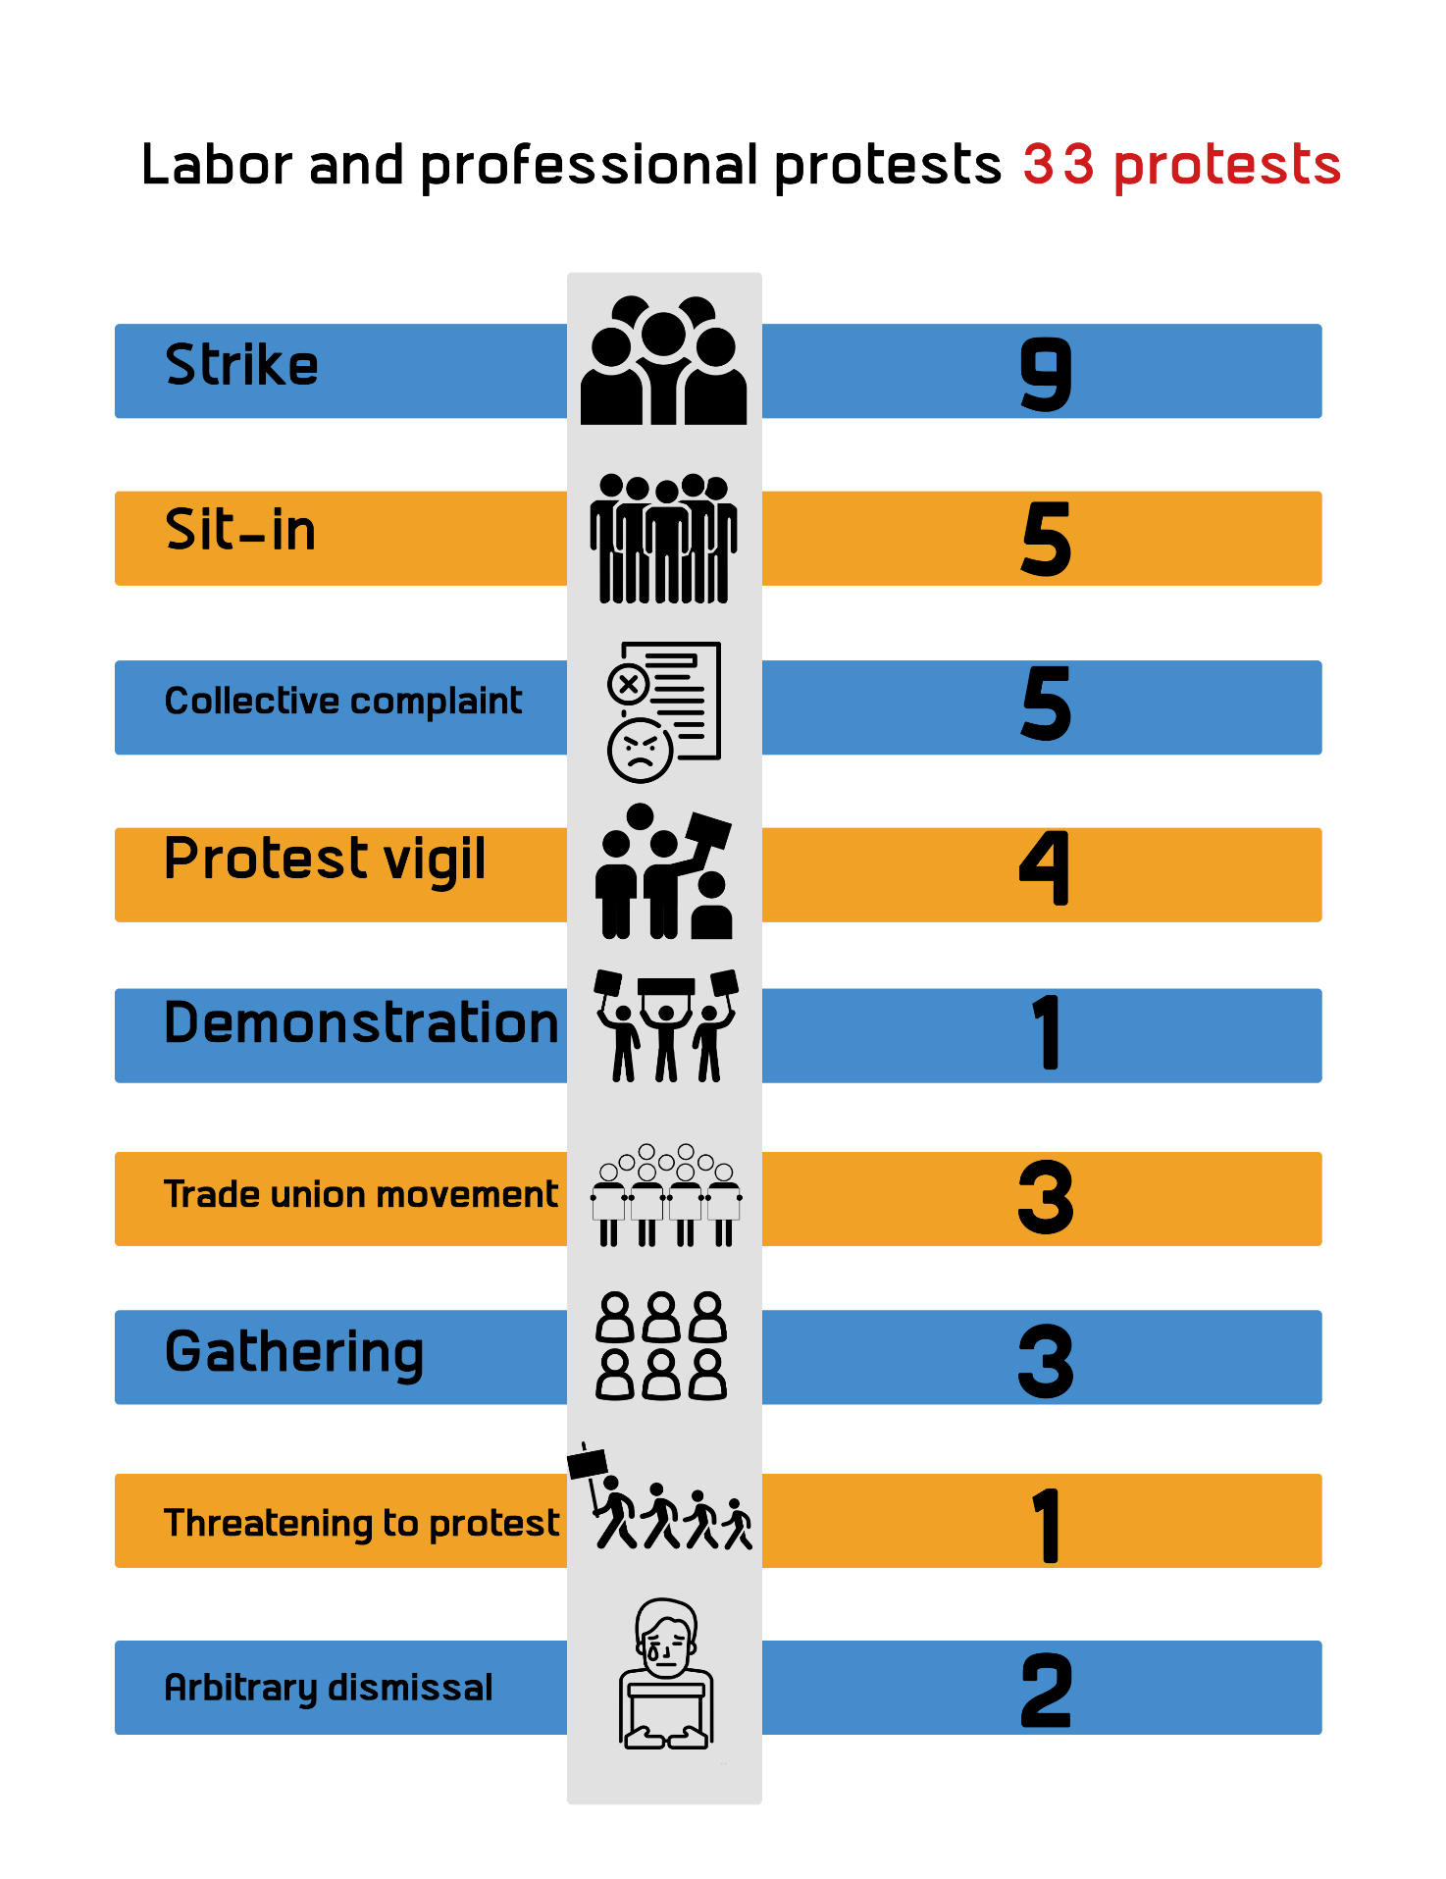

Details of labor protests:
Details and location | Kind of protest
1- Employees at the "T-Land Sea" ready-made garment company located in Cairo's Obour City went on strike  2- Employees at "Kiriazi" Electric Company at Obour city, Cairo went on strike  3- A strike launched by the workers of "Kazarin" factory for ready-made garments in Fayoum governorate.  4- Railway train drivers at Ramsis railway Station went on strike  5- An employee went on a hunger strike at Minya governorate  6- A strike launched by Taxi drivers at Menoufia governorate  7- A partial strike in Naga' Hammadi Hospital in Qena governorate  8- The Shubra El-Kheima Bar Association went on strike  9- Kafr El Dawar textile spinning workers continued their labor strike | Labor strike (9) | - 1
1- Employees at the Workers University in Cairo staged a sit-in  2- Employees at Egypt's Aluminum's Company complex in Nagaa Hammadi, Qena organized a sit-in  3- The sit-in of workers at "Samad Talkha" Company, Dakahlia Governorate  4- Workers at Alexandria Container Handling Company organized a sit-in  5- A sit-in by workers at the General Company for Research and Groundwater Regwa, Cairo Governorate. | Sit-in (5)
1- Workers at "Sasco Group" Factory in Al-Sharqiyah governorate filed a collective complaint  2- A collective complaint by the Olympic Club players in the Egyptian Football Association (EFA) at Alexandria  3- A collective complaint by "Baladiya Mahalla" Sporting Club in Gharbyia governorate against the club's administration  4- Workers at the clay brick factory in Beni Suef governorate filed a collective complaint  5- A collective complaint filed by taxi drivers against Luxor Traffic Department | Collective Complaint (5)
1- Employees at the government-controlled Egypt Workers Union organized a protest in Cairo  2- Portsaid Health Insurance Hospital's nursing staff organized a protest  3- Workers at the Misr Shebin Al-Kom Spinning and Weaving Company organized a protest in Monufia governorate  4- A protest organized by workers of Tanta Company For Linen And Oil, Gharbyia governorate | Protest vigil (4)
1- A group of nursing graduates organized a protest vigil in front of Ministry of Higher Education in downtown Cairo | Demonstration (1)
1- Trade union protests objecting to the new Unified Labor Law.  2- The Union of Iron and Steel Workers in Egypt filed a lawsuit to prevent the liquidation of the Egyptian Iron and Steel Company  3- Two pharmacists file a lawsuit to end the sequestration placed on the Egyptian Pharmacists Syndicate and accordingly allow the holding of elections | Union movement (3)
1- Employees at "19011 Pharmacies" gathered to protest non-payment of salaries  2- Workers at Nasr Textile Company gathered in Alexandria to protest non-payment of dues  3- Employees at the Watanyia Steel Industries Company in Suez governorate | Gathering (3)
1- Female employees at Fayoum Social Insurance Authority threatened to stage a sit-in at their workplace | Threatening to protest (1)
1- Badr Automotive Factory in Qalyubia governorate dismissed about 600 workers  2- Al-Masry Al-Youm newspaper arbitrarily dismissed 40 journalists | Arbitrary dismissal

Second: Social Protests (40 protests):
Kind of protests | Number of protests
Strikes | 2
Protest vigils | 4
Collective complaints | 4
Suicide cases | 10
Blocking off roads | 4
Demonstrations | 3
Gathering | 8
Sit-ins | 1
Attempted Suicide | 4

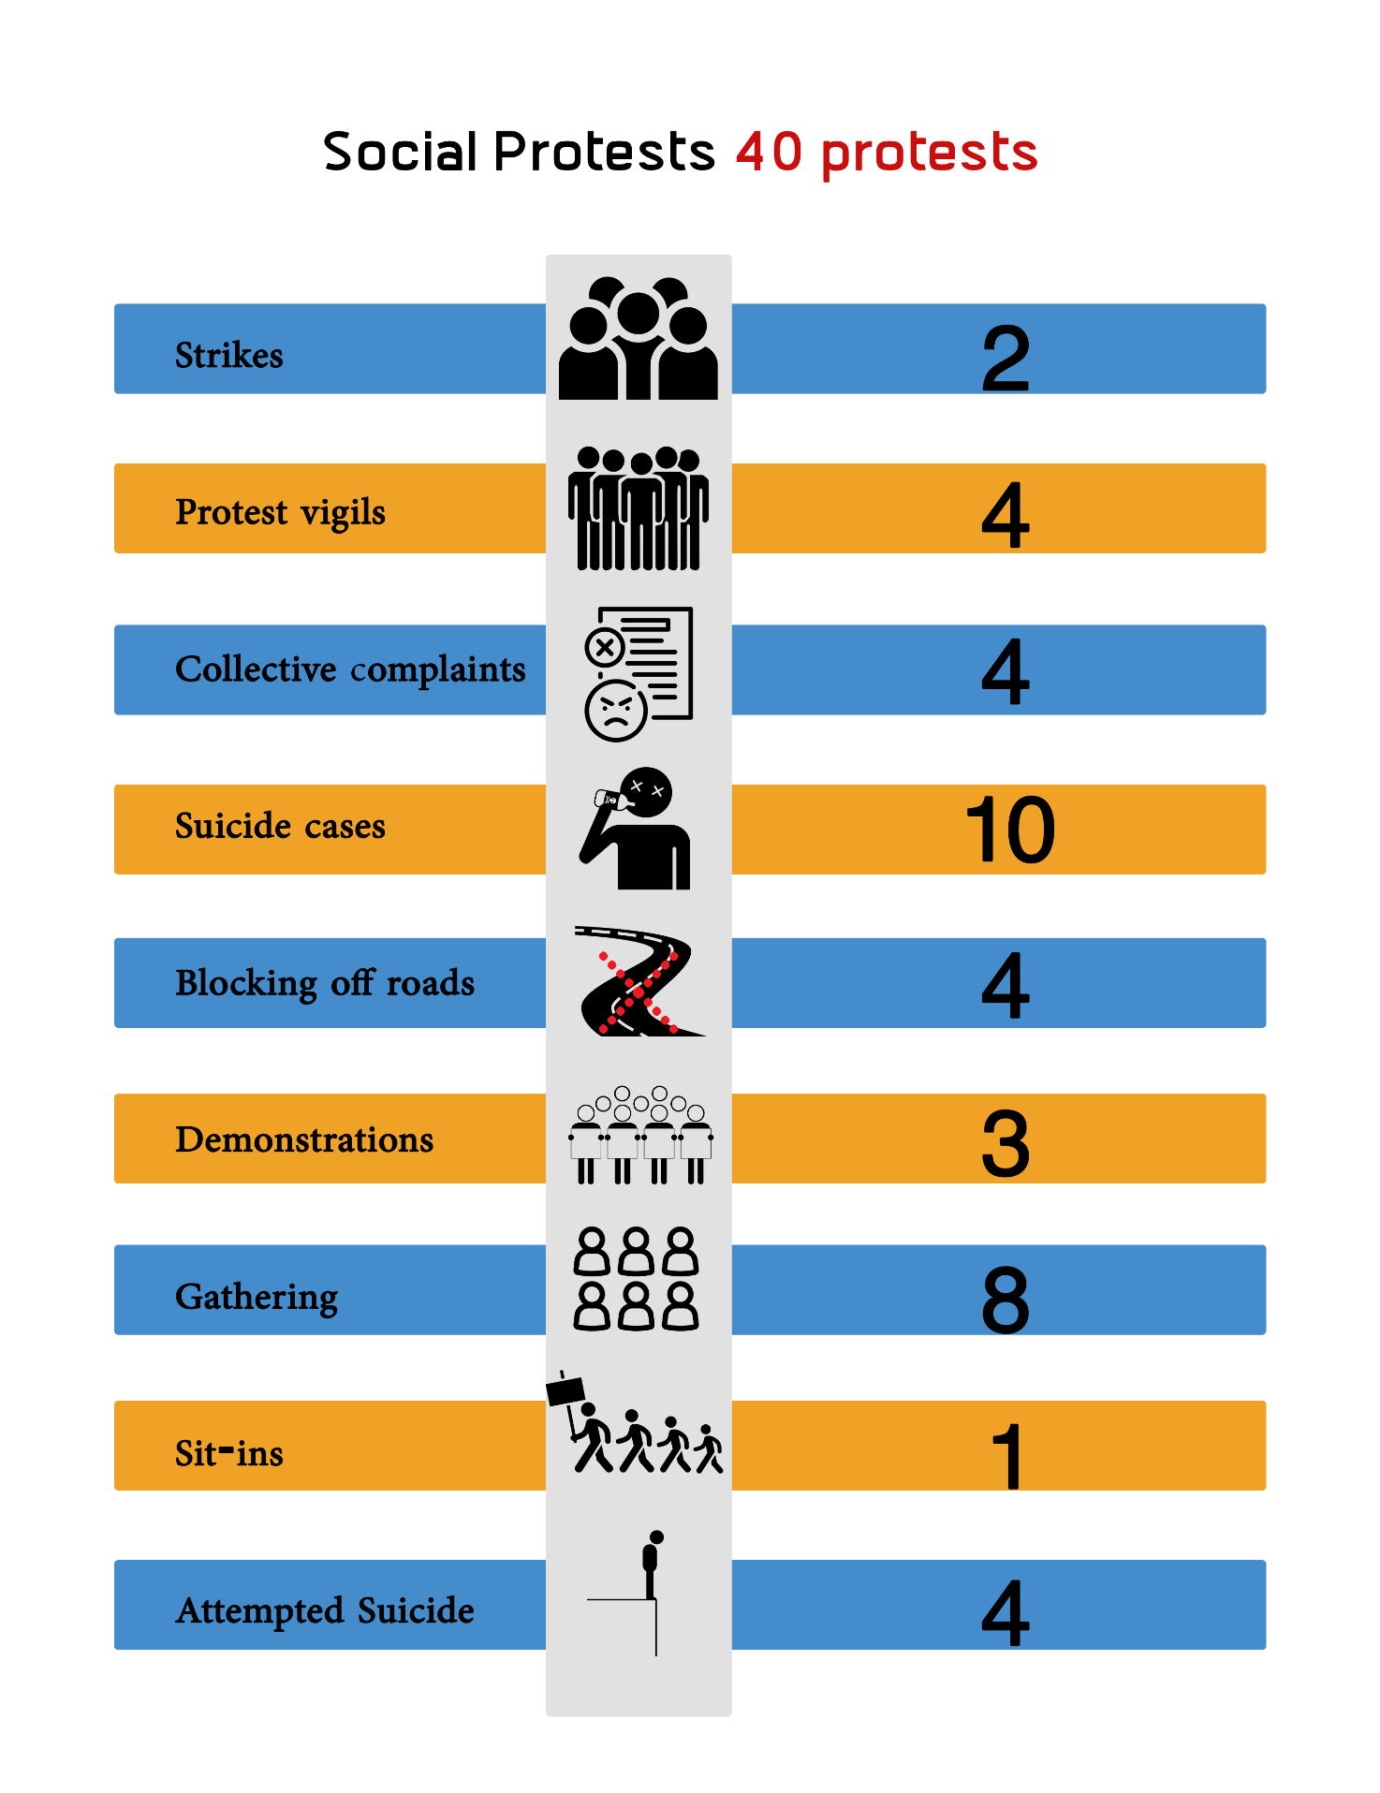
Details of social protests:
Details and location | Kind of protest
- Inmates at Tora Istiqbal prison went on strike to protest against the torture they are enduring  - A group of 300 students went on school strike at "Manshiet Al-Yaqoubia" in Al-Gharbia governorate | strikes (2) | - 1
- Students at the American University in Cairo organized a demonstration on campus to protest against the university administration decision to increase the tuition fees  - African refugees organized a protest in front of the United Nations High Commission for Refugees in Giza  - Industrial Education students organized a protest vigil in front of the Ministry of Education Directorate in Downtown Cairo  - Residents of "Al-Mandarawa" area in Kafr El-Sheikh governorate organized a protest | Protest vigils (4)
- Residents of "Mokattam" region filed a collective complaint against restaurants owners  - Students of Social Service Institute filed a collective complaint against faculty members  - Residents of "Kafr Shokr" city filed a collective complaint against the Electricity Company in Dakahlia governorate  - A group of students' parents filed a collective complaint against Al-Tud Educational Administration in Luxor governorate | Collective Complaints (4)
- A housewife committed suicide due to the accumulation of "debts"  - A young man took his life after passing through a financial distress at Al-Qanater Al-Khayriya area in Qalyubia governorate  - A man committed suicide after he suffered a psychological distress in Suez governorate  - A high school student committed suicide after passing through a financial crisis in Alexandria  - A citizen sets himself on fire in Tahrir Square in Cairo for not finding a job in the governorate  - A young man committed suicide in Sharqyia due to his financial hardship  - A company director in Obuor City committed suicide after passing through a financial crisis  - A plumber killed himself in Dakahlia governorate after he suffered a psychological distress because he couldn’t afford to cover his family’s expenses  - A worker committed suicide in Qalyubia governorate after passing through a financial distress  - A housewife took her life for not being able to pay back her debts | Suicide cases (10)
- Supporters of a parliamentary candidate blocked off the road to protest the election result in Qena governorate  - Supporters of a parliamentary candidate blocked off the road to protest the election result in Dakahlia governorate  - Residents of al-Munib district blocked the road to protest the demolitions of buildings and houses in Giza  - Residents of Zarqoun area in Beheira governorate blocked the road to protest the demolition campaign. | Blocking off roads (4)
- People of North Sinai villages organized a protest to demand the right to return to their homes  - Residents of Awamiya village in Luxor organized a demonstration  - Residents of Sidi Kreir demonstrated to protest their displacement from their homes in Alexandria. | Demonstrations (3)
- The Libyan community gathered in front of their consulate in Cairo  - Dozens gathered in front of a mutual funds firms in Qena governorate  - Dozens of people gathered in the villages of Upper Egypt to denounce the anti-Islamic caricatures  - A group of the Sudanese diaspora gathered in front of the Sudanese child's house Muhammad Hassan  - A group of religious extremists gathered against the Copts in Minya  - The family members of a person who died as a result of medical negligence gathered in front of Mahalla Health Unit to denounce his death due to the lack of doctors  - A gathering in front of a sports club in Mohandessin district  - A gathering of Aswan's Nasr al-Nubia area residents | Gatherings (8)
- A sit-in by the Sudanese community in Giza demanding revenge for the child Muhammad Hassan | Sit-in (1)
- A citizen who tried to commit suicide after passing through a financial distress in Damietta governorate was rescued  - A citizen who tried to commit suicide after passing through a financial distress in Sharqyia governorate was rescued  - A citizen who tried to commit suicide after passing through a financial distress in Menoufia governorate was rescued  - A farmer tries to commit suicide by throwing himself from the top of his house in Al-Gharbia due to his financial crisis survived | Attempted suicide (4)

Third: The geographical distribution of social and labor protests:
Both Giza and Cairo topped the list of governorates that witnessed protest movements during the reporting period with 15 protests each, followed by Alexandria governorate with 13 protests, then came in third place the governorates of (Sharqyia, Aswan, and Qalyubia) with 9 protests each. The governorates of (North Sinai, Dakahlia, and Qena) came in fourth place with one protest each, as follows:
Governorates | Number of protests
Cairo | 15
Giza | 15
Alexandria | 13
Sharqyia | 9
Aswan | 9
Qalyubia | 9
North Sinai | 1
Dakahlia | 1
Qena | 1

