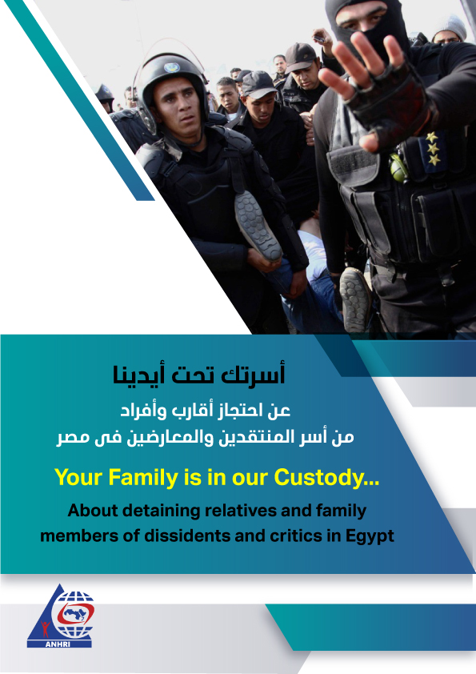

Your Family is in our Custody...
About detaining relatives and family members of dissidents and critics in Egypt
Introduction
The Egyptian Constitution stipulates the personality of the crime and punishment; i.e. penalties shall be imposed only on the perpetrator of the crime.
Article 95 of the Constitution provides that: "Penalties are personal. Crimes and penalties may only be based on the law, and penalties may only be inflicted by a judicial ruling. Penalties may only be inflicted for acts committed subsequent to the date on which the law enters into effect".
It is commonly acknowledged that criminal responsibility is personal, and therefore penalties should be inflicted and imposed only on the crime's perpetrator, in case the material and moral elements of the crime are fulfilled.
This is the law and this is what stipulated in the Constitution.
But what is happening in reality is totally different and incompatible with both the law and the Constitution.
The regime in Egypt prosecutes and punishes people only because they are the relatives and families of those who oppose or criticize it, whether they are held in custody as defendants or are living abroad. And of course, relatives of the Muslim Brotherhood members and leaders suffer the same harm; as they face the same accusations leveled against the opposition group's members, whether they committed such acts or not. Such an approach is sometimes used or adopted to exert pressure on opponents and critics- whether they are held as defendants in ongoing cases or moved abroad (expatriates)- or to retaliate against them by targeting their relatives, in violation of the Constitution and the law and in blatant disregard for human rights values and conventions.
This paper attempts to express the viewpoint of the Arabic Network for Human Rights Information (ANHRI) asserting the security services are defying the law and are using it as a tool for repression and revenge against political dissidents or opponents in general, whether they are inside or outside Egypt, by arresting their relatives and fabricating malicious accusations against them.
The paper also tries to refer to the extent of the judicial institutions' response and reaction to such attempts, and in the following lines, we will try to introduce some examples of these attempts, noting that there are many others but we refrain from mentioning them at the request of the defendants' families who fear of further oppression and abuse against their relatives.

Some examples:
1- Kamal al-Balshi (brother of journalist Khaled al-Balshi, former board member and deputy director of the Egyptian Journalists Syndicate's board)
He had been working in the field of tourism since his graduation and he is a member of Egypt's Chamber of Tourism Establishments. He was residing in Marsa Alam city, where he worked, before he moved to Cairo to stay with his brother Abdel-Sattar al-Balshi in downtown amid the coronavirus outbreak.
Kamal was arrested on 20 September 2020 while leaving his gymnasium near downtown Cairo. During a prison visit, he explained that the officer who stopped him had already released him before he realized that he is Khaled al-Balshi's brother so he arrested him again! He had been subjected to enforced disappearance for 11 days. Then on the 1st of October, he appeared before the Supreme State Security which added him to Case No. 880 of 2020 on charges of joining a terrorist group and spreading false news. Kamal al-Balshi is still being held in remand detention as of this writing.
It's not a hidden fact that Kamal al-Balshi has nothing to do with any political activity and those who conduct the investigative reports in the case know that. Kamal was arrested and detained just because he is the brother of journalist Khaled al-Balshi, who is a well-known opponent of the government and former head of the Freedoms Committee at the Journalists Syndicate.
2-Ola al-Qaradawi (daughter of Youssef al-Qaradawi)… and her husband Hossam Khalaf
A 58-year-old mother and grandmother to three grandchildren…
Ola al-Qaradawi's only offence is to be the daughter of Youssef al-Qaradawi, the famous scholar who is residing in Qatar. She was arrested on 3 July 2017 and interrogated into Case No. 316 of 2017 State Security and has been held in solitary confinement since then. On 6 July 2019, the criminal court ordered her release after spending two years in remand detention, bur she was "rotated" (added) into a new case for allegedly joining and financing a terrorist group, and managing meetings inside prison, despite the fact that she has been in solitary confinement since she was sent to prison. Ola is still behind bars in remand detention along with her husband just because she is the daughter of al-Qaradawi and bears his name.
3- Anas al-Beltagy (son of Mohamed al-Beltagy, Muslim Brotherhood's senior member)
"Anas" is now 26 years old. He was 19 years old at the time he was arrested…
Anas’s case constitutes the worst form of revenge against a person because of his father as his family assert!
Anas was arrested three months after the dispersal of the Rabaa Al-Adawiya sit-in. He was sentenced to 5 years in prison on charges of possessing firearms, inciting to violence, and joining a group that is established in contravention of the provisions of the law. The Court of Cassation then overturned the ruling and ordered Anas' acquittal in 2018, but as long as he bears the name of his father, he has to face an inevitable fate. The curse of "rotation"- adding pretrial detainees to new cases after receiving judicial release orders - had struck the young man to be investigated in seven successive cases in which he obtained two acquittals from different criminal and misdemeanor courts. He also received release orders pending other cases; however, in every time he was ordered to be released, he was rotated/ recycled into a new case over the same accusations.
And in this way, the young man just keeps going around in a closed circle; every time he is acquitted in a case, he is added to a new one and when he is declared innocent, he is included into a new case, and so on.
The circle of revenge does not stop at this point however. Anas has been denied family visits and daily exercise hours since 2017, during which he had never seen neither his family nor sunlight as if he is sentenced to die a slow death in prison.
4- Osama Morsi (son of former president Mohamed Morsi)
Osama Morsi is a lawyer and was a member of the defense team of his late father Mohamed Morsi. He was arrested from his home in the Sharqyia governorate on 8 December 2016, and had been tried in the case of "Rabaa sit-in dispersal" in which he was sentenced to 10 years in prison. Osama was arrested more than 3 years following the Rabaa sit-in dispersal incidents. He used to attend his father’s trial sessions and perform his duty and he hadn’t been arrested during this period, but after years of trying to defend his father he started to pay the price. Osama was sentenced to prison in a solitary cell, which he didn’t leave except twice; once to bury his father and the other time to bury his brother Abdullah Morsi.
5- Aaisha al-Shater (daughter of Khairat al-Shater)
She is the daughter of Muslim Brotherhood's senior leader Khairat al-Shater. She was arrested on 1 November 2018 and had been subjected to enforced disappearance for 21 days, during which she was being tortured, as she reported during investigation at the State Security Prosecution.
Aaisha is still being held in remand detention on a charge of joining a terrorist group pending Case No. 1552 of 2018 State Security. Languishing in solitary confinement and incommunicado, Aisha is deprived of prisoners' rights including exercise and family visits. She is also suffering medical negligence as she has aplastic anaemia, a rare and serious condition affecting the blood. Her health deteriorated rapidly and she was admitted with significant bleeding to Al-Qasr al-Ainy hospital. However, her condition requires ongoing specialist and intensive treatment in a properly equipped medical facility. In her current situation, her life remains at serious risk due to sepsis or bleeding.
Aaisha is a mother and her husband Mohamed Abo Horira is a human rights lawyer, who is held in pretrial detention pending the same case of her wife, although Criminal Procedure Law stipulates that in case two spouses are sentenced to prison and they have children, one of them shall be temporarily released until the other serves his sentence so that he or she can take care of their children. But this doesn’t happen because those who fabricate cases against innocent people won't care to implement the law and release either of the parents.
Article 488 of the Criminal Procedure Code states that "If two spouses are sentenced to imprisonment for a period of time not exceeding a one-year period, even if for different crimes, and said have not been previously imprisoned, the punishment sentenced on one of the spouses may be postponed until the release of the other if said are guardians of a child not exceeding exactly fifteen years of age and said have a known place of residence in Egypt".
Referring to this article, it is more appropriate to apply it to pretrial detainees who are still innocent until proven guilty by a court ruling, but the state refuses to implement the spirit of law, especially in the case of Aisha al-Shater who is being abused because of her father Khairat al-Shater.
6- Moaaz, Moatasem, and Mohanad Matar (brothers of media professional Moataz Matar)
Moaaz Matar was arrested in late December 2017 and was interrogated after being forcibly disappeared in January 2018 in connection with Case 640 of 2018 State Security in which he was accused of joining a terrorist group. On 4 February 2020, a release order was issued for him, but it wasn’t implemented, rather he was "rotated" and included into a new case over the same accusations. He is still languishing behind bars in remand detention as of this writing.
Moatasem and Mohanad were both arrested and investigated into Case No. 1413 and were released from the Prosecution thereafter. However, they were arrested and interrogated once more before being rotated into Case No. 1530 of 2019 in which they face the same charges of the previous case and are currently held in pretrial detention.
The three are facing incarceration and severe crackdown all because they are the brothers of Moataz Matar, the well known opponent and anchor for Al-Sharq TV.
7- Hazem Ghoneim (brother of Wael Ghoneim)
Hazem Ghoneim is a dentist and has nothing to do with politics. His name has never been mentioned prior to his arrest, which took place shortly after the reappearance of his brother Wael Ghoneim and his criticism of president al-Sisi on 19 September 2019.
Hazem Ghoneim was arrested to put pressure on his brother Wael Ghoneim, who later apologized for his criticism of the ruling regime, especially that Wael is not residing in Egypt and the authorities didn’t manage to arrest him, so they resorted to arrest his brother to exert pressure on him. Hazem appeared in the State Security Prosecution on September 21 and was charged with joining a terrorist group in Case No. 1338 of 2019 State Security, before he was released on 18 December 2019.
8- Islam and Youssef Mohamed Naguib (brothers of opponent Ghada Naguib who is residing in Turkey)
Ghada Naguib is a political activist who is residing in Turkey. Her brothers had been subjected to pretrial detention just because of their relationship with Ghada.
1. Islam Mohamed Naguib was arrested and interrogated in Case No. 441 of 2018, and a decision was issued to release him with precautionary measures.
2. Youssef Mohamed Naguib was arrested and interrogated in Case No. 441 of 2018 and after serving two years in pretrial detention, the Prosecution ordered his detention but the decision wasn’t implemented. Rather, he was subjected to enforced disappearance and brought once again before the Prosecution over the same accusations pressed against him in Case No. 880 of 2020.
9- Omar Magdy Shendi (Son of journalist and editor-in-chief of Al-Mashhad newspaper Magdy Shendi)
Omar is the son of the chief editor of Al-Mashhad newspaper and a student at the College of Music Education. He was arrested in September 2019 and was investigated in Case 1331 of 2019 State Security on charges of joining a terrorist group and spreading false news.
In fact, Omar has nothing to do with politics or public affairs, and has never been interested in journalism like his father. But like many others, he was arrested to punish his father and put pressure on him because the regime knows that this will be more painful to him.
Omar was ordered to be released on 22 September 2019, and the real reason behind his arrest is to pressurize his father to stop publishing the articles he used to publish in Al-Mashhad newspaper.
10- Mostafa Maher (brother of Ahmed Maher)
He was arrested in May 2019 and was interrogated in Case No. 741 of 2019 on charges of colluding with a terrorist group to achieve its goals and spreading false news. He was then ordered to be released with precautionary measures (appearing before the police station from 6 pm to 6 am) in March 2020 after spending one year in remand detention.
In fact, in Mostafa's case, there was no clear reason to put pressure on Ahmed, who, since his release from prison, hadn’t do nothing expect carrying out his precautionary measures (police surveillance) while trying to regain his normal life. However, he was arrested just because his brother Ahmed Maher is a political activist and a member of the April 6 opposition movement.
11-Mawwada al-Aqbawi (daughter of Osama al-Aqbawi)
Mawwada al-Aqbawi is a student at the Canadian University and the daughter of Dr. Osama al-Aqbawi, a businessman and member of the Supreme Committee of the Independence Party. She was arrested after the security forces raided her father's house in 24 June 2019 to arrest him, but because he wasn’t present at home they arrested her daughter to force him to turn himself in. Consequently, her father submitted a report to the Public Prosecutor and surrendered himself immediately thereafter, so that her daughter would be released from jail. However, the security services had reneged on their promise, as Mawwada appeared in the New Cairo Prosecution Office three days after being subjected to enforced disappearance. The girl was accused of joining a terrorist group and possessing publications and had been held in remand detention until she received a release order on 22 March 2020.
12- Five relatives of opposition human rights defender Mohamed Sultan
In response to a lawsuit filed by human rights defender Mohamed Sultan (residing in the United States) against former Prime Minister Hazem al-Beblawi, accusing him of direct responsibility for Sultan's treatment and overseeing his torture while in detention in the aftermath of the Rab'a al-Adawiya sit-in dispersal, the Egyptian security forces stormed the houses of five relatives and cousins ​​of Sultan in June 2020. The five relatives had been detained for five months until they were released in early November 2020. Although some people may relate their release with the victory of the Democratic candidate in the US elections Joe Biden, who always criticizes Egypt's human rights file, it is certain that they shouldn’t have been arrested in the first place and their relationship with Mohamed Sultan shouldn’t been a pretext for their arbitrary detention.
Conclusion
All the aforementioned examples prove that the constitutional principle which endorses the individuality/ personality of crime and punishment is being wasted nowadays.
Such examples don’t only reflect the undermining of constitutional principles through the incarceration of innocent people and the displacement of their families to retaliate against their blood relatives, but also they constitute an assault on citizens' freedom and personal safety and endanger the lives of some of them, as happened in Aaisha al-Shater's case. On the other hand, the coronavirus pandemic couldn’t serve to prompt the authorities to release them from prison to save their lives from such fatal disease.

