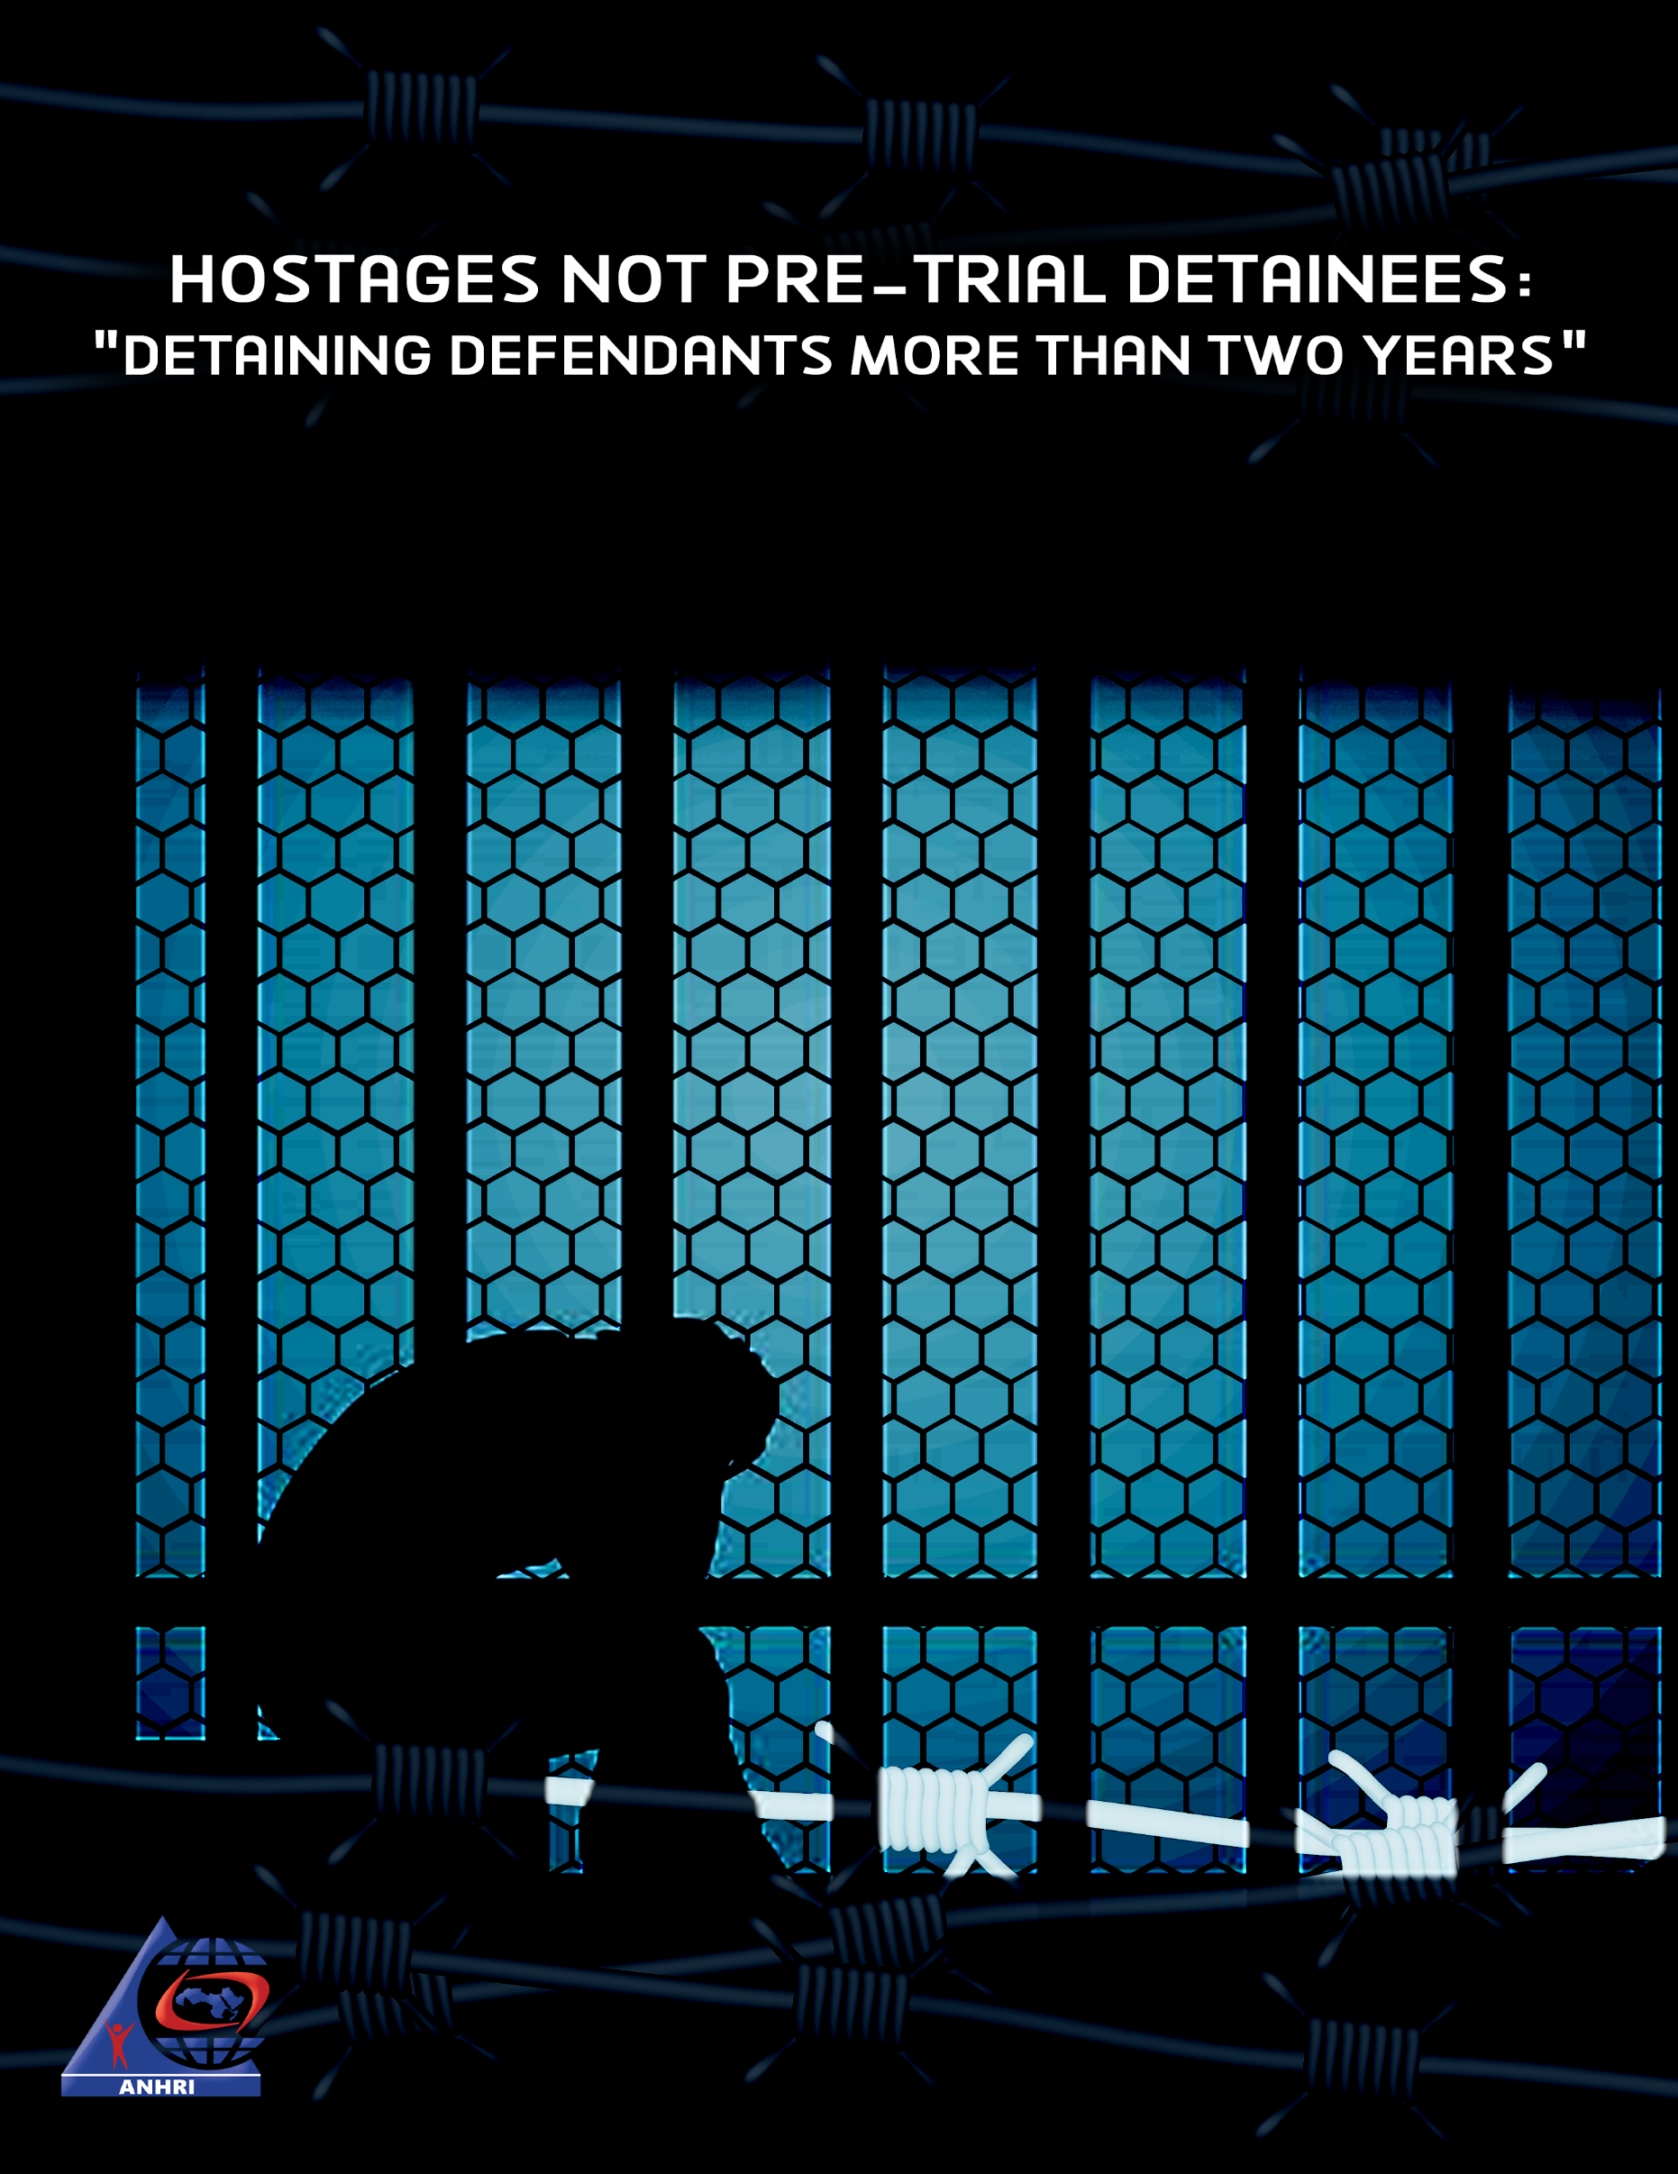

Hostages not Pre-Trial Detainees:
"Detaining defendants more than two years"

Introduction:
Their situation may even be worse than hostages. The hostage remains held until his relatives pay the ransom, or he or her parents fulfill something. But they do not know what is required of them to regain their freedom, some of them are hostages because they only expressed their opinions or criticisms, and some of them do not know why
s/he was detained, but they all do not know when and how to restore their freedoms. They are in custody, and most of them have exceeded the maximum limit of "two years" remand, however, they remain in detention outside the law, even if some are under false legal cover, which is called "rotation", they are on paper in reserve, but in practice, as the Ministry of Interior knows, the Public Prosecutor knows, and everyone knows: that they are hostages.
When the authority imprisoned political opponents for more than the period of pre-trial detention stipulated by both the constitution and the law, it went against all Egyptian legislation, and the families of those imprisoned outside the law for more than the legal period of pre-trial detention find no refuge or party to file their complaints.
Even the Public Prosecutor who has received reports and complaints from some of them!!
We are talking about hostages, some of them in retaliation for their opinions, some of them in revenge for their relatives, some of them are mistakes and nobody knows who can correct these mistakes. They all do not know what is required to regain their freedom.
They were detained or kidnapped by security services. This happens in many countries, and the solution is to resort to the public prosecution or the judiciary, but this does not guarantee justice! As Public Prosecution, itself, violates law and constitution, renew terms of detention a session after another, with no respect to the legal concept of assuming innocence.
Remember "Shadi Habash"? He died after spending in prison 26 months, two months after he had exceeded his remand! Even when the Public Prosecutor's Office issued a statement on his death, it ignored that it was a partner and that he was detained under its decision, and that it was responsible for exceeding the maximum length of pre-trial detention, but we neither forget nor we did or will. Shadi Habash was a hostage, died by kidnappers, with the knowledge of whom was supposed to protect him, it was by the public prosecutor's knowledge.

Pre-trial Detention: Accepting Oppression, while acceptance is not accepted!

Article 143 of the Code of Criminal Procedure, its last paragraph:
"The period of pre-trial detention may not exceed three months, unless the accused has been declared to be brought before the competent court before the end of this period. In such a case, the Public Prosecutor's Office must present the warrant of imprisonment within five days of the date of the declaration of referral to the competent court in accordance with the provisions of article 151, paragraph 1, of this Act in order to give effect to the requirements of these provisions, otherwise the accused must be released.
If the charge against him is a criminal offense, the term of pre-trial detention may not exceed five months unless it has been obtained before it has been ordered by the competent court to extend the term of imprisonment for a maximum of 45 days, renewable for a term or other similar periods, or the accused must be released.
In any event, pre-trial detention at the preliminary investigation stage and at other stages of criminal proceedings may not exceed one third of the maximum penalty for liberty, not more than six months in delicts, 18 months in criminal offenses, and two years if the penalty for the offense is life imprisonment or death.
However, the Court of Appeal and the Court of Cassation if the sentence was handed down to the death penalty or life imprisonment may order the provisional detention of the accused for 45 renewable days without being bound by the terms set forth in the preceding paragraph. "
Simply put, no matter how much the Interior and the prosecutor pleaded, whatever the charge against the accused, real or fabricated, he should not be held back for more than two years, 24 months.

This amendment to the duration of pre-trial detention was made by the interim president, Adli Mansour, in 2013, and people who got benefit from it are:
- Alaa and Gamal Mubarak, who were released and tried released until they were granted innocence in cases of corruption, presidential palaces and the pilots' land.
- Former Prime Minister Ahmed Nazif in 2016, benefiting from his excess of the term of pre-trial detention.
- Also King of Iron Ahmed Ezz 2017.
- Former Oil Minister Sameh Fahmy, who has exceeded his pre-trial detention period, spent 23 months in pre-trial detention.
But the law in Egypt is selective, as it takes the side of those who detroyed Egypt and turned it into a large prison, while it was violated when dealing with critics and opponents, just for opposing opinions.
Stating the conditions of pre-trial detention is irrelevant, we did it before, but justice has no place in Egypt.

Public Prosecutor
We make complaints, and reports, we are not asked to give our testimony or to start investigating.
We cannot criticize, who incarcerates innocent people, for longer than the maximum remand, whether they are rotated or forgotten, it is easy for him to keep you in prison if you criticize.

Some Hostages:
Some examples of prisoners who would not have been imprisoned, and whether they were “charged in new cases during their detention or before they exceeded the maximum period of pre-trial detention,” or they were not rotated. Of course, the space will not expand to monitor all cases of law violations and the defendants' conversion from pretrial detainees or prisoners of conscience, to hostages, we shall therefore enact examples of them
- Mahmoud Hussein
Date of detention: December 22, 2016; Media worker in Aljazeera channel network Media man Mahmoud Hussein was arrested on December 20, 2016 at Cairo Airport on his return from Doha and was referred to the State Security Prosecution, which decided to pre-detain him in custody in case No. 1152 of 2016 State Security, on charges of spreading false news and data about Egypt's internal situation, and the fabrication of false news and media reports and scenes.
On May 21, 2019, the Cairo Criminal Court decided to release the journalist under a precautionary measure but the decision was appealed against by the State Security Prosecution, and on May 23, 2019 the Cairo Criminal Court in a different district decided to reject the appeal and to support the release decision in implementation of the decision to release him.
On May 26, 2019, journalist Mahmoud Hussein was deported from Tora Prison for investigation, in implementation of the decision to release him, to police station cell of Giza, and on the same day he was transferred to the Abu Nomros Police Station, as he was informed of the implementation of the measure inside the police station. He was detained inside the station pending the arrival of the National Security signal to release him, but on May 27, 2019, he was taken to the State Security Prosecution and interrogated in the absence of his lawyer in Case No. 1365 of 2018, State Security was seized and imprisoned for 15 days and transferred to Tora Prison for investigation again.

- Badr Badr Mohamed Badr
Date of detention: 30 March 2017, former journalist and editor-in-chief of Al-Osra Al Arabya newspaper.
A preventive detainee pending trial No. 316 of 2017 State Security on charges of joining a group established in contravention of the provisions of the law and the Constitution, intended to disrupt state institutions and prevent them from operating.
On 3rd December 2019, the State Security Prosecution decided to release the journalist to exceed the prescribed period of detention by law and was deported to a third police station in October district. He was not released until early December 2019, the State Security Prosecution decided to release the journalist under residence guarantee, for exceeding the period of pre-trial detention. He remained in hiding until he appeared in the State Security Prosecution on February 25, 2020 and was investigated in case No. 1360 of 2019, State Security, charged with participating in a terrorist group, and decided to hold him in prison 15 days.

- Mostafa Gamal

Detained since 1st of March 2018, under accusations of participating in Rami Essam's song. There are claimes that Mostafa underwent violations like forced disappearance after arrest.
A decision of release issued after 28 months of his detention, he was rotated in a new cse no. 730 year 2020 State Security, with charges of joining a group founded in contravention to law, publishing false news and abusing social media. This took place after detaining him for two years and four months.
Mostafa Gamal is the last hostage held for the famous song after the death of director Shadi Habash, 24 years old, in Tora.

- Shadi Habash:
He was arrested in March 2018, for participating in Rami Essam's song.
He exceeded the stipulated duration of pretrial detention without being tried. He died in May 2020, two months after exceeding the pretrial detention legal period. Shadi Habash is a blatant example of a hostage that died during his detention.

- Motaz Wadnan:
A journalist who has been detained since February 2018, exceeding the maximum limit of detention for seven months.
He is an Egyptian journalist working for the Huffington Post Arabic. Moataz was famous when he was arrested by Egyptian authorities in February 2018 after an interview with Chancellor Hisham Genina in February 2018, where he addressed a number of topics including anti-corruption and support for Sami Annan instead of Abdel Fattah al-Sisi in Egypt's presidential election 2018.
Genina was arrested later on February 16 and the journalist Moataz, who had interviewed him, was arrested too. The prosecution issued a decision to release him, but the authorities have rotated him to case No. 1898 of 2019 (State Security), in which a group of activists face charges of "joining a terrorist group" and "spreading false news". He was held in custody for 27 months, pending case No. 441 of 2018.
The Wadnan family, in May 2020, issued a statement saying: "There is increasing concern, especially that (Moataz) has been subjected to medical neglect, starting from preventing him to wear his medical glasses, and by forcing him to interrupt the hunger strike he started. He was not allowed to leave his prison cell or to be exposed to the prison doctor after his kidney was hit by the strike, and he was prevented from sporting long periods during which he was infected with Rheumatology, and after consulting a private doctor about his condition, after he told his lawyer. we brought medicines and could not enter it.

- Ola Qaradawi:

On June 30, 2017, Egyptian authorities arrested Ola al-Qaradawi and her husband, Hossam Khalaf, claiming to be joining a group that had established in a violation of the law, planning terrorist operations targeting security and state institutions, and financing the group” and since then periodically renewed their imprisonment.
In July 2019, the Cairo Criminal Court released Ola al-Qaradawi with precautionary measures, hours later, the prosecution decided to jail her in a new case.
With the Egyptian authorities having arrested Hussam Khalaf and his wife Ola Al-Qaradawi, daughter of Sheikh Yousef Al-Qaradawi for three years, their daughter transmitted a video in which she expressed her fears on her parents, she spoke on behalf of Freedom to Ola and Hossam campaign, Aya Hossam, spoke of her parents facing threats under the Corona virus pandemic, condemning their detention in slitary confinement and prevention of family visits. She earlier asserted that her mother was subjected to torture for political reasons that had nothing to do with her, and also in retaliation of Sheikh Qaradawi, who is known for his hostility to Egyptian regime.

- Abdul Monem Abo Al Fotouh:
Detained since 2018, and a hostage seven months ago
The candidate for the 2012 presidential elections, the Secretary-General of the Arab Physicians Union, was a student leader in the 1970s and a former member of the Muslim Brotherhood Guidance Office in Egypt until March 2011.
He is now an institutional agent and chairman of Masr Al Qawya Party. He was arrested on February 14, 2018 after returning from London following an interview with Al Jazeera, in which he criticized President Abdel Fattah al-Sisi's rule.
Since the beginning of his imprisonment, Dr. Abdel Moneim Abu Al-Fotouh has been arbitrarily deprived of specialized health care, causing his health to deteriorate.
According to his family, Abul Fotouh suffers from many chronic diseases such as diabetes and blood pressure, as well as from severe heart muscle and prostate disorders, as well as severe sleep disorders, and over a year and a half of his absence in prison has led to a clear increase in the complications of these diseases. Abu Al-Fattouh suffers today from a worrying case of diabetes, in addition to new problems in the spine, especially neck, lumber and disk because of depriving him from sporting, which led to his appearance in recent sessions on a wheelchair after his movement stumbled. Abu Al-Fotouh is also suffering from severe prostate inflation, which entails urgent surgical intervention, not to mention the escalating heart muscle problems, which led to a repeat of his last angina pectoris on June 28-29, 2019, which threatens to deteriorate his health.

- Mohamed Adel:
Detained since July 2018, and held hostage two months ago. Mohammed Adel, one of the founders of the April 6 movement, was arrested by security services in Dakahlia on Thursday as he was leaving the Aga police station, following a three-year daily surveillance check-in, to carry out a previous judicial ruling. That was July 2017. That is, more than three years.

He was released from prison shortly afterwards, and was arrested in June 2018. Following a report by a citizen, the security forces arrested Mohammed Adel on June 18, 2018 after leaving Aga police station in Mansoura province for following up on the police surveillance sentence in another case and charged with joining a terrorist group and spreading false news · The Arab Network submitted a report to the Public Prosecutor that Mohammed Adel should be released for exceeding the term of pre-trial detention in July 2020, without a response! To become a hostage with knowledge and with the decision of the Public Prosecutor.

- Mahmoud Mohamed:

Mahmoud Mohammad.
Mahmoud Mohamed was released years ago, but his story remains a testimony to the scale of the injustice and oppression of the regime against its opponents, even when they are under the legal age. A young man who entered the prison is under 18 years old, and he got out of it on crutch, over 20.
“a homeland without torture”
A phrase was written on the T-shirt that was worn by Mahmoud Mohamed, the young man, or perhaps the child at that time.
The young man went out to celebrate the third anniversary of the January 25 revolution, on January 24, 2014, to be arrested for the phrase "homeland without torture" written on the "t-shirt" he was wearing.
Passing through the Marj check-point in Qalyubiyah, he had to wait for a trial for nearly 700 days.
The young man pointed out that the police officers deliberately targeted his right leg with severe torture after knowing that it suffers from injury, and targeted his genitals and other sensitive areas of his body.
The court's decision to release him was issued in the case: administrative No. 715 of 2014. Young man Mahmoud Mohammed was released on March 23, 2016, two months after the duration of legal pre-trial detention was exceeded.

- Mostafa Al Assar
His name is Ahmad Rajab and is known as Mustafa Al-Assar
Date of detention: February 4, 2018, freelance journalist, under preventive detention pending trial 441 of 2018; State Security on charges of joining a group established in violation of the provisions of the law and spreading false news. On May 7, 2020, the SSSC decided to release a journalist under residence guarantee for exceeding the prescribed period of pre-trial detention. On 10 May 2020, the SSSC investigated the journalist in a new case No. 1898 of 2019, charging him with promoting the ideas and purposes of a terrorist group and imprisoned him for 15 days.

- Shady Abo Zeid:
Shadi Hussein Abu Zeid is an Egyptian blogger and comedian born in Cairo. He has been famous since 2016 for some of his satirical videos and then became more famous as a reporter for the program "Abla Fahita” .
In 2016, Shadi, in partnership with another young actor, broadcast a video in which they gave condoms to security personnel in Tahrir Square as balloons, which provoked a major debate at the time and in one way or another contributed to his increasing popularity inside and outside Egypt.
On Monday, May, 2018, Egyptian police arrested Shadi and took him to an unknown place after they confiscated computers, phones, and other things from the house where he was living with his family. It was later discovered that the Egyptian security service
had taken the blogger to a prosecution in the suburbs of Cairo to investigate him. According to reports issued later, the SSSC has charged Shadi with heavy charges, including joining a terrorist group established in violation of the law aiming to call for the suspension of the provisions of the constitution and laws, and to prevent state institutions and public authorities from doing their work, as well as a publishing false news about the political and economic situations in the country.
In January 2019 Shadi's father died and the prison administration granted Shadi a controlled leave to bury his father. He attended the burial in the prison clothing.
In May 2020, a decision of release was issued, but Shadi was rotated in February 2020, following a decision to release him, as authorities accused him of meeting incitive elements in his prison! Shadi Abu Zaid is still held hostage by his kidnappers.

- Mohamed Al Qassas:
A dissident politician from the Brotherhood and a leading member of Masr Al Qawya party.
Arrested in February 2017, he was brought to trial in case 977 of 2017, known as "Mekamlin 2", in which he faced charges of involvement with the Muslim Brotherhood in "incitement against state institutions" of "organizational meetings with the group's armed movement elements to carry out operations in conjunction with the presidential elections" and "spreading false news".
On December 9, 2019, the Public Prosecutor ordered the release of Qassas, vice president of the Masr Al Qawya Party, pending the case No. 977 of 2017, known as the "Mekamlin 2" case, 22 months after his pre-trial detention.
The decision was "unique, final and came from the Public Prosecutor without any pretexts, with the guarantee of his residence and only, and irrevocable unless he finds new" but was implemented only today.
On January 21, 2020, the SSSC decided to renew Qassas detention, 15 days pending a new case, No. 1781 of 2019, after his release, on December 8, 2019 in case 977 of 2017, after nearly two years of solitary confinement in a highly-guarded prison.
For the second time, Muhammad al-Qassas was rotated, as his family and lawyer were surprised to present the Qassas to the State Security Prosecution for investigation in case No. 786 of 2020, on the same charges as he was accused in case No. 1781 of 2019 on 8 August 2020.
The court released him on Wednesday, August 5, 2020, after more than two years in pre-trial detention, the time prescribed by law for pre-trial detention.

- Aliaa Nasr El Din Awad:
Date of detention: October 23, 2017, journalist at Rassd site
In custody pending case No. 4459th of 2015, Helwan crimes, known as the Helwan Brigades case, on charges of joining a group based on the law's provisions and spreading false news.

- Ibrahim Metwalli:
Lawyer and founder of the Association of forcibly disappeared families.
Ibrahim Metwalli was arrested in September 2017, while traveling abroad, and was allegedly involved in case 970 of 2017.
During his release in October 2019, he was rotated in case 147 of 2019 to be imprisoned for 10 months, after the issuance of a release decision last August 2020, he was rotated for the third time in case 786 of 2020 a case that Mohamed Al Qassas, leading figure in Masr Al Qawya Party is detained in. Ibrahim is a prisoner since 2017, and a hostage a year ago.

Conclusion
These are examples of some hostages, which are just a few examples. We were unable to elaborate on all cases, because they are too many and difficult to enumerate. Physical, psychological and health violations to which the hostages are exposed, are crimes of which the Egyptian regime is accused.
The violation of law and the constitution by the Egyptian state is clear. Indeed, they no longer care or make an effort to hide or justify it. Egyptian authorities have resorted to a new trick to keep hostages inside prisons, which is a trick of "rotation".
The courts release the accused, and the National Security Service includes the accused in a new case on flimsy charges, which have reached the point of accusing the prisoners of committing terrorist crimes inside the prison, i.e. those in the custody of the state, for the prosecution to re-imprison them. This is to ensure that opponents are kept in jail.
Law can no more cover for the crime of kidnapping, crimes must be stopped, and those involved must be held accountable.

Darb Site: A statement by the family of journalist Moataz and Dunan. Posted May 2020 - Browse Date: August 2020 https://daaarb.com/%D8%A8%D9%8A%D8%A7%D9%86-%D8%A3%D8%B3%D8%B1%D8%A9-%D8%A7%D9%84%D8%B5%D8%AD%D9%81%D9%8A-%D9%85%D8%B9%D8%AA%D8%B2-%D9%88%D8%AF%D9%86%D8%A7%D9%86-%D8%A8%D8%B9%D8%AF-%D9%88%D9%81%D8%A7%D8%A9-%D8%B4%D8%A7/?fbclid=IwAR2RNdeobbR5Nfx27QFl00DrS-IO5Ue3hXIJVmQuh5XTOITovlnzIchZ6v4
Freedom for Ola Al-Qaradawi's page :Aya Hussam. Posted July 2020 Browse: August 2020 https://www.facebook.com/Freeolahosam/videos/273476130389313/?__xts__[0]=68.ARCDGp4-nkrPkWwZufJxIAhJ39aCh-j_1JTCqDd-3X0EErWNL8_q9zSs1cwABj9dIlKV4pD47csxJLvwHtGYlQM1psEjOQAqCvXBSAo7ikO6krpKYdQ6VzfnsvzXJt5_TRbtdyjCovhqLs4tZf0mu6-HpGxWYBRXe6EDeeOXjNs2ixDJD3eTe6-iSho1Axrg-sbwuxgkmcgQ8moyzuV5d8swYosrPYU10TCAYPVjIRv1axmxKmPT7ZhXbVFpYi0psEZraE63OgUpSDe6q9qJnkzt-u70cyDCTgWrhKh6SEZtMXDseAQf9_2nbbOzF4wATPLr12_RkI3j4AA1CT6fTXv0aSs&__tn__=H-R
Cairo Center for Human Rights Studies. Posted July 2019 Browse: August 2020 https://cihrs.org/%D8%A7%D9%84%D8%A5%D9%87%D9%85%D8%A7%D9%84-%D8%A7%D9%84%D8%B7%D8%A8%D9%8A-%D8%B9%D8%A8%D8%AF-%D8%A7%D9%84%D9%85%D9%86%D8%B9%D9%85-%D8%A3%D8%A8%D9%88-%D8%A7%D9%84%D9%81%D8%AA%D9%88%D8%AD/
Al Masry Al Youm: Arresting Mohammad Adel. Posted July 2017 – browsing date August 2020 https://www.almasryalyoum.com/news/details/1158847

