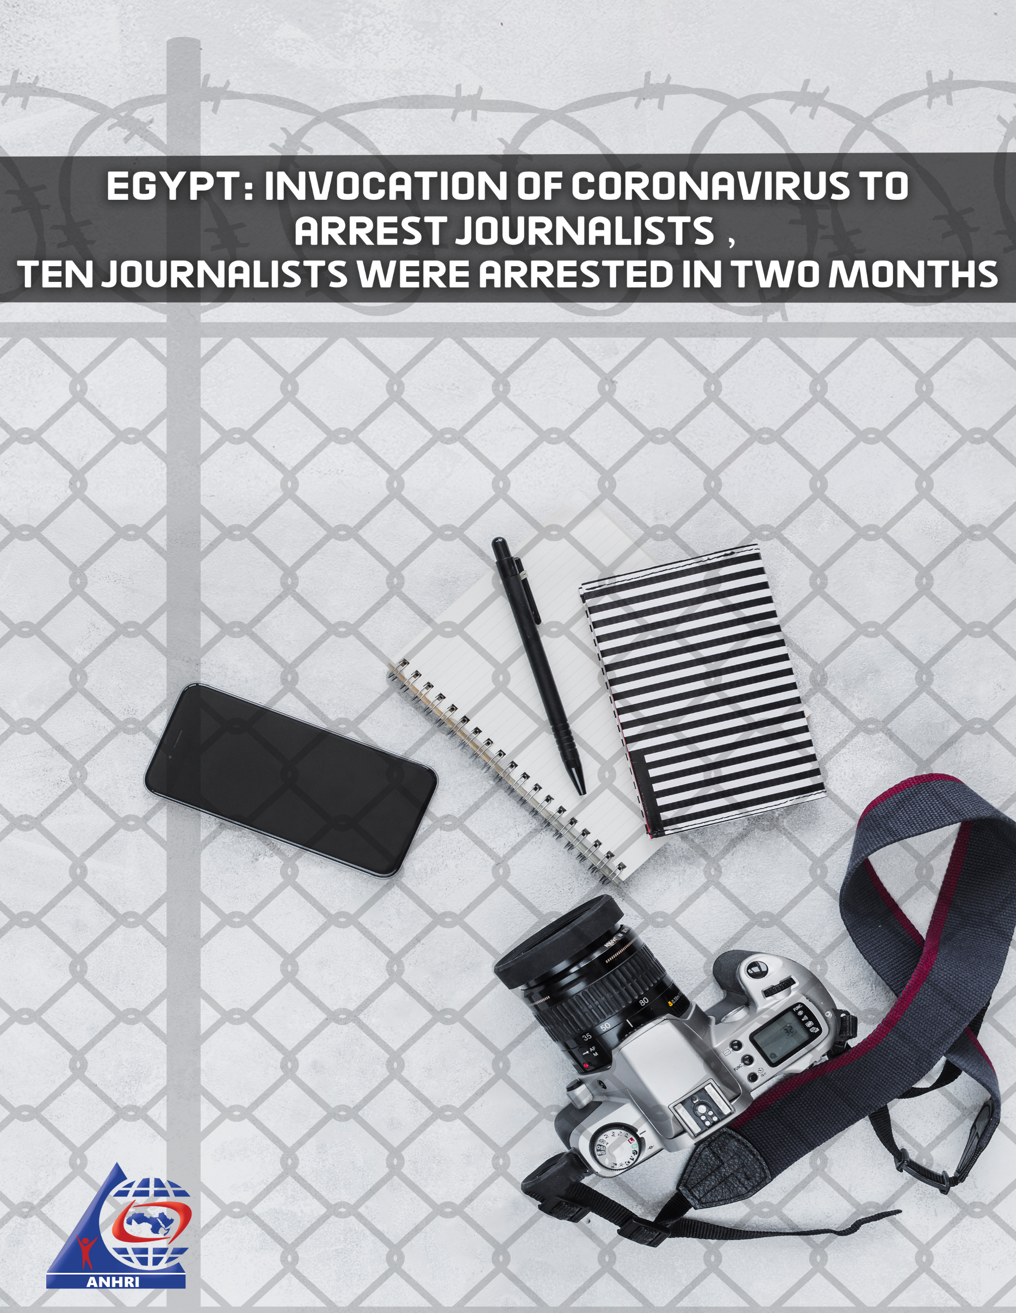

Egypt: Invocation of Coronavirus to Arrest Journalists,
Ten Journalists were Arrested in Two Months

Introduction:
While the whole world is suffering from a pandemic, in which the most developed countries lost control on its health systems, causing hundreds of thousands deaths worldwide. And while all countries worldwide try to contain the propagation of this pandemic, taking all measures to protect citizens, including prisoners, as the United States released a number of convicted prisoners. Moreover, one of the most fierce dictatorships; the Iranian regime, has released a number of detainees in the framework of measures to counter the virus spread.
The international community, under this crisis, demands to release even convicted prisoners in order to avoid the propagation of the pandemic. Nevertheless, the Egyptian authorities did not meet this demands, moreover, it increases the congestion in prisons by more illegal arrests which are closer to vengeance and silencing voices, detaining citizens, journalists, activists and translators. Adding to this the Egyptian regime, practices its favorite hobby which is “enforced disappearance” on some detainees, who disappear for a while them appear before the prosecution to be accused with repetitive accusations of “joining a terrorist group, publishing false news to threaten security and misuse of social media”.
Egyptian authorities also prevented visits by families of detainees, either in custody or in prison, and prevented any contact between prisoners and their relatives, which raises concerns among the detainees' families, especially with the death of director Fadi Habash
inside Egyptian prisons, raising doubts about the nature of his death. In particular, he had exceeded the period of pre-trial detention, which the law provided for a maximum of two years, at which time he was held in custody for two years and two months.
It is worth mentioning that the health conditions in Egyptian prisons are deteriorated, and prisoners do not receive the necessary health care, especially those who suffer from chronic diseases, and consequently, there are serious fears that the Coronavirus epidemic may spread in Egyptian prisons, which may lead to an inevitable disaster.
In this paper, we review journalists who were arrested between 18 March - the period of the epidemic officially being announced in Egypt - until 18 May, and we will display names and cases in chronological order from newest to oldest.

1- Lina Atallah:
The Egyptian security forces, arrested Lina Atallah, journalists and editor-in-chief of Mada Masr website, on 17th May 2020, after she interviewed dr. Laila Soweif, who went into hunger strike in solidarity with her arrested son, Alaa Abdul Fattah, who has went into hunger strike in protest against deteriorated situation in prison and depriving him from his family visit. Despite that Lina was cleared of any accusations, however, she was released with bail of 2000 L.E.

2- Sameh Hanin:

On May 16, Egyptian security forces arrested journalist and photographer Sameh Hanin, director of the “Pope's Life” film, and charged him with “helping a terrorist group in the fulfilling its goals” under case No. 586 of 2020, exclusive supreme state security, ... "Although he is a Christian secular," after preparing a documentary about a comedian band “Tholathy Adwaa Al Masrah” and selling it to Al Jazeera. The prosecution ordered him to be imprisoned for 15 days pending investigation into the case of 586 Supreme State Security.

3- Haitham Hassan

On May 11, 2020, Egyptian security forces arrested Haitham Hassan, a journalist in Al-Masry al Youm newspaper, after being accused of joining a terrorist group, financing that group and publishing and broadcasting false news, on the grounds of his participation in filming the documentary about a comedian band “Tholathy Adwaa Al Masrah” and selling it to Al-Jazeera.

4- Moataz Abdul Wahab:

On May 5, Egyptian security forces arrested journalist Moataz Abdel Wahab, who was making the above-mentioned film in collaboration with Haitham Hassan and Sameh Hanin. Egyptian authorities have hidden the director for five days, then appeared in the Supreme State Security Prosecution to be accused of joining a terrorist group in case 588, exclusive supreme state security and detaining him for 15 days pending investigation.

5- Mostafa Saqr:
On Sunday, April 12, Egyptian security forces arrested journalist Mustafa Saqr, editor-in-chief of the ASE, and owner of Business News, which is published by Daily News Egypt, pending the case No. 1530 of 2020, exclusive supreme state security. He was taken to one of the national security headquarters. He was then brought before the SSSC on the morning of April 13, and charged with joining an "unknown group" and ordered to be detained for 15 days pending investigation. Authorities issued a decision against Mostafa Saqr, founder of Business New Zealot, the decision was issued by Brotherhood's money Management Committee from Cairo Court of urgent matters in 2016 to hold and freeze his financial accounts and properties and prevent him from acting in it, claiming that these accounts and properties belong to the Brotherhood members.

6- Khaled Ghoneim

Khaled Ghoneim, a camerage broadcaster and Al Moshakes program presnter, was arrested by Egyptian security forces from his home in Alexandria governorate on April 13 and hidden for 15 days at the National Security Service headquarters in Samoha region. Until he appeared in the Supreme State Security Prosecution, April 28, 2020, to be investigated the case No. 558, supreme state security, and was accused of joining a group founded against law and broadcasting false news, after publishing news about the Corona epidemic.

7- Ahmed Allam:

Security forces arrested journalist Ahmed Allam from his family's house in El-Aayat, Giza Governorate, on April 21. He was hidden for 6 days at the Ayat police station and the National Security headquarters in Sheikh Zayed until he appeared in the SSSC on April 27, 2020, to be investigated case No. 558. Set to April 26. The prosecution accused him of joining a terrorist group, broadcasting false news and abusing social media, and ordered him to be imprisoned for 15 days pending investigation.

8- Atef Hassaballah:

On 18th March, security forces arrested Atef Hassaballha, editor-in-chief of “Al Qarar Al Dawly” newspaper, before his house in Aswan governorate. He was hidden from one month in several places; in Nassr police station in Nubia, then in Komobo police station then in National Security headquarter in Aswan, until he appeared in SSSC on 14th April 2020 to be investigated in case no. 558 State Security. He was interrogated about his work in newspapers and posts on his facebook account commenting on the number of corona patients and his criticism to the numbers announced by the state. He was accused of joining a terrorist group and publishing false news and he was ordered to be imprisoned for 15 days pending investigations.

9،10- Reaccusing Mostafa Al Asar and Moataz Wadnan:

Moataz Wadnan, a journalist in the Arab site of Haffington Post, has held an interview with Hisham Genina after Sami Annan declared his desire to run for the presidential elections, Hisham Genina, former head of the Central Auditing Agency, and Sami Annan campaign official, has launched controversial statements in his interview with Moataz. After Genina and Samy Annan were arrested, Wadnan was arrested in February 2018, and in case No. 1898 of 2019 he was accused of joining a terrorist group and broadcasting false news. He was released on May 7, 2020 after he had exceeded his legal pre-trial detention, but it was ink on paper, where he was imprisoned after joining a new "rotation" case with Mostafa Al-Asar on May 8, 2020. Mostafa al-Asar, a journalist, was also arrested in 2018 pending case No. 441. Both, Wadnan and Al-Aasar had passed the constitutional term of pre-trial detention and, after ordering the release, they were taken over by the Public Prosecutor's Office and brought into the case No. 588 of 2020 despite being in prison for more than two years and not having any activities of any kind. Once released from the two cases in which they were being held, they were ordered to be held in custody for 15 days in a new case.

Conclusion:
Ten journalists have been deprived of their freedom since the announcement of the Corona epidemic, whether they belong to the official or electronic press, it is a huge number of journalists in about two months, and it included cases that appear to be prepared for anyone who talks about the pandemic and the circumstances the country is experiencing.
The regime accused all those in it of spreading false news and joining a terrorist group. The case includes a number of Internet activists and lawyers beside journalists. Despite the recommendations of the World Health Organization and its emphasis on the need for social distancing, blemish and purification of all movables before and after use, and despite its emphasis on the need to move in the strictest limits to prevent contagion, and despite the fact that many countries, democratic or dictatorial, comply with these recommendations. But the Egyptian regime seems to have another opinion, as it risks the lives of citizens and even the lives of officers who are assigned to take missions to arrest anyone who expresses his opinion, without taking the necessary measures and instead of easing the load inside the Egyptian prisons that suffer from the deterioration of the health conditions, the Egyptian regime is stacking prisoners in prison, exposing the lives of all, including officials, officers, and prosecutors, to the risk of infection.

Website 24: US releases prisoners for Corona Posted: April 2020 Browse May 2020 https://24.ae/article/560319/%D8%A7%D9%84%D9%88%D9%84%D8%A7%D9%8A%D8%A7%D8%AA-%D8%A7%D9%84%D9%85%D8%AA%D8%AD%D8%AF%D8%A9-%D8%AA%D9%81%D8%B1%D8%AC-%D8%B9%D9%86-%D8%B3%D8%AC%D9%86%D8%A7%D8%A1-%D8%A8%D8%B3%D8%A8%D8%A8-%D9%83%D9%88%D8%B1%D9%88%D9%86%D8%A7
Russia today website: Iran releases 85,000 prisoners temporarily. Posted March 2020 Browse by May 2020 https://arabic.rt.com/world/1094557-%D8%B1%D9%88%D9%8A%D8%AA%D8%B1%D8%B2-%D8%A5%D9%8A%D8%B1%D8%A7%D9%86-%D8%AA%D9%81%D8%B1%D8%AC-%D9%85%D8%A4%D9%82%D8%AA%D8%A7-%D8%B9%D9%86-85-%D8%A3%D9%84%D9%81-%D8%B3%D8%AC%D9%8A%D9%86-%D8%A8%D9%8A%D9%86%D9%87%D9%85-%D8%B3%D9%8A%D8%A7%D8%B3%D9%8A%D9%88%D9%86-%D9%81%D9%8A-%D8%B8%D9%84-%D8%A7%D9%86%D8%AA%D8%B4%D8%A7%D8%B1-%D9%81%D9%8A%D8%B1%D9%88%D8%B3-%D9%83%D9%88%D8%B1%D9%88%D9%86%D8%A7/
Russian Today website : Hours after arrest by Egyptian authorities, Lina Atallah released on bail, Published: 17 May 2020 Date of browsing: Same day https://arabic.rt.com/middle_east/1115019-%D8%A8%D8%B9%D8%AF-%D8%A7%D8%B9%D8%AA%D9%82%D8%A7%D9%84%D9%87%D8%A7-%D9%84%D8%B3%D8%A7%D8%B9%D8%A7%D8%AA-%D8%A7%D9%84%D8%B4%D8%B1%D8%B7%D8%A9-%D8%A7%D9%84%D9%85%D8%B5%D8%B1%D9%8A%D8%A9-%D8%AA%D8%AE%D9%84%D9%8A-%D8%B3%D8%A8%D9%8A%D9%84-%D8%A7%D9%84%D8%B5%D8%AD%D9%81%D9%8A%D8%A9-%D9%84%D9%8A%D9%86%D8%A7-%D8%B9%D8%B7%D8%A7-%D8%A7%D9%84%D9%84%D9%87-%D8%A8%D9%83%D9%81%D8%A7%D9%84%D8%A9/
Darb: Photo story, two journalists and a lawyer. Posted May 17, 2020 Date of browsing: Same day. https://arabic.rt.com/middle_east/1115019-%D8%A8%D8%B9%D8%AF-%D8%A7%D8%B9%D8%AA%D9%82%D8%A7%D9%84%D9%87%D8%A7-%D9%84%D8%B3%D8%A7%D8%B9%D8%A7%D8%AA-%D8%A7%D9%84%D8%B4%D8%B1%D8%B7%D8%A9-%D8%A7%D9%84%D9%85%D8%B5%D8%B1%D9%8A%D8%A9-%D8%AA%D8%AE%D9%84%D9%8A-%D8%B3%D8%A8%D9%8A%D9%84-%D8%A7%D9%84%D8%B5%D8%AD%D9%81%D9%8A%D8%A9-%D9%84%D9%8A%D9%86%D8%A7-%D8%B9%D8%B7%D8%A7-%D8%A7%D9%84%D9%84%D9%87-%D8%A8%D9%83%D9%81%D8%A7%D9%84%D8%A9/
Egyptian Front for Human Rights website, Published: 13 May 2020 Date of browsing: 17 May 2020 https://egyptianfront.org/ar/2020/05/%D8%AD%D8%A8%D8%B3-%D8%A7%D9%84%D8%B5%D8%AD%D9%81%D9%8A-%D9%87%D9%8A%D8%AB%D9%85-%D8%AD%D8%B3%D9%86-%D8%B9%D8%A8%D8%AF-%D8%A7%D9%84%D8%B9%D8%B2%D9%8A%D8%B2-%D9%81%D9%8A-%D8%A7%D9%84%D9%82%D8%B6%D9%8A/

