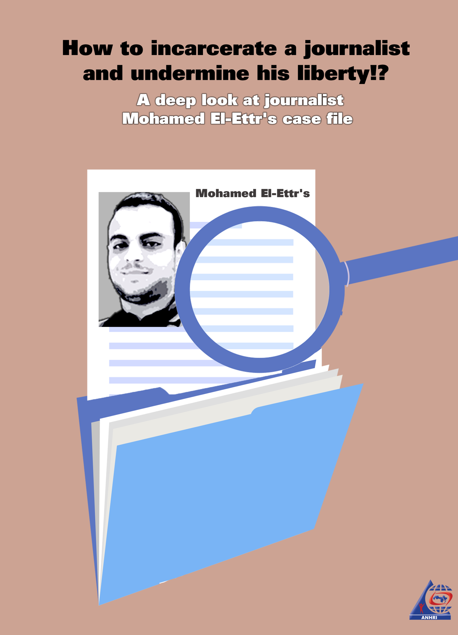

How to incarcerate a journalist and undermine his liberty?!
A deep look at journalist Mohamed El-Ettr's case file

First: Facts that fabrication cannot hide
- Mohamed El-Ettr was arrested from his house on 16 February 2020
- During his arrest, his laptop and his personal phone along with his wife's phone (Apple iPhone) were seized.
- Immediately after his arrest, his family sent telegraphs to: The Public Prosecutor, the public attorney of Southern Giza prosecutions, and the Minister of the Interior (Three bodies).
- Following his arrest, Mohamed El-Ettr's lawyers at the Arabic Network for Human Rights Information (ANHRI) submitted an official report to the Public Prosecutor (No. 15866 of 2020).
- El-Ettr hadn’t appeared before the Prosecution unless on 17 March 2020, a month after his arrest and enforced disappearance. However, the National Security Officer falsely claimed that the journalist was arrested on March 16 and that the investigation record was filed on the same day.
- Only the defendant's laptop was held as a potential exhibit while his cell phone wasn’t mentioned in the case file, as it was illegally seized by the security forces.
- The fabricated investigations included that "El-Ettr possesses weapons, ammunition, explosives, and dual-use explosive items in preparation for using them to attack security forces and carry out his hostile acts", despite the fact that only the laptop was proved to be in his possession.
- Under no evidence, the Prosecution repeatedly ordered the journalist's detention, without looking at the documents submitted by ANHRI's lawyers, which include evidence that their client was arrested in mid February refuting the National Security officer's allegation that the arrest took place in mid March.
Second: Unsubstantiated investigation and accusations
Question: What do you say about what is attributed to you that you are accused of joining and assuming the leadership of a terrorist group (Muslim Brotherhood group), while being aware of its goals; committing terrorist crimes and using terrorism as a means to achieve and implement these purposes, as indicated in the papers?
Answer: It didn’t happen.
Question: What do you say about what is attributed to you that you are accused of possessing a printing and recording means which you used to disseminate "takfiri" (blasphemy) views against the army and the police while targeting them using hostile operations, in addition to targeting the Christian community and their places of worship, calling for killing them and seizing their property, and targeting vital facilities, especially those affiliated with the security forces?
Answer: It didn’t happen.
Third: The case proceedings
The Haram Prosecution leveled the aforementioned baseless charges against the 20-year journalist Moahmed El-Ettr, 30 days after he was arrested from his home and forcibly disappeared. El-Ettr is a journalist who works as an editor and proofreader for the automotive, technology, science, health and tourism departments of the "Ultra Sawt" website since April 2017.
- He was arrested from his house on 16 February 2020 and had been forcibly disappeared for 30 days until he appeared on 17 March 2020 at the Haram Prosecution, where he was interrogated pending the Case No. 11429 of 2020 Haram Misdemeanor over the abovementioned charges.
- Immediately after his arrest, El-Ettr's family sent several telegraphs to the Public Prosecutor, the public attorney of Southern Giza prosecutions, and the Major General the Minister of the Interior. His family reported and proved the case of their relative's arrest from his home in addition to the intimidation of his wife and baby girl. In the meantime, ANHRI's Legal Unit filed a complaint (No. 15866 of 2020) with the Public Prosecutor reporting the incident of El-Ettr's arrest and its circumstances and calling for disclosing the journalist's whereabouts. ANHRI also demanded to open an urgent investigation into the matter and to hold those responsible or implicated in the incident accountable.
Fourth: Investigation, the vicious episode
With a one-page investigation paper which contains only unsubstantiated and flimsy words with no supporting facts or evidence or even a single presumption that can prove El-Ettr's involvement in such illegal acts, the journalist's detention is being renewed. So, what does the investigation paper revolve around?
- The National Security officer started the preamble of his investigation paper, dated 3/16/2020 at 2 pm, with the sentence commonly known for all those working in the field of law and is frequently used in most trumped-up arrest warrants and investigation records; which is: "We have received information from our confidential (reliable) sources, as confirmed by our (accurate) inquiries, that a number of leaders and cadres of the Muslim Brotherhood (MB) terrorist group, under the supervision of the MB's top leadership “The Higher Administrative Committee”, have been involved in the escalation of the group's terrorist and sabotage acts all over Egypt's governorates, in continuation of their denunciation of the June 30 Revolution." The investigation record continued as follows:
- "They orchestrated a plot to stir chaos and sabotage based on two paths: The first one is creating a security chaos in the street or what they call the "revolutionary movement".
- The second path is represented in "the direct targeting of members of the judiciary, armed forces and police as well as the public and private establishments, in addition to the use of some mechanisms and means to implement their aforementioned plan, i.e. (Arranging the necessary financial support for their hostile and subversive activities - preparing and calling for protest gathering and sit-ins at public squares in the Giza Governorate and other governorates- blocking public roads and transportation- printing and distributing posters, leaflets and statements that incite against state institutions) etc..
- The officer who conducted the investigation went on saying that: The inquiries and information have confirmed the aforementioned (Mohamed El-Ett)'s possession of weapons, ammunition, explosives, and dual-use explosive items in his place of residence, in preparation for using them to attack security forces and carry out his hostile acts among his fellow members of the organization.
- Based on this single miserable paper and such baseless and unsubstantiated investigation, the Public Prosecution unfortunately issued, on 16 March 2020, an order to arrest "El-Ettr", who had basically been in the custody of this National Security officer for 30 days!
In this regard, the Court of Cassation ruled that: Police investigation, as a presumption, is nothing more than a mere opinion of the one (police officer) who conducts it, and cannot be used, in itself, as sufficient or independent evidence to prove the accusation.
Fifth: The (deliberately) untold story
- During the arrest of El-Ettr, the security forces seized his laptop as an exhibit. His mobile and his wife's iPhone were also seized but were not held as exhibits. The security forces also did not find any of the explosive materials, weapons, or ammunition, or any pamphlets or messages that include statements inciting against the Egyptian state, or plans for specific terrorist operations to be committed against the state or to attack any of its establishments (the army or the police), as the National Security officer who conducted the investigation falsely claimed; because if the security forces found any of such items, they would have held it as exhibits to be presented to the Public Prosecution to take the necessary action. But in fact, the security forces raided El-Ettr's house, terrorized his wife and baby girl and seized his laptop as an exhibit, while illegally confiscating his personal belongings including his phone and his wife's, an act that is deemed by the law as a theft crime. Article (311) of the Egyptian Penal Code states that "whoever peculates a movable owned by another person shall be a thief", and since the officers in charge of implementing the arrest warrant against El-Ettr had violated their authorized task; by seizing the defendant's personal belongings without holding them as exhibits to be presented before the Prosecution accompanying the investigation record, they theoretically and practically are deemed as thieves who deserved the maximum punishment for their act of theft.
- Also, in implementation of the procedural legitimacy, just as the law grants all those who are in charge of carrying out any arrest warrant or a public service all the guarantees and rights to protect them during the performance of their duties, citizens who carry the burden of complying to such orders should be also granted all the same safeguards and rights, in a way that will guarantee that the law is applied to all people without any distinction or favoritism. Article (53) of the Egyptian Constitution stipulates that "All citizens are equal before the Law. They are equal in rights, freedoms and general duties, without discrimination based on religion, belief, sex, origin, race, color, language, disability, social class, political or geographic affiliation or any other reason."
- Furthermore, the fact that the National Security officer arrested "El-Ettr" a month before conducting his investigation record, while keeping the journalist under enforced disappearance during this period, constitutes a clear forgery of the investigation record and an act of deception for misleading the Public Prosecution, especially after providing evidence that the defendant was arrested before the officer conducted his investigation record (as shown in the telegrams sent to the Public Prosecutor, the public attorney of Giza prosecutions, and the Interior Minister). This is in accordance with Articles (211), (213), and (214) of the Egyptian Penal Code, as illustrated in the following lines:
- Article (211) of the Penal Code states: Any public office functionary who, during the performance of his functional duties, commits a forgery in ruled judgments, reports, minutes, documents, registers, books, or other governmental instruments and papers, whether by adding forged signatures or stamps to them, altering the written acts, stamps, or signatures, increasing words in them, including false names or pictures of other persons, shall be punished with temporary hard labor or imprisonment.
- Article (213) stipulated that: A punishment of temporary hard labor or Imprisonment shall be inflicted on any civil servant at a public administration of a court who alters, with the aim of committing a forgery, the subject or status of the documents, in case they are written by the concerned official in charge, whether such alteration is by changing the declaration of the official staff in charge, and the purpose of such declaration is to include it in these documents, or by rendering it a forged fact in the form of a true fact while being aware of its forgery, or by shaping it into a recognized fact in the form of a recognized fact
- Article (214) provides that: A punishment of hard labor or imprisonment for a period of three to ten years shall be inflicted on whoever uses the forged papers mentioned in the three previous Articles while knowing of their forgery.
Sixth: Regarding the abhorrent accusation of "joining and leading a terrorist group"
- After checking the case papers of journalist Mohamed El-Ettr at the Haram Prosecution, it has revealed that there is no substantial evidence to support the claim that El-Ettr belongs to a terrorist group. The Public Prosecution didn’t face the El-Ettr with any of the unlawful acts that the National Security officer alleged the journalist was involved in, which include that (El-Ettr is one of the leaders of the Muslim Brotherhood terrorist group in the Haram region being responsible for preparing and planning to carry out some hostile and sabotage operations against the state's tourist establishments, archaeological sites, police officers and the armed forces in Giza). Also, there is no single witness who can confirm that the defendant has any links with any of the terrorist groups, and the Public Prosecution did not face the accused journalist with any of the other persons whom the National Security officer claimed he has relation with. Additionally, none of the exhibits seized during the arrest of the suspect (in his place of residence) includes publications or pamphlets, or any weapons, ammunition or explosive materials, as claimed by the officer who conducted the investigation; because in case any of these items were indeed found inside the suspect's place of residence, the Public Prosecution would have used them as evidence of accusation against him. But the truth is that there is nothing but this baseless investigation record that led to the incarceration of the accused journalist, a matter that necessitates deeming the whole investigation a null and void due to the lack of its seriousness and the use of trumped-up and malicious accusations against the journalist, and hence all the subsequent procedures in the case should be deemed null as well.
- By checking all the writings published by El-Ettr at the "Ultra Sawt" website, a news website that is owned and run by a Qatari company, which we believe is the main reason for his arrest, we found that they are all pertaining to various general topics such as football, cinema, art and popular folk songs, in addition to some news reports about social media and its impact on public opinion. None of his writings has anything to do with what was mentioned or claimed by the National Security officer which led to his arrest. You can check El-Ettr's reports on "Ultra Sawt" website (You will need a proxy browser to unblock the website's content). (1)
- According to Article (65) of the Egyptian constitution, freedom of thought and opinion is guaranteed. Every person shall have the right to express his/her opinion verbally, in writing, through imagery, or by any other means of expression and publication.
Seventh: The diminishment of Justice is in favor of whom?
- The detention of journalist Mohamed El-Ettr was been last renewed for 15 days on Monday 11 May 2020, in a session considered by the Haram Prosecution, and as usual, pretrial detention is being used as a tool of punishment to crack down on opinion holders. Questions are always raised when we deal with cases where journalists, like Mohamed El-Ettr, are prosecuted. These questions include:
- What is the reason behind such freak and unjustified insistence of arresting everyone who tries to have a different opinion opposing the regime in Egypt, to the extent that some of those who were supporting the government at some day were not spared the suppression either? Examples are numerous, the last of which is the arrest of journalist Mohamed El-Ettr, who admitted during the Public Prosecution investigation that he was one of those people who elected the current president in the presidential elections that took place in 2018.
- So who can benefit from the diminishment of justice in Egypt? Who can benefit from restricting the public sphere by cracking down on opinion holders and journalists while supporting, on the other hand, the one-opinion and "Samsung device" media (referring to media workers receiving orders from the government via teleprompter/Autocueas part of its security dictates).
- Certainly, this will not be for the benefit of society.
In conclusion: We still recommend:
The Arabic Network for Human Rights Information (ANHRI) recommends the immediate and unconditional release of journalist Mohamed El-Ettr, the opening of investigation into the incidents of his arrest, enforced disappearance and the misleading of those in charge of the implementation of justice using fabricated and baseless investigation records. ANHRI also recommends opening an investigation into the illegal seizure of two mobile phones (Apple iPhone) belonging to the journalist and his wife during the journalist's arrest, without holding them as exhibits to be presented before the Prosecution accompanying the investigation record.
---------------------------------------------------------------------------------------------------
Footnotes:
- "Ultra Sawt"- Mohamed El-Ettr's writings and reports- Date of publishing:- https://www.ultrasawt.com/search/node/%D9%85%D8%AD%D9%85%D8%AF%20%D8%A7%D9%84%D8%B9%D8%AA%D8%B1

