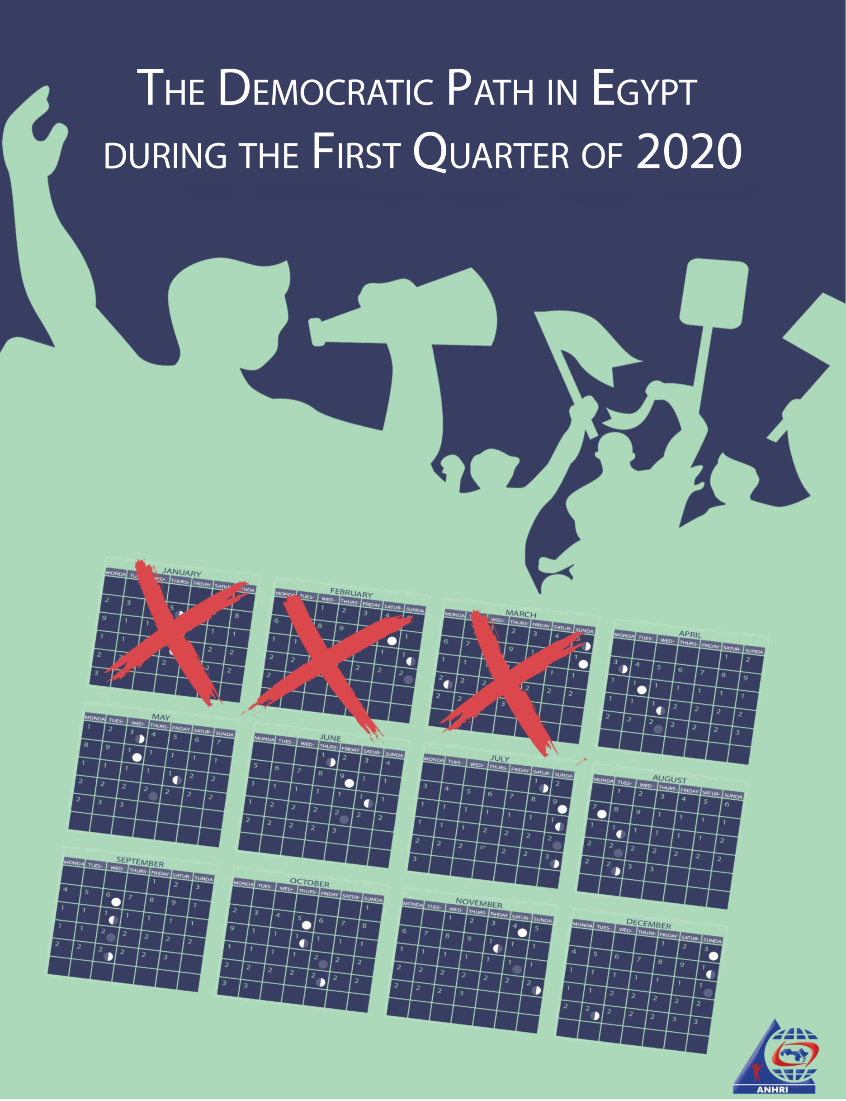

The Democratic Path in Egypt during the First Quarter of 2020

Before we begin:
The Democratic Path is a report that is launched by the Arabic Network for Human Rights Information (ANHRI) every three months, i.e. quarterly, starting from 2018. In previous years, ANHRI used to publish the report on a monthly basis through the “Lawyers for Democracy” initiative it launched in 2014 to monitor the democratic process in Egypt.
In addition to the monthly reports issued to monitor the state of democracy, ANHRI issued annual reports to monitor the democratic path in 2014, 2015, 2016, 2017 and 2018, which can be accessed through the “Reports” section on ANHRI’s website by clicking on the following link:
https://www.anhri.info/?cat=14&lang=en

Introduction
This is the first DP report issued by ANHRI during 2020. The first quarter of this year has witnessed a number of major incidents at all levels; including the death of former President Mohamed Hosni Mubarak as the Egyptian state declared three days of national mourning after holding a military funeral, which has sparked controversy given that Mubarak was stripped of all military honors after his conviction in the "Presidential Palaces" Case. Then the world has witnessed the new coronavirus COVID-19 pandemic and the Egyptian government started to take measures to limit its spread. In the meantime, a number of human rights defenders and organizations launched several campaigns calling on officials to release pretrial detainees and to carry out adequate legal measures to protect inmates in overcrowded prisons from the serious threat posed by this unparalleled pandemic. In response, the security forces arrested a number of those who initiated such campaigns, including Laila Sueif, her daughter Mona Seif, her sister Ahdaf Sueif, and activist Rabab El-Mahdy, along with lawyer Mohsen Bahnasi and activists Noha Kamal and Nermin Hussein.
Protest events didn’t stop during the first quarter of 2020; as 80 protests have been organized by different political forces throughout this period. Social and labor protests were at the forefront with 40 protests, followed by the Muslim Brotherhood (MB) and the National Alliance to Support Legitimacy (NASL) with 35 protest activities.
Military trials of civilians also continued in the first quarter of the year; as among the 48 trials held during this period, there were 5 military trials for 1,332 citizens.
Violations of media freedoms have not ceased during this period as well; with 43 cases of violations recorded, most notably pertaining to the investigations conducted by the Prosecution which amounted to 18 investigations during the period covered by the report.
On the other hand, the number of terrorist operations has declined compared to the previous years; as the first quarter of 2020 witnessed only five terrorist operations, three of which were carried out using improvised explosive device while the security forces managed to thwart the other two.
The details of the state of the democratic path during the first quarter of 2020 are outlined, in numbers and percentages, as follows:
First: Protest events
During the first quarter of the year, the various forces organized 80 different events, and their distribution was as follows:
* Social and labor protests: 40 protest events
* Muslim Brotherhood (MB) and the National Alliance to Support Legitimacy (NASL): 35
* Student protests: 2
* Pro-regime protests: 3
The following table shows the percentage of protest activities according to the organizing forces
Pro-regime protests | Social and labor protests | Student protests |  | MB & NASL
4% | 50% | 2% |  | 44%

The month of January came first in witnessing the largest number of protest events by 28 different protests, as shown in the following table:

Total | March | February |  | January
80 | 26 | 26 | 28

Out of these different events, 13 were attacked by security forces, 56 passed without attacks, and 11 labor and social protests were resolved after negotiations.
The following table shows the percentage of attacks on the protest events:
Protests negotiated | Protests not attacked | Protests attacked
14% | 70% | 16%

Labor and Social protests:
The first quarter of 2020 witnessed 40 different social and labor protests; six of which were attacked by security forces, whereas 23 passed without interference, and 11 were resolved after negotiations with their organizers.
The most important demands brought by the social and labor protests:
* Zamalek Sporting club employees protested the late salary payment and the non-receipt of their wages for several months
* Protesting price hikes and the deteriorating economic conditions
* A number of workers demanding installation in their jobs
* Demanding to apply the minimum wage limit
* A number of fishermen objected to the Insurance Law and the increase in fuel prices

The following table shows the percentage of attacks on the labor and social protests:
Protests negotiated | Protests not attacked | Protests attacked
28% | 57% | 15%

MB and NASL protest activities:
The first quarter of 2020 witnessed the Muslim Brotherhood (MB) and the National Alliance to Support Legitimacy (NASL) organizing 35 different protests, including 7 that were attacked by the security forces and 28 that were left without security intervention, while none of them was subject to negotiation.
The most important demands raised by Muslim Brotherhood and the National Alliance to Support Legitimacy:
* Commemoration of the January 25 Revolution.
* Demanding the release of detainees and improvements to prison conditions
* Demanding to topple what they described as the military rule
The following table shows the percentage of attacks on the MB & NASL protests:
Protests not attacked | Protests attacked
80% | 20%

Student activities:
The first quarter of 2020 witnessed only two protest activities organized by students and were left without any security intervention.
Student protests’ main demands:
* Kafr El Sheikh nursing school students objected to the decision to transfer them to another school that is far from their place of residence.
* Students from Al-Shaheed Abedo staged a protest to mourn the death of Brigadier Mustafa Abdel-Majid Abido and to support the state against terrorism.
Pro- regime events:
The first quarter of 2020 witnessed 3 protests took place in Cairo and other governorates, all of which were to celebrate the Police Day and support the decisions taken by the government.
Second: Trials
- Ongoing trials:
The first quarter of 2020 witnessed 43 trial cases that are being considered before the Egyptian judiciary. Of these, there were 17 rulings of conviction, 8 acquittals and 4 death sentences against 41 defendants.
The distribution of the 68 ongoing trials is as follows:
* 32 trials for the MB & NASL.
* 6 trials of the civil and democratic powers.
* 3 trials for Mubarak’s regime’s affiliates.
* 2 trials for affiliates of the post June 30th regime
* The military judiciary considered 5 trials for 1,132 civilians

The following table shows the percentage of the ongoing trials:
Post-June 30 regime trials | Military trials for civilians | Civil and Democratic Powers trials | MB& NASL trials | Mubarak regime trials
4% | 10% | 13% | 67% | 6%

The most prominent trials of MB and NASL are:
The cases known in the media as: (Talat Harb incidents, Isis's Upper Egypt Province, Rabaa Sit-in dispersal, arson of Al-Atamna Police Station, arson of Kafr Hakim Church, Helwab Brigades, Al-Nusra Front, Al-Moski violence incidents, raiding Al-Arab Police Station, May 15 violence incidents, raiding Al-Tebbein Police Station, Al-Masara Cell, raiding Kerdasa Police Station, Al-Maghara incindents)
The most prominent trials of Mubarak regime figures are:
The cases known in the media as: (The Interior Ministry corruption, Trial of Safwat al-Sherif over illicit gain charges, and customs corruption).
The most prominent trials of civil and democratic powers are:
The cases known in the media as: (The Oppressed of Downtown, The trial of Al-Warraq Island residents, The Cabinet incidents, objecting to the killing of Affrotto, and the seizure of Dr. Hassan Nafaa's funds).
The most prominent trials of post- June 30th regime’s affiliates are:
The cases known in the media as: (The Trial of Alexandria’s deputy governor on bribery charges, Trial of railway officials over Ramsis train station accident.)
The Military Trials of civilians:
In the first quarter of 2020, the military judiciary considered 5 ongoing trials for 1132 civilians.
- Sentences
During the reporting period, there were 17 convictions and 8 acquittals. The details are as follows:
Convictions:
During the first quarter of the year, the Egyptian judiciary issued 17 convictions, distributed as follows:
* 12 rulings against the Muslim Brotherhood (MB) and the National Alliance for the Support of Legitimacy (NASL).
* 2 rulings against post-June 30 regime’s affiliates
* 2 rulings against defendants in the military trials for civilians
* 1 ruling against defendants in the civil democratic forces’ cases
* While no ruling was issued against any of Mubarak regime’s figures
The following table shows the percentage of rulings of conviction:
Post-June 30 regime’s affiliates | Military trials for civilians | Civil and Democratic Powers | MB & NASL
12% | 12% | 6% | 70%

Acquittals:
During the first quarter of the year, 8 acquittals had been handed down, distributed as follows:
* 4 rulings of acquittal for the MB and NASL affiliates
* 2 acquittals for defendants in the military trials of civilians
* One acquittal for the Democratic and Civil Powers
* 2 acquittals for Mubarak regime’s figures
* While no ruling of acquittal was issued against any of post-June 30 regime’s affiliates
The following table shows the percentage of rulings of acquittal:
Military trials for civilians | Mubarak regime’s figures | Civil and Democratic Powers | MB & NASL
20% | 15% | 15% | 50%

Death sentences
Four death sentences were issued against 24 defendants during the first quarter of 2020, as shown in the following table:
1- Rulings
Total | Death sentences issued by military courts | Death sentences issued by civil courts
4 | 1 | 3

2- Defendants
Total (Number of defendants) | Number of defendants upheld by the Court of Cassation to be executed | Number of defendants upheld by the Mufti to be executed | Number of defendants referred to the Mufti
40 | 0 | 37 | 3 | Civil
1 | 1 | 0 | 0 | Military
41 | 1 | 37 | 3 | Total

3- Death sentences executed:
The Prisons Authority sector has executed two death sentences handed down against 9 citizens during the months of February and March. Details are as follows:
- On 25 February 2020, the Prison Authority sector carried out the death sentence that was issued by the Military Court against 8 defendants in the case publicly known as "church bombings".
- On 4 March 2020, the Prison Authority sector carried out the death sentence that was issued against top Egyptian militant Hisham Al-Ashmawy in a number of cases considered by civil and military courts.

Third: Violence and Terrorism
The first quarter of 2020 witnessed a total of 5 terrorist operations in Egypt’s different governorates, along with 4 counter-terrorism operations, detailed as follows:
- Terrorist operations:
Five terrorist attacks took place in the first quarter of the year; three of them had been carried out, while the security forces succeeded in thwarting the two others. The operations resulted in the killing of 15 people without causing injuries.
The following table shows the details of such terrorist operations
Diffused bombs | Terrorist attacks carried out
40% | 60%

The following table shows the percentage of terrorist operations and counter-terrorism ones:
Total | Operations thwarted | Operations carried out | Months
0 | 0 | 0 | January
5 | 2 | 3 | February
0 | 0 | 0 | March
5 | 2 | 3 | Total

The following table shows the number of terrorist operations and their distribution in the different governorates:
Total | Operations thwarted | Operations carried out | Governorates
5 | 2 | 3 | North Sinai
5 | 2 | 3 | Total

– These operations had resulted in 15 killed while no injuries took place.
The following table shows the number of killed and wounded and their distribution:
Total | Terrorists | Security forces | Civilians
9 | 0 | 9 | 0 | Number of killed
6 | 0 | 6 | 0 | Number of wounded
15 | 0 | 15 | 0 | Total

- Counter-Terrorism Operations
During the first quarter of the year, there were 4 preemptive attacks by the security forces which targeted what they described as terrorism hubs, resulting in the killing of 61, the wounding of 16 and the arrest of 54 others.
The following table shows the number of dead and injured
Total | Those targeted | Security forces
61 | 54 | 7 | Number of killed
16 | 11 | 5 | Number of wounded
77 | 65 | 12 | Total

Fourth: Attack on Freedom of Expression and Media Freedoms
The first quarter of the year witnessed 34 various violations against freedom of expression and media freedoms.
The following table shows the number of violations took place throughout the first three months of 2020:
Months | Number of violations
13 | January
10 | February
11 | March
34 | Total

Details are as follows:
Number of violations | Kind of violation
18 | Investigations and detention renewal sessions
4 | Arrest and/or detention
3 | Ban from media coverage
3 | Physical and verbal attacks
3 | Administrative penalties (fines)
2 | Disciplinary measures
1 | Banning websites
34 | Total

The following table shows the percentage of the attacks against freedom of expression and media freedoms:
Number of violations | Kind of violation
53% | Investigations and detention renewal sessions
12% | Arrest and/or detention
9% | Ban from media coverage
9% | Physical and verbal attacks
9% | Administrative penalties (fines)
5% | Disciplinary measures
3% | Banning websites

Fifth: Attack on Human Rights Defenders:
- On 3 January 2020, the Supreme State Security Prosecution renewed the detention of lawyer Ibrahim Metwaly, founder of the Association of the Families of the Disappeared, for 15 day pending the Case No. 740 of 2019 State Security, on charges of joining a terrorist group and committing crimes of terrorism funding. On 14 January, the Prosecution decided to renew the human rights lawyer's detention for 15 days and his incarceration is still being renewed until now.
- On 8 January 2020, the Supreme State Security Prosecution adjourned the detention renewal of labor union leader Kamal Khalil for the hearing of 12 January, pending the Case No. 488 of 2019 State Security, in which he is charged with abetting a terrorist group in achieving its aims, spreading false news and statements, and misusing social media. The adjournment was due the inability to transfer the defendant. On 12 January 2020, the Supreme State Security Prosecution ordered the continuation of the Khalil's detention for 15 days pending the aforementioned case and charges. On 4 February 2020, Cairo Criminal Court ordered the release of the labor leader with precautionary measures pending the aforementioned case and charges.
- On 8 January 2020, the Supreme State Security Prosecution renewed the detention of human rights lawyer Amr Imam for 15 days pending the Case No. 488 of 2019 State Security, in which he is accused of joining a terrorist group, misusing social media, and disseminating false news and statements. Imam's detention is still being renewed until now.
- On 8 January 2020, Cairo Criminal Court decided to adjourn the consideration of the detention renewal session of human rights lawyer Zyiad Elelaimy and journalists Hossam Moanis and Hisham Fouad for the hearing of 11 January 2020, pending the Case No. 930 of 2019 State Security, in which they face charges of abetting a terrorist group in achieving its goals and spreading false news and statements' due to the inability to transfer the defendants from their jail to the courthouse. On 11 January 2020, Cairo Criminal Court ordered the continuation of the defendants' detention for 45 days pending the aforementioned case and charges.
- On 12 January 2020, the State Security Prosecution renewed the detention of activist Sameh Seoudi for 15 days pending the Case 1338 of 2019 State Security on charges of abetting a terrorist group in achieving its aims, misusing social media, spreading false news and statements, and protesting without prior notice. The activist's detention is still being renewed until now.
- On 14 January 2020, Cairo Criminal Court adjourned the consideration of the detention renewal session of human rights lawyer Sayed al-Banna, Dr. Walid Shawki and linguist Ayman Abdel-Moati for the hearing of 15 January 2020, pending the Case No. 621 of 2018 State Security, in which they face charges of joining a terrorist group and spreading false news and statements. On 15 January 2020, Cairo Criminal Court decided to renew the three defendants' detention for 45 days pending the aforementioned case and charges, and their detention is still being renewed until now.
- On 14 January 2020, the Supreme State Security Prosecution renewed the detention of lawyer Sahar Ali for 15 day pending the Case No. 1358 of 2019 State Security, on charges joining a terrorist group and committing crimes of terrorism funding. The lawyer's detention is still being renewed until now.
- On 15 January 2020, the Supreme State Security Prosecution renewed the detention of blogger Mohamed Oxygen for 15 days pending the Case No. 1356 of 2019 State Security, on charges of abetting a terrorist group to achieve its goals, spreading false news and statements, and misusing social media. Oxygen's detention is still being renewed until now.
- On 15 January 2020, the Supreme State Security Prosecution renewed the detention of human rights lawyer Mahinour El-Masry for 15 days pending the Case No. 488 of 2019 State Security, on charges of abetting a terrorist group to achieve its goals, spreading false news and statements, and misusing social media. The lawyer's detention is still being renewed until now.
- On 20 January 2020, the Supreme State Security Prosecution renewed the detention of journalist Khaled Daoud for 15 days pending the Case No. 488 of 2019 State Security, on charges of abetting a terrorist group to achieve its goals, spreading false news and statements, and misusing social media. This is after the Prosecution moved to the journalist's jail due to the inability to transfer him to the prosecution's headquarters. The journalist's detention is still being renewed until now.
- On 20 January 2020, the State Security Prosecution renewed the detention of journalist Solafa Magdy for 15 days pending case No. 488 of 2019 State Security, on charges of colluding with a terrorist group to achieve its goals, publishing and broadcasting false news and statements, and misusing social media. The adjournment was because the journalist couldn’t be transferred from her jail to the Prosecution's headquarters. On 21 January 2020, the State Security Prosecution decided to renew the journalist's detention for further 15 days pending the aforementioned case and charges. The activist's detention is still being renewed until now
- On 22 January 2020, the Supreme State Security Prosecution renewed the detention of blogger and activist Alaa Abdel El-Fattah and human rights lawyer Mohamed al-Baqir for 15 days pending case No.1356 of 2019 State Security on charges of joining a terrorist group, committing one of funding-related crimes, spreading and broadcasting false news and statements, and misusing the Internet. The detention of the two is still being renewed until now.
- On 22 January 2020, the State Security Prosecution renewed the detention of journalist Hossam al-Sayyad for 15 days pending case No. 488 of 2019 State Security, on charges of colluding with a terrorist group to achieve its goals, publishing and broadcasting false news and statements, and misusing social media. The journalist's detention is still being renewed until now.
- On 4 February 2020, the State Security Prosecution renewed the detention of journalist Israa Abdel-Fattah for 15 days pending the Case No. 488 of 2019 State Security, on charges of colluding with a terrorist group to achieve its goals, publishing and broadcasting false news and statements, and misusing social media. The journalist's detention is still being renewed until now.
- On 8 February 2020, the Court of Administrative Justice decided to extend the sentencing hearing in the appeal No. 72 of 7720 judicial year, submitted by human rights lawyer Gamal Eid challenging the travel ban issued against him. The appeal was postponed for the hearing of 22 February 2020.
- On 15 February 2020, South Cairo Criminal Court said it would rule on the appeal submitted by 11 human rights defenders challenging their state-imposed travel bans issued by the investigating judge of the case known in the media as "the closure of the civil society" at the hearing scheduled for 23 April 2020.
- On 25 February 2020, Cairo Criminal Court decided to renew the detention of human rights lawyer Zyiad Elelaimy pending the Case No. 930 of 2019 State Security, in which they face charges of abetting a terrorist group in achieving its goals and spreading false news and statements.
- On 25 February 2020, Moqatam Misdemeanor Court adjourned the trial of Zyiad Elelaimy pending the Case No. 694 of 2020 State Security, in which he faces charges of abetting a terrorist group in achieving its goals and spreading false news and statements, due to the inability to transfer him. On 3 March 2020, the court set the trial of the right lawyer for adjudication at the hearing of 10 March 2020 pending the aforementioned case and charges. On 10 March, the court sentenced the human rights lawyer to one year in prison and a fine of EGP 20,000.
- On 18 March 2020, the security forces arrested Dr. Laila Soueif, Dr. Rabab El-Mahdi, writer Ahdaf Soueif, and activist Manal Seif after they staged a protest in front of the Cabinet's headquarters demanding the release of pretrial detainees over fears of a coronavirus outbreak in the country’s overcrowded jails. They were taken to Qasr al-Nil Police Station where a record No. 1909 of 2020 Misdemeanor was filed. The four ladies then appeared before the Public Prosecution which charged them with: "inciting demonstrations that aim at disrupting the interests of citizens, publishing and broadcasting false news and statements, and possessing publications containing fake news". The Prosecution ordered their release on bail of EGP 5,000 each.
- On 27 March 2020, the security forces arrested lawyer Mohsen Bahnasi in the vicinity of his home at Hadayek Helwan region before taking him to an unknown destination. The next day, 28 March 2020, the Supreme State Security Prosecution interrogated the lawyer into the Case No. 558 of 2020 State Security on charges of joining a terrorist group, spreading false news and statements and misusing social media. The Prosecution then ordered him to be detained for 15 days pending the case.
ــــــــــــــــــــــــ
Note: This report is based on the cases monitored by ANHRI and does not necessarily include all the incidents took place throughout the month.
To view the previous Democratic Path reports:
To view the Democratic Path Report in 2014, “Obscure and stalled”
To view the Democratic Path Report in 2015, “One step back, two steps further back”
To view the Democratic Path Report in 2016 “Closed until further notice”
To view the Democratic Path Report in 2017, “Very Steep”
To view the Democratic Path Report in 2018, “Mounting Anger".

