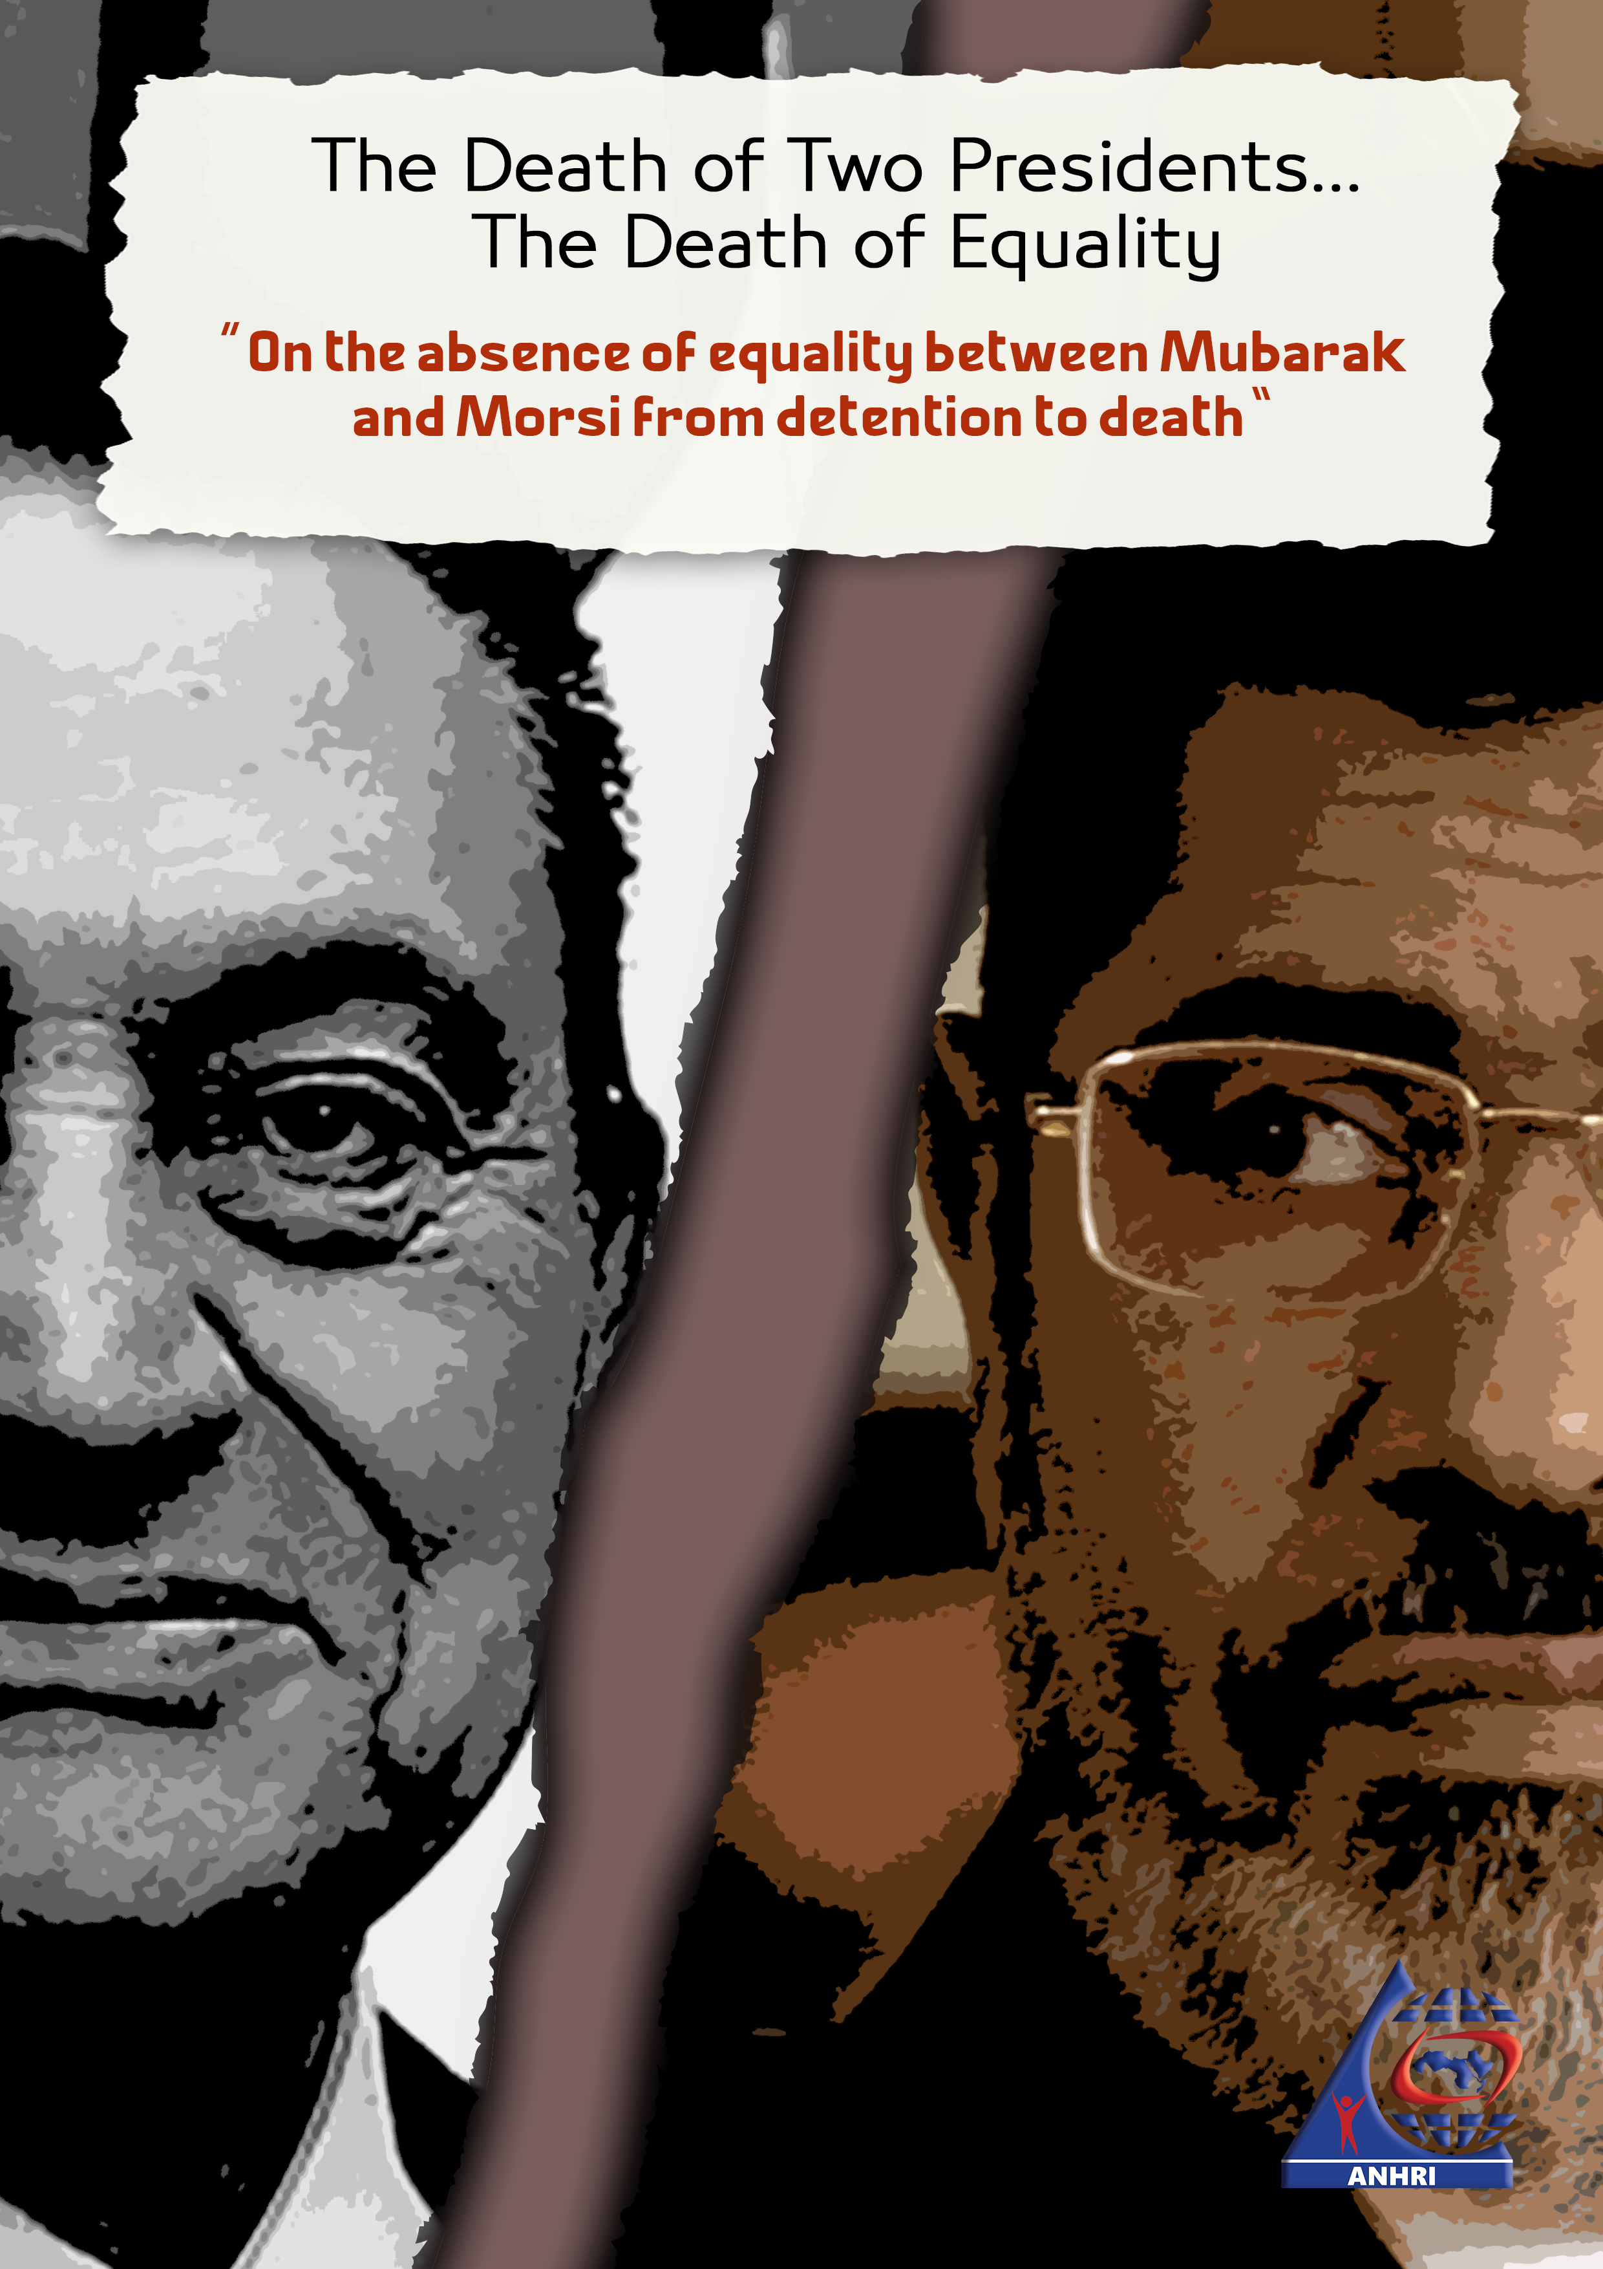
ء

Introduction
Mohamed Hosny Al-Sayyed Mubarak, former president of Egypt, has died, age 91, on the 25th of last February. 8 months earlier, on 17 June 2019, Mohamed Morsi Eissa El-Ayyat, also a former president of Egypt, has died, age 68. Both men have ruled Egypt, with a large difference of their respective tenures; the first has held office for almost 30 years, while the second has hardly held it for a year. Both men were deposed from office after public protests with millions of Egyptians taking part. In both cases, the military institution has stepped in, pressuring the first to step down by his own will, on 11 February 2011, while removing the second through a coup, on 3 July 2013.
Both men, once removed from office, have faced different criminal and political charges that ranged from participation in murdering protesters and communicating with foreign countries, to illicit gains and theft, but simple observation alone is enough to reveal a large difference in what each has gone through, starting with pressing charges, investigations, trial, pretrial detention, and imprisonment, until their death.
Hence, both legal courses of action, of the justice institution and law enforcement apparatuses, concerning the two men, while constituting exceptional cases of two men who held the highest executive office in the state, and for the first time in history were tried for criminal charges with judgments issued against both, these cases still, on the other hand represent an important example of the compliance of state institutions to principles of equality before the law, independence and impartiality of the judiciary, the standards of fair trial, and humane treatment of prisoners.
This paper seeks to compare the courses and conditions of filing charges, trial, and imprisonment of both presidents, with the purpose of highlighting the overlooked rights side in comparison with the political one, of relevant Egyptian state institutions' treatment of each. The paper also seeks through this comparison to re-shed the light over the severe rights violations of law enforcement apparatuses, which, although underlined repeatedly in many local and international human rights reports throughout recent years, still remains our duty to bring them up again to light with every new angle becoming available.
The paper uses the article of international human rights agreements and covenants, ratified by Egypt, as well as, the articles of the constitution and relevant laws as the base for comparison. Hence, after a brief historical background it goes through these article before detailing the different aspects of comparison between the cases of Mubarak and Morsi, and finally offers a few recommendations.

Brief Historical Background

Mohamed Hosny Mubarak
Mubarak has been a vice president of the late Mohamed Anwar Sadat, till the later was assassinated, on 6 October 1981. Mubarak name was offered to the people through a popular referendum, and based on its results became the fourth president of the Arab Republic of Egypt.
Mubarak has been the president of Egypt for almost three decades. His policies, through this long period, have led to the exacerbation of many social and economic problems, accompanied by a large record of severe human rights violations. Accordingly, the Egyptian people of different walks and classes have suffered a lot under his rule, hence millions of them have taken part in the popular protests in the streets and squares of Egyptian cities all over the country, which turned into the glorious Jan 25 Revolution, that succeeded in removing Mubarak, forcing him to abdicate, on 11 February 2011. The Supreme Council of Armed Forces, led by field marshal Mohamed Hussien Tantawy, minister of defense and general leader of the armed forces at the time, ruled Egypt for a transient period that lasted for one and half a year, before the presidential elections were held in 2012.

Mohamed Morsi
He is the first elected civilian president of Egypt, and the fifth of its presidents. He assumed his office as result of the first presidential elections held after the Revolution among several candidates, and witnessed a close competition that led to both Morsi, representing Freedom and Justice Party, the political arm of the Muslim Brotherhood, and General Ahmed Shafik, the last prime minister in Mubarak's era, facing each other in the second running of the elections. Morsi won with a small difference in votes. He was sworn into office on 24 June 2012.
Different problems have soon erupted, which Morsi didn't handle well, stirring the anger of the people who still lived the spirit of the Revolution, and looked forward to a new pattern of government. This led into several waves of protests against Morsi and the Brotherhood, culminating in the huge popular protests of 30 June 2013, in their aftermath, Morsi was removed from office by the military institution, on 3 July 2013. Presidency was assumed for a transnational period to Judge Adly Mansour, being the head of the Constitutional Court, until new presidential elections were held in 2014, leading to the assumption of the office by president Abdel Fata El-Sisi, who is still in office after being re-elected for a second term in 2018.

Rights and Legislative Frameworks
In the following we go through the most important articles of main international agreements and covenants, as well as the articles of the Egyptian constitution and laws relevant to equality in front of the law, the guarantees of fair criminal investigations and trials, and minimum accepted humane treatment of detained and imprisoned persons.

International Agreements and Covenants

The Universal Declaration of Human Rights
Concerning equality, the declarations states, in article 7 that "all are equal in front of the law, and entitled, without discrimination, to the protection of the law."
Concerning the guarantees of fair trials, the declarations states in article 10 that "Everyone is entitled in full equality to a fair and public hearing by an independent and impartial tribunal, in the determination of his rights and obligations and of any criminal charge against him."

International Covenant on Civil and Political Rights
Concerning equality the second article of the covenant in its second paragraph states that all states party to the covenant are obliged to "respect and to ensure to all individuals within its territory and subject to its jurisdiction the rights recognized in the present Covenant, without distinction of any kind, such as race, colour, sex, language, religion, political or other opinion, national or social origin, property, birth or other status."
The covenant also repeats in article 26, what the Universal Declaration of Human Rights have stated concerning the equality before the law, stating that "All persons are equal before the law and are entitled without any discrimination to the equal protection of the law."
Article 14 of the covenant in particular, states, in paragraph (1) that "All persons shall be equal before the courts and tribunals." Within the same article, concerning guarantees of fair trial, the text is clear in emphasizing that these guarantees are enjoyed in "full equality."
Concerning the guarantees of fair trial article 14 also states that "everyone shall be entitled to a fair and public hearing by a competent, independent and impartial tribunal established by law."

Guarantees of fair trial in different international agreements
Guarantees for judicial procedures in different stages as per international agreements and covenants can be summarized as follows:
- The right to not be subject to arbitrary arrest or detention.
- The right to be informed with rights.
- The right to the presumption of innocence.
- The right to a public trial.
- The right to equal treatment of prisoners and to humane incarceration conditions.

Egyptian Constitution and Laws

2014 Constitution
- Article 53 (Equality before the law)
- Citizens are equal in the eyes of the law, and they are equal in rights, freedoms, and public duties, with no discrimination based on religion, belief, sex, origin, color, language, disability, social class, political or geographical association, or any other reason. Discrimination and inciting hatred are punished by the law. The state commits to taking required measures for eliminating all forms of discrimination, and the law regulates the establishment of an independent commission for this purpose.
- Article 94 (Independence and impartiality of the judiciary)
- Sovereignty of the law is the foundation of government in the sate, the state submits to the law, and the independence, immunity, and impartiality of the judiciary are basic guarantees of rights and freedoms protection.
- Article 96 (presumption of innocence and guarantees of fair trial)
- A suspect is innocent until proved guilty by a public trial, in which he is provided with guarantees for defending himself. The law regulates appealing judgments issued in criminal trials. The state provides the protection to victims, witnesses, the accused, and informers when necessary as per the law.
- Article 56 (treatment of prisoners)
- The prison is a place fore reform and rehabilitation. The prisons and places of detention are subject to judicial supervision, and any breach of a human's dignity or endangering his safety is prohibited in any of them. The law regulates the provisions of reforming and rehabilitating the convicts, and facilitating their way to a dignified life after being released.

Prisons regulation law
Its law number 106/2015 modifying the provisions of law number 396/1956 concerning the regulation of prisons. The following are some of its articles:
- Article 34
- Any convict incarcerated in one of the limans, is deemed incapacitated by a special physician, is reported to the director of the medical services of prisons in participation of the competent health inspector. If his incapacity is proved, he is to be transferred to a general prison by an order issued by the minister's aid for prisons sector, after approval of the Attorney General.
- The administration of the prison where a patient prisoner is transferred should monitor his case and present a medical report to the director of the medical service and the competent health inspector, to examine him and look into returning him to the liman. If it turned out that the medical reasons for his transfer are over, he is to be returned to the liman by an order of the minister's aid for prisons sector, and approval of the Attorney General. The time spent by the convict in the prison is deducted from his sentence in the liman.
- Article 38
- With taking the provision of the law of criminal procedures into consideration, every convict is entitled to right to exchanging mail and telephone communication for a financial fee. His relatives may visit him twice a month. All to be under monitoring and supervision of the prison's administration, and pursuant to checks and procedures determined by internal bylaw.
- Article 44 - para 4
- Solitary confinement can be for no longer than 15 days.

Conclusion and General Provisions
We can't speak of a fair trial unless two conditions are met:
First: Adhering, throughout the trial, to norms set-up by international human rights agreements and covenants.
Second: The judicial authority must be both independent and impartial.
In addition to the different rights and principles mentioned above the independence of the judiciary is still an essential guarantee for accomplishing fair trial. A trial can't be characterized with fairness and justice, or seen by people to be so, if judges issuing judgment, and exacting penalties, lack independence, integrity, and impartiality, or distinguished for lack of bias, no matter what, and under any circumstances. For this reason the Human Rights Committee has emphasized the right to trial before an independent and impartial tribunal, as an absolute right that can have no exceptions whatsoever.
As for impartiality, it means that a judge should have no prior opinion of any case or file he considers, should have no interest in the consequences or results of considering the case, and should never behave in a way that privileges one party over the other. Taking into consideration that a judge should be allowed to work away from any influences of governmental authorities, and from means of temptation, pressure, or threat.
Under any circumstances, if the space is left to political bias, the sovereignty of the law is sure to be undermined, thus allowing the convergence of the conditions for violating human rights in the absence of retribution. In such case those charged with enforcing the law feel fully free to arbitrary detain persons, and torture suspects with no fear of being held accountable or punished. Hence, the feel among citizens that they have nowhere to turn asking for justice.

Mubarak and Morsi’s trials: the facts

Mohamed Hosny Mubarak
Mubarak was accused in cases concerning events that have taken place, documents that existed, and witnesses who testified to actions of which he was clearly and officially charged. The general prosecution accused Mubarak and others in four cases as follows:
- The case of murdering protesters in 2011, abusing office, making illicit gains in deal for selling gas to Israel.
- Illicit gains. (enlarging wealth in contradiction with legal income)
- Presidential palaces (final judgment of 2 years in prison).
- Receiving gifts from national journalist institutions (settled by returning gifts or their value).
Mubarak's health was stable after his removal from office. He however moved to Sharm El-Sheikh resort and stayed there from 11 February to 15 April 2011. The Attorney General has issued an order that he should be transferred to a military hospital, but this order wasn't executed.
As for the results of these cases; Mubarak was acquitted in the case of journalist institutions' gifts, while investigations are still under-way concerning the case of illicit gains. Mubarak was sentenced to life in prison for murdering protesters, on 2 June 2012, the judgment was appealed and the Cessation Court canceled it, on 13 January 2013, and ordered a retrial, that is still underway.
The Attorney General approved a release of the former president Hosny Mubarak after almost 6 years of his trial in several cases, thus he went back home in Heliopolis where he eventually passed away.

Mohamed Morsi
Mohamed Morsi was charged in many cases, the most important of them are:
- Incidents of Ithadia Palace (20 years in prison).
- Communications with Hamas (life sentence).
- Insulting the judiciary (3 years in prison, fine, and compensation; suspended on his death).
- Breaking into prisons (death penalty).
- Espionage for Qatar (acquitted posthumously).
- Breaching eastern borders (still underway, but over for him after his death).
After being arrested, on 3 July 2013, Morsi was forcibly disappeared for three months. He then was interrogated in many cases, with more accusation directed against him with time. He was detained in solitary confinement where he complained of maltreatment, absence of enough medical care, and ignoring his health conditions.
In February 2017, Morsi was transferred to a private hospital for complaining of continual pain in his left arm, he was the referred to police hospital in Agouza. A medical committee was formed and it verified that he suffered several deceases including high blood pressure, high blood sugar, chronic neuron inflammation, a benign tumor in brain vessels. The committee also revealed nervous spasms in left side of the face. In June 2017, the head of criminal court of Cairo ordered him to be medically examined. The results were the same as the previous examination. The judge still reordered a new examination on 29 November 2017, in Torah prison hospital, and a new committee was formed of 10 physicians, with the senior forensic physicians present, that confirmed the deceases he suffered especially being a pressure and diabetic patient.

Comparison of Mubarak and Morsi Treatment
The following table summarized the aspects of the treatment of both Mubarak and Morsi, till each passed away.
# | Aspect | Mubarak | Morsi
1 | Place of detention | Equipped hospital | Solitary confinement
2 | Trial publicity | Public | Not public
3 | Health conditions | Stable, hospitalized throughout detention period | Examined and proved to suffer from several deceases
4 | Visits | Family and others allowed to visit | Denied visitation right, family obtained judgment to be allowed visitation but visited him only a few times
5 | Court sessions | In a medical bed inside a normal cage | In glass walled cage
6 | Medical care | Full medical care in an equipped hospital | Didn’t receive enough medical care, held in solitary confinement
7 | Main Judgments | Final conviction of corruption (presidential palaces case) | Life sentence, 20 years in prison, death penalty, 3 years in prison.
8 | Death | In ICU in Gala’a military hospital | In Police Cadets Institute, Torah, during a court session
9 | Official Status | Official mourning, Military funeral | No official mourning, funeral not allowed
10 | Burial | In family graveyard in Heliopolis. | Authorities refused request of burying him in family graveyard in Shaqiya, buried in Wafaa and Amal cemetery, Nasr City

In addition to the elements mentioned in the table, both men’s death conditions should be considered. While Mubarak’s age and health conditions were considered during the stages of his trial, including his continual stay in a fully equipped hospital, where all medical care elements were available, and including provisions for transferring him to and from the court, Morsi, though in a very bad health condition, as attested to by many official medical reports, has spent most of the time in solitary confinement in very bad incarceration conditions that exacerbated his health deterioration, while being denied necessary medical care, which eventually caused his death.
The discrimination in state treatment didn't end with the passing away of both presidents. Morsi's family was forced to bury him almost in secret, and was denied the right to a funeral or receiving condolences, with security excuses. On the other hand, though the military court confirmed that due to being finally convicted with charges undermining integrity, Mubarak should be denied a military funeral, such legal obstacle was ignored so that a military funeral for Mubarak was held and attended by president Abdul Fatah Al-Sisi on head of all state officials. Mubarak’s family received the condolences of many institutions and from the public.

Conclusion
Regardless of the current state of affairs in the country, State institutions are not absolved of their commitment to respect international agreements and covenants ratified by Egypt, and the exact wording of the constitution and the laws, according to which there should be no discrimination in humane treatment and implementation of the law, as the law didn't determine that some people in particular should enjoy its guarantees while others receive treatment other than that stipulated by it, only for setting scores of political grudges.
In the comparison presented by this paper, between the treatment received by both former presidents Mubarak and Morsi, there can be no doubt that State institutions had different policies based on political orientations. Mubarak was treated as a son of the State and its military institution despite his crimes, while Morsi was treated as a member of the Muslim Brotherhood, panned by the law, and enemy of the regime. This led to tilting the scale of justice when it comes to their treatment, so Mubarak enjoyed more than the usual guarantees while Morsi was denied their minimum.

Recommendations
There is no way to fix the severe breach of justice and methodological ignorance of equality and fair trial guarantees prevalent currently as dictated by political considerations if the Egyptian state institutions didn't play their roles in setting rights these conditions. The Arabic Network for Human Rights Information, demands the following of these institutions starting with the parliament, the judiciary, general prosecution, and law enforcement institutions represented by the ministry of interior and before them all the president:
- Legislative reform by removing laws and articles constraining the independence of the judiciary, limiting its impartiality, and staying its hands from doing its job properly.
- Implementing what the constitution and the laws state of rules and rights of the accused persons, including the general prosecution supervision role to ensure compliance with these rules and to investigate any breach of them, particularly conditions of detention, and complaints of maltreatment.
- Implementation by general prosecution of its supervision role over prisons ensuring the implementation of the minimum dignified living conditions within legal places of detention, with medical care, and allowing the prisoners to get necessary medical service outside the prison if not available within it.
- Full compliance with fair trial guarantees, including full equality before the law, presumption of innocence of the accused till convicted by a final court judgment, publicity of trial, allowing full space for both conviction and defense witnesses, and allowing the defense lawyer to do his job, contacting his client, and accepting his legal requests.

