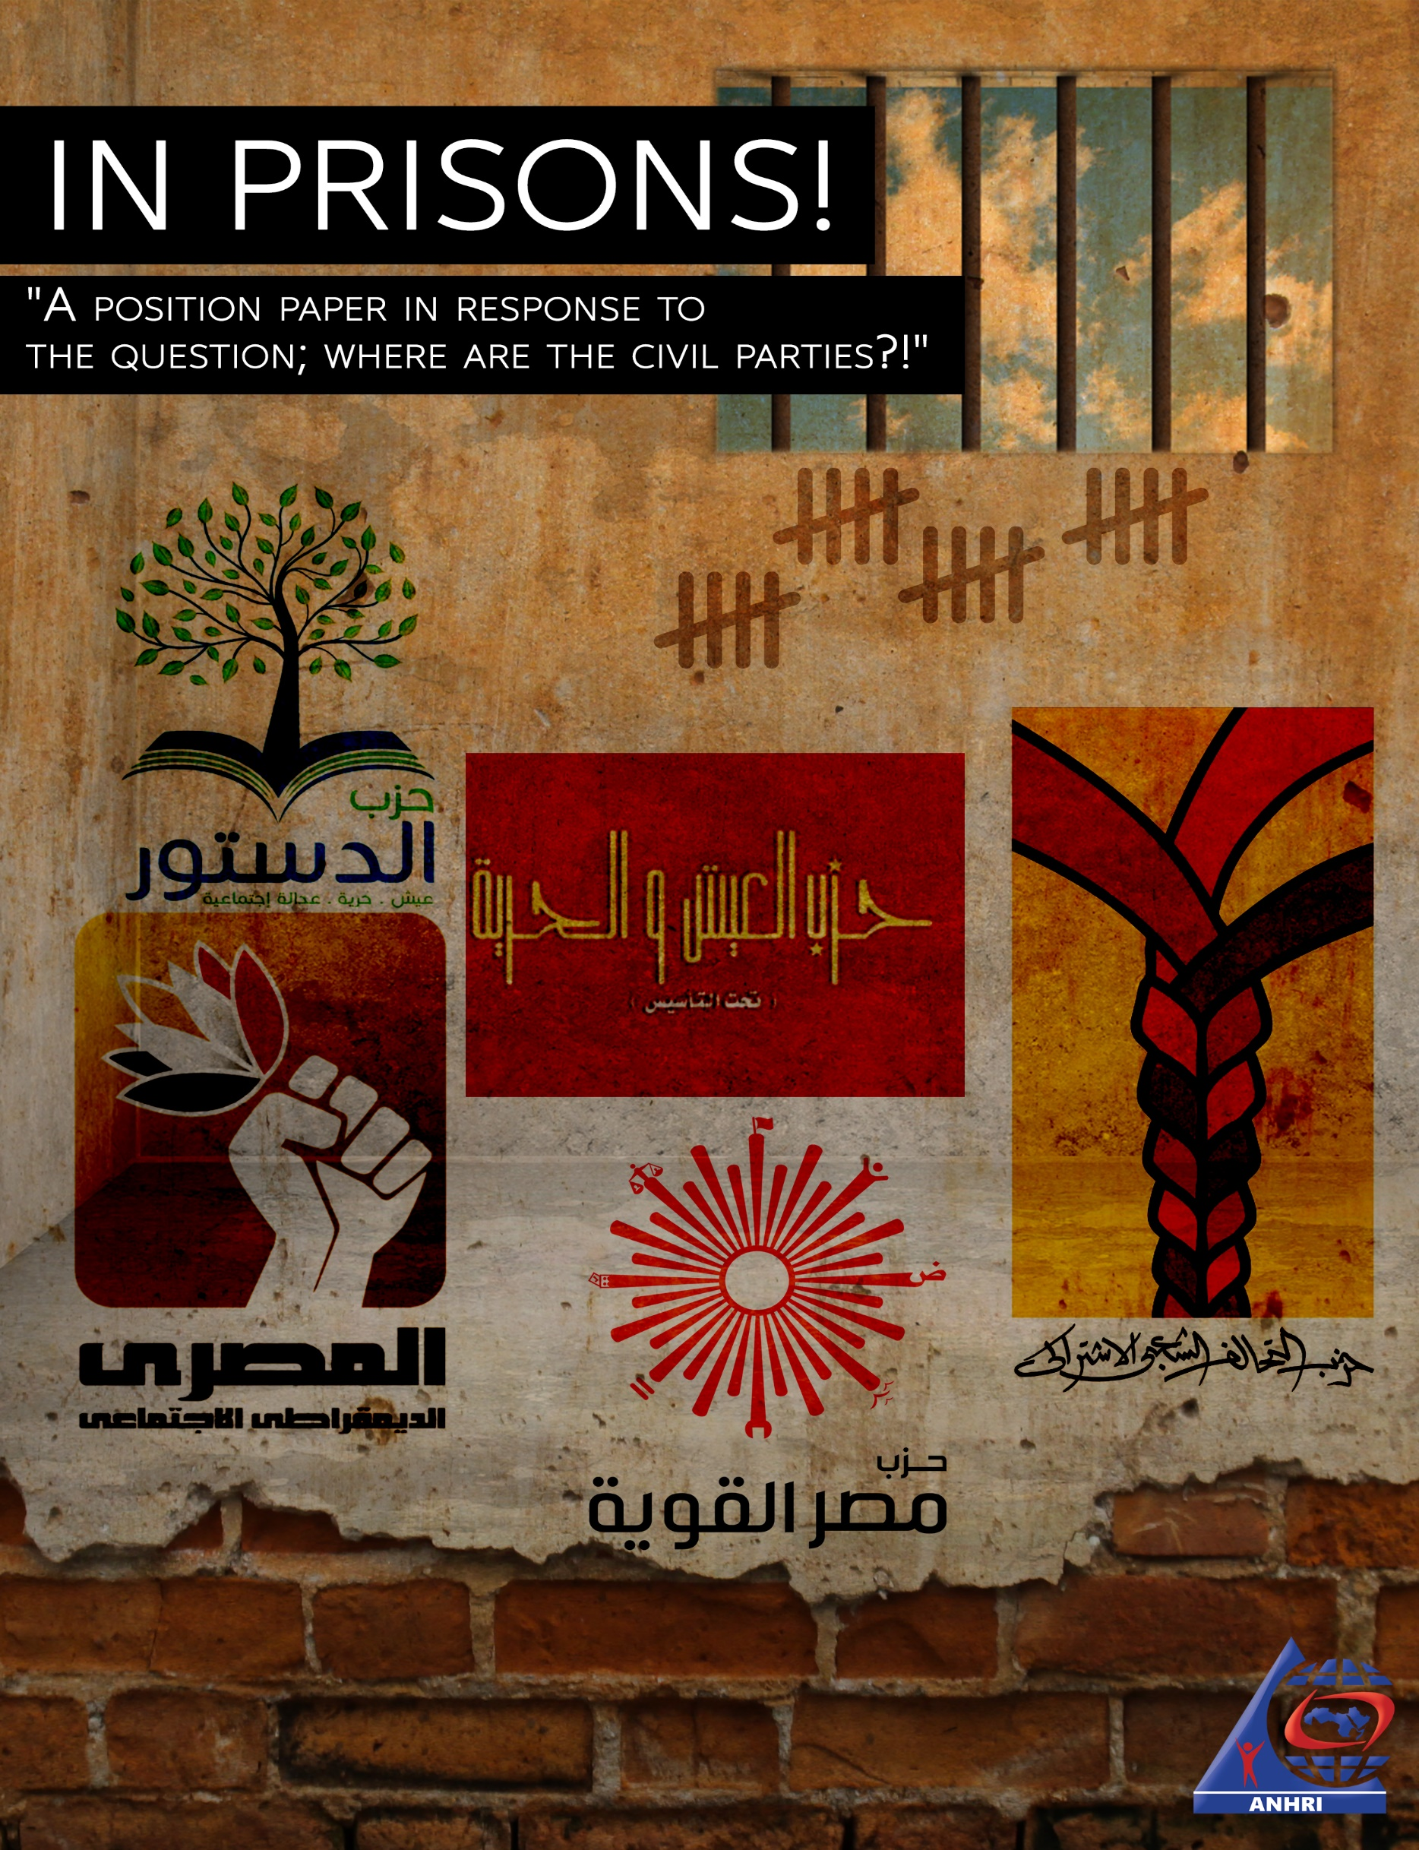

“Where are the civil parties?”

A twisted and manipulative question, that has been asked repeatedly by the media figures close to the Egyptian authorities, as if they were unaware or surprised of the answer!!

This paper answers the question; they are in prison, they are sieged and they are targeted for defamation.

All of the serious civilian opposition parties are subject to these violations, imprisonment of their members and leaders, defamation, restrictions on their activities, plus many of their symbols are always under security threats.

In the following report, we monitor 6 civilian, legal parties and dozens of their icons and leaders, who are - at the - behind bars, possibly as a punishment, probably as intimidation, may be as retaliation, and surely as an incorrect law enforcement.

A look at the civil parties in Egypt:

According to the state information service, the political arena in Egypt has witnessed a total of 34 parties of which the National Democratic Party was known to be the ruling and controlling party in reality, while most of the other parties had little role – if any – in either opposition or support., except for a few parties which were allowed to practice limited activities in a narrow space of freedom.

Today, there are 104 official parties in Egypt, of which only around 10 with actual activity whether in opposition or supporting the regime, and still it is hard to get a list of their names cause of their weakness or falsity.

AlDostour Party; Youth Cadres behind bars

About the party:
It was founded and officially declared in 2012. It was based on a simple ideology, as it supports the civil state and adopts a policy of dialogue with all civil parties and the legitimate institutions of the state, according to a statement issued by the party.
Party members in prisons:
During Sisi rule, members of AlDostour Party and its leaders suffered from imprisonment for various periods. In 2017, the party witnessed a campaign of arrests that affected its members in a number of governorates against the background of the party’s rejection of the agreement known as “selling the islands of Tiran and Sanafir”, some of whom spent prison terms ranging from months to a year in pre-trial detention pending state security cases, including:
- Party members in Cairo secretariat Omar Tharwat and Tariq Hussein.
- Mahmoud Abu Salah, Nael Hassan, Ahmed Fahmy, Muhammad Gamal and Muhammad Al-Naggar from Alexandria.
- Mustafa Saeed and Abdul Rahman Zaghloul from Damietta.
- As well as members of the party from various secretariats, including Muhammad Hamdi Abu Al-Ela, Muhammad Musa Al-Sadiq, and Mamdouh Abdel-Moneim.

Then the party leaders and members again suffered from the security grip, after the party had rejected the constitutional amendments and led a campaign calling for a vote of "No". After that, members of the party continued to be arrested at various times. A number of the leaders were arrested and are still being imprisoned.
They are:

- On Feb.25th, 2019 Ahmad Muhammad known as (Ahmad Al Rassam) – Secretary of the Media Committee of the Constitution Party – was arrested, Hilal Samir known as (Hilal Al-Masri) – a member of the party in Cairo, and Gamal Fadel, a member of the Party in Aswan. They all joined case No. 277 of 2019, and are still in pretrial detention.
- The of two party members Ramadan Abu Zaid – a member of the High Commission for Menia Governorate – and Khaled Mohammed Suwaida from Greater Mahalla, to be included in of Case No. 1739 of 2018, and they are still in pretrial detention.
- On Apr. 21st, 2019 during the referendum on amending the constitution, Amir Eissa – the media secretary in Qalub – was arrested, and was included to Case No. 674 of 2019, and is still in pretrial detention.
- On Sept. 25th, 2019, Dr. Khaled Dawoud, former president of the Party was arrested and included to Case No. 488 of 2019 known as the "fridge case", and he is still in pretrial detention.
- On Dec. 5th, 2019, lawyer Mohamed Helmy Hamdoun – a member of the legal secretariat of the party – was arrested, after his release from remand pending the case known to media as the case of the events of September the 20th, only to be included in a new case No. 1530 State Security.
- At the end of December 2019, a member of the Supreme Committee of the party was arrested from the municipality of Upper Egypt in Menia – Jobier Blank – who was detained pending case No. 5896/2019, which is resisted as Case no. 4, South Menia Total, 2020, and the case is currently at the State Security Prosecution for obtain an opinion.
- Party member in Alexandria, Wael Al-Daisty, is held in custody, under report No. 2018/1663 administrator of the Montaza Police station, "Burg Al Arab Prison".
- Sharqia Party member Maher Abdel Hakim is detained pending case No. 1956/2019 at Torra Prison.
- Party member Ahmad al-Ghandour from Kafr al-Sheikh, is imprisoned in connection with case No. 1956/2019 at Torra Prison.
- Two members from Sharqia Municipality, Tariq Yusuf, and Hamdi Zaki, are being held pending the case No. 1956/2019 in Torra Prison.
- In January 2020, member Khaled Sharraf was arrested in Mahmoudia, Beheira.

- Socialist Popular Alliance Party; leaders in prison

About the Party:
The party defines itself as a democratic party based on respect for the multiplicity of political trends within it. It is an anti-capitalist party that is opposed to the domination of capitalism and monopolies, with a socialist ideology, that comes to terms with the rest of the left.
The party was officially declared by the Party Affairs Committee on Oct.13th, 2011.

Party members in prisons:
- In July 2019, human rights lawyer Mohamed Ramadan – a member of the party in Alexandria – was arrested against the background of the case known as the "yellow vests case" and is still in pretrial detention.
- On Sept. 22nd, 2019, the deputy head of the party, Abdel Nasser Ismail, was arrested and forcibly disappeared for 8 days until noon of Sept. 30th when he was accused in case No. 488 of 2019, State Security, in the case known as the refrigerator case, and he is still being held in pretrial detention.
- On Dec. 24th, 2019, Emad Fathi – a member of the Party Central Committee and a Secretary of the Menia AlBassal Secretariat– was arrested and forcibly disappeared for 6 days until he appeared on Dec.30th noon as accused in case No. 1530
- In December 2019, Suleiman Awni – from the party's secretariat in Sharqia – was arrested and is still in pretrial detention.
- In mid-January 2020, two party members were arrested; Mahmoud Mohamed from the secretariat of Mansoura, and Soliman Saqr from the secretariat of Mahalla.

- Egyptian Social Democratic Party; in prison

About the Party:
The party was founded in 2011 after the January 25th revolution. The party adopts a liberal social ideology, and was acknowledged as a member of International Socialism on August 29th, 2012.

Party members in prisons:
The party witnessed a security crackdown after they rejected the agreement known as "selling Tiran and Sanafir" where a number of party members were arrested, they are; (Human rights lawyer Malik Adly – member of the Supreme Council of the Party – Islam Marei – Moataz Awad – Mohammad Al-Saeed – Yassin Darwish – Khaled Mahmoud) who were held in pre-trial detention for various periods until they were discharged.

Then the party suffered again from a security campaign that included both its leaders and members, including:

- On June 2019, deputy of party's founders – Ziad AlElaimy– was arrested, on the background of seeking to form an alliance to run for Parliament elections, known as the "Alliance of Hope", and was included to Case No. 930 of 2019. He is still in pretrial detention.
- On Nov. 17th, 2019, Labor Activist Party member – Khalil Rizk – was arrested and in included to Case No. 488 of 2019. He is still in pretrial detention.
- At the beginning of January 2020, several party members were arrested from the Damietta secretariat and they are; Ahmed El-Sakka, Mohamed Abdel-Wahab El-Talkhawy, Amr Hassouba. They are still in custody.

- Bread And Freedom Party; an attempt of siege.
Under foundation

About the Party:
The Bread and Freedom Party is a leftist party since the end of 2013 that has been trying to be formally declared since then. The party takes a leftist approach with a program that consists of four main points; full citizenship without discrimination, participatory and social democracy, sustainable human development and redistribution of wealth, and an independent foreign policy in the service of democracy and development goals.

Members in Prison:
The Bread and Freedom Party, under establishment, suffered successive security campaigns, at different times, with a large number of its young members affected. Despite the party's ideology and the identity of its left-wing members, however, a large number of his members were arrested on charges terrorism with other charges. We mention a number of imprisoned party members:

- On May 12th, 2017, Gamal Abdel Hakim was arrested from his home in Zagazig, and then in August 2017 the Zagazig Criminal Court ruled for imprisonment of five years in accordance with the terrorism law with the same charges that were brought against all politicians.
- On March 5th, 2018, Ziad Abu Al-Fadl was arrested from his home, and remained disappeared for 13 days, to be included to case number 1739, State Security.
- On April 22nd, 2018, Abeer Al-Safty was arrested while heading to Kafr El Dawwar station where she used to implement the precautionary measures prescribed to her in Case No. 718 of 2018, Supreme State Security, also known as the metro detainees case, when she was taken to an unknown location and then she disappeared for six days without her family being able to contact her. Then she appeared in the Supreme State Security Prosecution, pending case No. 674 of 2019, State Security.
- On Jan. 1st, 2019, lawyer Hisham Selim, was arrested from his home in Mansoura and remained forcedly disappeared for about two weeks, then he was presented to the State Security Prosecution on Jan.14th without his lawyer pending case No. 1739 of 2018 State Security.
- On Sept. 21st, 2019, Mamdouh Seddiq known as Mamdouh Makram – writer and literary critic – was arrested from his home in Abanoub, Assiut. He was then taken to an unknown destination and was forcedly disappeared for more than 20 days until he appeared on Case by State Security.
- On Sept. 22nd, 2019, Khaled Mohsen Ayoub was arrested from his home in Suez, then was brought up to the National Security Prosecution on Sept. 24th where he was imprisoned in Abu Zaabal, pending investigations in case No. 1338 of 2019.
- On Sept. 30th, 2019, Mohamed Walid was kidnapped from Cairo airport, after stamping his passport with the exit visa while heading to KSA where he works. He was forcibly disappeared for more than 2 weeks then appeared before the Supreme State Security Prosecution on October 16th and was remanded in custody pending case 1358 of 2019, State Security.
- On Oct. 13th, 2019, Abdullah Al-Saeed was arrested from his home, was forcibly disappeared for 34 days before appearing in the State Security Prosecution pending case No. 441 of 2018.
- On October 2019, a group of members from Suez were arrested. They were: Louai El-Khouly, Moemen Rabie, and Khalil Abdul Hamid. They were joined to issue No. 1358 of 2019, Supreme State Security.

- Tayar Al-Karama Party; Nationalists accused of terrorism

About the Party:
Al-Karama “Dignity” Party is a Nasserite Egyptian political party founded in 1997 and obtained its legal legitimacy on August 28th, 2011. It is based on a socialist ideology.
Two years ago, the party joined the "Egyptian Popular Current" so it became Tayar Al-Karama “Dignity Stream” party.

Party members in prisons:
The party and its leaders suffered from the security grip in August 2018, including:
- Dr. Raed Salama – economist and member of the Supreme Council of the party – was arrested after he had called for a referendum on Sisi’s staying in presidency. He was held in pre-trial detention for nearly a year and then was released along with the rest of the accused, in Case No. 1305 of 2018 known as the "feast detainees”.
- In April 2019, both Abdul Aziz Fadali and Khaled Bassiouni – members of Tayar Al-Karama party – were arrested and included in Case No. 1739 of 2018, State Security. They were kept in detention for more than 6 months until they were released.

Then again, a number of party leaders and members have been arrested and are still in custody, including:

- On June 25th, 2019, Hossam Moenis – party leader and spokesman of the Egyptian Popular Current – was arrested and included in the cases known as "Alliance of Hope", against the background of his efforts to create an alliance to run in the parliamentary elections. He is still in custody.
- At the end of December 2019, Engineer Abdul-Aziz Al-Husseini – Vice President of the party – was arrested and included to Case No. 488 of 2019. He is still in pretrial detention.
- At the end of December 2019, Party members; Sami al-Nahri, Karim Al-Baghdadi, Abu Zaid Barakat, and Alaa Al-Wakeel were arrested. They are still in pre-trial detention pending state security cases.

- Strong Egypt Party; a rejected intermediate attempt

About the party:
Strong Egypt Party is a party founded by Dr. Abdel Moneim Aboul Fotouh, the former presidential candidate in the 2012 elections. The party follows the ideology of the middle left parties, or what is known as social democratic political parties economically.

Party members in prisons:
- In February 2018, Dr. Abdel-Moneim Abu El Fotouh – head of the Strong Egypt Party – was arrested and included to Case No. 440 of 2018, Supreme State Security. He is still in pretrial detention. And before the two years were completed in February 2020 were he should have been released, he was joined to a new case No. 1781 of 2019 with similar accusations!
- Also in February 2018, Mohammad Al-Qassas – deputy leader of the party – was arrested and included in Case No. 977 of 2017, Supreme State Security in the case known to media as “Mekameleen-II’. After 22 months in prison, he was released. But before the implementation of the decision, he was joined to a new case, No. 1781 of 2019, State Security.
- On September 25th, 2019, Muhammad Gabber Suleiman al-Masri – member of the Supreme Committee of the party – was arrested and detained pending the case No. 488 of 2019, Supreme State Security. He is still in pretrial detention.

Summary and recommendations

Party leaders and political alternatives in prisons, from a party leader and deputy party leaders, to chairmen of committees, secretariats, and members of various civil parties; this is in contrast to members of parties known to support the authority. However, one of its members just spilled what has criticized the regimen, like Osama al-Haraki, a member of the National Progressive Unionist Party, Who was arrested after the September 20th demonstrations. He is still being held illegally in an unknown location.
The same applies to dozens of youth members of the Bread and Freedom Party – under establishment – once they sought to form a party, they suffered prisons consecutively. A number of them are now behind bars, with only one charge; their political activity.

We are monitoring and clarifying these cases, and we recommend that anyone interested in continuing stability in the Egyptian state support our request to immediately and unconditionally release political prisoners and prisoners of opinion, and opening the public sphere and allowing the parties to conduct their activities without threat and imprisonment.
This is if the president's calls were sincere in his quest to establish a partisan life in Egypt!

The State Information Service website, the evolution of party life in Egypt http://www.sis.gov.eg/section/325/121?lang=en , accessed January 2011.
Ibid.

