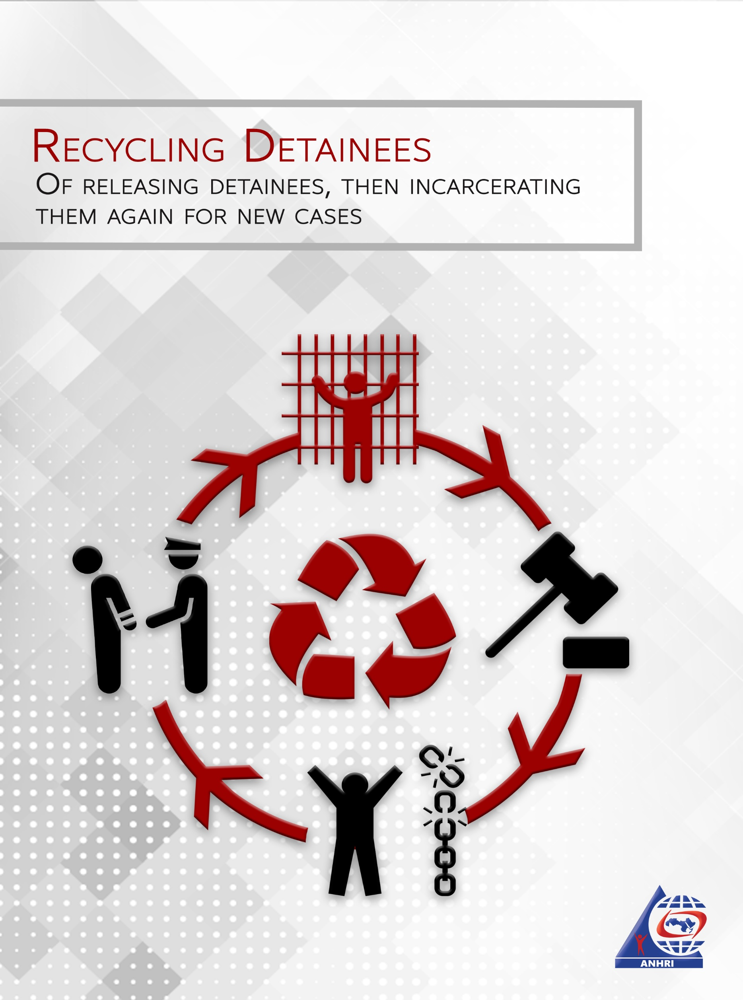

Introduction
Recycling is originally a modern industry concept, that cut expenses and reduce industrial process waste. In Egypt, however, recycling was turned into one of justice apparatus techniques that in contradistinction of its namesake increases justice process costs and waste.
The term "recycling" is used to denote cases where a long delayed release order is issued for a political detainee, who is then submerged by convoluted procedures, some of them are illegal, only to find himself once again referred to the prosecution for a new case with the same old charges or with new ones. He might even be included in a new case whose alleged events have taken place while he was incarcerated, making it practically impossible for him to have taken part in it. The detainee may enjoy his freedom for a few days, or months before being arrested and detained again, or he might not be allowed a single hour of freedom before returning to the prison again.

Post release order procedures
In case under investigations, the defendant is incarcerated on remand by an order of the prosecution till he is released bending further investigations either with a precautionary procedure or on bail. At this point there is what is legally supposed to happen, and there that what really happens.
In the following we first explain what is supposed to happen according to law:
- The release order is issued by the prosecution of the court with the following wording: "The defendant is to be released on bail or with precautionary procedure, unless otherwise wanted for other cases."
- The detainee's papers are sent to the case investigating prosecution department for stamping, in what is called "release verification."
- The detainee along with his release verification are sent to the police department to which belongs his place of residence, where his criminal record is inspected to ensure that no judgments against him need to be executed or that he is wanted for any other case.
- Finally the detainee is released from the police department.
The aforementioned procedures are as per the law, and they are supposed to be concluded in no more than two days, after the issuance of the release order.
What really happens however is the following:
- After issuance of the release order by the prosecution, the rest of the steps are followed normally up to the point where the detainee is supposed to be transferred to the relevant police department.
- In most cases the released prisoner is transferred to the police department in the usual time. In some cases however the transfer is postponed with illogical excuses. This was the case for the leftist pharmacist Gamal Abdel Fatah, and a number of activists, who were released with a prosecution's order on 22 July 2019, but they were not transferred from prison before days. They then stayed in their respective police departments for more than eight days.
- After transferring the released prisoner to his respective police department, an illegal phase starts, that however became routinized for all defendants released pending investigation of state security cases. This is the phase of waiting for National Security apparatus approval.
- This procedure is illegal, as the defendant waits official approval of his release by National Security, for several days and even for a month or more. The defendant remains in custody in the police department, or is transferred to one of the National Security quarters. This period is an illegal detention that is not registered in official papers.

Accused in a new case
In the time of waiting for the National Security approval, the apparatus inspects the defendant file and decides whether it will allow his release or not. In many cases the National Security bypasses the release order by recycling the defendant in a new case, referring him once again to prosecution with nothing more than an investigations report. The prosecution, goes on and issue a new order of detention, thus the defendant is once again incarcerated before even being released in compliance with the first order.
Cases of recycled detainees can be categorized into two types:
- Detention on remand of a new case before being actually released.
- Arresting the defendant once again for a new case weeks or months after the execution of the release order.
The following are some examples.

Detained before actual release

1. Ibrahim Metwally
A humans rights lawyer, founder of Disappeared Persons Families Association, which he founded after his son was disappeared after the Rab'a sit-in forceful dispersal. He is in solitary detention since 2017 in Aqrab prison. He suffers from health problems that were exacerbated due to harsh detention conditions. After being released on remand of the first case, he was recycled in a new one that began in the time he was in custody.
- First case: 900/2017 supreme state security roll
- Charges: Founded and assumed the leadership of an unlawfully based group based, dissemination of false news, contacting foreign entities to get their support for spreading his group's ideas.
- Case details: The lawyer was kidnapped for the airport while traveling to attend a conference in Geneva, on 10 December 2017. He was disappeared for 3 days, before appearing as a suspect in the case. His detention was renewed till 15 October 2019, i.e. beyond the maximum detention period allowed by the law, which is two years.
- The release order wasn't executed, and he was never out of jail. The lawyer remained illegally detained in unknown place till re-appearing on 5 November 2019, accused in a new case.
- The new case: 1470/2019 supreme state security roll
- Charges: Joining a terrorist group, dissemination of false news, abusing a social media means.
- Case details: After being forcefully disappeared for almost 20 days, in which, and as recorded in investigations file, he was tortured by National Security officers, his detention in Aqrab prison is continually renewed over a case that has begun in the time of his first detention.

2. Mohamed Al-Kassas
Deputy president of Strong Egypt Party. He was arrested at home on 8 February 2018, was forcefully disappeared for two day before being included in the case known as "Mekamileen 2". Kassas remained in solitary detention for 22 months, when he issued a release order, but before the execution of the order he discovered being included in a new case with the same old charges.
- First case: 977/2017 known as "Mekamileen 2"
- Charges: Joining and funding a terrorist group, dissemination of false news.
- Case details: Kassas remained in detention since 10 February 2018, till the issuance of his release order on 9 December 2019. He then was illegally kept in custody till 15 December, when he was once again referred to state security prosecution in a new case with nothing but National Security investigations report.
- New case: 1781/2019 supreme state security roll
- Charges: Joining and funding a terrorist group, dissemination of false news.
- Case details: After 22 months in detention, a release order that wasn't executed, and illegally detained for almost a week, he was recycled in a new case with the same charges.

3. Islam Refa'i "Khorm"
He is a sarcastic blogger, and a marketing manager, was arrested because of his sarcastic posts in November 2017, and was charged with accusation contradicting his known opinions. He remained in detention till August 2018, when an order of his release on bail was issued. Before the order was executed he was included in a new case to remain in detention till July 2019, when he was released again, only to find himself accused in a third case, and remains in detention till today.
- First case: 977/2017 state security roll
- Charges: Joining an outlawed group, dissemination of false news.
- Case details: In November 2017 he was arrested by National Security forces. He was forcefully disappeared for more than 48 hours before being included in the case. His detention continued till an order of his release on bail was issued in August 2018. The order wasn't executed till he was added to a new case and detained for it.
- Second case: 441/2018 state security roll
- Charges: Joining an outlawed group, dissemination of false news, and contacting anti-state groups while in custody.
- Case details: In August 2018 Islam's detention was continued with a new case, with the same charges. He remained in detention till July 2019, when a new release, with precautionary procedure order was issued. The order wasn't executed and he was included in a third case.
- Third case: 1331/2019 supreme state security roll
- Charges: Joining a group unlawfully established with the purpose of calling to constitution suspension and preventing state institutions and public authorities from performing their roles.
- Case details: After issuance of release order, he was illegally kept in custody for more than a month. For the third time he was included in a new case on 11 September 2019, with a reformulated charges with no evidence other than National Security investigations.

4. Ola Al-Qaradhawi
Ola Youssif Al-Qaradhawi, was arrested on 30 June 2017, and charged with a number of accusations to remain in solitary confinement till 3 July 2019, when she was included in a new case, only a few hours later, so that she went to solitary confinement again.
- First case: 316/2017 supreme state security roll
- Charges: Joining a terrorist group, supporting and funding Muslim Brotherhood group and its committees and terrorist cells.
- Case detainees: She and her husband (a leader of Wassat Party) were arrested on 30 June 2017. She remained in detention for more than two years.
- New case: 800/2019 supreme state security roll
- Charges: Joining and funding a terrorist group while in custody.
- Case details: Based on the National Security investigations report, Ola Al-Qaradhawi was able while in solitary confinement, to contact and fund a terrorist group, and accordingly her detention continues up till today.

5. Ahmed Baioumy
He was arrested on 20 December 2017, at his home in Dokki. All his belongings were confiscated including his mobile phone, his employment in Dyar newspaper, and social insurance papers, his criminal report, apartment contract, and journalistic archive. He remained in detention till the maximum legal period was over, thus a release order was issued in December 2019, but he wasn't released but was included in a new case. He is still in prison today.
- First case: 977/2017 known as Mekamileen 2
- Charges: Dissemination of false news, to undermine the state credibility, joining an unlawfully established group.
- Case details: After being arrested at home, and although the newspaper provided documents proving he works for and holds a permit issued by it, he still was referred after 3 days to prosecution. He had been in detention for almost two years when a release order was issued, though never executed.
- New case: 8577/2017 Kafr El-Sheikh
- Charges: Joining a terrorist group.
- Case details: After 8 days of illegal detention the journalist was once again included in a new case with the same charges.

A glimpse of freedom then into prison again
In such cases the prisoner is free for a few days, usually with a precautionary procedure. He gets some of his freedom for a while, only to find himself, once again, included in a new case, and detained in a short time.

1. Mohamed Oxogyn
- First case: 621/2018 state security roll
- Charges: Joining a terrorist group and dissemination of false news.
- Case details: He was forcefully disappeared for 19 days after being arrested on 6 April 2018, till he was included in the case. He was detained on remand till 31 July 2019, when a release order with precautionary procedure was issued.
- New case: 1356/2019 state security roll
- Charges: Sharing a terrorist group in carrying out its goals, dissemination of false news, and abusing a social media means.
- Case details: On 21 September 2019, almost two months after being release, he was kidnapped from the police department, where he preformed his precautionary procedure, and taken to unknown place. He remained illegally detained till 8 October 2019, when he appeared in the state security prosecution quarters.

2. Ahmed Yehia
- First case: 1739/2018
- Charges: Associating with a terrorist group, abusing social media sites, broadcasting and disseminating false news.
- Case details: Since March 2019, the pharmacist Ahmed Yehia was arrested while holding a banner on his own in Tahrir square. He remained in detention till released with precautionary procedures in July 2019.
- New case: 488/2019
- Charges: Associating with a terrorist group, abusing social media sites, broadcasting and disseminating false news.
- Case details: In December 2019 he was once again detained for the same charges in a new case, only 4 months after obtaining limited freedom.

3. Abeer Al-Safty
- First case: 718/2018 state security roll
- Charges: Associating with a terrorist group, protesting without notifying relevant authorities, and broadcasting and disseminating false news.
- Case details: On 12 May 2018, she was arrested for participation in a protest of Metro fare raise. She was forcefully disappeared for two days before being included in the case. Abeer has stated in official investigations records that she was tortured in the custody of National Security during her disappearance. She remained in detention for almost 7 months till she was released with precautionary procedures.
- New case: 674/2019 state security roll
- Charges: Joining an unlawfully established group.
- Case details: On 22 April 2019, only four months after gaining her limited freedom, she was arrested in a public transportation vehicle for refusing to forcefully vote on constitutional modifications. She remained forcefully disappeared for 6 days before being detained on remand of the new case.

4. Sameh Saudi
- First case: 1305/2018 state security roll
- Charges: Sharing a terrorist group in carrying out its goals, receiving funds for a terrorist purpose, and collusion for committing a terrorist crime.
- Case details: In August 2018, the political activist Sameh Saudi was arrested along with a number of prominent politicians, like Ambassador Ma'asom Marzook, Dr. Ra'id Salama, and Dr. Yehia Al-Kazaz, in the case known as "Eid Detainees". Saudi continued to be in detention till May 2019, when he was released with precautionary procedures.
- New case: 1338/2019 state security roll
- Charges: Associating with a terrorist group, protesting without notifying the relevant authorities, broadcasting and disseminating false news, and abusing communications means.
- Case details: After about 4 month of limited freedom, he was detained once again in the case known as "September Incidents". Although he complied with precautionary procedures and took no part in any incident in any way, Saudi is detained till today on remand of this case.

5. Mohamed Hamdoon
- First case: 1338/2019 state security roll
- Charges: Association with a terrorist group, protesting without notifying the relevant authorities, broadcasting and disseminating false news, and abusing communications means.
- Case details: After the incidents of 20 September, the lawyer Hamdoon was arrested along with his wife, the feminist activist Asma'a De'ebas, and his brother. He was detained on remand of the case known as "September Detainees" till being released with place of residence guarantee.
- New case: 1530/2019 state security roll
- Charges: Association with a terrorist group,, broadcasting and disseminating false news, and abusing communications means.
- Case details: After less than two months of being released the lawyer and his father were arrested at home and included in the case, and have been detained since then.

Conclusion
The cases above mentioned are only a sample of tens of similar cases of detainees, whose re-arrest was deemed necessary by National Security apparatus, and thus were recycled in new cases, to be kept in detention indefinitely. It's not only that the by law maximum detention periods are used as illegal penalty, but it is also being further elongated by recycling in glare preach of laws perpetrated as always by the National Security apparatus.

