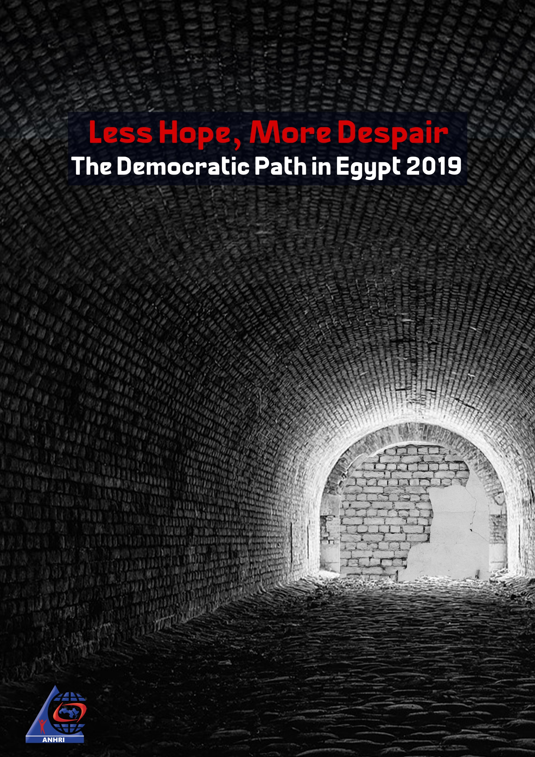

Introduction
Further oppression and harassment, another year moving towards a darker path; this is how we can describe the year of 2019. It began with constitutional amendments that are aimed at extending the President’s rule and expanding his powers and ended with a security crackdown targeting thousands of citizens, including lawyers, journalists, and university professors. Egypt's prisons have been filled with prominent opponents. Even students and housewives weren’t spared the security grip as thousands of them were randomly arrested in mass arrest campaigns. The third quarter of the year witnessed the eruption of the largest demonstrations demanding the overthrow of the president since the beginning of this era, followed by a new wave of arrests amid the ongoing security crackdown, which violates the rights of citizens and thwarts any attempt to push the democratic path away from its overwhelming darkness.
The same old violations persist and are compounded by new innovative methods. Besides trials, unlawful pretrial detention and travel bans, we have seen an escalation in the level of violations against human rights defenders. This includes: organized bullying campaigns, raids on press institutions' headquarters, torture and enforced disappearance of journalists and human rights workers, in light of the state's stepping up of its security grip against advocates of democracy and the rule of law.
Military trials of civilians continue in 2019 together with the ‘special judicial circuits’ assigned to handle terrorism-related cases, in addition to all other exceptional measures which haven’t ceased since the announcement of the state of emergency, not to mention the passing of laws (legislative amendments) that would help only to increase the use of security solutions and the targeting of opinion-makers.
Death sentences are still handed down on a regular basis in exceptional trials that do not meet minimum due process standards. Trials of the symbols of Mubarak's regime, which January Revolution sought to overthrow in the first place, have been proceeding since years while their defendants are set free, at the time when many young people and opinion holders are languishing in prisons and years of their life are being lost.
The regime’s attempts to close the public sphere and the attacks against media freedoms are still ongoing in 2019, when a list of sanctions that will apply to press entities under the Law Regulating the Press and Media has been issued. These bylaws, as described in the media, will lead to the elimination and the killing of the press.
Despite the above mentioned restraints, protests didn’t stop and terrorism hasn’t been eliminated, but rather freedoms are being confiscated, democracy is being disrupted and freedom of the media is being curbed. Those who rule the country have yet to understand that security solutions will not work alone neither will they serve any useful purpose.
This is the sixth annual report released by Lawyers for Democracy Initiative to monitor the state of Egypt’s democratic path during 2019 in details, numbers, percentages and figures.
“Lawyers for Democracy” Initiative:
“Lawyers for Democracy” is an initiative launched by the Arabic Network for Human Rights Information (ANHRI) in 2014. It consists of a group of lawyers in a number of Egypt’s different governorates and cities to monitor the events, cases, and incidents that took place in Egypt; such as protests, conferences, strikes and official and non-official practices that affect the democratic path in Egypt. Lawyers of the initiative monitor and document these incidents and provide legal support if needed, and then they release reports to elucidate Egypt's situation when it comes to the rule of law, respect for freedom of expression and the democratic path.

Chapter 1
Protest events

Protest events
The year 2019 has witnessed the Egyptian authorities clearly insisting on closing the public sphere and preventing the different political powers from organizing any protest, regardless of the reason behind the demonstration and no matter who they are, as if there is a prevalent fear of leaving space for those who have dissenting opinions.
Druing 2019, the various political powers organized 491 different protest events, in spite of the measures taken by the authorities to face such protests and their constant efforts to thwart them, either under the Protest Law issued under former President Adly Mansour’s rule or upon any other security measures.
The details of the 491 protest events that took place during the year and their distribution according to different powers and months are as follows:
The following table shows the number of protest activities and the security attacks they were subjected to during 2019:
Months | Protests that didn’t face security attacks | Protests that faced security attacks | Protests subject to negotiations | Total in 2019
January | 28 | 4 | 2 | 35
February | 12 | 15 | 10 | 37
March | 22 | 10 | 2 | 34
April | 42 | 6 | 0 | 48
May | 32 | 21 | 1 | 54
June | 44 | 10 | 2 | 56
July | 24 | 8 | 3 | 35
August | 27 | 4 | 3 | 34
September | 24 | 27 | 5 | 56
October | 9 | 24 | 2 | 35
November | 7 | 20 | 3 | 30
December | 12 | 15 | 10 | 37
Total in 2019 | 283 | 164 | 44 | 491

The Egyptian authorities were specifically targeting the demonstrations organized in wide public streets, big squares and in the vicinity of Tahrir Square, and none of them were spared the attack of the security forces.

Therefore, political powers, particularly the National Alliance to Support Legitimacy (NASL) and the Muslim Brotherhood (MB), had to stage quick protests on side streets to avoid security interventions, which explains why a large number of protest events didn’t face any attacks by the security services.

A comparison between the numbers of protests from 2014 to 2018

2019 is the second year that witnessed the lowest number of demonstrations; after years of systematic targeting of protests, either through legislation (The Protest Law) or security practices, along with the arrest and detention of protesters. Only 491 protests were organized during the entire year, following the year of 2018 which saw only 485 protests being organized.
On the other hand, the year 2014, during which President al-Sisi officially took the reins of power, is the year that witnessed the largest number of demonstrations; as 1,515 different protest events were organized.
The year 2016 ranks second in terms of the highest number of protests, with 1,318 different protest events being staged. This year saw a significant rise in the number of protests due to the deterioration of economic conditions, price hikes, and the signing of Tiran and Sanafir maritime border demarcation agreement.
Back then, in 2015, 766 different events were organized, making it the second year that saw a low number of demonstrations, followed by 2017 when only 779 different events were organized.

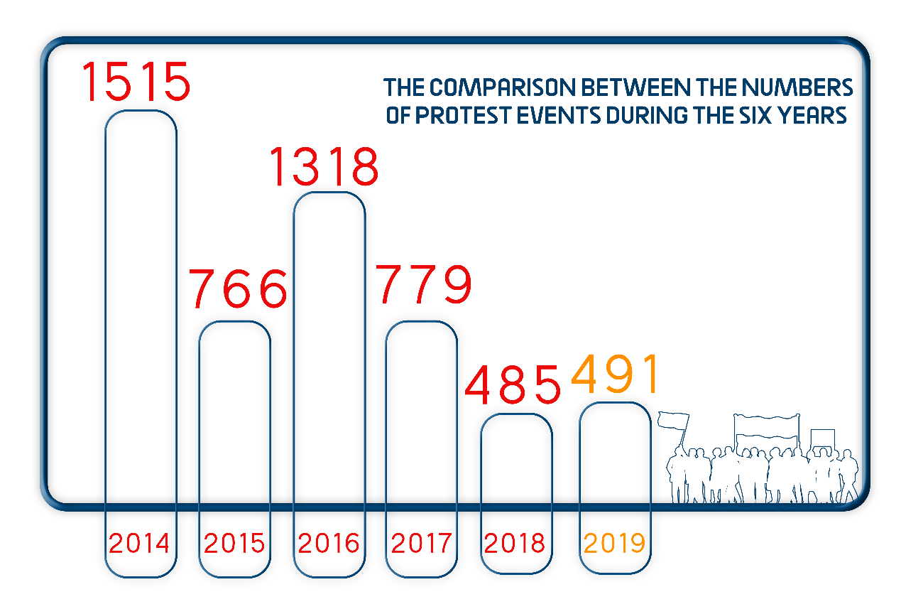
2014 | 2015 | 2016 | 2017 | 2018 | 2019
1515 | 766 | 1318 | 779 | 485 | 491

Pro and anti-regime protests
Thanks to the mass rallies held in support of the proposed constitutional amendments, the pro-regime activities have increased, with 29 protest events being organized during the year comparing to 2018, which witnessed only 7 events.
As usual, the Protest Law hasn’t been implemented on the pro-government protest events; as none of them was banned or attacked as it is the case with the anti-government events.
While there were 462 events of opposition, the year only witnessed 29 pro-regime events as shown in the following table:
Pro- regime events | Anti-regime events
29 | 462
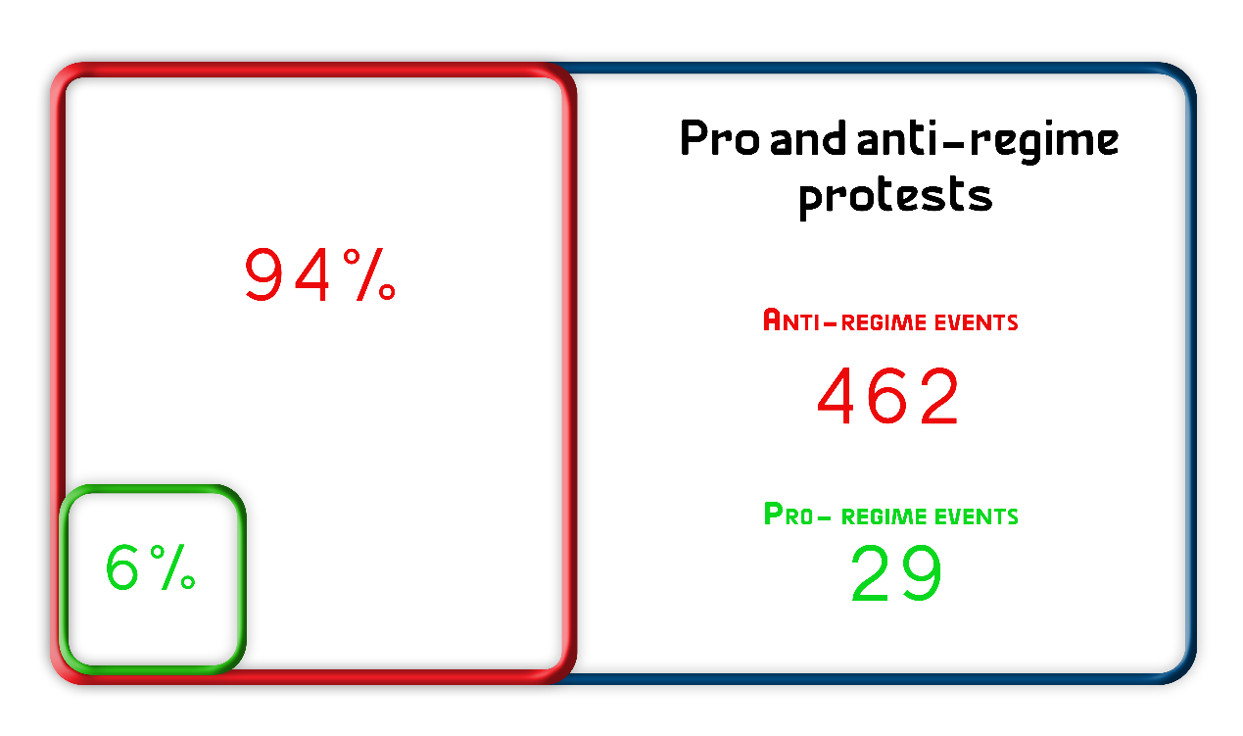
Security attacks on protest events:
During 2019, 491 different protest events were organized, 80 of which were attacked by the security forces, while 370 went on without attacks, and 35 were resolved after negotiations.
The following table shows the number of protest events that faced security attacks:
Total number of events | Events didn’t face security attacks | Events faced security attacks | Events negotiated
491 | 283 | 164 | 44

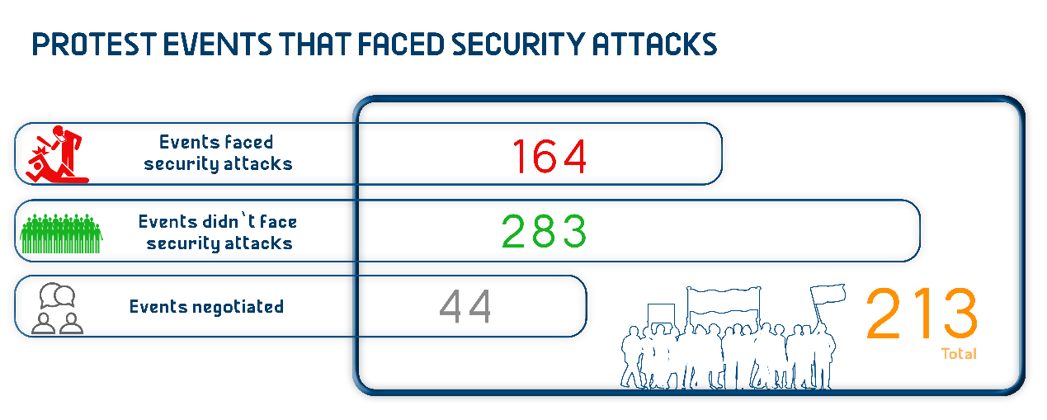

Protest events according to the powers organizing them:
The protests organized by the Muslim Brotherhood (MB) and the National Alliance to Support Legitimacy (NASL) were at the forefront of the protests scene with 213 protests, followed by the Labor and Social Protests which was amounted at 180 events. The year 2019 has witnessed an incidence that occurred for the first time since the release of the Democratic Path report; which is represented in the civil powers and MB jointly organizing 25 protest events.
The following table shows the number of protests according to the forces that organize those events:
Forces organizing protests | MB & NASL | Social and labor protests | Students protests | Civil and democratic powers | Pro-regime protests | Civil powers and MB altogether
Number of protests | 213 | 180 | 41 | 3 | 29 | 25
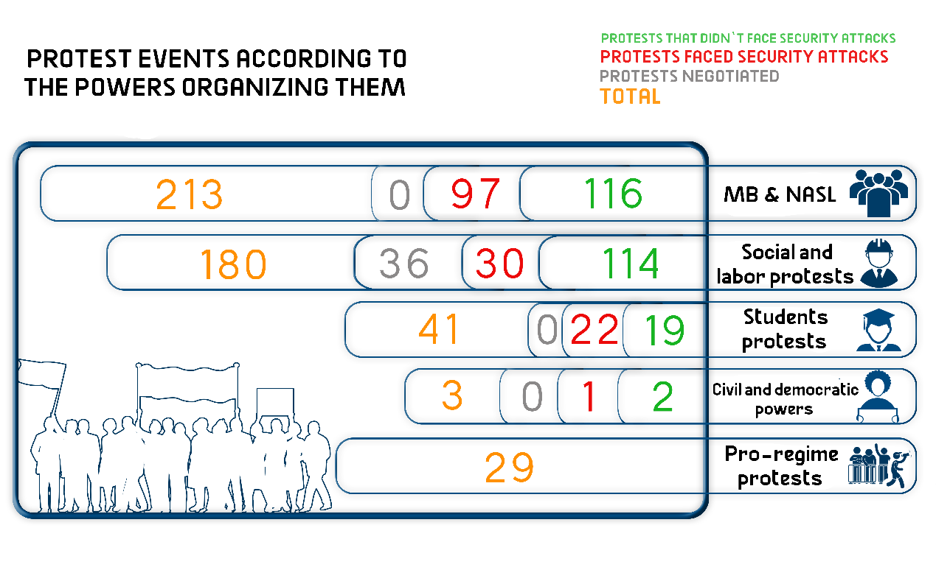

The most important demands by the different powers:
The year of 2019 has witnessed all the civil and democratic powers alongside the MB and NASL sharing 25 protest events, which stepped up their clear demands such as:
- Demanding the release of political prisoners
- Protesting against poor economic and social conditions
- Protesting against the military trials of civilians
- Protesting against the imposition of the state of emergency
First: (MB) & (NASL) protest events:
During 2019, the Muslim Brotherhood (MB) group and its ally, the National Alliance to Support Legitimacy (NASL), continued to organize protest events and what is dubbed as whirlwind protests; in a way to make the security services unable to disperse them or arrest their participants. Both the MB and NASL have jointly staged 213 protest events throughout the year.
The following table shows, in months, the number of the MB and NASL’s protests:
Months | Protests that didn’t face security attacks | Protests faced security attacks | Protests negotiated | Total
January | 9 | 1 | 0 | 10
February | 4 | 12 | 0 | 16
March | 9 | 6 | 0 | 15
April | 8 | 5 | 0 | 13
May | 15 | 10 | 0 | 25
June | 22 | 8 | 0 | 30
July | 10 | 5 | 0 | 15
August | 16 | 4 | 0 | 20
September | 8 | 2 | 0 | 10
October | 5 | 20 | 0 | 25
November | 6 | 12 | 0 | 18
December | 4 | 12 | 0 | 16
Total during 2019 | 116 | 97 | 0 | 213

The month of June topped the year's months in terms of the number of protest events, which were organized in conjunction with what is called "June 30 Coup".
The security services continued to target the protests staged by the MB and NASL groups, with 97 protest events being attacked throughout 2019.
The following table shows the attack on MB and NASL's protests in numbers:
Protests that didn’t face security attacks | Protests faced security attacks | Protests negotiated | Total
116 | 97 | 0 | 213
The most important demands brought by the Muslim Brotherhood (MB) and the National Alliance to Support Legitimacy (NASL) during 2019:
- Toppling what they called the military coup and demanding the departure of al- Sisi and the return of legitimacy
- Protesting against the deteriorating economic conditions in the country
- Protesting against the imposition of the state of emergency
- Demanding to hold accountable those responsible for the dispersal of Raba’a al-Adawiya Sit-in
- Protesting the enforced disappearance of NASL members
Second: Civil and democratic powers protest events
The year 2019 has witnessed a continuous decline in the numbers of protest activities organized by the democratic civil powers; and this was due to the severe security restrictions and the besieging of the demonstration areas, especially the vicinity of Tahrir Square and the Journalists' Syndicate. The civil and democratic powers managed to organize only three protests during the entire year.
The following table shows the number of social and labor protests and their distribution in 2019:
Months | Protests that didn’t face security attacks | Protests faced security attacks | Protests negotiated | Total
January | 1 | 1 | 0 | 2
February | 0 | 0 | 0 | 0
March | 1 | 0 | 0 | 1
April | 0 | 0 | 0 | 0
May | 0 | 0 | 0 | 0
June | 0 | 0 | 0 | 0
July | 0 | 0 | 0 | 0
August | 0 | 0 | 0 | 0
September | 0 | 0 | 0 | 0
October | 0 | 0 | 0 | 0
November | 0 | 0 | 0 | 0
December | 0 | 0 | 0 | 0
Total in 2019 | 2 | 1 | 0 | 3
The only protest events organized by the civil powers throughout the whole year were that organized in January at the Karama Party's headquarters to commemorate the eighth anniversary of the January 25 Revolution, in addition to the hunger strike staged by a number of civilian detainees inside Tora prison demanding better prison conditions.

Only one protest was attacked by the security forces, and the two other ones were left without any interference.
Protests that didn’t face security attacks | Protests that faced security attacks | Protests resolved through negotiation | Total number of protests
2 | 1 | 0 | 3
The following table illustrates the number of attacks on the civil and democratic powers' protests

The most important demands brought by the civil and democratic powers:
- Demanding to improve the conditions of detainees inside Tora Prison
- Celebrating the anniversary of the 25 January Revolution

Third: Social and labor protests
Labor protests continued in 2019 owing to the poor economic and living conditions, as the number of protest events organized during the year reached 180, most of which sought to improve the conditions of workers.
The following table shows the number of social and labor protests and their distribution in 2019:
Months | Protests that didn’t face security attacks | Protests faced security attacks | Protests negotiated | Total
January | 16 | 2 | 3 | 21
February | 8 | 2 | 10 | 20
March | 10 | 1 | 2 | 13
April | 14 | 1 | 0 | 15
May | 8 | 2 | 1 | 11
June | 19 | 2 | 2 | 23
July | 13 | 2 | 3 | 18
August | 8 | 0 | 3 | 11
September | 12 | 0 | 5 | 17
October | 4 | 3 | 2 | 9
November | 1 | 8 | 3 | 12
December | 1 | 7 | 2 | 10
Total in 2019 | 114 | 30 | 36 | 180

Attacks on social protests:
During 2019, the security forces intervened to forcibly disperse 30 protests organized by the labor and social powers and succeeded to resolve 36 events through negotiation, while left 114 events without interference.
The following table illustrates the number of attacks on labor and social protests:
Protests that didn’t face security attacks | Protests that faced security attacks | Protests resolved through negotiation | Total number of protests
114 | 30 | 36 | 180

Protests that didn’t face security attacks | Protests that faced security attacks | Protests resolved through negotiation | Total number of protests
114 | 30 | 36 | 180
Social protests’ most important demands in 2019:
– Protesting against the dismissal of workers
– Protesting against low salaries and demanding better economic conditions
– Protesting delayed payment of financial dues
– Demanding the regularization of workers’ conditions
– Demanding an increase of the annual allowance

Fourth: Students’ protests
During 2019, students organized 41 protest events compared to 307 organized during 2014 marking a significant decline in the number of protests, which resulted from the severe repressive measures taken by the authorities and university administration to ban the exercise of public affairs’ activities on campus. These measures include: using force to break up students’ gatherings, arresting them, issuing administrative decisions to outlaw political activities on campus, banning them from organizing student exhibitions, dismissal from the university, and depriving students of completing their studies.
The following table shows the number of student protests and their distribution during 2019
Months | Protests that didn’t face security attacks | Protests faced security attacks | Protests negotiated | Total
January | 0 | 0 | 0 | 0
February | 0 | 0 | 0 | 0
March | 2 | 4 | 0 | 6
April | 6 | 5 | 0 | 11
May | 9 | 9 | 0 | 18
June | 0 | 0 | 0 | 0
July | 1 | 1 | 0 | 2
August | 0 | 2 | 0 | 2
September | 0 | 1 | 0 | 1
October | 1 | 0 | 0 | 1
November | 0 | 0 | 0 | 0
December | 0 | 0 | 0 | 0
Total in 2019 | 19 | 22 | 0 | 41

Attacks on student protests:
During 2019, the security forces attacked 22 protest events while left 19 others without any intervention.
The following table shows the number of attacks on students’ protest events
Events that didn’t face attacks | Events that faced attacks | Events negotiated
19 | 22 | -

The most important demands by student protests:
- Thanawyia Amma (Secondary School) first year students objecting to the new tablet- based examination system
- Assiut University students protested to demand an investigation into the assault on a female student at the University hostel
- Kafr El Sheikh nursing school students objecting to the decision to transfer them to another school that is far from their place of residence.

Fifth: Pro-regime protests:
During 2019, 29 different protest events supporting the authorities and the current regime were organized, and none of them were attacked by the security services. The most prominent two events were held during the month of January concurrently with January Revolution's anniversary, but with the aim to commemorate the National Police Day, and to cut off the road before opponents and prevent them from celebrating the January uprising.
20 pro-regime events were organized in April 2019 to support the referendum on the constitutional amendments, and three others were organized in September to show support for the President in what the pro-regime forces called a "coup plot" or a conspiracy to undermine him during September 20 incidents.

Chapter 2
Ongoing Trials and Judicial Rulings

First: Ongoing trials
2019 witnessed 86 deliberated trials that have been considered before the Egyptian judiciary against the different political powers, Mubarak’s regime figures, and post-June 30 regime’s figures. Of these trials, 73 are being considered by civilian courts and 13 by the military judiciary.
1- Trials deliberated by the civilian judiciary:
2019 witnessed a continued rise in the number of trials against various political powers; due to the slow judicial process and the lack of rapid adjudication over trials on the one hand, and the introduction of new cases on the other hand. The civilian judiciary is considering 73 trials related to public affairs against different political powers.
The following table shows the number of ongoing trials against the different political powers
MB and NASL | Civil democratic powers | Mubarak regime | Post-June 30 regime | Other cases pertaining to public affairs | Total in 2019
53 | 9 | 8 | 3 | -- | 73
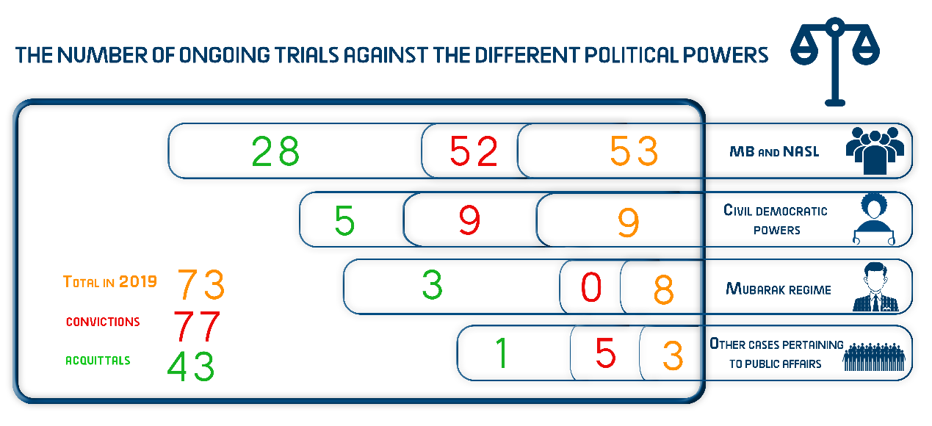
The Muslim Brotherhood (MB) group remained on top of all the powers facing trial, followed by the civil and democratic powers, and then came in third place Mubarak’s regime figures whose trials have yet to be adjudicated over since years, as part of the cases that had been lodged against Mubarak’s regime affiliates in the wake of January 25, 2011 Revolution.

2- Military trials for civilians:
The year 2019 saw the deliberation of military trials against civilians and citizens who were brought before the special (exceptional) military tribunals.
During the year, 13 ongoing trials were being considered before the military judiciary, compared to 24 trials in 2019, 38 trials in 2017 and 32 trials in 2016.
In 2019, 1832 civilians appeared before the military judiciary while in 2018, the number of civilians brought to military trials was 1562, compared to 1869 in 2017 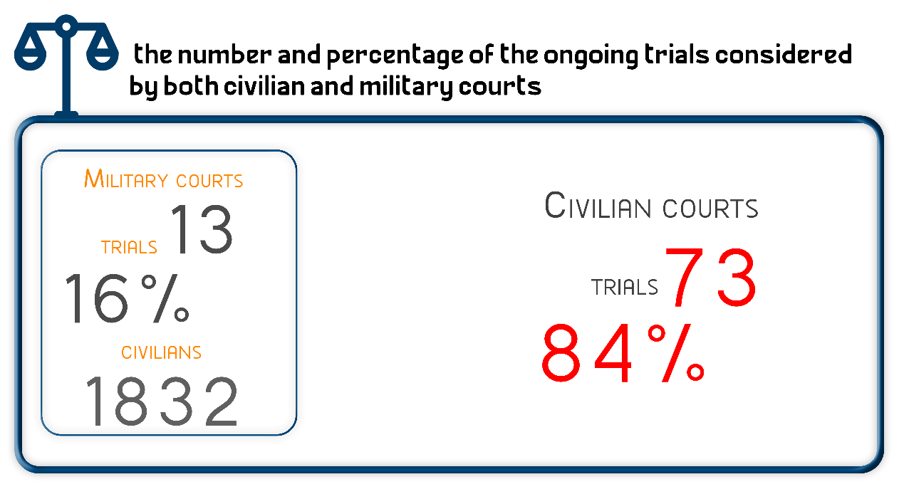
Second: Judicial Rulings
122 sentences were handed down by the Egyptian judiciary in 2019 over cases related to public affairs; of these, there were 77 rulings of conviction, 43 acquittals, and two suspended sentences issued by the criminal courts.
1- Convictions:
During the year, 77 convictions were issued against the different political powers; 11 rulings were handed down by the military judiciary against civilians, and the MB and NASL groups were at the forefront of forces that received convictions.

The following table shows the distribution of convictions among the different political powers:
MB and NASL | Civil democratic powers | Mubarak’s regime | Post-June 30 | Military trials for civilians | Other cases | Total in 2019
52 | 9 | -- | 5 | 11 | -- | 77
2- Acquittals
During 2019, 43 different rulings of acquittal in public affairs-related trials have been issued; of these, 9 acquittals were handed in military trials for civilians and 45 in trials before civil courts.
The following table shows the distribution of Acquittals in numbers
MB and NASL | Civil democratic powers | Mubarak’s regime | Post-June 30 | Military trials for civilians | Other cases | Total in 2019
28 | 5 | 3 | 1 | 6 | -- | 43

3- Sentences issued with the suspension of execution of the penalty
During 2019, criminal courts issued two rulings of conviction and ruled to suspend the implementation of the penalty in favor of members of the Muslim Brotherhood and the Alliance for the Support of Legitimacy.
4- Death sentences
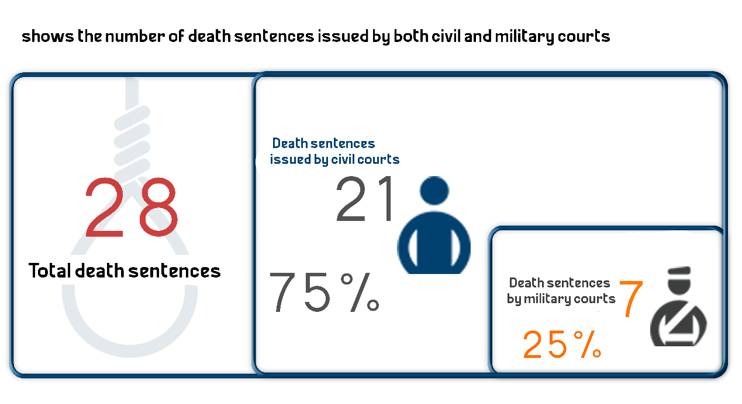
28 death sentences were handed down against 101 citizens in 2019.
The following table shows the number of death sentences issued by both civil and military courts
Death sentences issued by civil courts | Death sentences issued by military courts | Total death sentences
21 | 7 | 28

The following table shows the number of defendants who were handed down death sentences in 2019
 | Number of defendants referred to the Mufti | Number of death sentences confirmed to be executed by the Mufti | Number of defendants whose death sentences confirmed by the Court of Cassation | Total number of defendants
Civilian | 28 | 24 | 24 | 76
Military | 14 | 2 | 9 | 25
Total | 42 | 26 | 33 | 101

Death sentences executed in 2019

– The Prisons Authority sector has executed the death sentences handed down against 18 citizens into 6 cases, details are as follows:

- On 7 February 2019, the Prison Authority sector carried out the death sentence that was issued by Mansoura Criminal Court against 3 defendants convicted of murdering the son of Al-Mansoura Terrorism Court's President.

- On 13 February 2019, the Prison Authority sector carried out the death sentence that was issued by Cairo Criminal Court against 3 defendants in the case known in the media as "Killing of Major-General Nabil Farrag".

- On 20 February 2019, the Prison Authority sector carried out the death sentence that was issued by Cairo Criminal Court against 9 defendants in the case known in the media as "Assassination of the Public Prosecutor".

- On 8 December 2019, the Prison Authority sector carried out the death sentence that was issued by the Military Court against one defendant in the case known in the media as "Niger Embassy bombing".

- On 8 December 2019, the Prison Authority sector carried out the death sentence that was issued by the Military Court against one defendant in the case known in the media as "Sinai Province Organization".

- On 10 December 2019, the Prison Authority sector carried out the death sentence that was issued by Cairo Criminal Court against one defendant in the case known in the media as "Helwan's Marmina Church incidents".

Chapter 3
Terrorism and Counter-Terrorism Operations

First: Terrorist operations
Terrorist operations continued in 2019. Although their number had considerably declined compared to the previous years, the exceptional measures and the announcement of the state of emergency didn’t stop organized terrorism from targeting state institutions and the Christian minority in Cairo and Egypt’s different governorates.
Lawyers for Democracy team have monitored 26 terrorist operations carried out in 2019, compared to 400 terrorist attacks in 2015 and 259 in 2016.
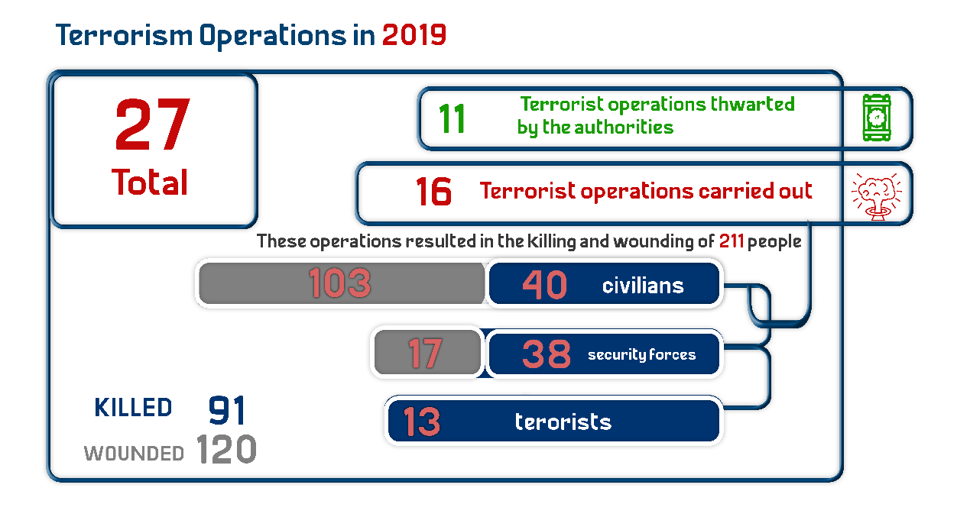
The following table details the terrorist operations that took place during 2019:
Terrorist operations carried out | Terrorist operations thwarted by the authorities | Total of terrorist operations
16 | 11 | 27

The following table shows the number of terrorist operations in 2019
Months | Terrorist operations carried out | Terrorist operations thwarted | Total
January | 1 | 1 | 2
February | 1 | 2 | 3
March | 0 | 0 | 0
April | 1 | 1 | 2
May | 1 | 0 | 1
June | 4 | 1 | 5
July | 1 | 1 | 2
August | 1 | 2 | 3
September | 0 | 0 | 0
October | 3 | 1 | 4
November | 2 | 0 | 2
December | 1 | 2 | 3
Total in 2019 | 16 | 11 | 27

Terrorist operations in different governorates:
North Sinai continued to be the center and focus of terrorist and extremist groups. As is the case in previous years, Sinai is at the forefront of the provinces that witnessed terrorist attacks during 2019, followed by the capital Cairo.
The following table details in numbers the terrorist operations and their distribution in different governorates:
Governorate | Operations carried out | Operations thwarted | Total
North Sinai | 12 | 8 | 20
Cairo | 3 | 1 | 4
Giza | 1 | 2 | 3
Total | 16 | 11 | 27

These operations resulted in the killing and wounding of 211 people during the year, detailed as follows
 | Civilians | Security forces | Terrorists | Total
killed | 40 | 38 | 13 | 91
wounded | 103 | 17 | 0 | 120
Total | 143 | 55 | 13 | 211

Second: Counter-terrorism operations
In 2019, there were 43 preemptive attacks by the security forces which targeted what the Egyptian authorities described as terrorism hubs, resulting in the arrest and ‘liquidation’ of some elements whom the authorities hold responsible for the terrorist operations carried out in the country.
These operations have resulted in the killing of 523, the wounding of 40 others and the arrest of 3061 people.
The following table shows the details of terrorist operations during 2019
Killed | Wounded | Arrested | Total number of operations
523 | 40 | 193 | 43

Chapter Four
Attacks against Freedom of Expression and Media Freedoms

The year 2019 has witnessed a continuation of the massive crackdown and the ongoing targeting of media freedoms. Lawyers for Democracy monitored 171 various violations of freedom of the press and media freedoms compared to 289 violations in 2016 and 343 in 2015.
The following table shows the number of violations against freedom of expression and media freedoms throughout the year
Months | Number of violations
January | 11
February | 12
March | 16
April | 20
May | 17
June | 15
July | 13
August | 12
September | 17
October | 15
November | 13
December | 10
Total violations in 2019 | 171

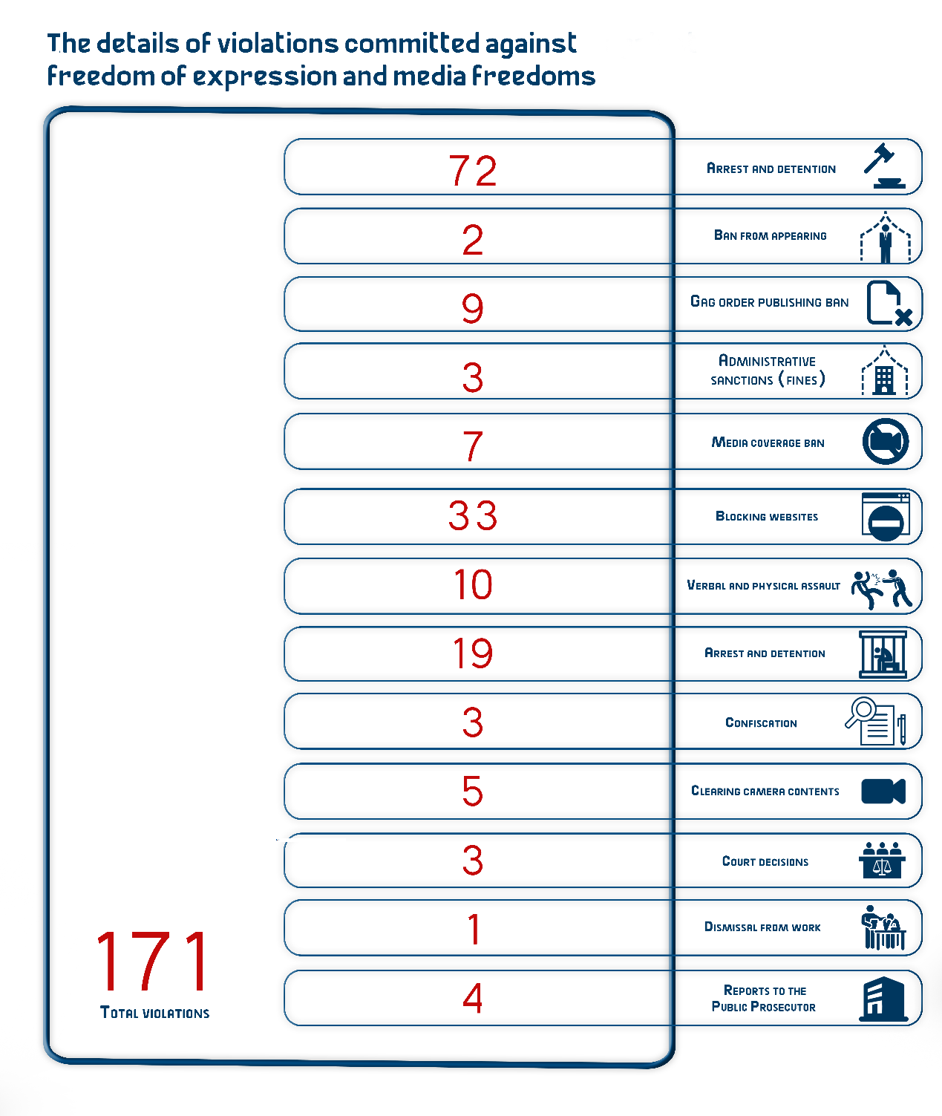

The following table shows in numbers the details of violations committed against freedom of expression and media freedoms:
Type of violation | Number of violation
Arrest and detention | 72
Ban from appearing | 2
Gag order (publishing ban) | 9
Blocking websites | 3
Administrative sanctions (fines) | 7
Media coverage ban | 33
Verbal and physical assault | 10
Arrest and detention | 19
Confiscation | 3
Clearing camera contents | 5
Court decisions | 3
Dismissal from work | 1
Reports to the Public Prosecutor | 4
Total violations | 171

From the previous table, we can notice a large and remarkable increase in the trials and pretrial detention renewal sessions against opinion-makers and journalists because of their views, in addition to the cases of arrest and detention of journalists and media professionals. Also the year 2019 witnessed the mid-term elections for the Journalists Syndicate in which prisoner of conscience Hisham Jaafar was excluded and deprived of his right to run for election.

Chapter 5
The attacks on Human Rights Defenders (1)

The year 2019 has seen an escalation in the systematic targeting of human rights defenders who have been subjected to constant harassment and violations, which range from arrest and detention to ongoing trials and the use of pretrial detention as a punishment.
At time human rights defenders are subjected to continuous targeting, two of them received international awards.
First: Violations against human rights defenders:
Pretrial detention, investigations, and travel bans are no longer considered the most serious and common violations committed throughout 2019- as is the case in previous years; rather the onslaught against human rights defenders have escalated and intensified that the number of defenders who received judicial rulings or brought to trial has increased in a considerable way.
The following table shows the number of attacks on human rights defenders in 2019:

Type of violation | Number of violations
Prison sentences and pretrial detention orders against HRDs | 56
Travel bans | 96
Precautionary measures (security probation) | 6
Torture, dehumanizing treatment, assaults and bullying | 5
Enforced disappearance and unlawful detention | 5
Confiscation of funds | 5
Referring to disciplinary boards | 3
Defamation campaigns or incitement to murder | 60
Total | 233

Second: Awards received by human rights defenders:
- Amal Fathy awarded the "Bruno Kreisky" prize
On 20 May 2019, Euro-Mediterranean Organization (EuroMed Rights) announced that Egyptian woman human rights defender Amal Fathy had been awarded the "Bruno Kreisky" prize for human rights for her courageous work defending human rights in Egypt. It added that Amal received the award against the backdrop of her activism speaking out against the arbitrary detention of other activists and violence against women in Egypt, which has led to her being arrested, held in pre-trial detention for several months and charged in two cases, over one of which she was sentenced to two years in prison.
- Al-Nadeem Center wins the Franco-German Prize for Human Rights and the Rule of Law
On 9 December 2019, Al-Nadeem Center for Rehabilitation of Victims of Violence- represented by Dr. Aida Saif Al-Dawla, Dr. Suzan Fayyad, Dr. Magda Adly and Dr. Mona Hamid- was awarded the 2019 Franco-German Prize for Human Rights and the Rule of Law, which is presented by the German and French governments to human rights activists around the world in different countries; in recognition of the center's activities in the support and rehabilitation of torture victims, despite the fact that the Egyptian regime closed its headquarters in 2017.

Chapter 6
Milestones in the Democratic Path

Influential milestones in the democratic path
The year of 2019 has witnessed a number of crucial events that have influenced the democratic process and the paths of the rule of law, which can be summarized in the following lines:
First: Holding a referendum on constitutional amendments
In early 2019, Egypt's parliament submitted motion to amend some articles of the Egyptian Constitution, the most prominent of which is the article pertaining to presidential term limits extending president's time in power from four to six years, which would allow the current president to run again in the presidential elections for an additional six-year term. In the second half of April, the voting process for the proposed constitutional amendments was conducted, and on April 23, Egypt's High Elections Commission announced the results of the referendum saying that over 88% of voters, out of the illegible voters cast their votes in the referendum (27 million Egyptians), had approved the constitutional changes that could see President Abdel Fattah al-Sisi stay in power until 2030.
Second: Extending Egypt's state of emergency
In continuation of the imposition of the state of emergency, which was declared for the first time by President Abdel Fattah al-Sisi in 2017 in the aftermath of the terrorist attacks which targeted two Coptic churches in Alexandria (St Mark's church) and Tanta (St George's church), the President ratified on 13 January 2019 the presidential decree No. 17 of 2019 extending the state of emergency in the country for further three month. On 23 April 2019, the nationwide state of emergency was renewed for another three months upon a presidential decree No. 2018 of 2019.
On 4 July 2019, the President issued a decree No. 317 of 2019 extending the state of emergency across the country for three months, which was further renewed for a three-month period on 26 October 2019 upon the presidential decree No. 555 of 2019. Since then, the emergency law is in effect and is being used to prosecute journalists and those who are opposing the current regime by referring their cases to the Supreme State Security courts.
Third: Issuing a sanctions list for the Law Regulating the Press & Media
On 18 March 2019, the Supreme Council for Media Regulation (SCMR) issued a decision No. 16 of 2019 enacting a list of sanctions/regulations and measures that may be applied against entities governed by the provisions of the Law Regulating the Press, Media and SCMR. The decision provoked a wave of objection among writers and journalists arguing that the sanctions list would "kill or execute the press and media".
Fourth: Former parliamentarian and journalists arrested, accused of what they called "The Plan for Hope"
On 25 June 2019, the security forces arrested former Member of Parliament Zyad Elelaimy, a leading member of the Egyptian Social Democratic Party, the Karama Party member Hossam Moanis, and a number of writers and journalists; against the backdrop of holding a meeting to discuss their stance in the upcoming parliamentary elections. They faced several charges in Case No. 930 of 2019 State Security, which the Interior Ministry dubbed "Thwarting the Coalition for Hope".
Fifth: September 20 incidents
This year witnessed an incidence that occurred for the first time since the release of the Democratic Path report in 2014; which is the scattered protests organized by all political forces in Egypt in what is known in the media "September 20 protest". These protests broke out against the backdrop of the statements directed by Egypt's President Abdel Fattah El-Sisi at the National Youth Conference, when he said: "Yes, I have built presidential palaces, and I will build more. But those are not for me, they are for Egypt", commenting on the recently-raised economic issues pertaining to the construction projects carried out by the Armed Forces' Engineering Authority accusing the authorities of corruption and mismanagement of state funds. In response, thousands of citizens, politicians and university professors were arrested against the backdrop of these protests.
============================
- ANHRI's website, "More than difficult" report, published on 10 December 2019, last accessed on: 30 December 2019
https://www.anhri.info/?p=12971

