The Arabic Network for Human Rights Information (ANHRI)
"Lawyers for Democracy" Initiative

The Democratic Path in Egypt during the Second Quarter of 2019
Before we begin:
The Democratic Path is a report that is launched by the Arabic Network for Human Rights Information (ANHRI) every three months, i.e. quarterly, starting from 2018. In previous years, ANHRI used to publish the report on a monthly basis through the “Lawyers for Democracy” initiative it launched in 2014 to monitor the democratic process in Egypt.
In addition to the monthly reports issued to monitor the state of democracy, ANHRI issued annual reports to monitor the democratic path in 2014, 2015, 2016, 2017 and 2018, which can be accessed through the “Reports” section on ANHRI’s website by clicking on the following link:
https://www.anhri.info/?cat=7

Introduction:
The second quarter of this year witnessed Egypt's High Elections Commission announcing the results of the referendum on the constitutional amendments- most prominent of which is the article pertaining to presidential term limits extending president's time in power to six years- saying that over 88% of voters, out of the illegible voters cast their votes in the referendum, had approved the constitutional changes. The last month of the reporting period also witnessed the death of former President Mohamed Morsi in a courtroom during one of his trial sessions in the case known in the media as "spying for Hamas". During this period as well, the Egyptian authorities arrested a number of journalists along with a former parliamentarian for allegedly participating in what they called "Hope Plan" to topple the Egyptian state coinciding with the commemoration of the June 30 Uprising. Protest events didn’t stop during the second quarter of 2019, when 158 protests had been organized by different political powers; the Muslim Brotherhood (MB) and the National Alliance to Support Legitimacy (NASL) were at the forefront with 68 protests, followed by the social and labor protests with 49 protest activities.
Military trials of civilians also continued in the second quarter of the year; as among the 66 trials held during this period, there were 7 military trials for 1,655 citizens.
Violations of media freedoms have not ceased during this period, with 52 cases of violations recorded, most notably pertaining to media coverage ban which amounted to 29 cases during the period covered by the report.

The details of the state of the democratic path during the second quarter of 2019 are outlined, in numbers and percentages, as follows:

First: Protest events
During the second quarter of the year, the various forces organized 158 different events, and their distribution was as follows:
- The Muslim Brotherhood (MB) and the National Alliance to Support Legitimacy (NASL): 68
- Social and labor protests: 49
- Student protests: 18
- Pro-regime protests: 23

The following table shows the distribution of protest activities in percentages according to the forces organizing them
 |  | Pro-regime protests | Civil and democratic powers | Student protests | Labor and social protests | MB and NASL
 |  | 14% | 0% | 11% | 32% | 43%
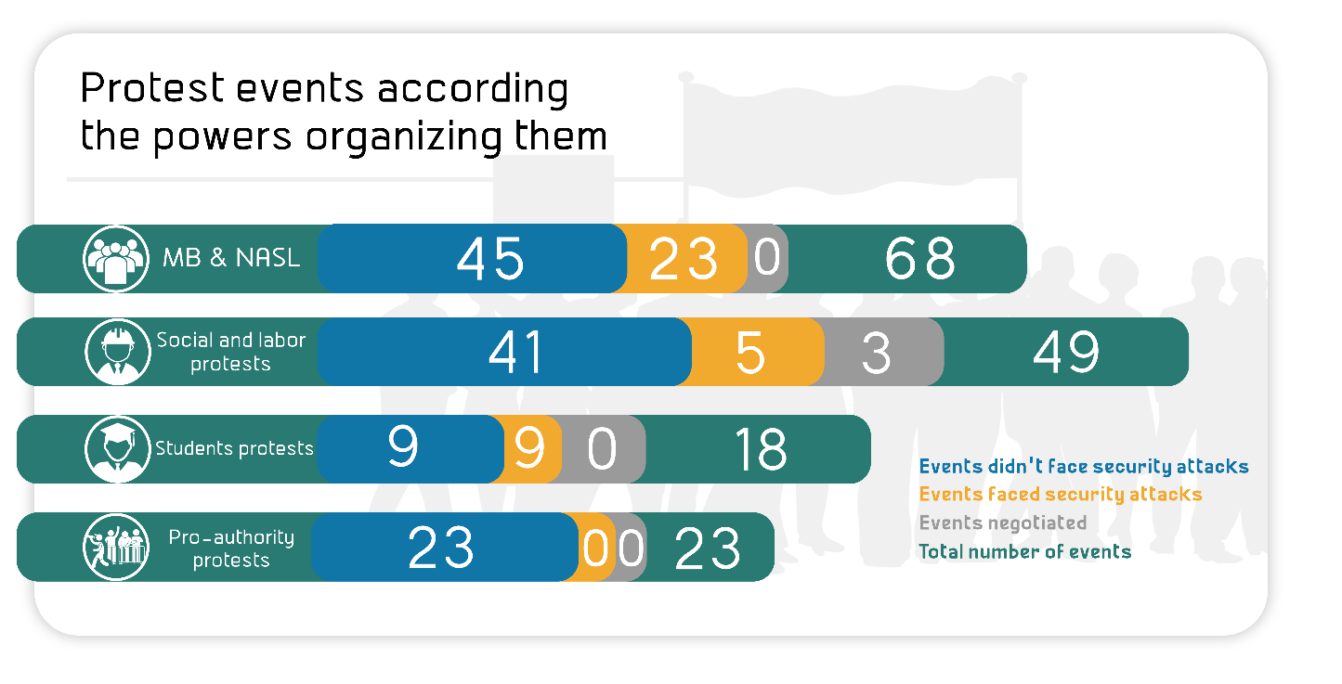

The month of June came first in witnessing the largest number of protest events by 56 different protests, as shown in the following table:
Total | June | May | April
158 | 56 | 54 | 48

Out of these different events, 37 were attacked by security forces, 118 passed without attacks, and 3 labor and social protests were resolved after negotiations.
The following table shows the percentage of attacks on all protest activities:
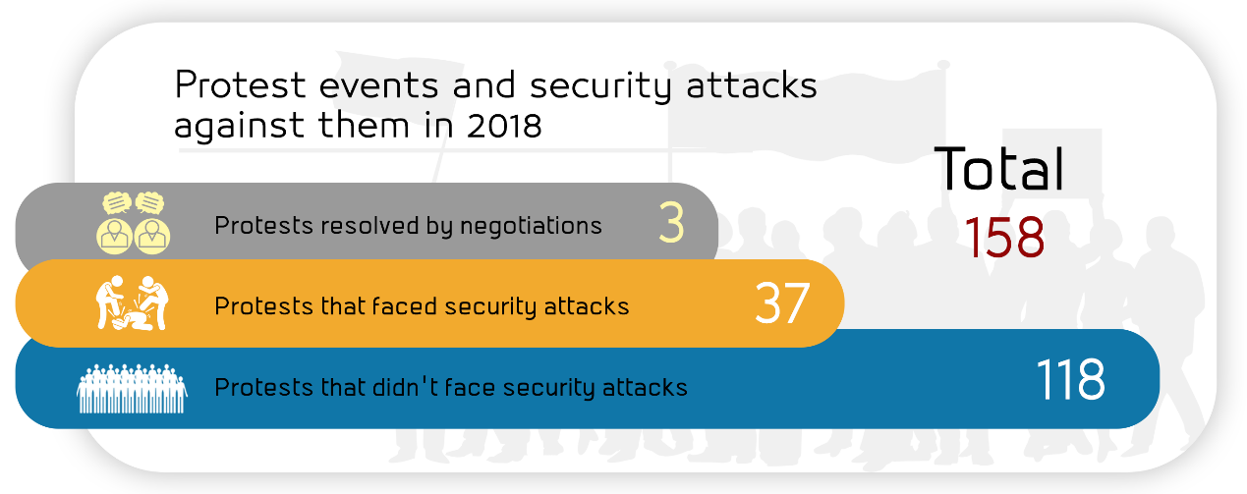
Protests settled by negotiation | Protests not subject to attack | Protests subject to attack
2% | 75% | 32%

Labor and Social protests:
The second quarter of 2019 witnessed 49 different social and labor protests; 5 of which were attacked by security forces, whereas 41 passed without interference, and 3 were resolved after negotiations with their organizers.
The most important demands brought by the social and labor protests:
- Workers at textile spinning mills protested the late salary payments and the non receipt of their annual bonus
- Protesting price hikes and the deteriorating economic conditions
- Residents at Arment village in Luxor protested the demolition of their homes.
- A number of workers demanding installation in their jobs
- Protesting against the amendments to the law regulating the Bar Association (lawyers' act)
- Protesting the arbitrary transfer decisions against workers
The following figure illustrates the percentage of attacks on Labor and Social protests:
Protests resolved following negotiation | Protests not attacked | Protests attacked
6% | 84% | 10%

MB and NASL protest activites:
The second quarter of 2019 witnessed the Muslim Brotherhood (MB) and the National Alliance to Support Legitimacy (NASL) organizing 68 different protests, including 23 that were attacked by the security forces and 45 that were left without security intervention, while none of them was subject to negotiation.
The most important demands raised by Muslim Brotherhood and the National Alliance to Support Legitimacy:
- Demanding the release of detainees and improvements to prison conditions
- Demanding to topple what they described as the military rule
- Protesting against what they call "the slow murder inside prisons" in the aftermath of former President Mohamed Morsi's death

The following figure illustrates the percentage of attacks on the activities of the MB & NASL
Protests not subject to attack | Protests subject to attack
66% | 34%

Student activities:
The second quarter of 2019 witnessed 18 protest activities organized by students and their families. Nine of these protests were attacked by the security forces, whereas the nine others were left without any security interventions.
Student protests' main demands:
- Thanawyia Amma (High schools) students objecting to the new tablet-based exam system

The following figure illustrates the percentage of attacks on the student protest activities
Protests not subject to attack | Protests subject to attack
50% | 50%

Pro- regime events:
The second quarter of 2019 witnessed 23 protests in Cairo and other governorates, all of which were to celebrate the June 30 Revolution anniversary, besides marches and rallies supporting the constitutional amendments during the voting process.
Second: Trials:
The second quarter of 2019 witnessed 66 trial cases that are being considered before the Egyptian Judiciary. Of these, there were 19 rulings of conviction, 13 acquittals and 8 death sentences against 32 defendants.
Ongoing trials:
The distribution of the 66 ongoing trials is as follows:
- 44 trials for the MB & NASL.
- 4 trials of the civil and democratic powers.
- 8 trials for Mubarak’s regime's affiliates.
- 3 trials for members of the post June 30th
- The military judiciary considered 7 trials for 1655 civilians

The following figure illustrates the percentages of the ongoing trials:
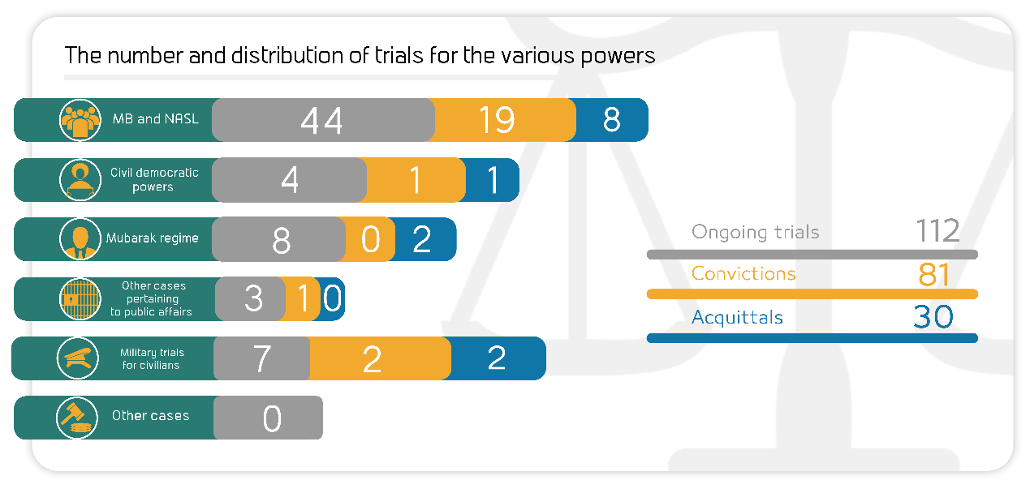

Post June 30th | Military trials for civilians | Civil and Democratic Powers trials | MB & NASL trials | Mubarak regime trials
5% | 9% | 6% | 68% | 12%

The most prominent trials of MB and NASL are:
- The cases known in the media as: (Breaching the eastern borders, Atfih violence incidents, Popular Resistance Committee in Kerdasa, Spying for Hamas, Al-Nahda Sit-in dispersal, High Pressure Towes, Al-Warraq terrorist cell, Marmina Church incidents, Helwan Brigades, Rabaa Sit-in dispersal, October terrorist cell, Al-Nusra Front "Jabhat al-Nusra").
The most prominent trials of Mubarak regime figures are:
- The cases known in the media as: (Trial of Mohamed Ahdy Fadhly and others on illicit gain charge, Stock market manipulation, Al-Ahram gifts, The Interior Ministry corruption, Trial of Ibrahim Soliman in the Green Belt case).
The most prominent trials of civil and democratic powers are:
- The cases known in the media as: (Trial of Al-Warraq Island's residents, Al-Moqattam Police Station incidents).
The most prominent trials of members of post- June 30th regime are:
- The cases known in the media as: (Former Agriculture Minister's profiteering, Appeal of Alexandria's deputy governor against her asset freeze decision).

Military trials of civilians:
In the second quarter of 2019, the military judiciary handled 7 ongoing trials for 1655 civilians.
Sentences:
During the reporting period, there were 23 convictions and 13 acquittals. The details are as follows:
Convictions:
During the second quarter, the Egyptian judiciary issued 23 convictions, distributed as follows:
- 19 rulings against the Muslim Brotherhood and the National Alliance for the Support of Legitimacy.
- 1 ruling against defendants in the civil democratic forces' cases
- 2 rulings against defendants in the military trials for civilians
- 1 ruling against post-June 30 regime's affiliates
- While no ruling was issued against any of Mubarak regime's figures
The following illustration shows the distribution of the convictions in percentages:
Post-June 30 regime's affiliates | Military rule against civilians | Civil democratic powers | MB & NASL
4% | 9% | 4% | 83%

Acquittals:
During the second quarter, 13 acquittals had been handed down, distributed as follows:
- Eight rulings of acquittal for the MB and NASL affiliates
- One acquittal for the Democratic and Civil Powers
- Two acquittals for Mubarak regime's affiliates
- Two acquittals in the military trials for civilians
The following illustration shows the distribution of acquittals in percentages:
Military trials | Mubarak regime's figures | Civil democratic powers | MB and NASL
15% | 15% | 8% | 62%

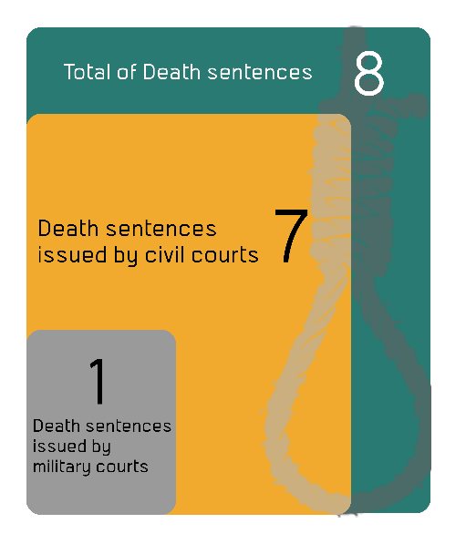
Death sentences:
Eight death sentences were issued against 32 defendants during the second quarter of 2019, including 3 final verdicts against 19 defendants pending ratification by the President of the Republic for implementation, as shown in the following table:

- Rulings
Total | Death sentences issued by military courts | Death sentences issued by civil courts
8 | 1 | 7

- Defendants

 | Number of defendants referred to the Mufti | Number of defendants upheld by the Mufti to be executed | Number of defendants upheld by the Court of Cassation to be executed | Total
Civil | 11 | 2 | 18 | 31
Military | 0 | 0 | 1 | 1
Total | 11 | 2 | 19 | 32

Third: Violence and Terrorism:
The second quarter of 2019 witnessed a total of 8 terrorist operations in Egypt's different governorates, along with 7 counter-terrorism operations, detailed as follows:
- Terrorist operations:
Eight terrorist attacks took place in the second quarter of the year; six of them had been carried out, while the security forces succeeded in thwarting the two others. The operations resulted in 36 killed, 49 wounded and 12 citizens kidnapped by the extremist elements.

The following table shows the percentages of terrorist operations in detail:
Terrorist operations thwarted | Terrorist operations carried out
25% | 75%

The following table shows the details of such terrorist operations during the second quarter of 2019:

Months | Operations carried out | Operations thwarted | Total
April | 1 | 1 | 2
May | 1 | 0 | 1
June | 4 | 1 | 5
Total | 6 | 2 | 8

The following table shows the numbers of terrorist operations and their distribution in the different governorates:

Governorate | Operations carried out | Operations thwarted | Total
North Sinai | 5 | 2 | 7
Giza | 1 | 0 | 1
Total | 6 | 2 | 8

These operations had resulted in 36 killed, 49 wounded and 12 citizens (residents from Al-Arish city) kidnapped.

The following table shows the number of killed and wounded and their distribution

Total | Terrorists | Security forces | Civilians
36 | 9 | 19 | 8 | Number of killed
49 | 0 | 0 | 49 | Number of wounded
85 | 9 | 19 | 57 | Total

- Counter-Terrorism Operations:
During the second quarter of the year, there were seven preemptive attacks by the security forces which targeted what they described as terrorism hubs, resulting in the killing of 94, the wounding of 4 and the arrest of 75 others.
The following table shows the number of dead and injured
Total | Those targeted | Security forces
94 | 89 | 5 | Number of killed
4 | 0 | 4 | Number of wounded
98 | 89 | 9 | Total

Fourth: Violation Against Freedom of Expression and Media Freedom:
The second quarter of the year witnessed 52 various violations against freedom of expression and media freedoms.
The following table shows the number of violations throughout the second half of 2019:

Number of violations | Months
20 | April
17 | May
15 | June
52 | Total

Details are as follows:
Number of violations | Kind of violation
19 | Ban from media coverage
17 | Ongoing trials & interrogations
3 | Physical and verbal attacks
3 | Confiscation
2 | Blocking websites
2 | Administrative penalties (fines)
2 | Sentences
1 | Ban from appearing on media
1 | Gag orders
1 | Detention and arrest
1 | Clearing camera contents
52 | Total violations

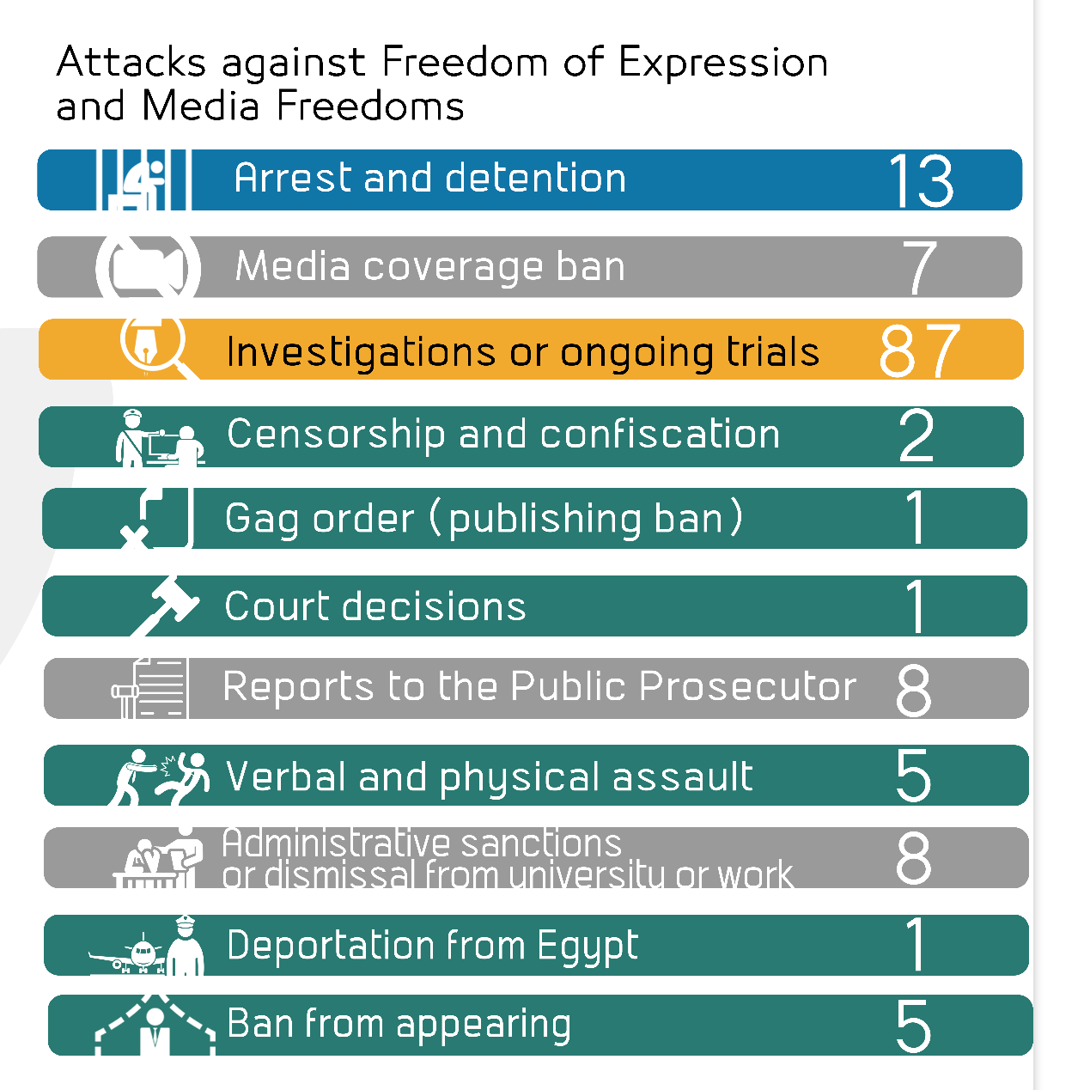

The following table details the media violations in percentages:
36% | Ban from media coverage
32% | Ongoing trials & interrogations
6% | Physical and verbal attacks
6% | Confiscation
4% | Blocking websites
4% | Administrative penalties (fines)
4% | Sentences
2% | Ban from appearing on media
2% | Gag orders
2% | Detention and arrest
2% | Clearing camera contents

Fifth: Attack on Human Rights Defenders:
- On 6 April 2019, Cairo Criminal Court ordered the continuation of the precautionary measures for human rights lawyer Haytham Mohamdein for 45 days pending case No. 718 of 2018 State Security, in which he is accused of colluding with a terrorist group to achieve its goals and inciting to protest. On 16 May 2019, the Supreme State Security Prosecution decided to hold lawyer Haytham Mohamdein in detention for 15 days pending investigation into case No. 741 of 2019 State Security on a charge of colluding with a terrorist group to achieve its goals, and on the 28th of the same month, the State Security Prosecution renewed his detention for further 15 days pending the aforementioned case and accusation.
- On 9 April 2019, Cairo Criminal Court decided to renew the detention of doctor Shady al-Ghazali Harb for 45 days pending case No. 621 of 2018 State Security, in which he faces charges of joining a terrorist group and spreading false news and statements.
- On 10 April 2019, the Supreme State Security Prosecution decided to hold engineer Yehia Hussein Abdel Hady in detention for further 15 days pending investigations into case No. 277 of 2019 State Security, on charges of joining a terrorist group, misusing one of social media means and providing financial support to terrorist groups.
- On 10 April 2019, the Supreme State Security Prosecution decided to renew the detention of human rights lawyer Mohab al-Ebrashi, pharmacist Gamal Abdel-Fattah, and activists Khaled Abdel-Galil and Khaled Bassioun for 15 days pending case No. 1739 of 2018 State Security, on charges of; joining a terrorist group, broadcasting false news and statements, and using Internet personal accounts with the aim of committing a crime that is punishable by law and disturbing public order.
- On 13 April 2019, Cairo Criminal Court ordered the continuation of precautionary measures issued against blogger Wael Abbas for 45 days pending case No. 441 of 2018 State Security, in which he faces charges of participating with a terrorist group and publishing false news and statements.
- On 13 April 2019, Cairo Criminal Court ordered the release of journalist Hossam Al-Sweifi with precautionary measures (appearing before the police station twice a week) pending case No. 977 of 2017 State Security, on charges of joining a terrorist group and publishing false news and statements. On 16 April 2019 and in implementation of the court's decision, the security forces at Hadayek al-Qoba Police Station set the journalist free.
- On 13 April 2019, Cairo Criminal Court decided to renew the detention of ambassador Masoum Marzouk, economist Raed Salama, university professor Yehia al-Qazzaz and activists Sameh Seoudi, Amr Mohamed, Abdel Fattah al-Banna, and Nermin Hussein for 45 days pending investigations conducted with them into case No. 1305 of 2018 State Security, in which they face charges of joining a terrorist group, supporting it financially, and spreading false news and statements. On 20 May 2019, the Public Prosecutor ordered the release of the defendants under the guarantee of their place of residence.
- On 15 April 2019, Cairo Criminal Court decided to renew the detention of lawyers Sayed al-Banna and Ahmed Sabry Abo Alam, along with activists Ayman Abdel-Moati and Walid Shawky, for 45 days in case No. 621 of 2018 State Security, in which they face charges of joining a terrorist group and publishing false news and statements.
- On 16 April 2019, Montazah Prosecution renewed the detention of human rights lawyer Mohamed Ramadan for 15 days pending case No. 16576 of 2018 Montazah, aka "yellow vests" case, on charges of joining a terrorist group, spreading false news and statements and inciting to protest.
- On 16 April 2019, Zagazig Prosecution decided to hold lawyer Ahmed Mouad in detention for further 15 days pending investigations into case No. 532 of 2019 Zagazig Administrative, on charges of joining a terrorist group, promoting its views and possessing publications.
- On 22 April 2019, security forces arrested activist Abeer al-Safti from Muharram Bek parking lot while she was trying to travel, and led her to an unknown location. Her arrest was because she didn't respond to a security officer's request for voting in the constitutional amendments' referendum while she sticks to her vote boycott.
Then, on 28 April 2019, six days following her arrest, al-Safti appeared before the Supreme State Security Prosecution which interrogated her over case No. 674 of 2019 and brought against her charges of; joining a terrorist group and using an Internet account with the aim of committing a terrorist crime for the purpose of disturbing security and public order. The Prosecution decided to hold Abeer al-Safti in detention for 15 days.
- On 14 May 2019, security forces from Katameya police station (The Third Settlement) arrested activist Mostafa Maher from his house, and seized his laptop and mobile phone before leading him to an unknown location. On 16 May 2019, the Supreme State Security Prosecution decided to hold activist Mostafa Maher in detention for 15 days pending investigation into case No. 741 of 2019 State Security on a charge of colluding with a terrorist group to achieve its goals, and on the 28th of the same month, the Prosecution ruled to renew the activist's detention for further 15 days pending the aforementioned case and accusation.
- On 25 June 2019, the security forces arrested human rights lawyer Zyad Elelaimy and journalists Hossam Moanis and Hisham Fouad from different places. Then they appeared before the Supreme State Security Prosecution for investigation into case No. 930 of 2019 State Security, before the Prosecution decided to hold them in detention for 15 days, on charges of colluding with a terrorist group to achieve its goals and spreading false news and statements.
ــــــــــــــــــــــــ
Note: This report is based on the cases monitored by ANHRI and does not necessarily include all the incidents took place throughout the month.
To view the previous Democratic Path reports:
To view the Democratic Path Report in 2014, “Obscure and stalled”
To view the Democratic Path Report in 2015, “One step back, two steps further back”
To view the Democratic Path Report in 2016 “Closed until further notice”
To view the Democratic Path Report in 2017, “Very Steep”
To view the Democratic Path Report in 2018, "Mounting Anger"

