The Arabic Network for Human Rights Information (ANHRI)
Program of Freedom of Expression for Labor and Social Movements

Labor and Social Protest Index during May 2019
Introduction
Before going into detail about the labor and social protests took place during the month of May, we have to shed light on two major incidents:
The first incident: "worker in al-Basateen district commits suicide"
At first glance, it may seem a minor incident we frequently hear on the news "A worker in al-Basateen district commits suicide". But when we go into detail and consider the context surrounding the incident, we shall learn that the suicide of Mohamed A. H. S. is not just a passing incident; it is the first case monitored by the Freedom of Expression for Labor and Social Movements program when a worker committed suicide by hanging himself in a machine in the factory where he works at the 10th of Ramadan region in Sharqiya governorate; for passing through financial distress.
As you can imagine, this is the situation of regular workers, let alone the non-regular or unemployed workers.
And, more importantly, why did Mohamed prefer to willingly kill himself while he had the ability to practice other forms of mass and organized protests?
The second incident: protests organized by first-grade secondary students
Despite the siege and repression, high school students took to the street organizing various forms of protests that are scattered across the country's several provinces. The protests are to denounce the Ministry of Education's failure to implement the new electronic education system known as "the tablet system", which the Minister of Education introduced it as the best cure for the "Thanawyia Amma" malfunction and the most effective tool to eliminate private tutoring.
The program of Freedom of Expression for Labor and Social Movements monitored 49 protests during the month of May, including 9 labor and professional protests and 40 social protests, summarized as follows:
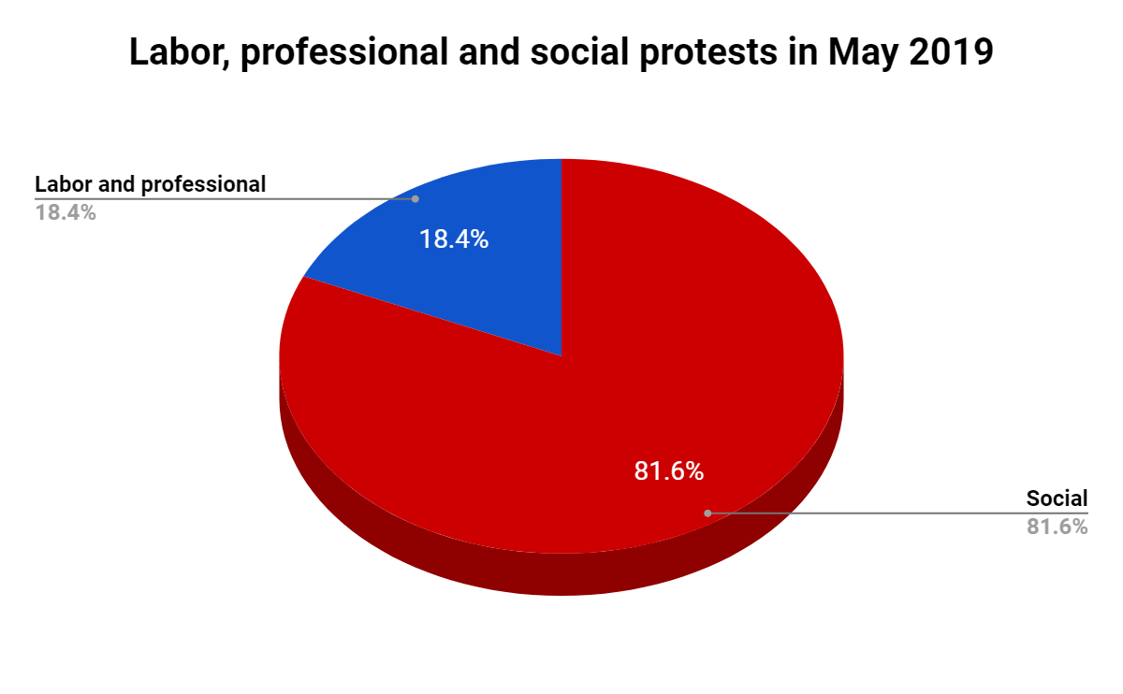
First: Labor and Professional Protests:
The program has monitored 9 labor and professional protests, distributed as follows:
- Strike to work: 3 cases
- Protests or vigils: 2 cases
- Complaints and/or petitions filed: 3 cases
- Sit-ins: 1 case
- Suicide/ attempted suicide: 1 case
The details of such protests go as follows:
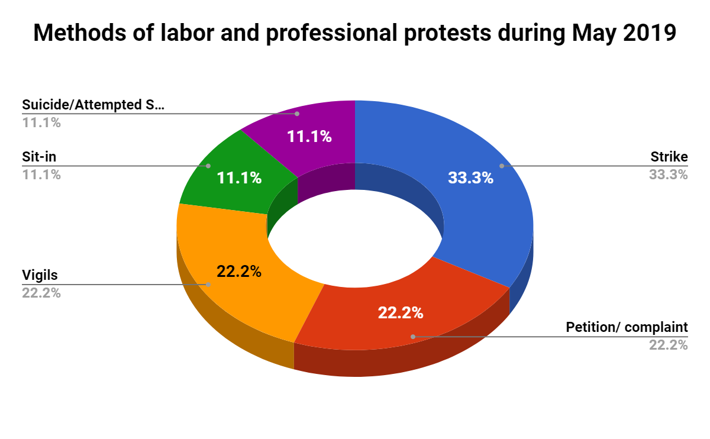
- Strike to work:
Workers and employees used striking to work (work stoppage) as a method to protest 3 times this month, as follows;
- Printing presses workers at Cairo's General Authority for Books went on a strike on 25 May and refrained from doing their overtime work, in protest against the verbal insult made by the president of the General Authority for Books using obscene words, when they demanded an increase in their salaries.
- Workers at Alexandria's Zahran Group Co. entered a general strike to work, on 21 May, due to the nonpayment of incentives and Eid bonus.
- Thousands of morning shift workers of Ghazal al-Mahalla Company, a subsidiary of the Textile Industries Holding Co in Gharbia governorate, entered an open labor strike and sit-in inside the company's factories, in protest against the officials disregarding the payment of their monthly wages and the month-and a half- incentive coinciding with the holy month of Ramadan.

- Vigils:
The program has monitored two vigils organized by workers during May;
- Employees of Top Business Group at Portland Cement Factory in Bani Mazar, south of Minya governorate, organized on 27 May a vigil inside the factory's administrative building, to protest the fact that they haven’t received any annual increases on their basic salaries since 2015.
- Workers at Developed Refrigeration & Air Condition Industries Equipment Co. at the 10th of Ramadan City (Sharqiya governorate) staged a vigil in front of the company's headquarters on the first of May. The protest was because of the company's refusal to let workers enter the company to exercise their daily work, after they refused to be transferred to another company under the same management.

- Petition or Complaint:
During the month of May, labor and professional movement witnessed two cases where workers filed complaints as one of peaceful protest's methods, as follows;
- On May 14, a number of workers at Ceramic El Jawhara Company submitted a memorandum to the Manpower Directorate in Sadat City, Monofiya governorate, after they were dismissed for allegedly inciting strikes and disrupting work.
- On May 8, a large number of employees at Al Maamoura Company for Construction and Tourist Development in Aswan (a holding company) filed a complaint to the deputy of Aswan's Nasr Nubia parliamentary circle, asking him to intervene to pay their cash allowance.

- Sit-in
The program monitored only one sit-in that was held as one of the labor protests' methods during the month of May, as follows;
- Workers at Faiyum Sugar Works Company announced, on 25 May, they staged a sit-in inside the factory in protest against the ruled on the disbursement of profits and incentives as well as the arbitrary practices against workers.

- Suicide/Attempted Suicide:
For the first time, the program of Freedom of Expression for Labor and Social Movements monitored in May a case of suicide due to poor economic conditions among workers, as;
- Mohamed A. H. S, a worker lives at al-Basateen district in Cairo, hanged himself in the factory where he works in 10th of Ramadan city, Al-Sharqia governorate after going through a financial crisis.

Second: Social Protests:
The program monitored 40 social protests during the month, detailed in the following chart:

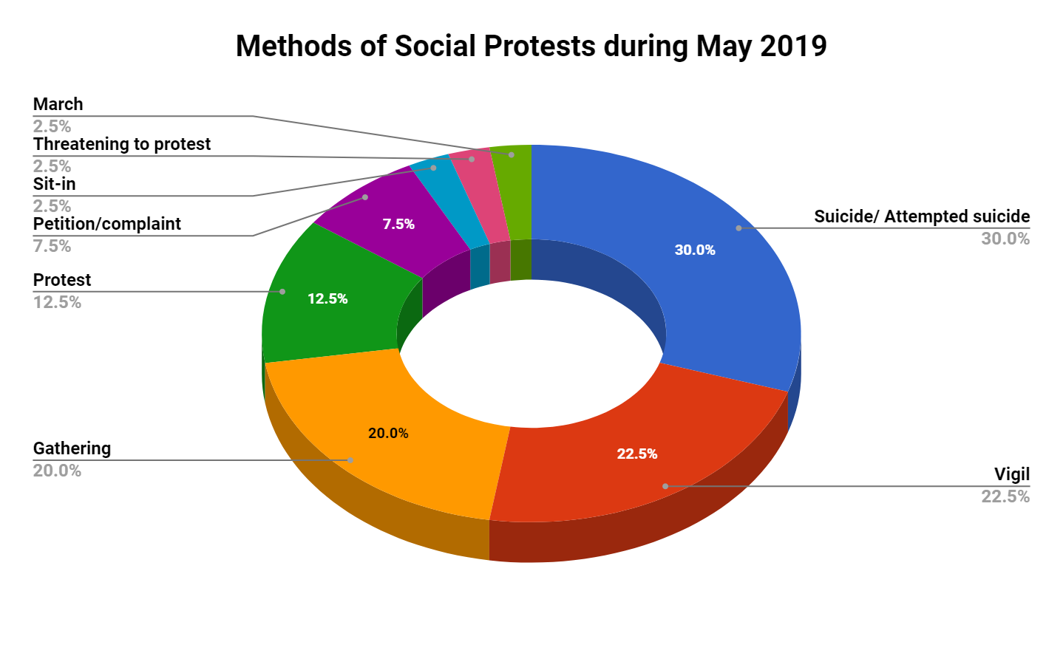
- Suicide/attempted suicide occupied the first place among the social protests' methods with 12 cases
- Protest rallies/ vigils came second in social protests organized during the month with 9 cases (9 vigils)
- Gathering came in the third place with 8 cases
- Protesting came fourth with 5 cases
- Submitting complaints or petitions came fifth with 3 cases
- Sit-ins, threatening to protest and marches came in the sixth place with one case each

1) Suicide and attempted suicide:
12 cases of suicide and attempted suicide took place during February 2019 leading it to be at the forefront of social protests' methods. All of these cases were to protest against the deteriorating economic and social conditions.
The details of these cases are outlined as follows:
  - A low ranking police officer "R.T", 37, who lives in Matai district in Minya governorate, committed a suicide on 31 May, after going through a financial crisis because he was suspended from work for three months.
  - Galal A., a furnace worker, hanged himself to death in his home at Tatai village, Al-Santah center in Gharbia governorate, on May 29, because of financial constraints.
  - On 29 May, Yasser A. S., a 30-year-old blacksmith, committed suicide by hanging himself in his house at El-Ezba El-Bahria in Helwan region, due to financial difficulties and accumulated debts.
  - On 27 May, L.M.M. A, 30, unemployed, hanged himself to death in his house's entrance at Al-Siyouf area, east of Alexandria, after he had been in a bad psychological state due to financial difficulties.
  - Nadia, 25, committed suicide on May 19 by throwing herself off the balcony of her home in Alexandria, after a quarrel she had with her husband who refused to buy her new clothes for the Eid (feast) a few days after they got married.
  - Ali, a 72-year-old psychiatrist, died in Alexandria on May 18 by throwing himself off the balcony of his apartment, due to the deterioration of his psychological and financial state after suffering from heart and aging-associated diseases.
  - On 17 May, M. A., 29, hanged himself at Beit Dawud village, Gerga Center, Sohag, after passing through a psychological crisis for not being able to find a job.
  - On 11 May, worker M. M., 27, committed suicide by hanging himself in his bedroom in Qalyub city, Qalubiya governorate, because he had been in a bad psychological state after he lost his job and became unable to propose to his beloved woman.
  - On 14 May, A. K., 42, worker, killed himself inside his apartment in Al Balina Center, south of Sohag, by cutting off his hand to escape his debts after falling victim to fraud.
  - M. A., 35, hanged himself in his place of residence at Awayed region in Alexandria, on 6 May, after he had been in a bad psychological state due to financial difficulties.
  - Said, 31, a grocery store owner and resident of Abu Zaabal village at the Khanka Center, committed suicide after shooting himself, due to financial constraints and the accumulation of debts.
  - On 15 May, M. A., a worker at a gas station, hanged himself to death because he had been in a bad psychological state following a financial crisis.
2) Vigils:
The program monitored 9 vigils took place during the month of May, placing vigil in the second ranking of social protests:
  - On 31 May, the residents of El Salam City in Suez governorate organized an evening vigil in front of the Bar Association in El-Galaa Street demand an end to the water and electricity shortages and the poor road conditions in the city.
  - On 21 May, a number of first-grade high school students in front of Borg Al-Aaela school complex in Dekheila district of Al-Ajami Educational Administration in Alexandria, to protest against the new tablet-based (electronic) exams system, calling for reverting the examinations into paper exams.
  - Students of the first year of secondary school in Suez organized a protest in front of the Governorate's General Bureau on May 21, after students complained they could not access the electronic exam platform of the new tablet-based system.
  - On 21 May, dozens of first-year high school students in Fayoum held a protest in front of the Directorate of Education protesting against the continuation of the new electronic exam system "tablet". In response, the police forces intervened to disperse the vigil which lasted for several minutes.
  - First-year high school students organized a protest rally in front of the General Directorate of Menoufia governorate in Shebin El Koum on 21 May after they failed to access the electronic exam platform for the third day in a row in order to take the second foreign language test.
  - Dozens of students in the first grade secondary school in Al-Kharga city, the New Valley governorate, held a protest in front of the Directorate General of Education Directorate on May 21, to express their deep dissatisfaction with the electronic exam system.
  - On 21 May, a number of first-grade high school students in Al-Fashn city organized a protest in front of Al-Fashn Educational Administration in South Beni Suef, to protest against the new examination system for its malfunction which made them unable to take their exams.
  - A number of first-grade high school students, also on 21 May, held some protest vigils at the Directorate of Education in Sohag following their the French language exam. They demanded to cancel the tablet-based system and return to the paper exams system. They also called for the dismissal of the Minister of Education.
  - On 7 May, dozens of people residing in the churches area of Bullin village at Kafr El-Dawar city in Beheira governorate organized a vigil in front of the governorate's General Bureau, to protest breaks in the drinking-water supply. The governor, as a result, promised them to solve the problem.
3) Gatherings
Gathering came third in the social protests with 8 cases took place this month as follows;
  - On 28 May, people of Naja Abu Usba region gathered in Karnak, Luxor governorate, to protest against a campaign to evict them from their homes by force, demanding the need to provide alternatives.
  - On 21 May, dozens of first grade secondary students gathered near the Directorate of Education in Aswan to demand the cancellation of the final exams conducted through the tablet; due to the system's difficulty and the continuous disruption of the network.
  - Dozens of parents of first-grade secondary students gathered in front of a number of secondary schools in Luxor on May 21, chanting against the new electronic system and the Minister of Education Tarek Shawki.
  - On 19 May, dozens of first-grade secondary students gathered outside Ismailia Governorate's General Bureau following the end of the Arabic Language exam, to protest against the disruption of the tablet-based system, which prompted them to answer the exam's question on a piece of paper.
  - Dozens of first-grade secondary students gathered in front of the General Directorate of Al-Gharbia governorate on May 21 to protest against the new electronic education system.
  - On 16 May, a number of citizens gathered outside the house of a low-ranking police officer in Ain Shams, after he shot two people following a quarrel he had with them over a traffic issue.
  - Some parents of preparatory school schools gathered in front of Martyr Ahmed Sarhan School in Mansoura Dakahlia governorate on May 14, after their children complained about the difficulty of the Geometry exam.
  - People of Bella city at Kafr El-Sheikh governorate formed a gathering along the road, on 10 May, to protest shortages and breaks of drinking water without prior warning, especially on the advent of the holy month of Ramadan.
4) Protests
Protests came in the fourth ranking of the methods of social protests during the month of May, which witnessed 5 cases of protests and demonstrations, as follows:
  - On 21 May, first-grade secondary students at Kafr El Dawar schools in Beheira governorate demonstrated in front of the local unit of Kafr El Dawar city/center and the educational administration building, to protest the difficulty of the exam and the tablet-based examination system.
  - Dozens of parents of first-grade secondary students, along with their sons, demonstrated, on 21 May, in front of the Ministry of Education's building demanding the cancellation of the electronic exam system. The police intervened, in response, and arrested a number of students before they were released later.
  - Dozens of first-grade secondary students demonstrated at al-Saa'a Square in Damietta on May 21, after they took the French language exam, expressing their objection to the new electronic system and the confusion they face after dealing with it.
  - On 20 May, dozens of first-grade secondary students demonstrated in front of Ismailia Governorate's General Bureau after they finished their Biology exam. They protested against the difficulty of the exam and the failure of the electronic system, and chanted against the Minister of Education.
  - On 12 May, dozens of Nile University's students organized a protest in front of the university's headquarters in the 6th of October City. They chanted slogans calling on the university's board of trustees and officials to quickly intervene to establish a footbridge or a speed bump in front of the university in order to reduce traffic accidents on the highway.
5) Petitions or Complaints:
Filing petitions or complaints ranked fifth in the social protests' methods of May with 3 cases during the month:
  - 11 parents of students at Bani Obaid Commercial Secondary School in Dakahlia governorate filed a collective complaint against one of the school's officials, after he insulted their children using absence language and profanities during the morning queue. Consequently, Dikirnis Prosecution opened an investigation into the complaint on the 23rd of May.
  - On 11 May, a number of parents and preparatory students in Hurghada, Red Sea Governorate, filed a complaint to the governorate's Directorate of Education reporting that the Arabic Language exam included questions that are not in the syllabus or curriculum, in addition to the difficulty of the other questions.
  - Parents of preparatory students at Hassan Abu Bakr Language School at al-Qanatir Al-Khairia district submitted a complaint to the Qanater Educational Administration, demanding to investigate the extent to which exams meet the standards and criteria of the Ministry of Education.
6) Sit-in
It came in the sixth ranking with one case took place in May;
  - Students of 7 schools in East Mahalla al-Kubra Educational Administration in Gharbia governorate, held a demonstration on May 20 in front of the administration's headquarters to protest against the ambiguity of the Biology exam. They also also called for the cancellation of the tablet-based system, before the sit-in was quickly dispersed by the administration's officials.
7) Threatening to protest:
It also came in the sixth ranking in the protests' methods of May with one case;
  - On 11 May, the Nile University threatened to organize a vigil on campus to call on the state services to establish a footbridge or a speed bump in front of the university to protect the lives of students and citizens.
8) Marches:
Organizing rallies and marches came sixth in the social protest's methods of May with only one case;
  - Hundreds of first-grade high school students participated in marches on the 21st of May in front of the educational administrations of "Mansoura, Dikrans, Sineblawin and Mit Ghamr" demanding the cancellation of the new electronic examination system and the return of the old "Thanawyia Amma" system, chanting slogans against the Minister of Education.
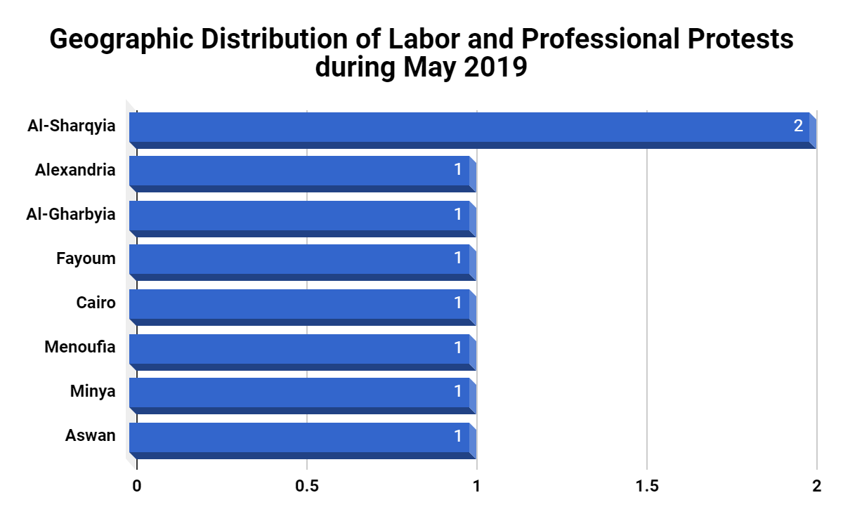

Third: Geographical Distribution of Labor and Professional Protests:
With two protests organized this month, Sharqyia governorate was at the forefront of labor and professional protests. Then the governorates of Alexandria, Gharbia, Fayoum, Cairo, Menoufia, Minya and Aswan came second with one labor and professional protest took place in each of them.
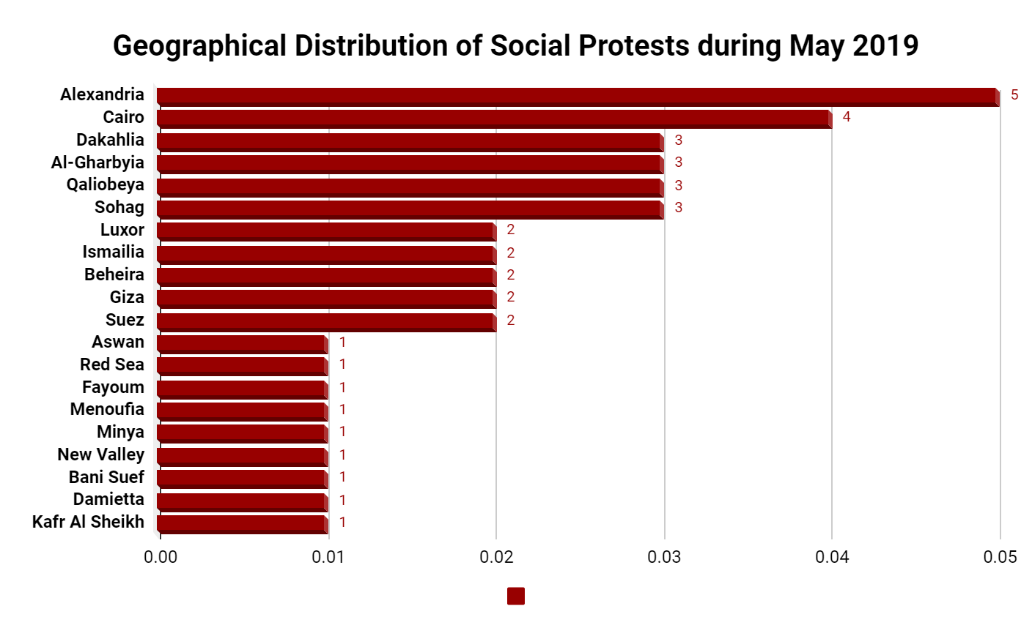
Fourth: Geographical Distribution of Social Protests:
Social protests in May were divided into five groups in terms of their number. Alexandria topped the social protests with five protests organized during the month, followed by Cairo with 4 protests, then came the governorates of (Dakahlia, Gharbia, Qalioubia and Sohag) in the third group with 3 social protests each.
The fourth group then included the governorates of Luxor, Ismailia, Beheira, Giza and Suez, with two protests for each governorate.
The fifth and final groups included Aswan, Red Sea, Fayoum, Menoufia, Minya, El Wadi El Gadid, Beni Suef, Damietta and Kafr El Sheikh Governorates with only one protest each.

Fifth: Sectorial Distribution of Labor and Professional Protests:
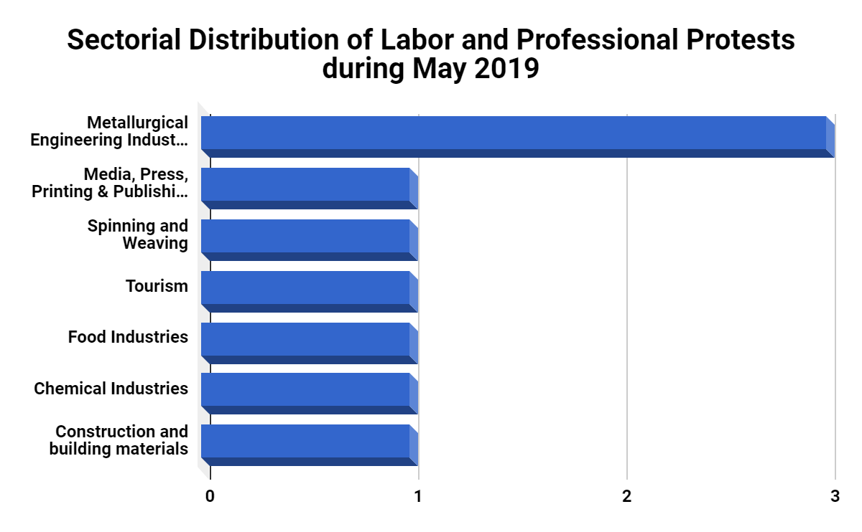
The (Metallurgical Engineering Industries) sector topped the labor and professional sectors with 3 protests this month, followed by the sectors of (Media, Press, Printing, Publishing, Spinning and Weaving, Tourism, Food Industries, Chemical Industries, Construction and building materials) in the second place with one protest each.
Sixth: Sectorial Distribution of Social Protests:
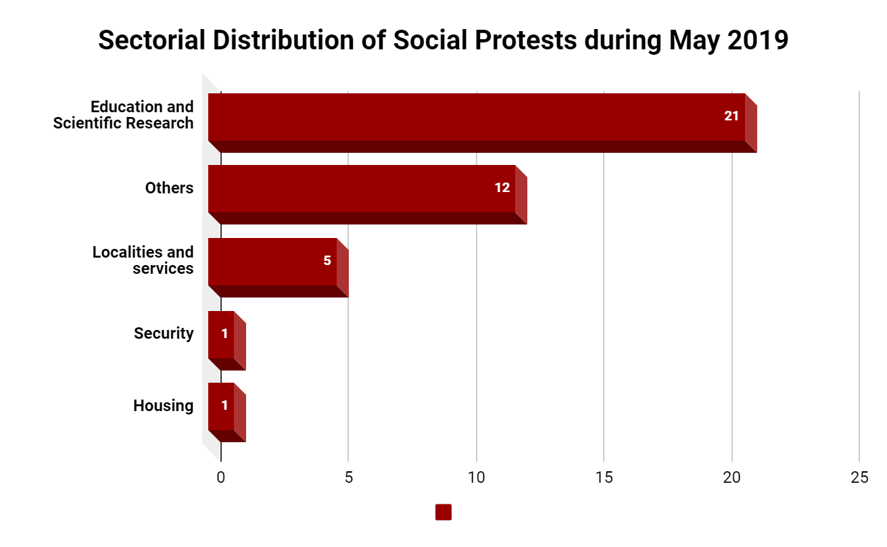
The Education and Scientific Research sector came at the forefront of the social sectors that witnessed protests during the month of May with 21 protests; this is due to the student protests that swept most of Egypt's provinces denouncing the new electronic examination system. Suicide, however, fell to second place with 12 cases of suicide that took place due to poor living conditions. Then, the "Localities and Services" sector, which witnessed protests against poor services, came in the third place with 5 cases, followed by the Security and Housing sectors in the final rank with only one case each.
The Arabic Network for Human Rights Information (ANHRI)
Program of Freedom of Expression of Labor and Social movements

