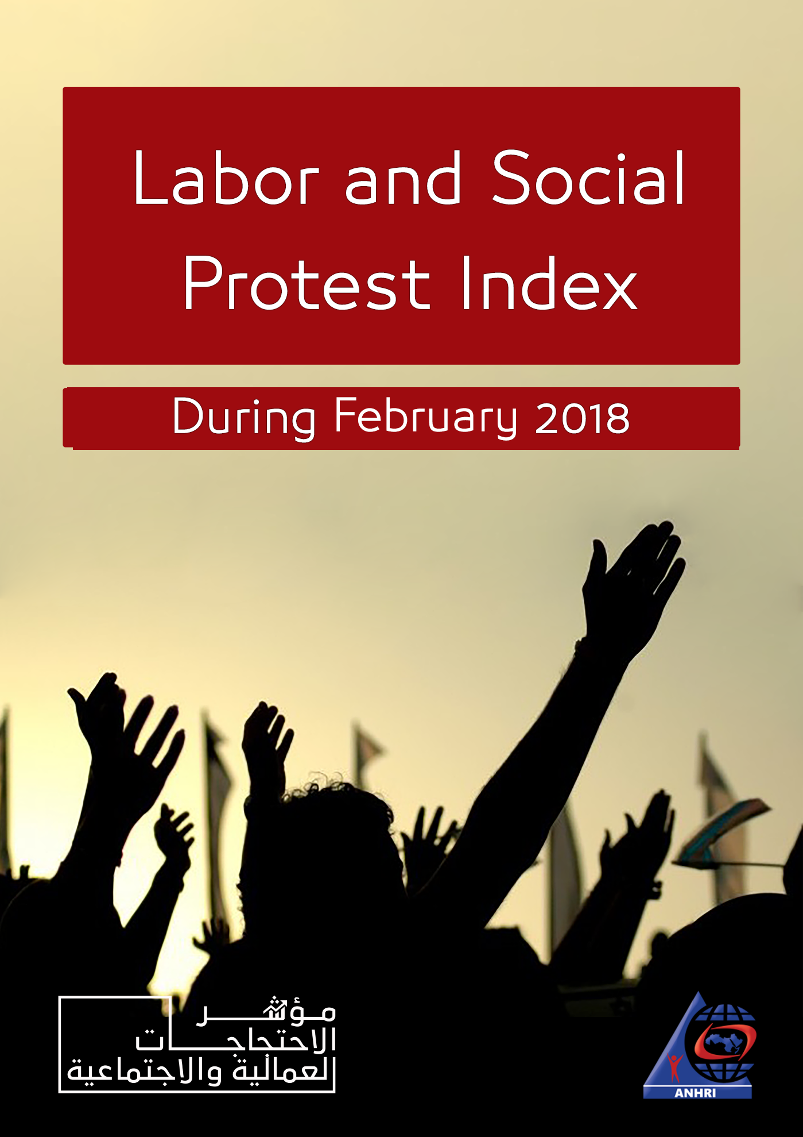

The Arabic Network for Human Rights Information (ANHRI)
The Freedom of Expression for Labor and Social Movements program

Labor and Social Protest Index during February 2019

Introduction
This month, the program monitored a unique phenomenon. Owners of stores and industrial workshops in Egypt's different governorates have shut down their shops for several days and started to lay off daily wage workers and craftsmen; after it has been reported that "a tax inspection campaign will take place imposing huge and arbitrary levies on shops leading their owners to pay large sums of money and those who don't pay taxes to have their shops sealed".
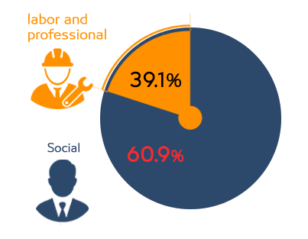
This news has provoked an outburst of anger in such governorates, not to mention the state of confusion that has hit the market there.
The campaign started on February 23 from Damietta governorate, where many workshops and stores were shut down in different parts of the province, before it has extended to reach Kafr El-Sheikh, Dakahlia and Gharbia governorates.
The program monitored 46 protests during the month of February, including 18 labor and professional protests and 28 social protests, summarized as follows:

First: Labor and Professional Protests:
The program has monitored 18 labor and professional protests, distributed as follows:
- Protests: 5 cases
- Labor strike: 4 cases
- Sit-ins: 4 cases
- Threatening to protest: 2 cases
- Complaints and/or petitions filed: 2 cases
- Gathering: 1 case
The details of such protests go as follows:
1) Protests
Protests came at the top of the methods of labor and professional protests during February 2019 with five cases detailed as follows:
- On Sunday, February 3rd, a group of journalists from partisan newspapers staged a protest on the stairs outside the Journalists Syndicate; demanding to swiftly be granted a license to create a website for partisan newspapers' journalists, besides the determination of their wages. After the protest, the syndicate's head met with the protesters in bid to calm their anger.
- Workers at the Union of Beheira Workers organized a protest rally at the headquarters of the General Union of Egyptian Workers’ Syndicates in Cairo on February 4th; to voice their objection to the non-payment of salaries for four consecutive months and the non-disbursement of grants for the past two years. Consequently, the union's Secretary-General intervened and promised to pay all the workers' dues during the month of February.
- Workers at the Spinning and Weaving Factory in Damietta governorate organized, on February 4th, a protest in front of the company's main square calling for the urgent payment of their late salaries.
- The workers of "Bidco International" textile and spinning factory in the 10th of Ramadan City, Sharqiyah governorate, organized a protest rally, on Sunday February 17th, to demand the non-closure of the factory and to protest against the non-payment of the annual allowance and the workers' production incentives.
- On February 17th, workers at "Magawish" Village Resort in Hurghada, Red Sea governorate, staged a protest rally demanding to grant temporary workers permanent employment, and to know their fate after the closing of the village resort. To prove and keep a record of this peaceful protest, protesters communicated with Egypt's Tourism and Antiquities Police and filed a communiqué about the incident.
2) Striking to work:
Striking to work (work stoppage) came in the second place in terms of the protesting methods adopted by labor and professional protests, with 4 cases detailed as follows;
- On the first of February, 200 workers at the International Company for Agriculture Production & Processing (ICAPP), Farm Frites-Egypt, in Sharqiyah governorate, entered a labor strike demanding the increase of periodic allowance from 12% to 18%. In response, Sharqiyah's Directorate of Manpower intervened to negotiate with the striking workers and the company's administration with respect to the demands they raised.
- More than 350 workers, employees and engineers of the Arab Aluminum Company in Ismailia launched a labor strike on February 18th, demanding that the company be obliged to pay medical treatment expenses for all its workers as stipulated in Egypt's Labor Law. A committee affiliated with the Manpower Directorate, hence, started investigating the complaints made by most of the employees.
- The workers of "Factory 7" at the Misr Spinning and Weaving Company in Gharabyia governorate went on a strike, on February 19th, in protest against the delayed payment of salaries; as there had been a work stoppage for 15 minutes, which prompted the company's board of directors to order the disbursement of the workers' salaries to put an end to the crisis.
- Most of industrial workshops and stores in different parts of Damietta governorate were closed on February 23rd; after it has been reported by unknown source that a committee of tax inspectors and representatives of the Industrial Security and Safety Authority will be arriving from Cairo to Damietta by bus for inspection. Therefore, many of shops were shut down by their owners for fear that they would be subject to tax increase.
3) Sit-in
Coming in second on the list of labor protests' methods, the month of February witnessed at least 4 sit-ins, as follows:
- The employees of Express International Company held a sit-in on February 1st demanding higher wages, the payment of a cost-of-living allowance and the disbursement of profits. As a consequence, Giza's Directorate of Manpower intervened and ended the sit-in after an agreement has been reached between both sides upon which workers' salaries are increased by 50 Egyptian pounds.
- A number of commission collectors at Giza's Drinking Water And Sanitation Company staged a sit-in on February 14th demanding a contract of employment, after their repeated failed attempts to meet with the chairman of the board to bring their complaints before him.
- Around 2,000 employees at North Delta Electricity Distribution Company held a sit-in, on February 24th, in the headquarters of the company in Mansoura, Dakahlia governorate, in protest against the reduction of incentives and the extension of working hours. Dakahlia Governorate, hence, intervened to reach an agreement on the incentives planned to be disbursed to employees.
- On February 25, workers at ExxonMobil Egypt Company's warehouses held a sit-in at the company's garage in Gesr El-Suez region; after the company's board refused to pay compensation to its workers for the previous period they served in the company, following the conclusion of its contract with the intermediary company. The workers demanded from the company to pay them 6-months salary for each year of work.
4) Threatening to protest:
With only two cases, threats to protest came third in terms of the methods of labor and professional protest during February 2019, as follows;
- Dozens of workers at the Misr Spinning and Weaving Company in Gharbia governorate threatened, on February 13th , to enter a partial labor strike to protest against the continued delay of their semi-monthly salaries for the second month in a row.
- A number of drivers at Uber and Careem companies for smart transportation services threatened, on February 20, to go on a four-day strike to demand a minimum ride fare limit and that the two companies reduce their share of the fare earned by drivers on every ride. They’re also demanding for an option that would grant them the right of reply before closing their accounts from the company, as well as increasing the share of fare in rugged and unpaved areas.
5) Complaints
Filing memorandums or complaints came third among labor and professional protests with 2 cases as follows:
- On February 13th, Amr Badr, a Journalists Syndicate's board member, revealed that he had prepared a memorandum to be submitted to the Syndicate Council demanding to issue a decision to ban the publishing of the name and picture of Governor of Daqahlia, and to discuss the possibility of filing a complaint against him with the Attorney General for expelling al-Masry al-Youm photojournalist Mahmoud al-Hafnawi while he was covering the governor's meeting with a group of citizens.
- On February 18th, a number of journalists at the Egyptian Radio and Television Union Magazine in Maspero filed a legal complaint (No. 2620) at the General Prosecutor's office against the head of the National Media Authority, in protest against the withholding of their dues of the Training and Technology allowance granted to all journalists enrolled in the Journalists Syndicate.
6) Gathering
Gathering came in the fourth and final ranking among labor and professional protests took place during the month of February with only one case;
- On February 11th , dozens of taxi drivers gathered in front of the city council of Al-Mahalla Al-Kubra in Gharbia governorate to protest against the widespread presence of " Tuk-Tuk" all over the city's streets. They also demanded to activate the decision of unifying the governorate's taxi color with Tanta governorate's Taxi. The security forces, however, intervened attempting to thwart the vigil.

Second: Social Protests:
The program monitored 28 social protests during the month, detailed in the following chart:
- Suicide occupied the first place among the social protests' methods with 16 cases (of suicide and/or attempted suicide)
- Gathering came second with 4 cases
- Threats to protest and road blocking came in the third place with 3 cases
- Protest rallies/ vigils and striking to receive services came fourth in social protests organized during the month with once case for each, as detailed in the following lines:
1) Suicide and attempted suicide:
16 cases took place during February 2019 leading it to be at the forefront of social protests' methods. The details of these cases are outlined as follows:
- Shaima H., 32, committed suicide by jumping in front of the subway at Saqiya Mekki station on February 1; after failing to meet the minimum needs of her four children, in addition to the accumulation of debts after getting divorced from her husband, who in turn gave up his role paying for the expenses of his children.
- Walid A., 25, killed himself by hanging on February 2 in the apartment he prepared for marriage, located in Al-Badrashin area south of Giza; after he failed to pay for a donkey his brother had stolen from one of his neighbors.
- Ibrahim A. Sh., 29, a Tok-tok driver, set fire to himself on February 3 in Barmbal al-Qadima village affiliated to Minya al-Nasr police station in Dakahlia governorate; after the repeated quarrels he had with his mother for being unable to cover his marriage expenses and to pay for his mother's needs along with his divorced sister and her four children.
- Taha E., a 29-year-old driver, committed suicide by hanging himself in his bedroom in Bandaf village of Minya al-Qamh district, Sharqiyah governorate; after passing through bad psychological and financial distress.
- M. A. S., a 26-year-old housewife, attempted to commit suicide on February 5, by throwing herself from an apartment on the third floor at Al-Hagan Street, Shubra al-Khaima district; after she and her husband had repeated disputes over their house expenses and hard living conditions.
- Al-Sayed M., a worker, committed suicide after he hanged himself on February 12 in Ain Shams district on top of the roof of the cafeteria, where he was working before the owner of cafe expelled him from work. Record No. 1011 of 2019 Ain Shams Misdemeanor was issued to investigate the incident.
- Ibrahim M. A., 40, unemployed, hanged himself to death on February 16 in his apartment in Mit Ghamr, city Dakahlia governorate; after he had been in a bad psychological state due to financial difficulties.
- Ehab S. B, a 35-year-old worker, committed suicide after he hanged himself on February 16 in his apartment in Minya al-Qamh district, Sharqiyah governorate; for passing through financial distress.
- Mughnam M., 32, committed suicide on February 17 by hanging himself in his bedroom at al-Saf district, where he and his wife used to fight because of his financial difficulties, as reported by Mughnam's father and brother.
- Hanan, 47, committed suicide by throwing herself off the balcony of her 5th-floor apartment in Dar El- Salaam neighborhood on February 21; because she couldn't afford her daughter's marriage expenses and arrangements.
- N.N., 37, resident at Malawi Center Minya province, committed suicide on February 21 after swallowing insecticide (toxin) for passing through financial distress and the inability to afford marriage expenses.
- M. M, 40, a maintenance technician in a water and sanitation company, lived in al-Matareya district, attempted suicide by cutting his hands on 21 February for passing through financial distress, before he was taken to the hospital for treatment.
- A young man in his thirties age attempted suicide on February 23 by throwing himself off the top of an apartment in al-Hod aread in the vicinity of the Coptic school in the center of Luxor governorate after passing through a severe financial distress, but citizens succeeded to prevent him from killing himself.
- On February 24, a daily wage worker in the fourth decade of his life committed suicide by throwing himself from a 3rd floor apartment in Masr al-Qadema Police Department's circle; after having many quarrels with his wife over hard living conditions.
- Gomaa A., a young man in his 30s, committed suicide on February 26 by hanging himself in his bedroom at Abu Al-Nimras Police Department's circle because of his financial difficulties.
- Samir, a 55-year-old engineering technician at Sadr Hospital and a resident of the Dar al-Ramad area of Fayoum city, committed suicide on February 26 by taking a poisonous substance for passing through financial distress.

2) Gathering:
Gathering came second in the social protests with 4 cases took place this month as follows;
- A number of Christians gathered outside the Esna police station in Luxor on February 8 and 9 to protest the disappearance of the 18-year-old girl, Marina M. G. and to call for the determining of her fate.
- Hundreds of residents of Kafr Ghannam village, affiliated to Sinbillawin Center, Dakahlia governorate, gathered, on 10 February, in Kafr Ghannam High School, whose opening was attended by the governor. The residents protested against the contamination of drinking water by sanitation, which causes many diseases and endangers the lives of their children. The governor, hence, promised to address and study the issue.
- A number of residents who are harmed by the collapse of Karmouz west Alexandria building gathered, on February 20, to protest the failure of providing them alternative accommodation after the evacuation of their homes.
- A number of families of the people injured in Ramses Railway Station's train crash gathered, on February 28, in front of the Railway Hospital demanding to be allowed entry to the hospital to ask after the health of their relatives.

3) Threats to protest:
Threats to protest came third in the social protesting methods with 3 cases occurred in February, as;
- Parents of "Gawad Ali Hosni" official language school in Shubra threatened on Saturday, February 9th, to organize a protest rally in objection to the ongoing excavation and new construction works inside the school, which puts the lives of students at risk.
- On 15 February, a number of residents of Hadaeq Al-Ahram area in Giza threatened to organize a rally in protest against the deteriorating security conditions and services, against the backdrop of an armed robbery at a jewelry shop before the assailants fled the scene.
- On February 26, the general coordinator of the Bakeries Division at Qalyoubia Chamber of Commerce threatened to organize a rally in front of Qalyoubia Directorate of Supply Commodities; to protest the fines imposed on bakery owners over fake balances through the Golden Card.

4) Road blocking:
Road blocking came third in the social protesting methods with 3 cases occurred in February, detailed as follows;
- On February 2nd, residents of Crore district in Aswan governorate blocked the Sadat Road using stones after a police car ran over a woman from the same district. Senior tribes and families then intervened and helped security forces to open the road.
- On February 8th, dozens of residents of Al Hogayrat Village affiliated to Qena Police Department blocked the road in protest against interruption of drinking water services for more than 10 days, forcing people to resort to salt water through artesian wells. With the intervention of the security director of Qena promising to resolve the problem, residents managed to disperse the gathering at the end.
- On February 26, Stall owners objecting to the demolition of unlicensed stalls at 'Ash'ash Abu al-Saud in Masr al-Qadema district gathered and blocked the road around the park of Fustat; out of their fear that they wouldn’t find an alternative for their work at Al-Asmarat neighborhood. To put down the protest, Cairo Security Directorate asked for further security forces to handle the matter.

5) Protests
The month of February saw only one protest rally as a means of social protest:

- A group of Mercedes car owners organized a protest rally on February 23, in front of the company's headquarters in Kattamiya denouncing the non-receipt of the custom value of the 2019 car models.

6) Striking to receive services
There was only one case of striking to receive services in the month as;
- A number of students at the Egyptian Japanese School in the fourth district of Beni Suef east of the Nile went out of school, on February 10, and refused to enter classes in protest against the high school fees compared to the service provided.

Third: Geographical Distribution of Labor and Professional Protests:
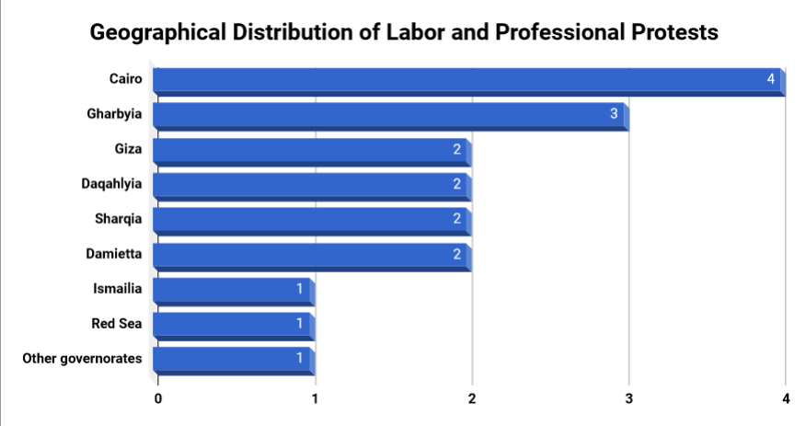
With 4 protests organized this month, Cairo continued to be at the forefront of labor and professional protests for the second consecutive month this year. Then Al Gharbia came second with 3 protests each, and (Giza, Dakahlia, Sharqia and Damietta) governorated came third with 2 protests each. Then finally we have (Ismailia, Red Sea, and several governorates) with 1 each.
Fourth: Geographical Distribution of Social Protests:
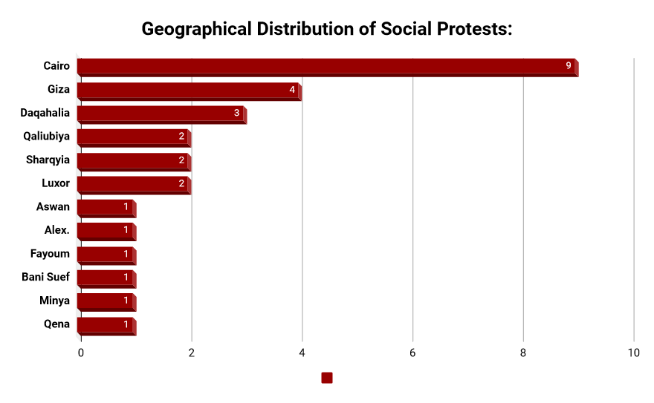
Social protests in February have largely been centered in the governorates of Cairo, Giza and Dakahlia. Cairo topped the social protests this month with 9 protests, followed by Giza with 4 ones, then came Dakahlia governorate with 3 protests. Protests then extended in a lower range to cover the governorances of Qaliubiya, Sharqiya and Luxor with two protests each, then to Aswan, Alexandria, Fayoum, Beni Suef, Minya and Qena governorates with one protest each.

Fifth: Sectorial Distribution of Labor and Professional Protests:
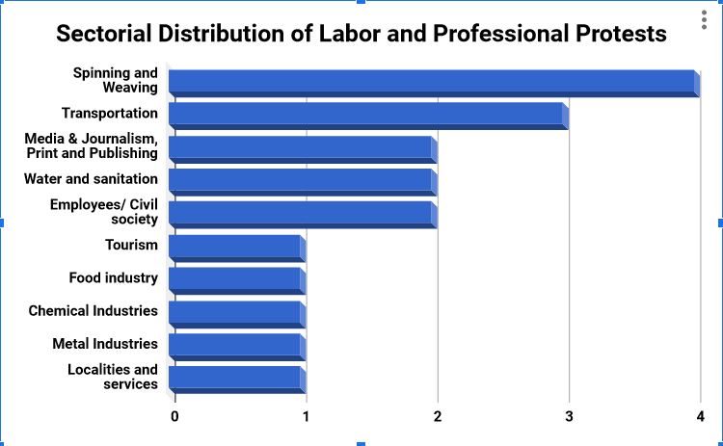
The Spinning and Weaving sector topped the labor and professional sectors with 4 protests this month, followed by the Transportation and Communications sector represented by 3 protests, while (Media and Journalism, Water and Sanitation, Electricity, and Employees) sectors came third with 2 protests each.
The fourth and final rankings are occupied by sectors of (tourism, food industries, chemical industries, metallurgical industries, localities and services) with 1 protest each.

Sixth: Sectorial Distribution of Social Protests:
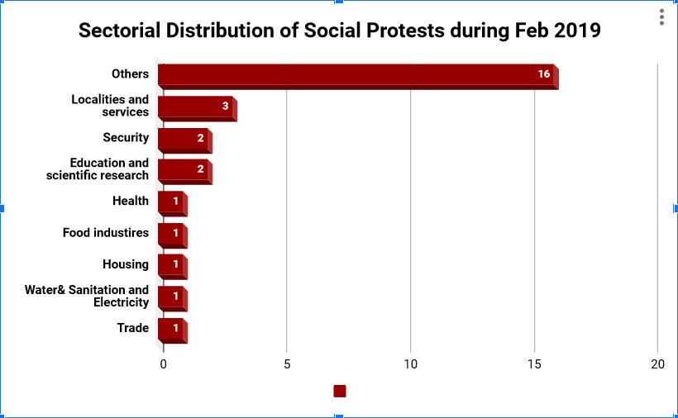
"Other" sector; "Suicide and Attempted Suicide", topped all social sectors this month with 16 cases, while the "Localities and Services" sector ranked second with 3 protests.
Sectors of (Security, Education and Scientific research) came third with 2 cases each. Social Protests organized in February included sectors of (Health, Housing, Trade, Food industries, Water& Sanitation and Electricity) with one protest each.

Thus, as indicated in the presentation set out above:
Suicide or attempted suicide continued to increase in February as a result of poor economic conditions, and it continues to top the main methods of social protesting. While most labor protests have been ended through negotiations, many social protests have been put down using repression and the dispersal of protest rallies.

It is also clear that Cairo continues to occupy the forefront of social protests as well as the labor ones.

The Arabic Network for Human Rights Information (ANHRI)
The Freedom of Expression for Labor and Social Movements program

